How well do you know our projects?
Not much to help you identify this project unless you were there and helped. This was a painting project at Buck Aiazzi baseball field. During a visit to Yerington in Spring of 2013 Cindy Collins (sister to Buck Aiazzi) noticed that the buildings and backstop were looking rather shabby. She volunteered to pay for the materials if Rotary would do the painting. We took the job and spent a day scraping and wire brushing the old paint and applying a new green trim paint to all four buildings there.
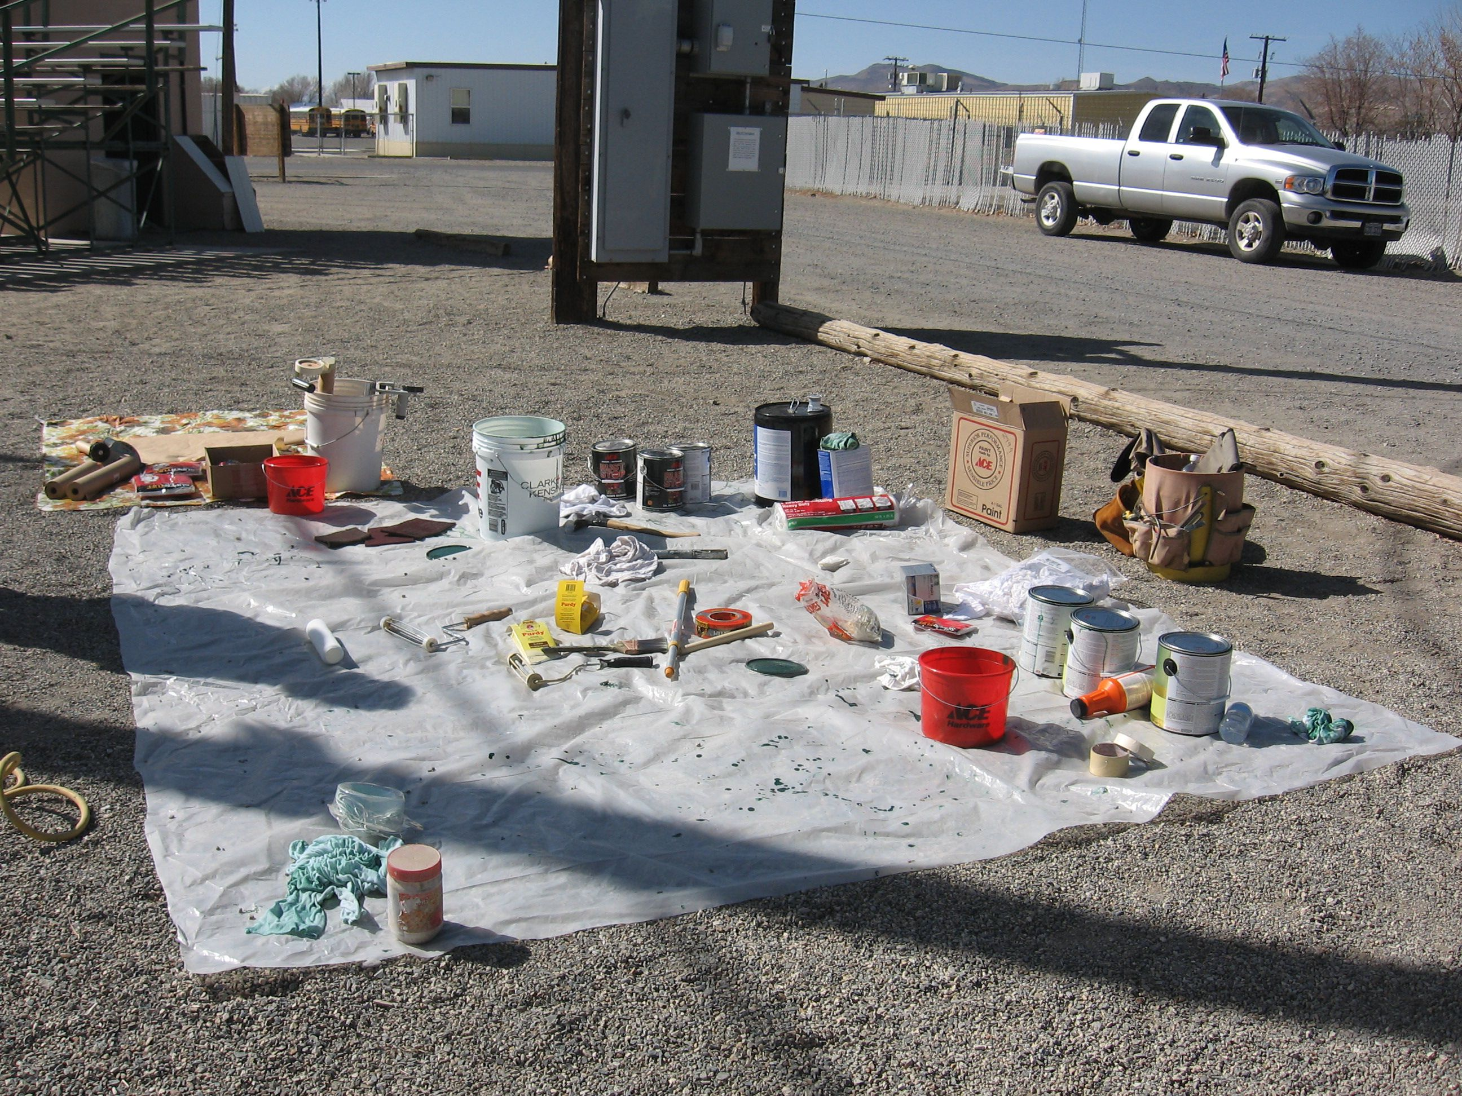

Later that same year (2013) Rotary was asked (by the City, I think) about helping solve another problem at the same baseball fields. Several of the roofs were leaking and the buildings could not be used to store equipment and
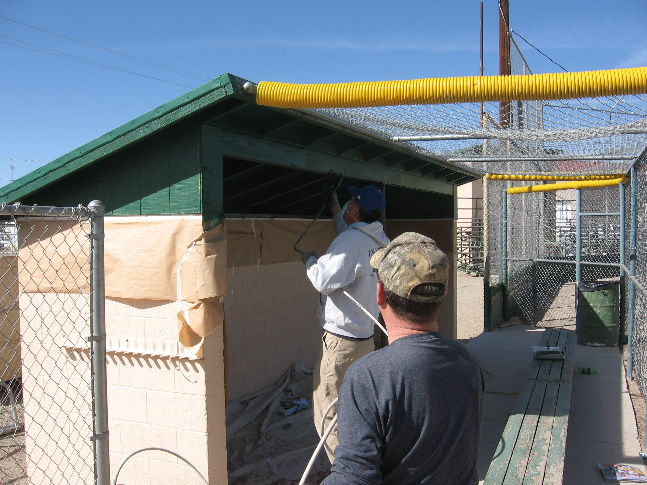
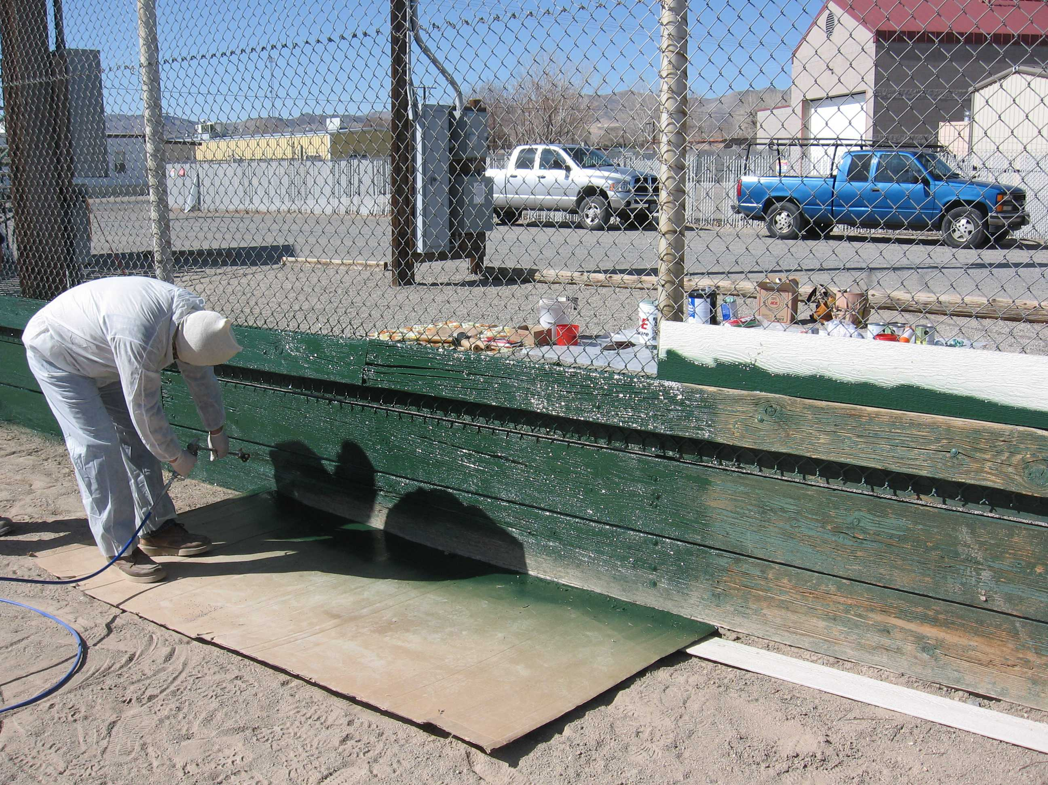
materials. Again Rotary stepped up and took the job. With the help of a District 5190 Service Grant, we agreed to put new metal roofs on the four buildings there. Valley Building Materials gave us a very good price on the necessary roofing materials. In November 2013 we spent a Friday stripping off old asphalt roofing paper and then Saturday putting the new metal roofing on three of the buildings. We had help from several ROP students for that work. The next Monday a few Rotarians together with several City workers finished the fourth building.
