How well do you know our projects?

Pretty easy to guess this project. I like this photo because it shows the size of the arched sign. What I want to say about this project is that it was really a community project, led by Rotary. Before reading my description , see if you can name 5 or 6 community organizations that contributed labor, equipment or materials to make this project happen. The idea of an arched sign at this intersection had been around for several years, but when the City of Yerington received a grant for improving Littell Street they asked Rotary about resurrecting the project. We accepted.
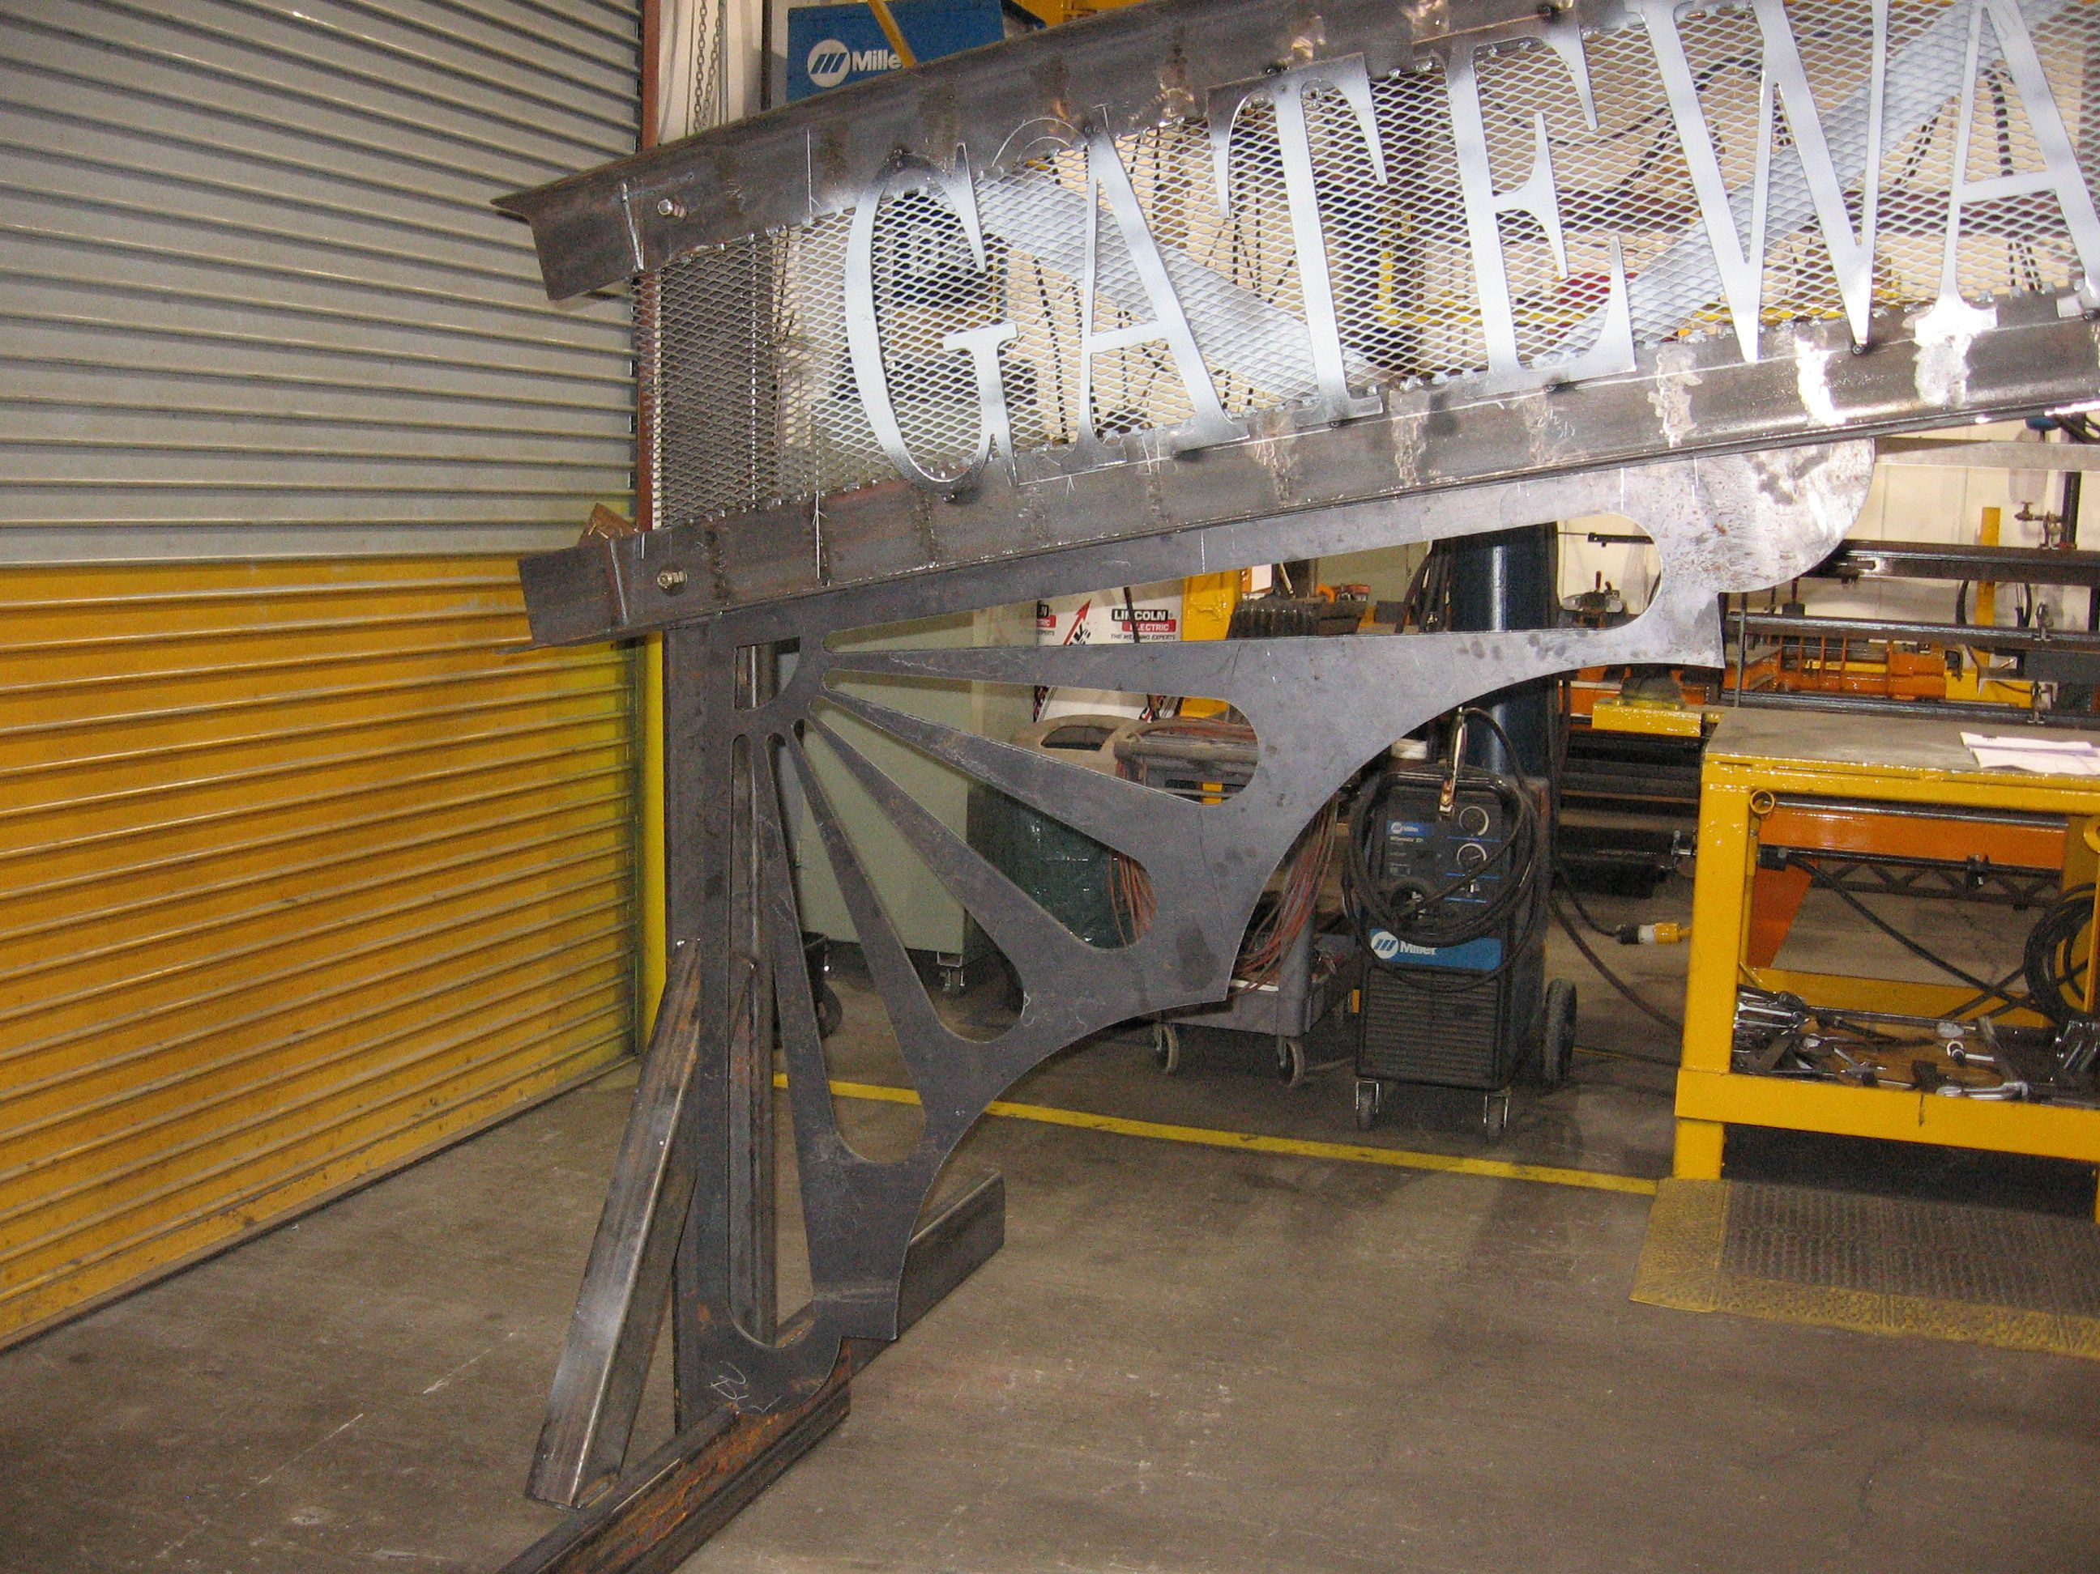

Phase one of the project was to erect the poles needed to support the sign. The City of Yerington removed some of the sidewalk on either side of the intersection. Green Valley Rentals provided a skidster with a 24” auger to bore holes for the anchor blocks (2’ diameter by 5’ depth). Desert Engineering built the anchor bolt frame and did the critical installation of it (The frame not only has to fit the plate on the bottom of the poles, but the poles have preset brackets for mounting the sign and those brackets must be properly aligned so the sign can be bolted to them.). Hunewill Construction donated the concrete for the anchor blocks. Sierra Pacific (now NV Energy) lifted the poles into place, completing Phase One. The poles cost $5,000 each and were certified by the manufacturer to hold the weight of the sign and withstand the force of the wind. Rotary paid for one of the poles (in part with a District Simplified Grant) and The Walker River Basin Communities Foundation paid for the other.

Once the poles were installed, we carefully measured the distance between them and thus finalized the specs for the sign. The engineering and design of the sign was done by Peak Engineering of Carson City (Rotary paid about $2,000 for that). The specs included top and bottom pieces being 5” I-beams bent to have a 2’ arch. Marathon Corporation had volunteered to donate the materials and labor to make the sign. Determining how to bend 5” I-beams was the first (and worst) problem they had to deal with. They had to make dozens of cuts most of the way through the I-beam, bend the beam a little then weld the cut back together. Lots of cuts, lots of welding not to mention having a 33’ object sitting in your workspace for a month or two. A recently retired Lyon County worker, Steve Kostenbader, who was an experienced welder volunteered many hours to help with the welding. Eventually, the construction and painting of the arched sign was completed. Steve Berrington volunteered to use his hay truck to move the sign from the Marathon Corp. site to Littell St. Sierra Pacific brought in their crane truck to lift the sign and early one morning in May 2009 the arched sign was bolted to its poles. Everything fit like it was supposed to.
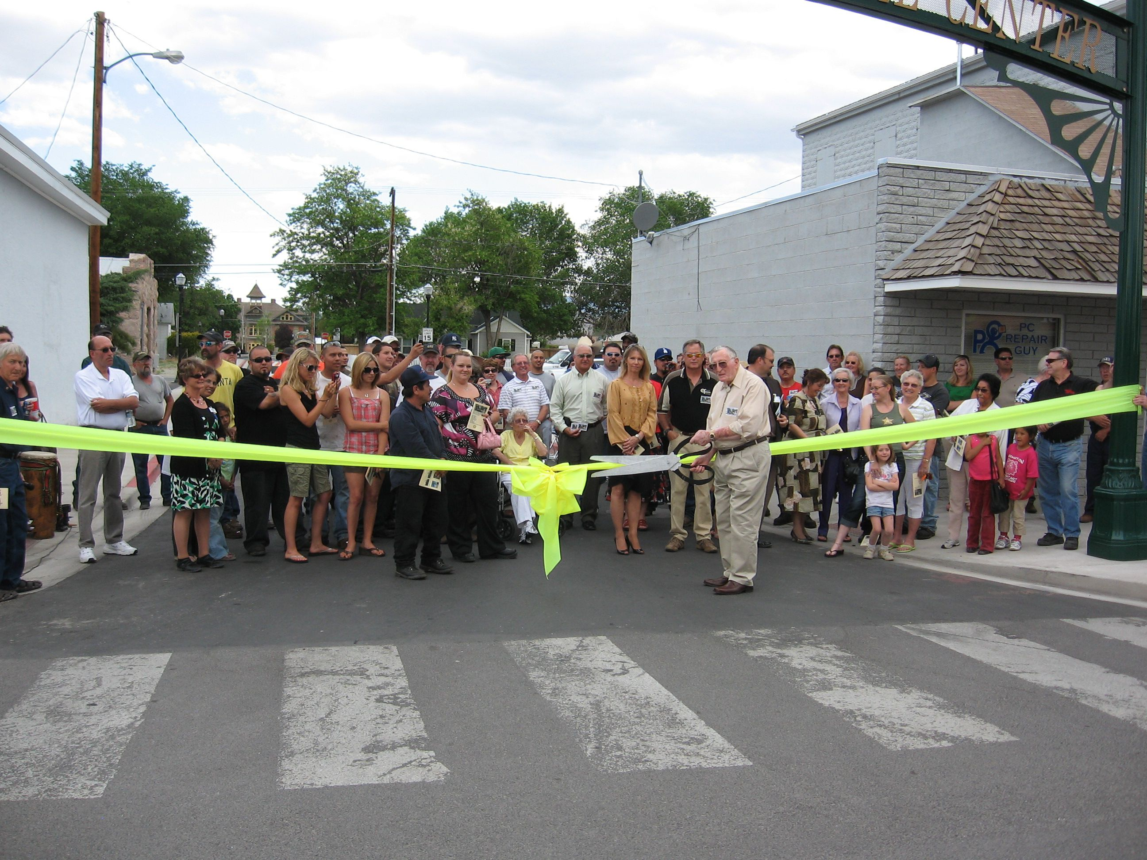

This photo was taken at the Chamber of Commerce “Opening Ceremony”, May 19, 2009. The Chamber provided beverages and treats as well as a sound system and a ribbon. Joe Dini cut the ribbon. Following the ribbon cutting the attendees were invited to a “Celebrate the Arch” Gallery showing at the Jeanne Dini Center.

For more photos of this project go to the Yerington Rotary website (www.yeringtonrotary.org). Under Site Pages, click on Projects we have completed, then click on Arched Sign – Littell Ave.

