How well do you know our projects:

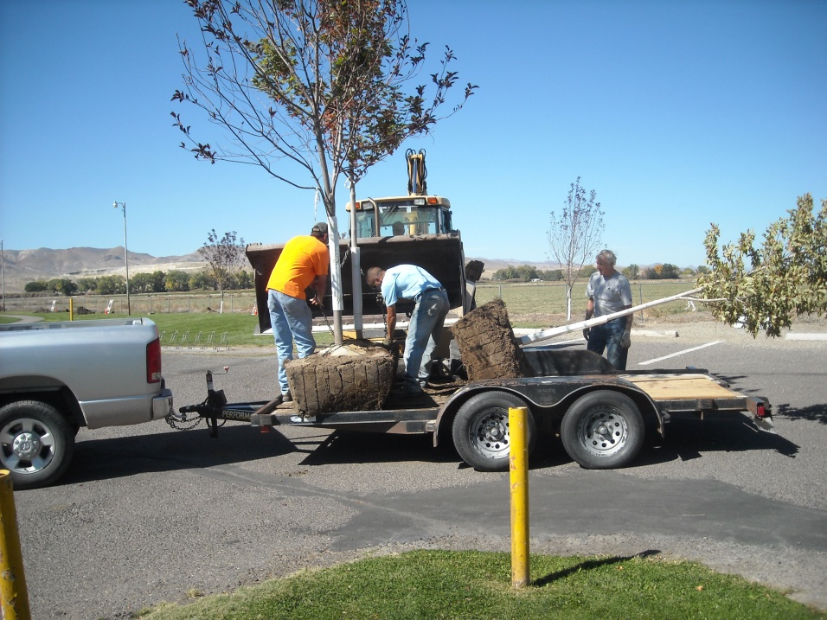
This photo was taken 10/10/2014. This work day was the second half of a tree planting project at Mountain View Park. This part consisted of planting about 10 or 12 Red Maple trees along the North border of the Park. The first half of the project was carried out in the Spring of 2014 and consisted of planting about 10 or 12 Flowering Pear trees along the West border of the Park. The trees came from the Open Waters Nursery in Smith Valley (Gary LaFleur, owner, gave us a good price on these large trees). I could only fit 3 trees on Kathie’s trailer so it took lots of trips to get them all to the Park.

Rotary had purchased some bare root cottonwood trees and planted them there many years earlier, but lack of a watering system lead that attempt to failure. The City put in a watering system for the trees as part of this project and they dug the holes for planting the trees (they needed to be big holes too). Member Craig Stevens brought his tractor with back hoe to move the first batch of trees from the trailer to the holes and the City brought a back hoe to move the second batch of trees.

More recently we have replaced a few of the trees in these borders.
