How well do you know our Projects: This is not a community service project, but certainly was a Rotary activity.

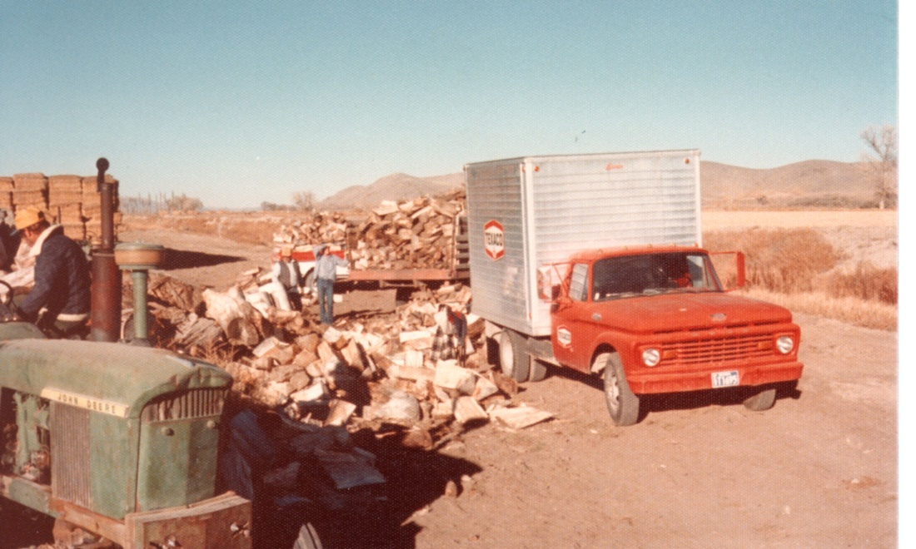

What’s going on and who’s doing it?

Ed Snyder is the only currently active Rotarian who was part of this project. Probably in the early 1970’s, maybe even the late 1960’s (Jim Snyder remembers the project, but claims he was too young to help with it) Yerington Rotary sold fire wood as a fundraiser. Back then firewood was a very common fuel for heating homes and since firewood sellers were few and far between this really was a community service. For several years Club members cut and split firewood and sold it, delivered, for $20 per cord. One source of wood was a group of big Cottonwoods from the corner of Pursel Road and Mac Kenzie Road. Eddie says they did at least have a mechanical wood splitter (powered by a tractor), but it was a lot of hard work.

