Officious Newsletter of Yerington Rotarians

March 19, 2017

Meetings:
Tuesday Evening 7:00 PM
Dini’s Lucky Club

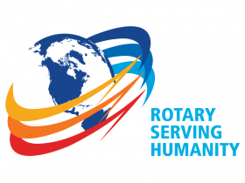
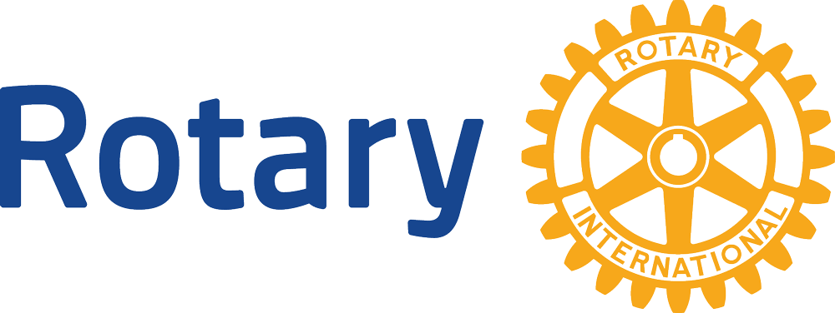

President
Mary Swirsky
463-4015

Secretary
Ann Rudolph
463-5803

Treasurer
Candy LoBue
463-2677

President-elect
Lynda Boody
202 355-4201

Board Members

Term thru 6/17
James Schreiber
463-3377
John Diekmann
463-7162
Carolyn Strelo-Smith
463-4696
John Murray
463-5550

Term thru 6/18
Jim Snyder
221-3986
Oscar Hernandez
463-1873
Peggy Bitler
463-4239
Richard Ernst
916 749-8479
Kathie Mann
463-4265

Newsletter
Prices 463-3794
Program Schedule:

Mar. 21 CEO South Lyon
Medical, Toni Inserra
Mar. 28 CEO of the Nevada
Area Council, Boy Scouts of
America, Paul Penttila
Apr. 4 Open
Apr. 11 Open
Apr. 18 Student of the Month

Upcoming Events:

Mar. 25 Spring Dinner/Dance

Future Programs: For more years than most of can remember, Lucy has taken responsibility for organizing the programs we enjoy at our meetings. She didn’t do it without help from other members, but she has definitely been the major contributor. She not only organized the programs but she directly arranged many of them. We owe Lucy a huge thank you for her efforts on this task.

Amy Geddes has agreed to take over this important job and has gotten off to a good start. She has arranged several programs for March. This is not her responsibility alone. All members are responsible for arranging 1 or 2 programs each year. At least for the time being, we will continue the plan of designating about one fourth of our membership as being primarily responsible for suggesting/arranging speakers during one quarter of the Rotary year. The group responsible for April, May and June is: Eddie Snyder, Jim Snyder, Carolyn Strelo-Smith, Bill Swirsky, Mary Swirsky, Dale Theiss and Laurie Thom.

Let’s all put some serious thought and effort into arranging entertaining and informative programs. Keeping our Club aware of what is going on in our community is critical to achieving our mission.

Spring Dinner/Dance: It’s this coming weekend (March 25). Plan on helping with the decorations and food preparation Saturday morning 9:00. Peggy (and others) will have last minute requests and schedules for helping Tuesday night at our regular meeting. The food is pretty well planned at this point but still requires effort to have it ready and serve it. The wine tasting is looking quite good. I think it will be a real positive this year. Lynda and Ted have

both put in the effort necessary to make the tasting be worth while. Decorations are well planned out and just need lots of help to finish them on Saturday. This is our last major fundraiser for this year. Let’s do it right.

Speech and Music Contests: On Feb. 28 we held our Club Speech competition (no contestants were entered in Music Contest). Amanda Aldridge, English instructor at YHS, brought the 5 top contestants from her classroom Speech competition. All 5 gave excellent presentations. Their talk had to be 5 minutes in length and had to be on this year’s Rotary assigned theme (“What 'Rotary Serving Humanity' means, personally, and in my own words.” ) It was surprising how many of the speakers had personal experiences with Rotary (usually through programs such as REGL, RYLA and RYE). All addressed the required theme very well. The competition was won by Miss Alexus Bodenstein. Miss Rebecca Singer was second.

On Saturday March 18 Yerington Rotary hosted the Area 10 Speech and Music Contest. Contestants sponsored by the Fallon, Fernley and Yerington Rotary Clubs competed on the stage at the Jeanne Dini Community Center. The winners will compete once more at the Rotary 5190 District Conference May 20 in Reno. The two winners of the Area contests are Yerington’s Miss Alexus Bodenstein in Speech and Fallon’s Mr. Raymond Plasse (who played the piano) in Music. Good luck to both of them in the final stage of the competition.

Board elections: At our Feb. 28 meeting, members were asked to nominate members for serving on our Club Board of Directors. At our March 7 meeting members were asked to vote for who should serve for the next two years on the Club Board of Directors. The five elected members of the Board are: James Schreiber, Gary Hardesty, Ken Bitler, Dale Theiss and Amy Geddes. Their term on the Board will begin July 1, 2017 and end June 30, 2019.

Positions needing volunteers: We still need someone to serve as Club President for the July 1, 2018 through June 30, 2019 Rotary year.

We also need someone to fill the Club Secretary position that Ann has held for several years. It is a necessary position but not really that demanding. It’s just a matter of keeping things going.

