Officious Newsletter of Yerington Rotarians

March 28, 2016

Meetings:
Tuesday Evening 7:00 PM
Dini’s Lucky Club

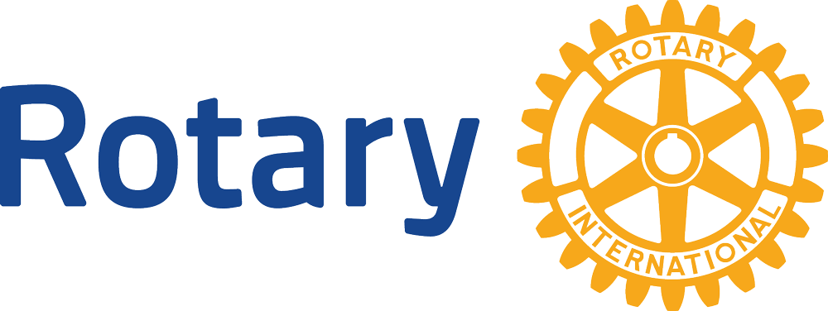


President
Ted Rudolph
463-5803

Secretary
Ann Rudolph
463-5803

Treasurer
Candy LoBue
463-2677

Board Members

Term thru 6/16
Ken Bitler
463-4239
Steve Chiquete
463-3510
Candy LoBue
463-2677
Mary Swirsky
463-4015

Term thru 6/17
James Schreiber
463-3377
Tim Dake
463-3510
John Diekmann
463-7162
Carolyn Strelo-Smith
463-4696
John Murray
463-5550

Newsletter
Prices 463-3794

Program Schedule:
Mar. 29 – YHS HOSA & Interact
Jessica Angle
Apr. 5 – American Mediflight Air
Ambulance – Mary Swirsky
Apr. 12 – Student of the Month
Apr. 19 – New laws re: wills, trusts,
etc. – Carolyn Strelo-Smith
Apr. 26 – Solar Energy - Rural
grant – Carolyn Strelo-
Smith

Upcoming Events:

Apr. 23, 26 – Rocket Park work
days
May 21 – Spring Dinner/Dance
June 18? – Ice Cream Social

Last few weeks: Yerington Rotary has been busy the last few weeks. Saturday March 12 was the Snyder Livestock Bull Sale. To get buyers in the mood to spend money, Lucy has Rotary prepare a variety of beef dishes for potential buyers to enjoy. New York roast, stuffed mushrooms, beef sate’s, apricot and brandied meatballs and steak salad were on the menu this year. In return for our efforts Lucy was very generous in donating to both the Rotary Club and our Interact Club.

On Saturday March 19 the Yerington Rotary BBQ crew prepped and cooked 300 steaks for the Friends of NRA fundraiser. Several Rotarians were also involved in setting up the serving lines, warming up the food and keeping the serving lines moving. That went much better than last year.

Speech Contest: For the first time in several years it looks like we will have some contestants to enter in the annual Speech and Music Contest. We aren’t doing so good on the music, but YHS instructor Amanda Aldridge has some students interested in entering the Speech contest. Each contestant must prepare and present a 5 minute talk on the theme “What it means to Be a Gift to the World, personally, and in my own words”. The Club competition will be held in April, probably the 12th or 19th. The winner of that competition will go on to the Area 10 Contest to be held on Wednesday April 20 in Fernley. The winner of that contest goes on to the District 5190 competition held at the District Conference in May.

Newsletter: After some time off Judy and Tom have volunteered to send out a newsletter to help keep our membership informed and involved. It may not come out as regularly as before but it will come out.

Rocket Park work days: Last Fall Rotary promised the Park Board that we would repaint the Rocket slide (next to the swimming pool). We never got it done last Fall so it has been rescheduled for this Spring. It will take two days. One to scrape and wire brush the old paint and another to put a new coat of paint on the structure. These are scheduled for Saturday April 23 and Tuesday April 26. Both days will require several workers and some equipment. Jim Schreiber, who is also a member of the Park Board, is in charge of this project. Talk to him about what you can contribute.

Spring Dinner Dance: John Murray and Jim Schreiber are the master-minds of this event. It will be held at the Fairgrounds Large Barn. The NightHawks of Smith Valley have been hired. This is the same band we used last year. The date is May 21, 2016 with doors open at 5:30pm and dinner at 7:00pm. The theme will be “Picnic in Spring“. At this time the food will include country pork ribs, chicken, with corn on the cob, potato salad, beans and bread. The meal will be finished off with apple, cherry and blueberry pies. This event will be advertised as being held in honor of our two Joes (Frade and Giomi), long-time Rotary members and businessmen in Mason Valley. John and James will be asking for your help with this event. Be ready to help. Lynda Booty has agreed to head up the auction, be ready to help her as well. This is one of our larger events, all need to be ready to sell tickets. The only way we make money is to sell tickets to cover expenses.

Ice Cream Social: This has been a popular event with members in the past. It will probably be held on Saturday, June 18th, the day before Father’s Day. The event will be held at the Nordyke House and tours will be provided by Tom and Judy along with the best home-made ice cream in the valley. Be thinking about how you can help with making ice cream or toppings. We haven’t held this event in a while and have had people in the valley asking about it. This is an opportunity for community members to see what has been done to the Nordyke House. This will be the first time since the House’s listing on the Nevada Historic Preservation list.

Yerington Rotary Club Foundation (YRCF): There has been some confusion regarding YRCF and the The Rotary Foundation (TRF). Both Foundations are 501 (c) (3) foundations, which allows you to use donations as income tax deductions. The Club Foundation is local and supports our Yerington Rotary Club. TRF is Rotary International’s Foundation. It supports global projects such as End Polio Now, and club projects with international partners.

The Club Foundation has a Board which is responsible for managing funds for designated Club service projects and goals. It was set up to handle scholarship funds and can also handle major projects that the Club has. An example of a project that YRCF could have handled is the Hospital Park Project which involved major donations and grants. YRCF has also handled the wine and beer tasting to allow donations of wine and beer to be acknowledged for tax purposes.

Board members are nominated by the YRCF Board and approved by the Rotary Club Board. Current Board members are: Skip Bolton - President, Steve Rye - Vice-President, Judy Price - Secretary, Tom Price - Treasurer, Gerry Boschert - Scholarship Committee Representative and James Neely, Ken Bitler and Gary Hardesty Board members. The current Club President and President-elect are also members of the Board.

At the Board’s 3-14-16 meeting James was nominated to a second term on the Board. It was also recommended to the Club Board that one of our two 4-year Scholarships be permanently named in memory of Joe Giomi. It is important to the Board to honor Joe’s commitment to the scholarship committee. It was also recommended that our other 4-year scholarship be named in Joe Frade’s memory for this year’s scholarship. The Board also recommended that the stipend for the John Giomi 2-year scholarships be raised from $500/year to $1,000/year. The Board also voted to put the Klamath Falls Scholarship money into the general scholarship account. This would allow us to provide a second one-time memorial scholarship to honor a worthy departed member should this be needed.

