Officious Newsletter of Yerington Rotarians

March 22, 2018

Meetings:
Tuesday Evening 7:00 PM
Dini’s Lucky Club

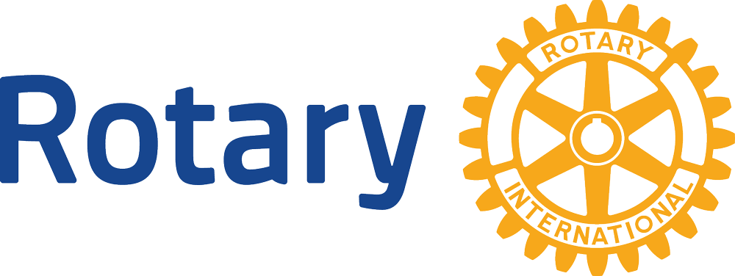


President
Lynda Boody
202 355-4201

Secretary
Ann Rudolph
463-5803

Treasurer
Candy LoBue
463-2677

Board Members

Term thru 6/18
Jim Snyder
221-3986
Oscar Hernandez
463-1873
Peggy Bitler
463-4239
Richard Ernst
916 749-8479
Kathie Mann
463-4265

Term thru 6/19
James Schreiber
463-3377
Gary Hardesty
463-1648
Dale Theiss
463-9215
Amy Geddes

463-6645

Newsletter
Prices 463-3794

Program Schedule:
3-27 Speech Contest
4-3
4-10 Board Meeting
4-17 Student of the Month
4-24 Fire House Tour

Upcoming Events:
4-7 District Assembly
4-7 David Fulstone’s 95th birthday
4-7 Spring Dance
4-10 Board Meeting
4-28 Rotarians at Work Day
5-18,19,20 5190 Conference
5-26 Off Road BBQ

Spring Dance: April 7th is getting closer. Spring Dance planning is progressing well. The big factor for now is selling tickets. In past years most of the “profit” for supporting our scholarship programs and other service activities has come from the raffle and silent auction. There is no silent auction this year (I think that is actually a selling point) and the raffle is mainly included in the ticket price.

The $50 ticket price not only includes dinner and dancing, but a raffle ticket and two drink tickets. Additional raffle tickets and drink tickets can be bought at the door. There are two raffle prizes: a gun safe (from Ace Hardware) and 200 gallons of propane (from Affordable Propane). Raffle drawings will be held during the dance.
Dinner will include a salad, green beans, baked potato, garlic bread and a nice big juicy rib eye steak plus dessert..

With no silent auction and limited raffle ticket sales, our only hope of making this event financially successful is to sell lots of tickets. EVERYONE NEEDS TO HELP!!!

Get to know fellow Rotarians: President Lynda started a new program Tuesday. This was suggested in the recent member questionnaires about Club performance. A couple of members will be asked each week to give a 30 second synopsis of their life. Jay Reconzone and Steve Singer started the program on March 20. Neither managed to limit their presentation to 30 seconds but both were reasonably brief as well as informative. Both have served as Club President. Jay served as Club Secretary for many years and Steve has served District 5190 as a RYLA Director. Both explained their work background and Steve credited the bankruptcy of his Bay area business with bringing him to this area. Be prepared, you could be next.

Rotarians at Work Day: April 28 (the last Saturday in April) is Rotary’s designated world wide work day. Lynda has several possible routine projects, but if someone has a better idea it might still be possible to organize it. Let her know.

Past programs: The March 13 program was a great example of why we put so much effort and resources into our scholarship program. The speaker was Jafeth Salido Sanchez. Jafeth is a graduate of the Yerington school system. She received a 4 year scholarship from our Rotary Club in 2001. She completed her undergraduate degree at UNR in 3 ½ years and proceeded directly into graduate school. She completed a Masters degree in 2 years and received her PhD in 2009. Her areas of interest include both math and educational administration. She taught math at Hug High School in 2010 and was named Math Teacher of the Year. She is currently an Assistant Professor in the Education College at UNR.

In addition to our scholarship she received a very lucrative scholarship from the Bill and Melinda Gates Foundation, but we can certainly be proud of our contribution to her success.

Pinewood Derby car: The March 10 trial run of the Pinewood Derby cars was cancelled because other clubs are not as well organized as we are. They did not have their cars ready. The next (and final) trial will be at District Assembly on April 7. The official run will be at District Conference.

Klamath Falls Investment: Many years ago in a world different than the one we now inhabit, we had a golf course right here in Mason Valley. A very active Rotarian and very avid golfer as well as a strong arm twister, namely Joe Giomi, organized an annual golf tournament to help support the Rotary Scholarship program. Vendors and suppliers from his Ace Hardware operation as well as local business people flocked to support his tournament (and to avoid his wrath). Cheryl’s current golf tournament efforts are very helpful, but Joe raised even more money than she does. Joe paid most of the expenses of the scholarship program back then, but he held back a little of the money (only a few thousand I think) and invested it in the stock market. It did well until it didn’t and then it did well again. I don’t recall how many times it went way up and then crashed, but by about 2006 or 7 it was way up again (about $90,000) and the real estate market was booming. The Club cashed in a $10,000 CD and combined we bought a $100,000 investment in a real estate development project in Klamath Falls, Oregon. It paid 10% interest. We received several monthly interest payments of almost $1,000 each, which fully supported the scholarship program at the time. You can probably guess what the next part is. After the legal dust settled, we received a payment of about $9,700 from the sale of much of the land owned by the project. We have just received a final payment of about $2,700. This money, $9,700 + $2,700, is currently held by the Yerington Rotary Club Foundation. It has been designated, by the Foundation Board and approved by the Club Board, to be used for certain extra scholarship expenses. More specifically when we permanently named one of our two four year scholarships as the “Joe Giomi Memorial Scholarship” we felt we might have a time when we lost two Rotarians worthy of honoring with a “Memorial Scholarship” in a single year. This money can be used to fund the necessary extra scholarship.

