Officious Newsletter of Yerington Rotarians

July 14, 2018

Meetings:
Tuesday Evening 7:00 PM
Dini’s Lucky Club



Ann Rudolph, Sec.
463-5803
Kathie Mann, Pres.
463-4265

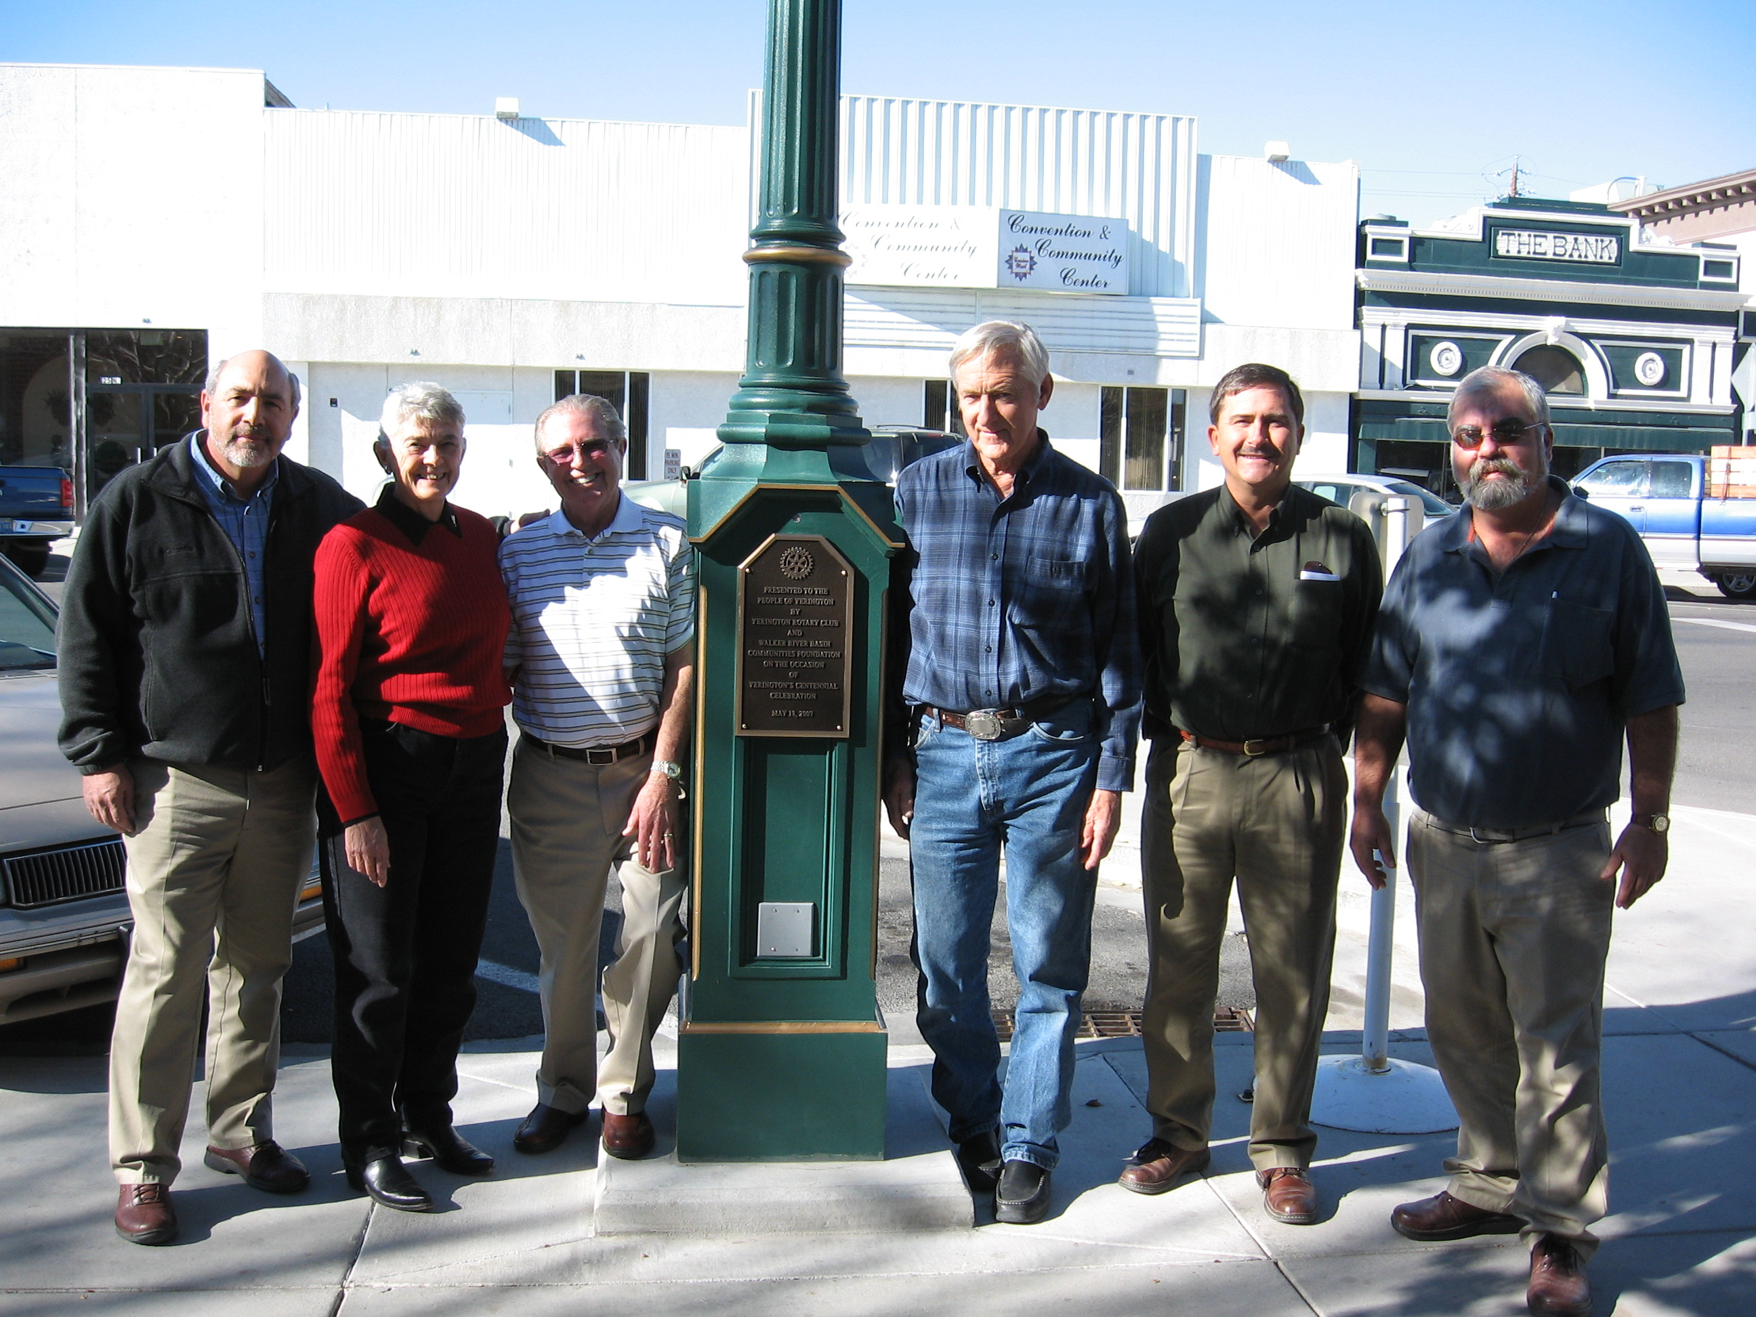
Programs:
July 17 Nevada Highway Patrol
July 24
July 31

Events:
July 27,28 Night in the Country
Aug. 12 Joe Giomi Golf Tournament
Aug. 16,17,18,19 Lyon County Fair
Sept. 15 Taste of the Valley Dinner

Night in the Country: It’s almost here! We could use a few more workers. It will be a different selling format this year with only cans. We used to do that in the early days of NITC, but then we collected cash. After a few hours what the sellers had was a wet mess of soggy bills. Counting it in the morning was a slow process. We shouldn’t have the money to deal with now but I bet the bar rags will be plenty wet. Hope we get lots of them. I don’t know if anyone knows exactly what the setup will be but we might have fewer selling stations to man this year. Should be interesting anyway. James Schreiber will be organizing the final work schedule Tuesday at our meeting.
What is the occasion? Who are the Rotarians and non-Rotarians? Why are the non-Rotarians there?

If you can help and haven’t signed up yet, get moving. Go to website: NightInTheCountry.org. Click on Menu; then Be Involved; then Volunteers and fill in the volunteer form. At the end of the form be sure to select Yerington Rotary to receive your “pay”. Otherwise we don’t get credit for your working and won’t get arm bands to admit you.

3rd Annual Joe Giomi Memorial Golf Tournament: Sunday August 12 at the Fernley Golf Course. We still have some time for organizing final details, but keep this event in mind. Peggy has the luncheon pretty well planned and Cheryl and Ann have most of the details of the golfing and prizes under control.

Keep in mind that this event is the major contributor to our scholarship program. Contributing to this event honors Joe’s years of service to Rotary and helps pay our scholarship costs.

Dues and meals: July 1 was the start of a new Rotary year. About half of us owe our annual dues of $100 (that is probably the lowest Rotary club dues in the USA). Almost all of this money is passed on to Rotary International and District 5190. It is also a new quarter for meals (or a new year if you pay by the year). The meal cost is still
$600 for the year, $150 per quarter and $20 per meal. Don’t forget to pay up.

New Newsletter Format: Hopefully you have noticed by now that the design of the newsletter has changed. I spent many hours trying to use ClubRunner’s Bulletin software for our Newsletter. It was cumbersome to do what I wanted to do but being able to use their emailing system would have simplified that process (and made it more accurate, because I wouldn’t have to maintain a separate list of email addresses). Unfortunately using their software brought along several ads that would appear in each newsletter. It would cost $100 to eliminate those ads. I will continue to use MS Word and my usual email system.

A new feature I am introducing is a Club history quiz. We are a service organization and have a very good history of service projects in this area. Each Newsletter will have a photo (or something) from a past Club service project or other activity with several questions about it. Hopefully, the photos and questions will stimulate some conversations about the situation and maybe even stimulate some thought and conversations about future projects.

I am not sure, yet, where my answers to the questions will appear. Maybe in the next newsletter, maybe at our Club meetings or maybe on the Club website. Or maybe somewhere else. But they will appear somewhere.

Club Treasurer: Club President-Elect Club Foundation Directors:
Candy LoBue Ted Rudolph Skip Bolton, Pres.
Judy Price, Sec.
Club Board of Directors: Steve Rye, VP
Term ending 6/30/209 Term ending 6/30/2020 James Neely
James Schreiber John Garry Gary Hardesty
Gary Hardesty Cheryl Giomi Gerry Boschert
Dale Theiss Peggy Bitler Candy LoBue
Amy Geddes Jay Recanzone Kathie Mann, Club Pres.
Ted Rudolph, Club PE
Tom Price, Treas.

Greeters: Kathie is reestablishing our Greeter program. For those of you not familiar with that program, for each meeting, a member is assigned to meet members (and anyone else) as they enter our meeting/dinner room with a welcome message. For new members being a greeter is a great way to get to know other members, but it helps to have a longer term member helping a new member greeter. Kathie will be publishing a list of assigned greeters.

