Officious Newsletter of Yerington Rotarians

September 22, 2018

Meetings:
Tuesday Evening 7:00 PM
Dini’s Lucky Club



Ann Rudolph, Sec.
463-5803
Kathie Mann, Pres.
463-4265

Programs:
Sept. 25 –
Oct. 2 – Game Feed
Oct. 9 -
Oct. 16 –
Oct. 23 -
Events:
Oct. 18 – YHS Pride dinner

Greeters and Programs: Greeters for the

Greeters and Programs: Greeters for the
next several meetings are:
9/25 – Candy LoBue & Ann Rudolph
10/2 – Kathie Mann & Lucy Rechel
10/9 – James Neely & Dennis Rechel
10/16 – Judy Price & Jan Recanzone
10/30 – Tom Price & Willie Skroch

Remember, the 2nd quarter group (Oct., Nov. & Dec.) responsible for programs is: Cheryl Giomi, Gary Hardesty, Oscar Hernandez, Laura Lane, Candy LoBue, Kathie Mann, Al McNeil, James Neely and Judy Price.

YHS Pride Dinner: This is purely a community service event. In fact we are paying to do it. YHS Pride is an organization of Yerington High School students and parents. Their mission is to promote the welfare of the students, faculty and staff by fostering a closer relationship between home, the school and the community. The dinner on October 18 is their primary organization and planning meeting for the year.

Rotary’s part is to prepare and serve the meal. Current estimate is about 300 meals will be needed. The meal will be a buffet style beef tri-tip dinner. Our Board of directors voted to support this event by donating the tri-tips as well as preparing and serving the dinner.

Peggy will be organizing this event and she will need lots of help when we get to the final preparations. It will be held in the big barn at the Fair Grounds. Be ready to help Peggy.

How well do you know our projects?: Who are the kids in the photo and what are they doing? Where are they?

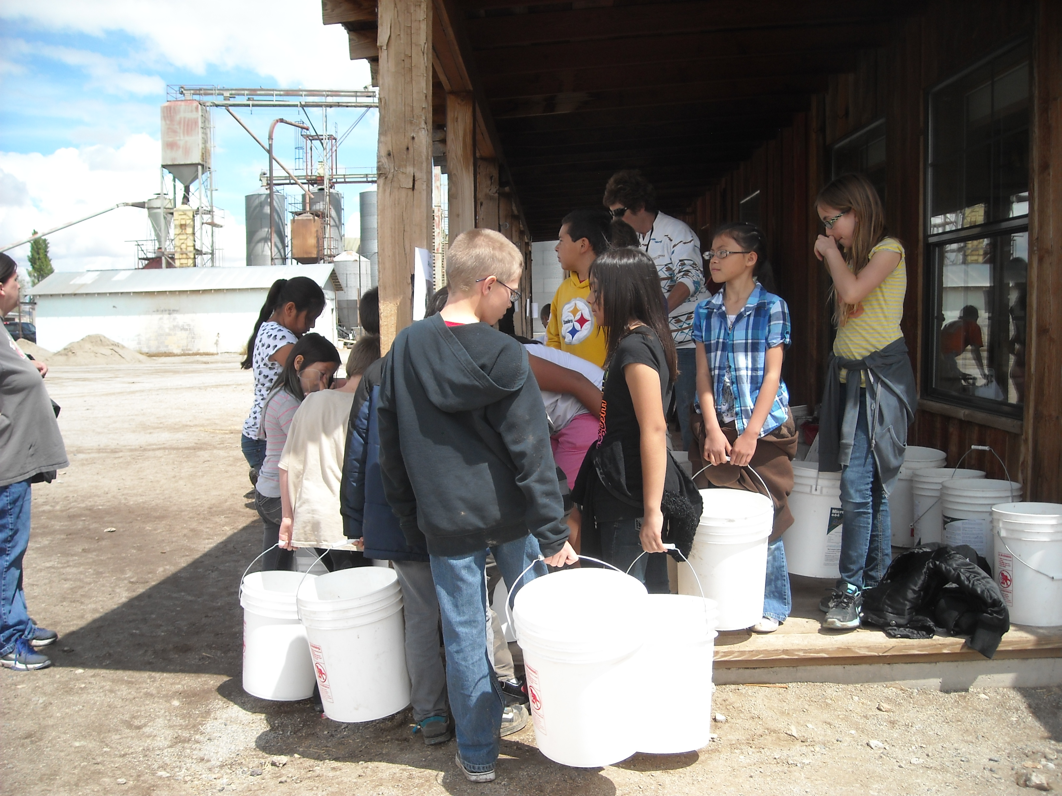

Yerington Rotary Foundation: The Financial Report for the fiscal year 7/1/2017-6/30/2018 has been audited and is now available. If you would like a copy, talk to Tom Price. During the year the Foundation received almost $5,000 in donations in memory of Ron Nagel to support scholarships. They received over $9,000 in memory of Kenny Bitler. Peggy is considering establishing and funding a new scholarship, probably a 2 year scholarship, in Kenny’s name. This possibility will be discussed at the upcoming joint meeting of the Foundation Board and the Scholarship Committee. In addition to the above donations the Foundation received almost $6,000 in additional donations to support our scholarship program. The Giomi Memorial Golf Tournament raised over $12,000 for the scholarship program (this was last year’s tournament). Most of that money is donations.
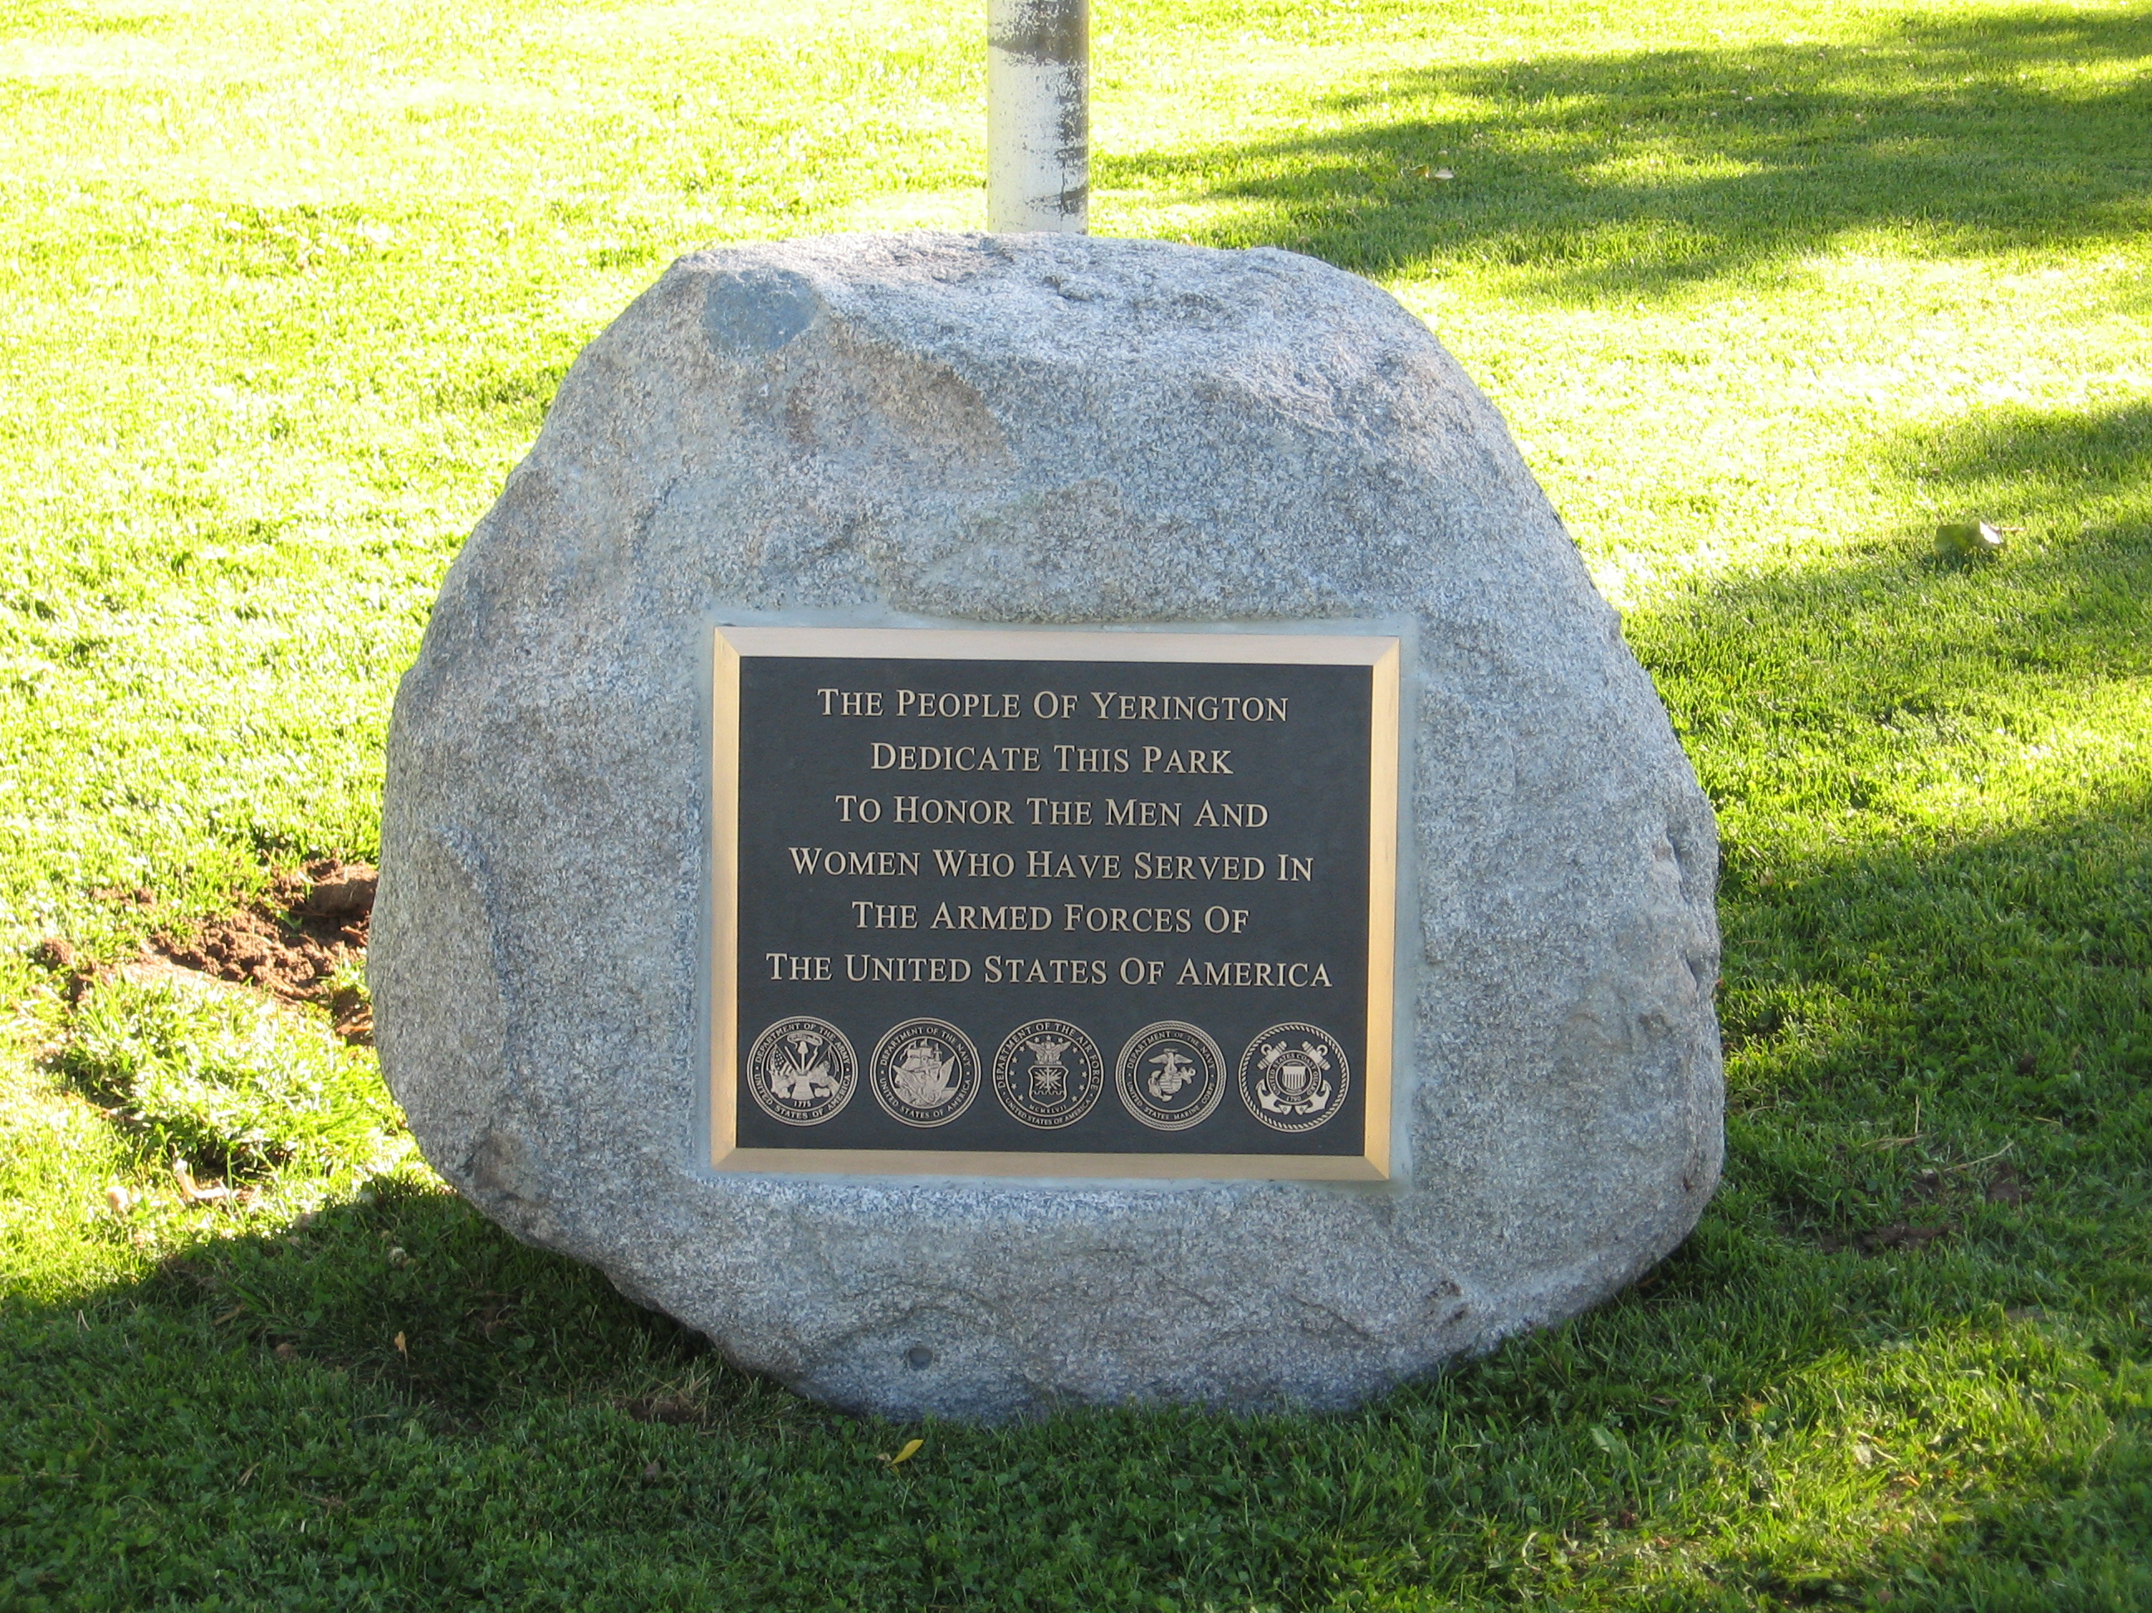
Keep in mind that many of the donations the Foundation receives require the 501(c)(3) tax exempt status that the Foundation has. Donations to the Rotary Club do not offer the same benefit.

Last issues’ “Do you know our projects?”: This was a 2007 Rotary project. Veteran’s Park, located on Oregon Street between the city’s baseball/soccer fields was in the process of several upgrades. The city was replacing the children’s playground equipment. The Rotary Club installed two picnic table gazebos to provide shade from summer sun. Several local businesses helped with this work. Grant Smith Aggregates provided the base and concrete for the gazebo pads. Dennis Rechel and Sons Construction helped with pouring and finishing the concrete and Marathon Corporation provided the steel framework and construction of the gazebos. Member Kurt Werner of Green Valley Rentals provided the necessary equipment for erecting the first gazebo and member Jim Perry provided the equipment for erecting the second one. Considerable effort in digging out for the pads, preparing for the concrete, pouring the concrete and erecting the gazebos was provided by the Rotary Club members, City of Yerington employees and Lyon County trustees. The city installed additional lighting in the park and the Rotary Club provided a plaque dedicating the park to the men and women who have served in the U.S. armed services. This park has been part of the Yerington park system for many years and these upgrades improved its usability and its role as a reminder of those who have served our country making it stronger and safer.
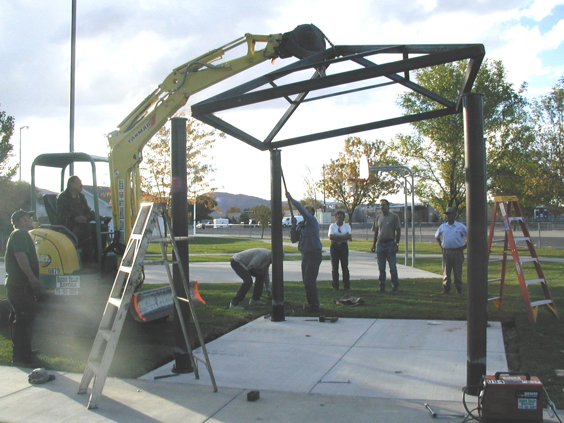

Club Treasurer: Club President-Elect Club Scholarship Committee:
Candy LoBue Ted Rudolph Lucy Rechel, Chair.
Kathie Mann
Club Board of Directors: Dale Theiss
Term ending 6/30/19 Term ending 6/30/20 Gerry Boschert
James Schreiber John Garry Skip Bolton
Gary Hardesty Cheryl Giomi Jim Sanford
Dale Theiss Peggy Bitler Ann Rudolph
Amy Geddes Jay Recanzone

