Joy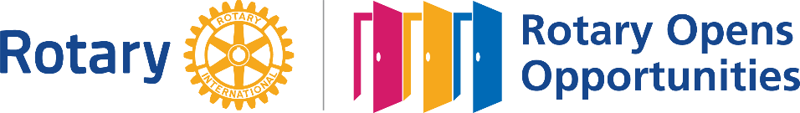

The Tahoetarian
Rotary Club of South Lake Tahoe
July 21, 2021

President James Smack called the meeting to order. Dr. Duke led the invocation. President James then led the Pledge of Allegiance and asked members to state the 4-way test. Everyone did a fantastic job thanks to James having the 4-way test available on the agenda!

We welcomed Joy Ellison to our meeting as a guest. Joy used to be a member of our club years ago and is interested in rejoining now that her work allows her to be here in South Lake Tahoe more often.

Open discussion: David Kurtzman shared a Rotary Act of Kindness. There were some visitors here that suddenly needed a wheelchair. They heard about the Rotary Mobility Program and David was able to get them wheelchair right away! They were surprised that it was free and went away very happy.

Little Genius: Guy Lease led us in an exciting round of little genius. Everyone that he picked on was asked to share something good that happened during COVID and to give a “voluntary contribution”. Be ready for the next meeting and remember to wear your Rotary pin. Just a heads up….

Presentation: Dr. David Borges gave a very interesting presentation on Lake Tahoe history.

Club administration:

- Service Projects: Dave Huber will be organizing the next service day which will probably be at Kiva Beach.
- Fundraising: David Kurtzman confirmed that we are set for the Valhalla event on October 9th. It will be a wine, beer, and dessert event with a one act play and the Improv Players.

Search for a Permanent Meeting Location. President James is actively looking and seeking help from others to find a location for our in-person meetings. More to come.

Next Meeting: August 4, 2021, at 12:00 at the Tahoe Wellness Center Community Room.

The speaker will be Dr. Clint Purvance, CEO Barton Healthcare System who will be discussing Community Food Insecurity.

