Rotary Club of Grass Valley South

Board Meeting Minutes – Wednesday, July 20, 2022
12:00 PM, River Valley Community Bank Board Room

Attendance: Melissa Collins, Norma Moore, Susan Drown, Charlie Litton, Carol Scofield, Shannon Buehler, Janeille Litton

1. Treasurers Report: Susan Drown:
Current bank balance is $21,867
Accounts Receivable: $1225

As of 7/20/2022 we received notification from Wyn Spiller and the district our international grant was approved to send the $5000 and they will be sending to us immediately. We have funded EVAC and Susan will send Melissa the information so we can pay Operation Snow Leopard. Truckee club has not paid as of today.
Alta Sierra School Grant is all in the district grant site and Melissa and Susan are working on uploading proof of payments for each line item to finish it up.

Susan Drown reported to the board that we will be finishing out and closing the books for the 2021-2022 fiscal year with Tri- Counties and will begin the year with the new accounts opened at River Valley Bank. Melissa reported the check fees will be refunded to the accounts.

2. August 16th meeting will be the in-service Fundraising meeting where the committee will present to the membership the fundraising ideas for this year. The meeting will be held at the Emmanuel Episcopal Church at 235 S Church St, Grass Valley in the Buck Hall at 7 AM. Susan is contacting Eric Sams to see what we need to make sure to do to have a ball drop this year and report back.

3. Social at Trailblazers is confirmed for July 26th at 5:30 PM Carol will let the members know.

4. Zoom discussion – do we want to continue to pay for Zoom? It was decided there are other options such as facetime or google meetings that do not cost. Since there are very few members utilizing zoom, we will try to accommodate using other means than zoom. We will ask members to let Carol or Norma (whomever is sending out the meeting notice) know so we can figure out an alternate way to connect digitally. Melissa and Shannon are both willing to explore options and test things out. We really do not have an available laptop to continue on with Zoom.

5. Corporate Memberships- Melissa and Susan will meet this week to get a proposed corporate membership suggestion to the board for review. There has been interest in joining the club if we can add in corporate memberships into our options.

6. Carol asked if the new member document was up to date. Susan believes it is and she will double check and confirm with Carol.

7. Discussion was had about member responsibilities and Carol shared a document GV Rotary uses called ‘The Team’ to get others engaged and help with tasks. Carol and Norma are essentially ‘doing’ everything for meetings including set up, tear down, selling raffle tickets etc. and are asking for members to help!

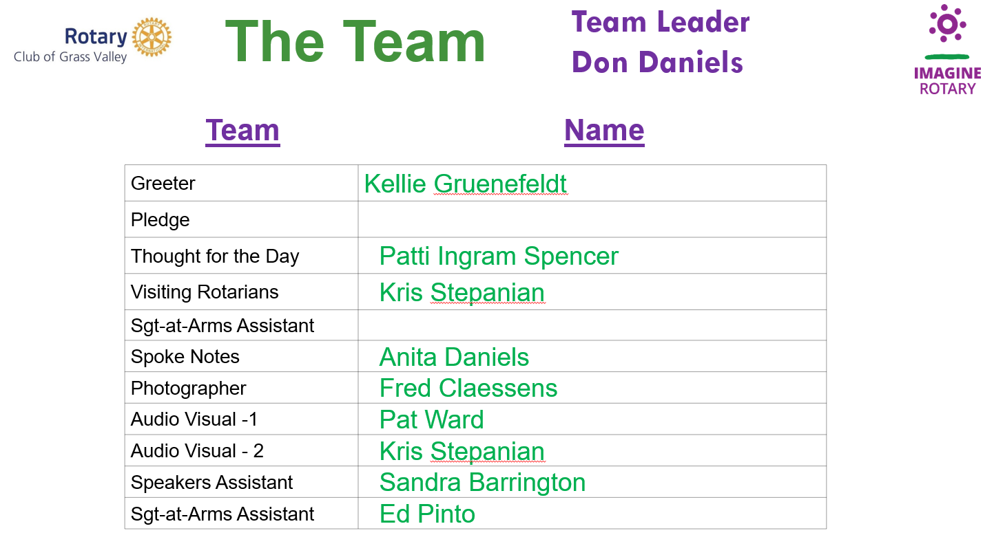

Next board meeting will be August 17th River Valley Bank 12:00 conference room.

Respectfully submitted:

Melissa Collins, Secretary

