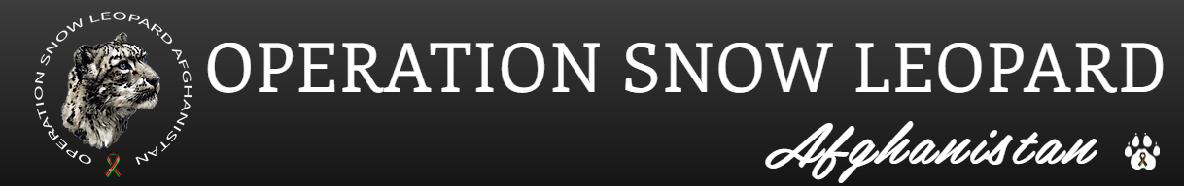

Operation Snow Leopard is a 501c3 organization that provides direct aid on behalf of Afghan Allies and their families, who were left behind after their democratic government was overthrown by the Taliban in August, 2021. Many of these individuals provided direct support to US troops and US support personnel in a variety of very visible roles. Some are members of a minority groups targeted for extinction by the Taliban; some are journalists, lawyers/judges, human rights supporters, teachers, and members of the fallen government.
Volunteer Opportunity
Interact with Operation Snow Leopard team members using the secure messaging and a VPN that will be provided
Use spreadsheets to find and enter data
Training provided on processes and procedures
Volunteer must be:
Recommended by a person know to OSL and will be vetted by the OSL Board
Somewhat computer literate – able to use simple spreadsheets, links, follow written instructions, use messaging apps, run standard software updates on computer and apps as required.

