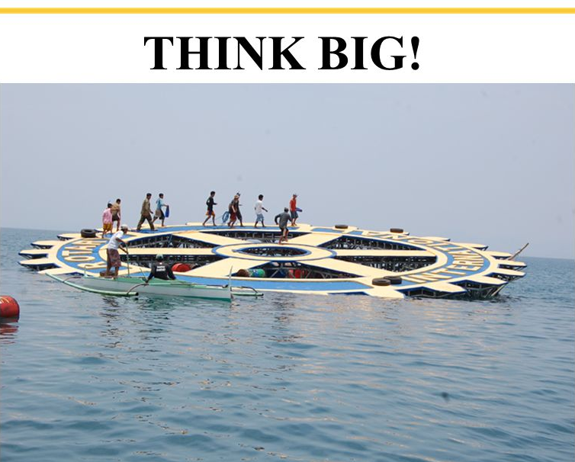
In Rotary we do BIG things. Sometimes as it is with Polio Eradication it is small steps with a big purpose. Note Eradication of polio was an Aussie World Presidents dream!
Sometimes the BIG things are not obvious. Like our investment in young lives through Youth Programs like Youth Exchange.
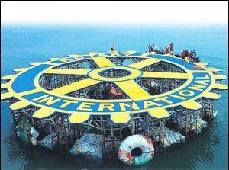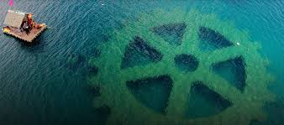

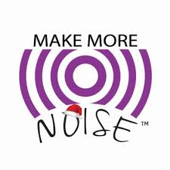

In life what is one of the Biggest things you have been involved in?

Why do you think of it as BIG?

What was your role or involvement?

No.
If you were to bring 1 BIG idea to Taree Rotary … what would it be?
(Be very concise in its description)

What are the steps you see to bring this “Big idea” to reality? (Be detailed)

What will be your involvement? (You don’t necessarily have to be involved at all!)

How should you and Taree Rotary progress or make a noise about the idea?

Submitted [ ] Discussed [ ] Progressed (P) or stored (S) [ ] Completed [ ]

