A Happy Dolly Parton Imagination Library Recipient

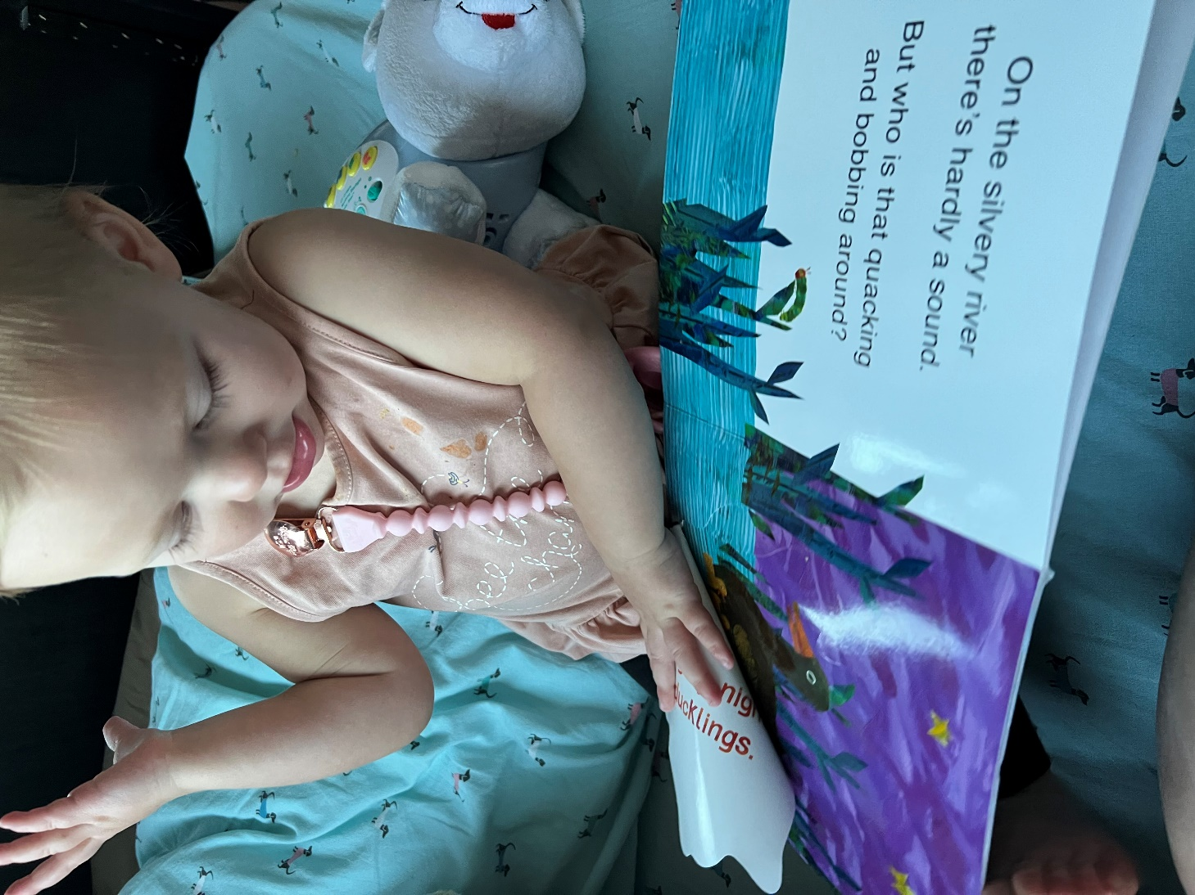
This photo was sent to us by the parent of the reader shown above.

