MAY 15, 2017

Responsibilities
Drawing, Tina Ray; Words, Jim Brubaker
Pledge, Maureen Simons; Greeter, Joscelin Magana
Roto-Rooter: Rev. Laura Sheridan-Campbell; Reporter: Rick Grove

SCRIPPS GADGETS, GISMOS AND GOOD HEALTH
SUSAN TAYLOR

UPCOMING PROGRAMS
May 22 Dr. Karl Luber, SurfAid-Erin Miserlis
May 29 DARK
June 5 Pacific Ridge School, Bob Ogle
June 12 Empowering Women, Dana Bristol Smith
June 19 TaylorMade Golf, Thomas Kroll
June 26 Year in Review, Hi-Noon Rotary Board of Directors

OTHER EVENTS
May 19: Stone Brewery 5-7pm; refer Kori Dolkas
June 23: Club Demotion Dinner, Sheraton
Sept. 9: Brewfest; refer JR Phillips

MEETING OF May 8, 2017
Welcome: President Dawn Van Siclen opened the meeting at 12:20, and Steve “Sunshine” Mott led the “Smile” song, and “God Bless America” accompanied by Kathy Choi. Justin Peek presented brief words from Marcus Aurelius: “Waste no more time arguing about what a good man should be. Be one.” Jim Brubaker led the Pledge.

ANNOUNCEMENTS
Guests were introduced, including Greg Swienton, Jeff Walker, Frank Silva, Bryan Bratt, Charles Epting (Speaker), and five RYLA students with Carlsbad High School counselor Norma Fahlstrom.

President Dawn introduced Joy Prowse, who introduced Carlsbad High School teacher Paul Isbel, and his student Tatiana Edquist, who represented CHS and our Club at last month's national Model UN program, held at USD. Tatiana represented Germany at this growing Rotary program for high school students.

Bob Fenner offered up the opportunity for interested parties to order club hats and jackets. Contact Fenner for more information.

Mike Metts introduced five of the nine Carlsbad High School students our Club sent to the Rotary Youth Leadership Awards (RYLA) this year, and their counselor, Ms. Fahlstrom. Each student gave a heartfelt accounting of how RYLA has affected their life. Each spring, 280-300 carefully selected high school juniors attend the District's weekend-long RYLA Conference at a camp at Idyllwild, together with adult mentors and program participants.

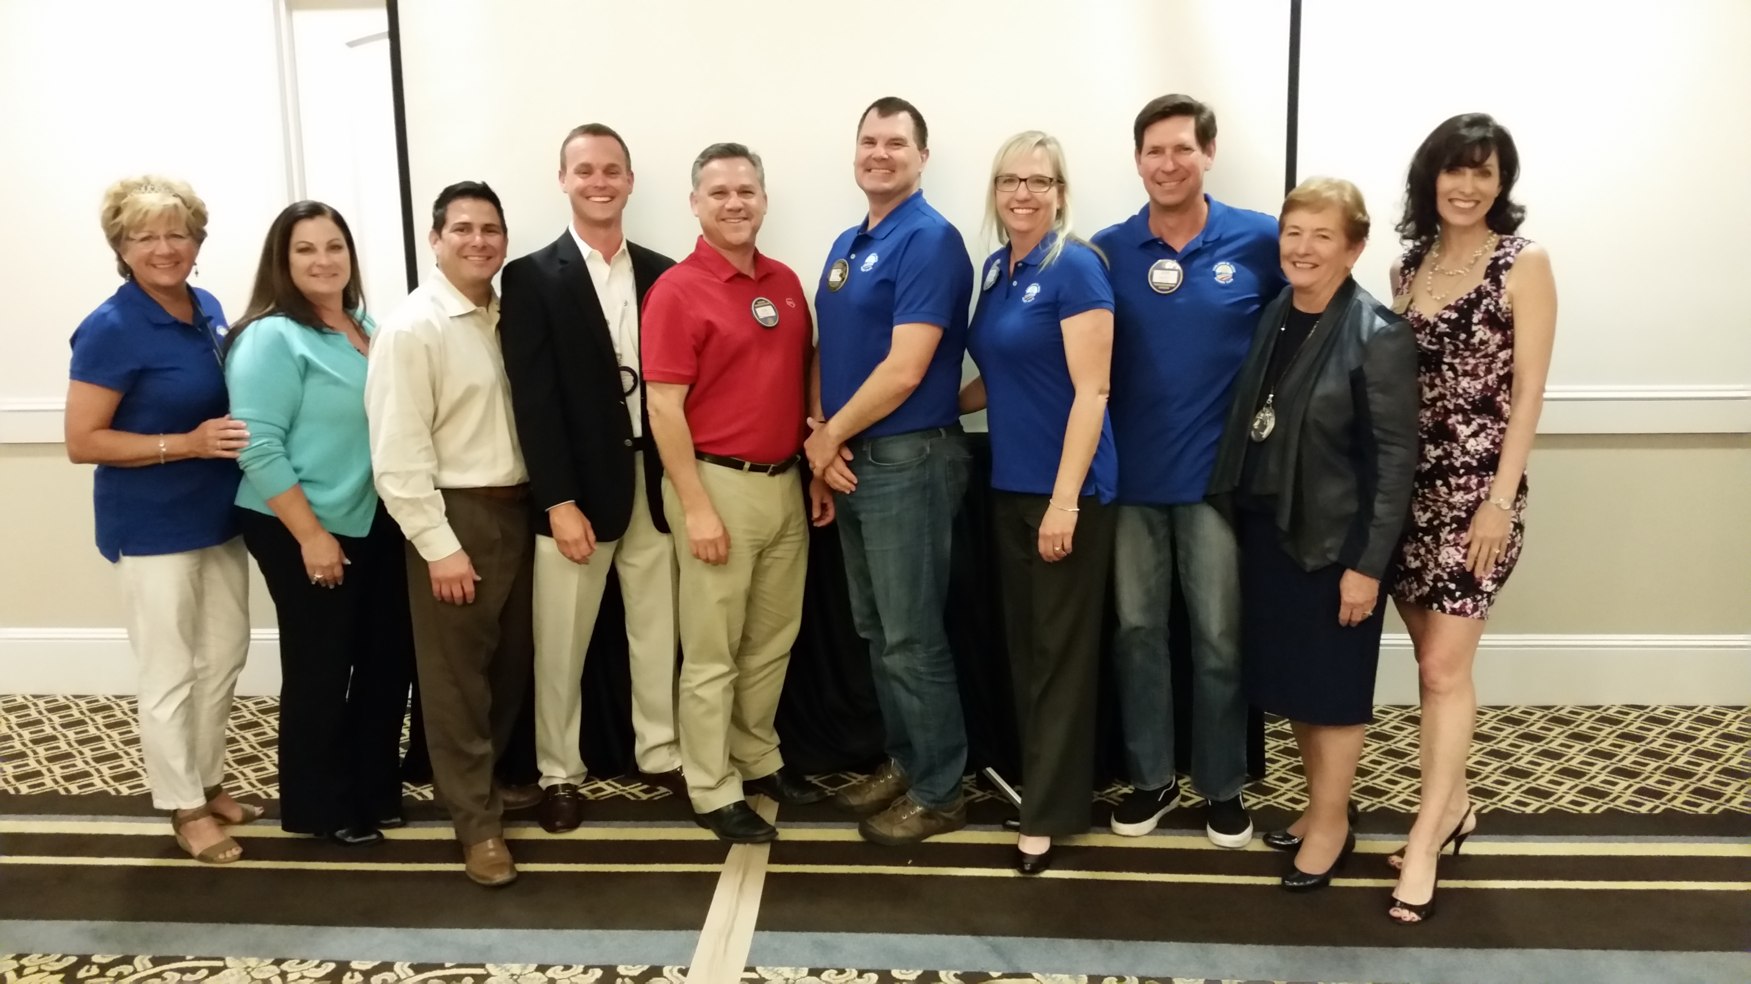
Patty Johnson announced members graduating from red to blue badges after completing the comprehensive list of requirements. Honorees included: LeAnn Rytz (sponsored by her husband, Josh Rytz); Lou Tapia (sponsored by Justin Peek); Jos Magana (sponsored by Kori Dolkas); and Sam Ross (sponsored by his mother-in-law, Maureen Simons).

Kori Dolkas announced future social events: Stone Brewery tour and tasting, May 19; Bocci Ball Tournament, date to be determined and possibly a visit to a Shooting Range (contact Dolkas if interested).

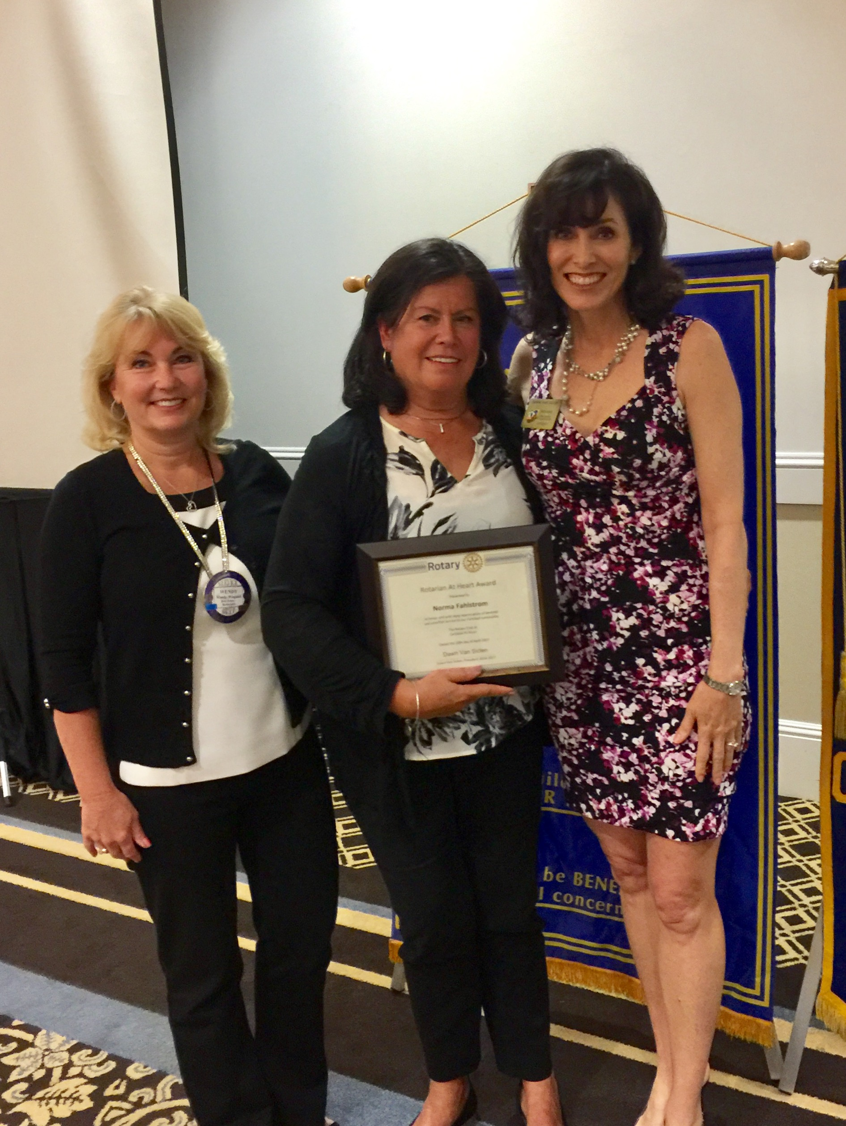ROTARIAN AT HEART
Wendy Wiegand announced this quarter's recipient of the “Rotarian at Heart” award. Norma Fahlstrom, retiring Carlsbad High School guidance counsellor, who has been this club's “eyes and ears” at the high school for many years, and mentor to innumerable students over the years. Truly a “Rotarian at Heart.”

ROTO-ROOTER
Roto-Rooter Rev. Laura Sheridan-Campbell called-out Rotarians for their fame, fortune, and foibles: May birthdays, Rotary anniversaries, and wedding anniversaries; Kip McBane and Beth Garrow for being cousins; Mark Beardsley for his new Porsche and 20-hour course to learn how to drive it, with side congrats for his recently born sixth grandchild. Bob Kreisberg was fined for getting his MOJO working (Mira Costa-Oceanside Jazz Orchestra), which was just rated #1 Community College Jazz Orchestra by Billboard magazine--which included a picture of Bob in its recent issue. Speaker, Chris Epting, and his dopplenamer (who ordained Reverend Laura into the clergy) caught the eye of the Roto-Rooter. A big thank you to Fire Chief Mike Davis and his department for their heroic work three years ago today--the anniversary of the Poinsettia Fire.

PROPOSED NEW MEMBERS
Nan Gelando (Law-Estate Planning) sponsored by Alex Klingensmith and George Porter (Insurance-Retired) sponsored by Dave Kulchin are proposed new club members. Any comments on these proposed members should be referred to Patty Johnson or President Dawn within the next seven days.

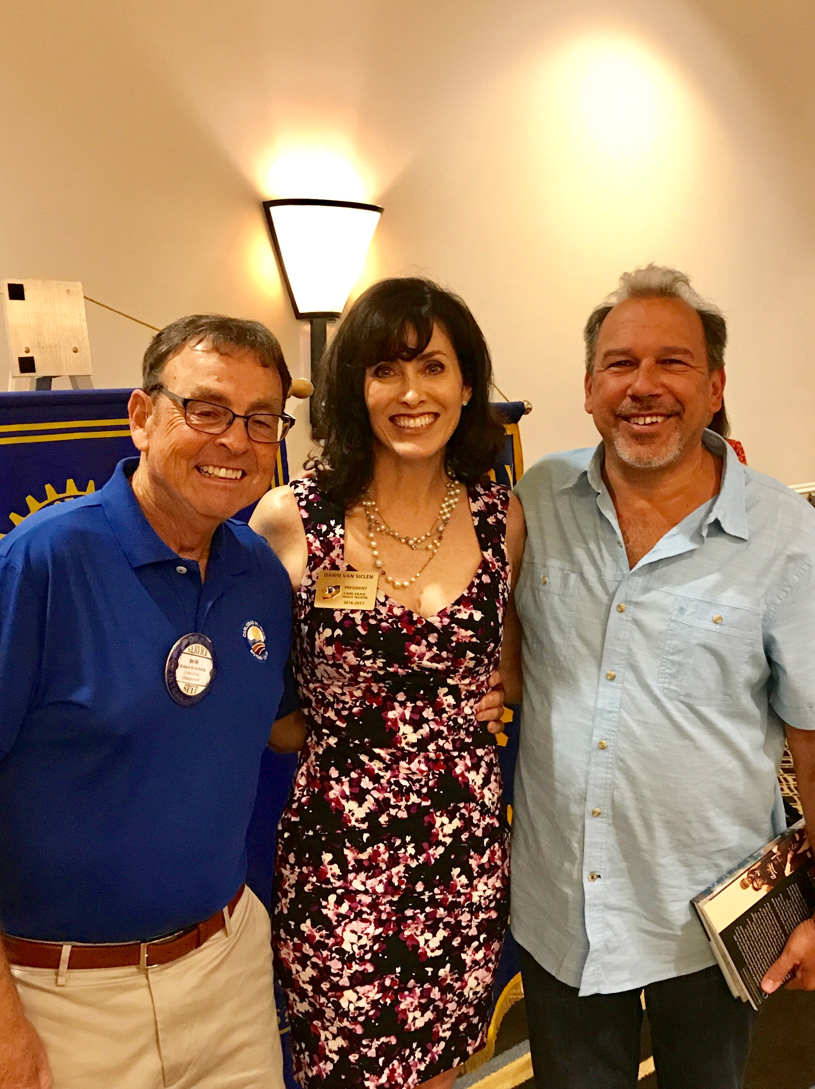PROGRAM:
CHRIS EPTING,
SOCAL BASEBALL HISTORY

Prolific historian, author, and story teller Chris Epting (+/- 33 books) entertained and informed us with his tales of baseball in Orange County. Organized baseball began in Orange County in the late 1880s, when community teams began forming among oil well workers. Around 1900, a farm boy from Kansas named Walter Johnson arrived with his family. Before long, the future Hall-of-Famer was dominating games throughout the county as a star for Fullerton Union High School. Joe DiMaggio, Babe Ruth, and many other legends visited Orange County over the years. In 1920, at the request of the City of Brea, which was having financial problems, Walter Johnson brought an all-star team to play a fund-raising game against another all-star team formed by Babe Ruth dubbed “The Brea Bowl.” Babe Ruth pitched for his team, and hit two home-runs against Walter Johnson, one thought to have flown over 600 feet.

Another important baseball figure who lived in Orange County was the Tin Pan Alley songwriter Jack Norworth, who, having never seen a baseball game, wrote the baseball theme “Take Me Out To The Ball Game”. After a successful songwriting career, he retired in relative anonymity in Laguna Beach, where he died a few years later. Epting recently discovered Norworth's undistinguished grave in a cemetery within sight of Angels Stadium, and Epting and others raised funds to erect an appropriate memorial marker nearby.

President Dawn fined Bob Fenner $50 for remarks about shirt sizes. President Dawn invited Mr. Epting to sign a book to be donated to a school library. Josh Rytz drew the winning raffle ticket: $4.

Jackpot for May 15, $150

Responsibilities for May 22, 2017
Drawing, Maureen Simons; Words, Mimi Gaffey
Pledge, Eric Lodge; Greeter, Joscelin Magana
Roto-Rooter: Rev. Laura Sheridan-Campbell; Reporter: Randy Ferren

MAY 15, 2017

HI-JINX
Official Publication of the

CARLSBAD HI-NOON ROTARY CLUB

P. O. Box 741, Carlsbad, CA 92018
President: Dawn Van Siclen
Editor: Harry Peacock
Reporter: Kip McBane
Photographer: LeAnn Rytz

Web address for Make-ups: www.rotaryeclubone.org

Carlsbad Hi-Noon Rotary Officers and Directors 2016-2017
President: Dawn Van Siclen Secretary: Velyn Anderson
Pres-Elect: David Harrison Treasurer: Alex Klingensmith
Community: Nancy Starling Club: Wendy Wiegand
Vocational: Alice McDermott International: Harry Peacock
Sergeant-at-Arms: Jim Brubaker Past-President: Stan Prowse
District 5340 Governor Marilyn Sanderson
Rotary International President John Germ
www.carlsbadhinoonrotary.org

