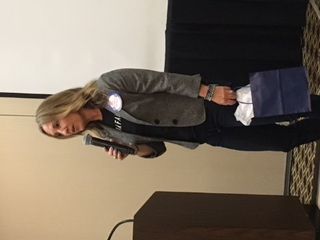
JUNE 5, 2017

Responsibilities

Drawing, Wendy Wiegend; Words, Tina Ray
Pledge, Angie Russo; Greeter, Maureen Simons
Roto-Rooter: TBA; Reporter: TBA

Pacific Ridge School – Bob Ogle

UPCOMING PROGRAMS

June 12 Empowering Women, Dana Bristol Smith
June 19 Taylor Made Golf, Thomas Kroll
June 26 Year in Review, Hi Noon Board of Directors

OTHER EVENTS

June 3: Bocce Ball Tournament, Magee Park 11 am
June 23: Club Demotion Dinner, Sheraton
Sept. 9: 4th Annual Brewfest: Holiday Park
October 7: Oktoberfest: Holiday Park

MEETING OF May 22, 2017

President Dawn Van Siclen welcomed all the members and guests, to the “Greatest Club in the Universe”, Stan Prowse led us in the “smile” song and “God Bless America” minus Cathy’s music which we need to offset the off-key singing. Jamie Hartnett gave us the words and Eric Lodge led us in the pledge. After a quick lesson from President Dawn on proper guest introductions and the threat of a $5 fine, guests were introduced with only Dave Kulchin digging into his pocket.

ANNOUNCEMENTS

Rotary Merchandise: Bob Fenner has a dozen Rotary hats and jackets for sale, please see Bob for details. Patty Johnson still has several of the new Hi-Noon Rotary shirts that haven’t been picked up, please see her today to get your shirt or you’ll have to make arrangements to pick them up as she won’t be bringing them to the Monday meetings anymore.

Rotary Foundation 100-year Celebration: President Dawn let the club know that Carlsbad Evening Club would be hosting the event at the Agua Hedionda Discovery Center on Thursday July 1st. Please contact their President, Frank Silva, if interested in attending the event.

Bocce Ball Tournament and BBQ: Nancy Starling passed a sign-up sheet for the 5th Annual Bocce Ball Tournament at Magee Park on Saturday June 3rd at 11 am. Jim Brubaker will be providing and cooking hamburgers and hot dogs and we will have a potluck for side dishes.

Who Am I: Angie Russo was born and grew up in Granville, Ohio just outside of Columbus. Even though everything was about Ohio State and the Buckeyes growing up, she moved to Southern California and attended the University of Redlands. She is currently a commercial underwriter for the Hartford Insurance Company in Carlsbad. Angie has been married for 12 years and has an 11 year old son and 5 year old daughter. Rotary has always been a large part of her life as her dad was a long-time Rotarian and her sister and stepmom participated in the Operation Smile project in Brazil. She really felt the impact of Rotary when her father was diagnosed with stage 4 throat cancer in 2006 (he has been now been cancer free for 10 years!) and when her daughter was diagnosed with diabetes when she was 2 years. During those times her family received a ton of support from other Rotary members.

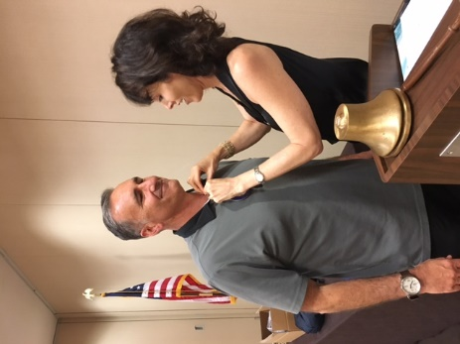
Paul Harris: Neal Stehly was awarded his 3rd Paul Harris and he received his +2 sapphire pin. Way to go Neal!

District Conference: President Elect David Harrison talked more about the events leading up to conference, which was last Saturday, including packing up his car with the donated back packs and peanut butter, misplacing our Hi-Noon Rotary flag, then locking his keys in his car when he was so excited he found the flag. David mentioned he is trying to set low expectations when he becomes President in a few weeks. He eventually made it to the conference, marched with our Club flag and heard some very powerful speakers.

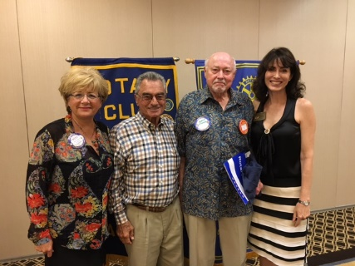
New Member Inductions: Patty Johnson inducted new member; George Porter and his sponsor is Dave Kulchin. George was in the insurance business for over 35 years and was a member of the Vista Rotary Club for over 30 years, please welcome George!

ROTO ROOTER – LAURA SHERIDAN-CAMPBELL

Stan Prowse was fined $100 for what the Rooter called the “lamest announcement” she’s ever heard. The announcement was for the Demotion Dinner, which will be held on Friday June 23rd at the Sheraton.

Alex Klingensmith was fined for his road trip to Utah for his cousins’ wedding. The Rooter tried to sharpen President elect Harrison’s math skill by having him do the calculation for the $75 fine. Jessica Jones was fined $50 for back to back weekend events, first her team won a 24 hour race at Zions Park and the following weekend was her first Indian Princess outing.
No fine for Robyn Hill who took time during her school break to teach a 4-week Spanish class, and the Rooter was one of her students.

Jeff Wohler was fined $50 for 3 recent accomplishments; Chairman elect for the Palomar College Foundation, Volunteer of the year for the Humane Society, and negotiating a $1/year lease with Imperial Beach for a surf camp.

Finally Bob Fenner was fined $100 for his possible exaggerations, does he really have 35 grand and great grandkids, been married 49 years? He was definitely exaggerating a jacket size a couple meeting ago.

PROGRAM – Erin Miserlis - SURF AID

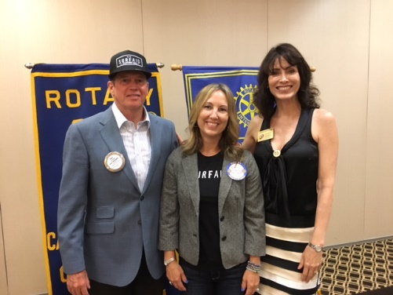
Pat Hurley introduced Erin Miserlis, who is the director of development
and the only US employee for the non-profit Surf Aid which is based in New Zealand. Surf Aid was started by Dr. David Jenkins, when he was on a surf trip in the Mentawai’s Islands of Indonesia and he decided to take a trip to the local village. He was the first doctor to ever visit the village and he found women and children dying from malaria, malnutrition and inadequate living standards. That’s when he decided to start Surf Aid to improve the health, well-being and self-reliance of people living in isolated regions connected to
them through surfing.

Surf Aid believes that no matter where you live, you have a right to access quality basic services. They provide practical support including materials to build water tanks, water taps and toilets for clean water and sanitation, mosquito nets to avoid malaria and vegetable seeds to establish nutrition gardens to reduce malnutrition. From 2004 to 2010, because of all the natural disasters in the region, they became more of an emergency response operation but since 2010 they have gone back to their goal of developing community health volunteers and government staff to provide basic services for the people in their villages. They are currently working on 4 areas; Mentawai Islands, Nia’s Island, Sumbawa, and Sumba and have plans to expand. In July they will be having a Celebrity Surf Contest in Cardiff, so if anyone is interested in volunteering or participating please contact Erin.

Responsibilities for June 12, 2017

Drawing, Mary Fritz-Wilson; Words, Bud Carroll
Pledge, Yvonne Finocchiaro; Greeter, Nancy Starling
Roto-Rooter: TBA; Reporter: TBA

MAY 22, 2017

HI-JINX
Official Publication of the

CARLSBAD HI-NOON ROTARY CLUB

P. O. Box 741, Carlsbad, CA 92018
President: Dawn Van Siclen
Editor: Harry Peacock
Reporter: Randy Ferren
Photographer: Jaime Hartnett

Web address for Make-ups: www.rotaryeclubone.org

Carlsbad Hi-Noon Rotary Officers and Directors 2016-2017
President: Dawn Van Siclen Secretary: Velyn Anderson
Pres-Elect: David Harrison Treasurer: Alex Klingensmith
Community: Nancy Starling Club: Wendy Wiegand
Vocational: Alice McDermott International: Harry Peacock
Sergeant-at-Arms: Jim Brubaker Past-President: Stan Prowse
District 5340 Governor Marilyn Sanderson
Rotary International President John Germ

www.carlsbadhinoonrotary.org

