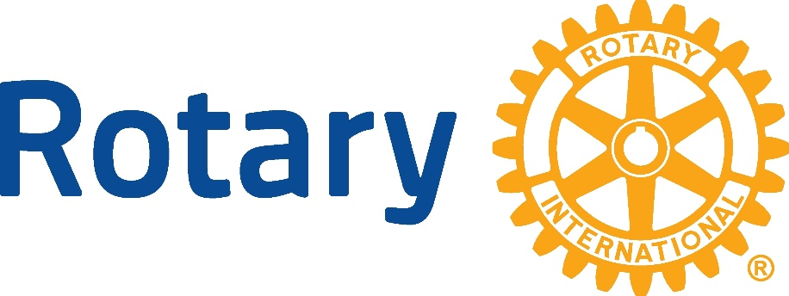

CARLSBAD HI-NOON ROTARY
SCHOLARSHIP RAFFLE 2025

ALL funds generated from this raffle will be used to fund scholarships for Carlsbad students who are interested in furthering their education via college/university OR trade/technical schools.

PURCHASE: $20 EACH or 6 for $100 (Maximum 3,000 tickets sold.)

PAYABLE: CHECKS: Carlsbad Hi-Noon Rotary Foundation
P.O.Box 130175, Carlsbad, CA 92013 (Must be received by April 11, 2025.)

ZELLE: carlsbadhnrf@gmail.com or QR Code (below)
Your tickets will be mailed back to you.
California regulations preclude online raffle ticket purchases.

PRIZES: 1st Prize = $5,000.00 cash
2nd Prize = Sedona AZ – 4 night accommodation at Hyatt Pinion Point ($2,000 value)
3rd Prize = E-Bike ($1,800 value)
4th Prize = Wine Basket ($500 value)

DRAWING: Monday, April 14, 2025, 1 pm, CHNRotary meeting at the Harding Center, Carlsbad.
Winners need not be present to win.

INFORMATION: CHNR Website: carlsbadhinoonrotary.org
Scholarship Applications available on club website; deadline is March 27, 2025.
Contact: JoAnn Ross, Raffle Chair, 760-652-9385 or ross93291@aol.com

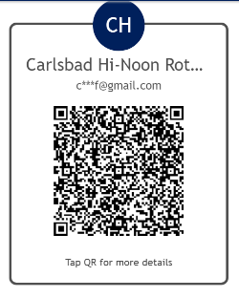
This raffle is registered with the CA Department of Justice
under Raffle Registration RF0013534.

