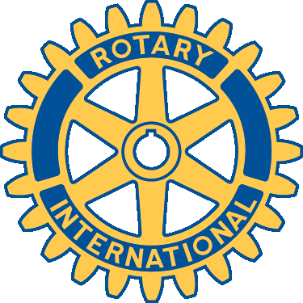

20 Reasons to Join Rotary

- Friendship: In an increasingly complex world, Rotary provides one of the most basic human needs: the need for friendship and fellowship. It is one of two reasons why Rotary began in 1905.
- Business Development: The second original reason for Rotary’s beginning is business development. Everyone needs to network. Rotary consists of a cross-section of every business community. Its members come from all walks of life. Rotarians help each other and collectively help others.
- The Opportunity to Serve: Rotary is a SERVICE club. Its business is mankind. Its product is service. Rotarians provide community service to both local and international communities. This is perhaps the best reason for becoming a Rotarian: the chance to do something for somebody else and to sense the self-fulfillment that comes in the process and return of that satisfaction to one’s own life. It is richly rewarding
- The Development of Ethics: Rotarians practice a 4-Way Test that governs one’s ethical standards. Rotarians are expected to be ethical in business and personal relationships.
- Family Programs: Rotary provides one of the world’s largest youth exchange programs, high school and college clubs for future Rotarians, opportunities for spouse/partner involvement, and a host of activities designed to help family members in growth and the development of family values.
- Citizenship in the World: Every Rotarian wears a pin that says “Rotary International.” There are few places on the globe that do not have a Rotary club. Every Rotarian is welcome – even encouraged – to attend any of the 29,000 clubs in 194 nations and geographical regions. This means instant friends in both one’s own community and in the world community.
- Assistance When Traveling: Because there are Rotary clubs everywhere, any Rotarian in need of a doctor, lawyer, hotel, dentist, advice, etc. while traveling has found assistance through Rotary.
- Personal Growth and Development: Membership in Rotary continues one’s growth and education in human relations and personal development.
- Leadership Development: Rotary is an organization of leaders and successful people. Serving in Rotary positions is like a college education. Leadership – learning how to motivate, influence and lead leaders.
- Vocational Skills: Every Rotarian is expected to take part in the growth and development of his or her own profession or vocation; to serve on committees and to teach youth about one’s job or vocation. Rotary helps to make one a better doctor, lawyer, teacher, etc.
- Citizenship in the Community: Membership in a Rotary club makes one a better community citizen. The average Rotary club consists of the most active citizens of any community.

- Continuing Education: Each week at Rotary (whether in-person or via electronic transmission) there is a program designed to keep one informed about what is going on in the community, the nation and the world. Each meeting provides an opportunity to listen to different speakers and a variety of timely topics. Rotary is fun . . . a lot of fun. Meetings are fun, club projects are fun, social activities are fun . . . and service is fun.
- Public Speaking Skills: Many individuals who joined Rotary were afraid to speak in public. Rotary develops confidence and skill in public communication and the opportunity to practice and perfect these skills.
- Entertainment: Every Rotary club and District has parties and activities that provide diversion in one’s business life. Rotary holds conferences, conventions, assemblies, and institutes that provide entertainment in addition to Rotary information, education and service.
- The Development of Social Skills: Every week and at various events and functions, Rotary develops one’s personality, social skills and people skills. Rotary is for people who like people.
- Cultural Awareness: Around the world, practically every religion, country, culture, race, creed, political persuasion, language, color and ethnic identity is found in Rotary. It is a cross-section of the world’s most prominent citizens from every background. Rotarians become aware of their cultures and learn to love and work with people everywhere. They become better citizens of their countries in the process.
- Prestige: Rotary members are prominent people—leaders of business, the professions, the arts, government, sports, military, religion and all disciplines. Rotary is the oldest and most prestigious service club in the world. Its ranks include executives, managers, and professionals – people who make decisions and influence policy.
- The Absence of an “Official Creed”: Rotary has no secret handshake, no secret policy, no official creed, no secret meeting or rituals. It is an open society of men and women who simply believe in helping others.
- Nice People: Rotarians, above all, are nice people—the nicest people on the face of the earth. They are important people who follow the policy of “It is nice to be important but it is important to be nice.”
- “He profits most who serves best.”

