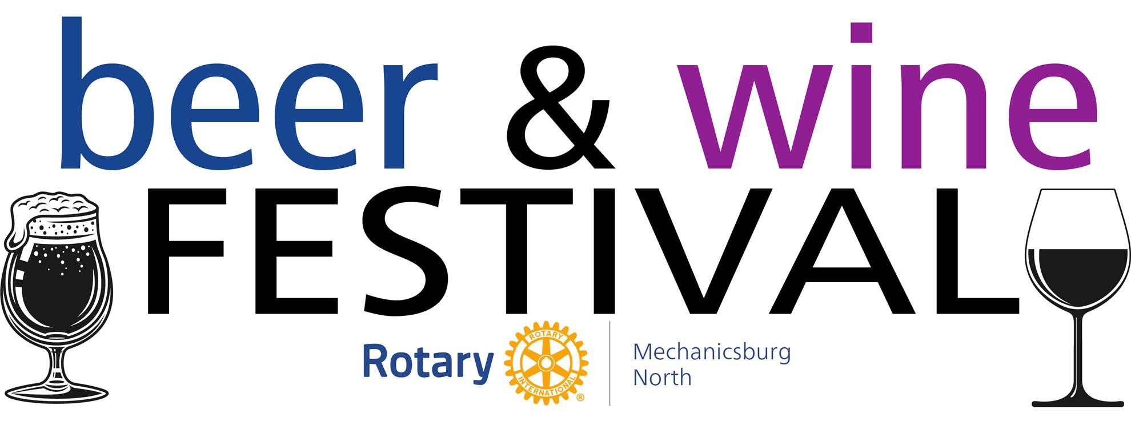
When: April 26, 2025, 3 PM – 7 PM
Where: Eureka-West Shore Lodge No. 302, F&AM
910 S. Market St., Mechanicsburg
Benefits: Rotary Scholarships to High School Seniors/Local Charities/Food Pantries/Libraries
Breweries, Wineries, Food Trucks and Live Music!
We will have RAMP certified volunteers to help pour if staffing is short…


Tickets:
$30.00 per person if ordering online through April 25th
$40.00 on the day of the event
$5.00 Designated Drivers*
*Receive a $5 food voucher

Ticket site: https://bit.ly/41HrQqL
If your brewery or winery is interested in participating reach out to:
Brewery Contacts:
- Ken Hugendubler 717-319-5440 or hugendubler1@gmail.com
- Ben Jackson 717-947-5192 or bjackson@barlett.com

Winery Contacts:
- Amy Spotts 717-226-9624 or amyspo@hotmail.com
- Marty Cook 717-395-6462 or marty.cook@martyonwine.com

We are also looking for sponsors! Promote your business and support the community. More information can be found at: https://bit.ly/3XuF6g3

