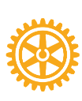
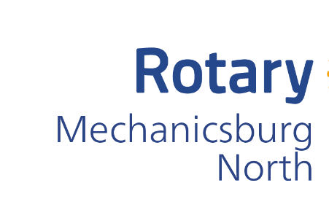

2025 Sponsorship Packages

- Beer and Wine Festival – April 12, 2025: Annual beer and wine festival featuring some of the best and most popular breweries and wineries in Central Pennsylvania in addition to food trucks and live music. The event is being held at the Eureka-West Shore Lodge No. 302, F&AM, 910 South Market Street, Mechanicsburg, PA 17050. Rain date: April 26, 2025.
- Purse Bingo: To Be Determined
- Taste of Central Pennsylvania: Date To Be Determined
- Package will include any other events as determined throughout the 2025 calendar year.

Proceeds of your sponsorship support the various student scholarships, non-profit philanthropic and other service initiatives throughout the Central Pennsylvania Region.

______________________________________________________________________________
Company Name Company Contact
______________________________________________________________________________
Address ______________________________________________________________________________
City State Zip
______________________________________________________________________________
Contact Phone # Contact Email

Sponsorship LevelS
$10,000 Presenting Sponsor $1,000 Friendship Sponsor
$5,000 Good Will Sponsor $500 Beneficial Sponsor
$2,500 Fellowship Sponsor $100 Patron Sponsor

Graphics or Logo Attached Yes No

Send completed form to: David Blain – dblain@macpas.com
Send your digital logo to: mbadorf@homelandhospice.org. Format: EPS, PDF 300 DPI

Make Checks Payable and Mail to – The Rotary Club of Mechanicsburg North
C/O David Blain
415 Fallowfield Road
Camp Hill, PA 17011

Presenting Sponsor for ALL events: $10,000 – exclusive
- Tables at all events
- Speaking opportunity at all events
- Logo on registration forms/social media graphics for each event
- 30 tickets to Beer and Wine Festival
- Large sponsorship signage at all events
- FB tags year-round plus opportunity for quarterly social media post highlighting business
- RCMN website banner year-round and ancillary materials and press releases
- Opportunity to speak at one morning Meeting and one evening Meeting.
- Corporate RCMN Membership for 2 business representatives
- Logo/Company info on all yearly meeting PowerPoint presentations

Good Will Sponsor: $5,000 - 2 available
- Tables at all events
- 16 tickets to Beer and Wine Festival
- Sponsorship signage and Logo’s on materials at all events (size dependent on level of sponsorship)
- Speaking opportunity at one of the events (Sponsors choice)
- Corporate RCMN Membership for 1 business representative
- FB tags year-round
- RCMN website banner year-round and ancillary materials and press releases
- Opportunity to be a speaker, if the times and space are available at Rotary, at the AM and/or PM meetings

Fellowship Sponsor: $2,500 - 4 available
- Tables at all events
- 8 tickets to Beer and Wine Festival
- Sponsorship signage and Logo’s on materials at all events (size dependent on level of sponsorship)
- FB tags year-round
- RCMN website banner year-round and ancillary materials and press releases
- Opportunity to be a speaker, if the times and space are available at Rotary, at the AM and/or PM meetings

Friendship: $1,000
- Tables at all events
- 4 tickets to Beer and Wine Festival
- Sponsorship signage and Logo’s on materials at all events (size dependent on level of sponsorship)
- FB tags year-round
- RCMN website listing year-round and ancillary materials and press releases

Beneficial: $500
- Tables at all events
- 2 tickets to Beer and Wine Festival
- Sponsorship signage and Logo’s on materials at all events (size dependent on level of sponsorship)
- FB tags year-round
- RCMN website listing year-round and ancillary materials and press releases

Patron: $100 and below
- Name listing in programs of all the events and on any event T-shirts.

In-kind (services and products):

The amount of the in-kind gifts equals the benefits listed above.

