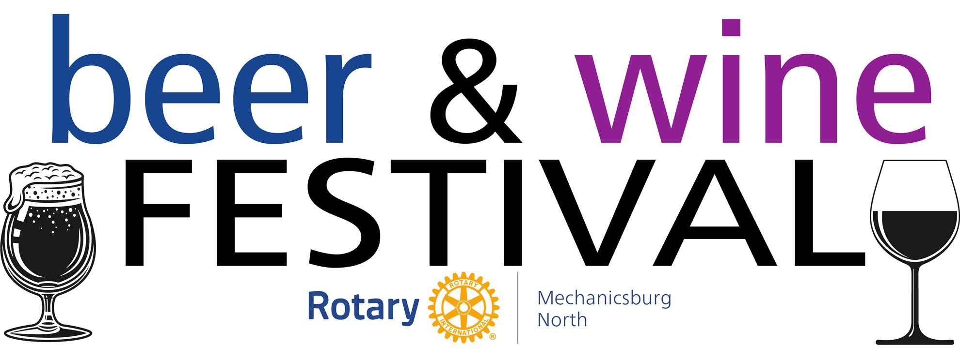

When: April 26, 2025, 3 PM – 7 PM
Where: Eureka-West Shore Lodge No. 302, F&AM
910 S. Market St., Mechanicsburg
Benefits: Rotary Scholarships to High School Seniors, Local Charities, Food Pantries, and Libraries
Featuring live music, food trucks, and a free beverage glass for tastings at participating Breweries and Wineries!

Tickets: $30.00 per person if ordering online through April 25th
$40.00 on the day of the event.
$5.00 Designated Drivers*
*Receive a $5 food voucher

Learn more and order your tickets online at:


https://bit.ly/41HrQqL

