Orange Peel
Rotary Club of Orangevale
District 5180
March 11th, 2022, Club Meeting
Club members and guests were greeted by Bob Kurtz and Brad Squires. Bob led the club in reciting the pledge of allegiance to the US flag. Brad eloquently delivered the invocation.
Guests: Brad Bailey, Pastor Vadim Dashkevych, Joe Duran, Gee, Janice Howarth, and Chrystal Rodine.
Prez Dennis thanked all who served at the Food Bank on March 4th. He mentioned that the Little League team we sponsored is the Junior Cubs. Schedule not yet available, but their opening game will be scheduled for late March. When available, schedule will be announced. Stay tuned. Droning on, he mentioned that our next vocational tour is now set for 9 am on March 25th at Orangevale Community Park with botanist, Jim Grove. A sign-up sheet was circulated.
Club Service: Don R whet appetites for next dine-around: Tuesday, March 15th, Out of Bounds Craft Kitchen and Biergarten, 13407 Folsom Blvd in Folsom at 5:50 pm. https://www.outofboundsbrewing.com/menu.html
Don also encouraged wine donations for the cork pull component of the drive-thru BBQ fundraiser slated for Wednesday, April 20th. This is a major fundraiser this year, so sell tickets and plan to help.
Community Service: Steve mentioned a project lined up for a laying cement pad on March 24th for later installation of outdoor fitness equipment Orangevale Community Park. Contact Steve to volunteer.
Ann Hively thanked those who volunteered and assisted at the March 8th speech contest. Our first-place winner was Tabitha Olsen and our second place winner was Ben Ferneau. Tabitha will go on to compete in semi-finals on April 5th, 6:30 pm at Folsom Lake Community College. Thanks, Ann, for spearheading the speech contest.
President-elect David spoke about getting good ideas and making new connections at the Presidents-Elect Training Seminar he attended March 4th thru 6th. Gearing up for next year, David mentioned some initiatives he has on the horizon for harnessing technology for streamlining some of our processes and improving meeting experience for Zoom attendees. David also encouraged next year’s board members to plan on attending the Rotary District 5180 Assembly for 2022-2023 club officers and directors on Saturday, April 9 from 8:30 am – 12:30 pm, location TBD.
Speaking of next year’s board, David mentioned that he emailed a slate of next year’s club officials for consideration. A motion was made for accepting the slate of officers, directors, and chairs for the next Rotary year, it was seconded, and subsequently passed.
Congratulations and best of luck to our officers, directors, and committee chairs for 2022 – 2023!
Officers
President David Shepard
Pres Elect Don Morris
Past Pres Dennis Sarkisian
Secretary Phyllis MacDonald
Treasurer Steve Blair
Sergt/Arms Jeff Valtman
Directors
Club Service Don Russell
Com Service Don Glover
Int’nl Service Jim Buntin
Voc Service Sean Palmer (tentative)
Youth Service Ann Hively
Membership Audrey Smith-Wiburg
Rotary Found. Bill Wagner
Media/Web Catrina Womack
Committee Chairs
Speaker Brad Squires
Newsletter Lorie Rheams
Auction TBD
Technology TBD
Youth Safety Bob Kurtz
Vocational Speaker: Brad Squires spoke about Heirloom Acres Farm, where he and his wife, Megan and their children live and make a living. He came prepared with pictures worth a thousand words of the beautiful flowers grown, available for customers to get close to nature and pick their own flowers, fresh from the garden. In addition to flowers, they also grow pumpkins and Christmas trees for customers to select. Heirloom Acres also has an array of critters, like chickens, rabbits, and goats. Brad’s presentation reminds us that Orangevale is truly a great place to live.
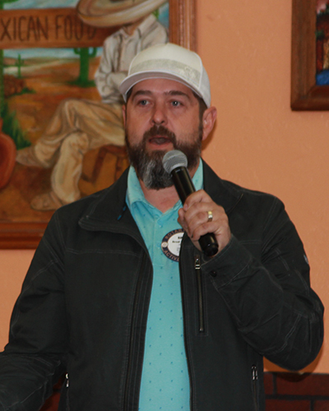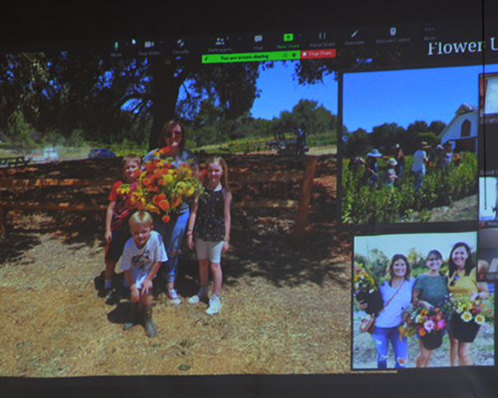
Our guest speaker was Vadim “Dash” Dashkevych, the Senior Pastor at Spring of Life Church in Orangevale. Born and raised in Chernivtsi, Ukraine, where he attended a private Christian English-Ukrainian school and later earned a degree in law from Chernivtsi National University. He holds theology degrees from Blagovest School and Golden Gate Baptist Theological Seminary. Vadim and his family immigrated to the US in 2005. He and his wife, Olga, have four children. He just recently returned from Poland, where took part in relief efforts for Ukrainian’s seeking refuge from the unwarranted and violent Russian invasion of their country.

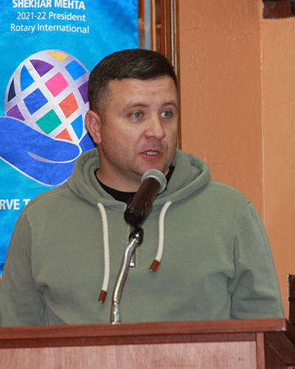
Pastor Dashkevych provided a firsthand account of his recent trip to Poland, where he and others from his church delivered supplies and met with refugees from Ukraine and people providing food, shelter, and assistance to them. He praised Poland and its people for opening their arms to care for over a million refugees. Dash spoke to the brutality of invading Russian forces and the fierce resistance they are encountering from Ukrainian military and many civilians. He also spoke of friends and relatives in Ukraine living with the constant threat of attack. Responsibility for this unwarranted, ruthless invasion rests on Vladimir Putin. The evil is compounded by the disinformation campaign Russian media perpetuates to conceal the truth about the invasion from Russian citizens. How to help Ukraine? Pastor Dash encourages prayers. He also recommends monetary donations, allowing purchases closer to where goods and supplies are needed to lower costs and minimize logistical challenges. In addition to weaponry, Ukraine is in great need for medical supplies, food, and vehicles for transporting people seeking refuge in a neighboring country. Pastor Dash provided info on how to donate if you choose to Spring of Life Church with all funds going toward Ukrainian relief. He described a goal of purchasing several buses/minivans for transporting women and children fleeing for safety. Our hearts go out to the courageous people of Ukraine as they fight for their freedom.
EDITOR ADDITION: At the 49 minutes and 20 seconds point into the following Youtube link, you can see a 6-minute video Pastor Dash presented at the Spring of Life Church service on Sunday. It is in Ukrainian, however, it captures much of what he described at our meeting and depicts the danger and hardships the people of Ukraine are enduring, as well as the humanitarian assistance Poles are providing refugees.
https://www.youtube.com/watch?v=Ks4qVfSq3M8

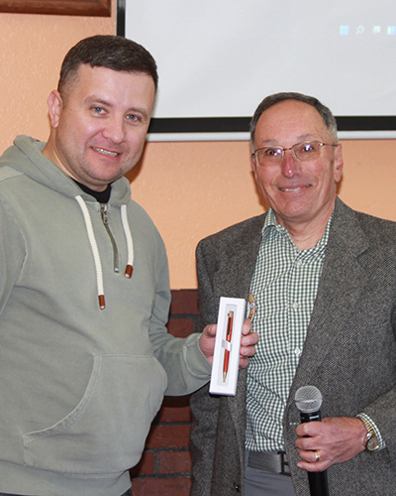
Raffle: Prez asked Gee of Spring of Life Church to pick a ticket from the bucket. Ann Hively had the winning ticket, literally, grabbing the orange golf ball to raising it for all to see. She immediately declared that the $111 prize money will go to humanitarian relief for Ukraine and a check was promptly given to Pastor Dash.

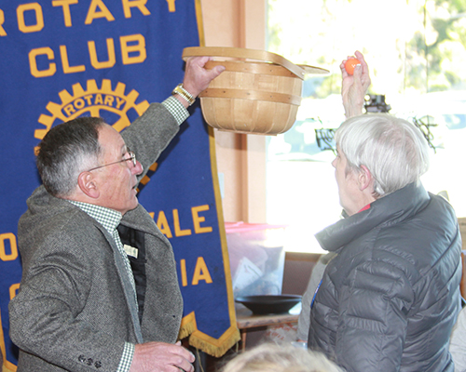

Next week’s guest speaker: Bob Clouse of the Orangevale Grange
Greeters: Sean and Kirk Invocation: Bert Vocational Speaker: Bill Wagner

English translation of Ukrainian Sayings:
“A friendly word is better than a heavy cake”
“Act swiftly, think slowly”
“Your head is not only for putting a hat on”

