Orange Peel
Rotary Club of Orangevale
District 5180
March 18th, 2022, Club Meeting
Club members and guests were greeted by two cheerful Rotarians, Sean Palmer and Kirk Camunez. Kirk led us in the pledge of alliance. Bert Smith delivered the invocation eloquently.
We were delighted to have as our guests: Bob Clouse, Scott Bailey, and Chrystal Rodine
Prez Dennis announced sad news of former club member Pastor Bill Graf passing away on March 10th and circulated a sympathy card for his wife, Annelise. He read a thank you message from Friends of the Orangevale Library, expressing gratitude for our club’s recent $500 donation. Next, he announced that due to rising costs of labor, food, utilities, and other overhead expenses, our per meal cost is going up from $11 to $15, starting in April.
A sign-up sheet was circulated for the March 25th vocational tour at Orangevale Community Park with botanist Jim Grove guiding us and describing the plant life on display. Show time, 9 am.
Club Service: Don Russell shared a humorous riddle and then spoke of the good food, drink and cheer dine-around attendees enjoyed at Out of Bounds Biergarten in Folsom on March 15th.
Community Service: Steve Blair announced that volunteers will be setting forms at 1:30 pm on Tuesday, March 22nd at Orangevale Community Park for concrete delivery on Thursday at 8 am. After concrete sets, outdoor fitness equipment will be installed. This is our top community service project this year.
Jonathan Spangler announced a couple of local events coming up. The monthly Veterans Meet-up and launch party for Women’s Veteran Magazine will be held at Dad’s Kitchen in Fair Oaks, 4 – 7 pm on March 23rd. The Orangevale Chamber of Commerce will be having an Orangevale Food Festival on Saturday, March 26th from 6 – 9 pm at the Orangevale Grange. Music, drinks, and artisan food! Tickets are $50 in advance; $55 at the door. Visit www.orangevalechamber.com for more details and purchase advance tickets.
Ann Hively announced a training on March 19th for assembling Water Pasteurization Indicator (WAPI) tubes. Those receiving training will take part in training Interact students for assembling WAPIs in quantity for ultimate distribution to people in developing countries lacking access to drinkable water.
Bill Wagner served as our vocational speaker and shared the path of his professional career. He attended University of San Francisco, where he graduated with a Bachelor of Science degree in Accounting. After college, he went to work for Ingersoll Rand, an international manufacturing company, where he served as an auditor and later advanced to positions of increasing responsibility. He later ventured into private practice as a certified public accountant, providing service to corporations and local business clients. After a number of years, Bill's career shifted to financial planning, when he served clients as a financial advisor with Edward Jones. This became his forte and Bill progressed, earning certified financial planner credentials. He went on to serve for many years with Raymond James Company, providing advice and assistance to clients on a range of investment and financial management matters. In semi-retirement, Bill continues to advise a few clients.

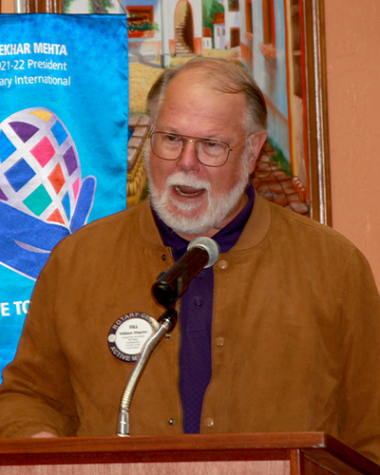

Prospector: Our March 2022 prospector, Barry Ross, arbitrarily imposed fines on unsuspecting members and even those sitting on either side of them. His movie trivia questions stumped even the movie buffs in the room. He politely shunned any questioning with an additional fine for arguing, textbook prospecting.
Guest Speaker: Bob Clouse, president of Orangevale Grange served as our guest speaker. Founded in 1867, the Grange is the oldest national agricultural organization in the USA. This organization has long served to promote agriculture on a range of issues, including economic development, education, and keeping America strong. Having a thorough process for vetting legislative proposals, they actively promote legislation and have been influential getting various laws enacted. Organized in 1910, the Orangevale Grange is the oldest service organization in Orangevale. They played a pivotal role in bringing electricity and telephone service to our area. The Grange is family-oriented and include spouses and children in their activities. Bob shared a couple of stories that made evident he a civic-minded man who cares a lot about family, the community, and our country. We salute you, Bob, for your 62 years of community service with the Grange.

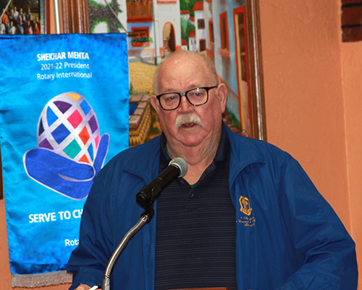

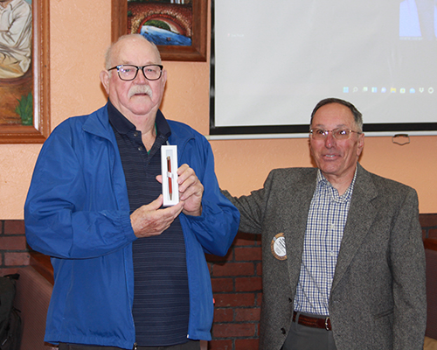
A raffle ticket purchased by Rob Auernig was selected from the orange bucket and bad news first; he picked a white ball from the basket. Good news was that the pot grew larger, and we have a great raffle ticket salesman for next week.

Upcoming Guest Speakers:
March 25th, George Myer of Family Search Library and its resources
April 1st, Mike McKibbin to talk about local school district’s pandemic to endemic experience

Our club attaining Every Rotarian, Every Year (EREY) distinction again this Rotary year is within reach. Thank you to those who have made a qualifying donation. We encourage every active member to donate a minimum of $25 to The Rotary Foundation, Annual Fund at least 2 weeks prior to June 30th. Contact our Foundation Chair, Bill Wagner, if you have any questions.

