Orange Peel
Rotary Club of Orangevale
District 5180
March 18th, 2022, Club Meeting
Members and guests were warmly welcomed by greeters Mairy and Catrina. Prez Dennis opened the meeting with a greeting and mentioned it was National Medal of Honor Day. Mairy led us in the pledge of allegiance. Audrey eloquently delivered the invocation.
We were glad to have several guests: George Myers, Jeannine Sparks, Ms. Bear Williams, Janice Howarth, Joe Duran, and three siblings: Briana, Dylan, and Sophia Smith.
A special ceremony was conducted for informing our outbound Rotary Youth Exchange (RYE) student, Briana, where she would be going for her year living and learning abroad. Ann Hively took to the podium, as did Jeannine Sparks our District 5180 RYE Chairperson and Bear Williams, District 5180 RYE Outbound Coordinator (and former RYE student). Next, they called up Briana for the special announcement. Each raising the anticipation level with hints that narrowed it down from somewhere on the planet to one of Briana’s preferred countries, Belgium. Hearty applause ensued with the good news. Then, Dennis presented Briana with an Orangevale Rotary Club banner to eventually give to her host Rotary club in Southern Belgium in exchange for their club’s banner. Bill Wagner announced that he will soon be getting a Paul Harris pin for Briana to proudly wear. Bon voyage en Belgique, Briana!
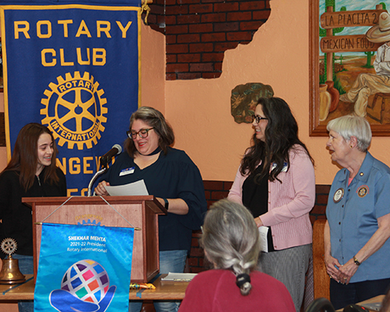

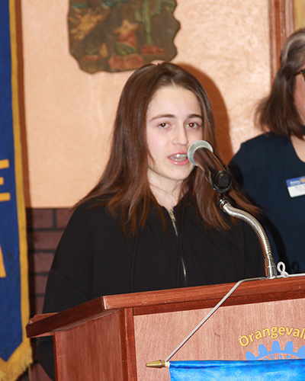
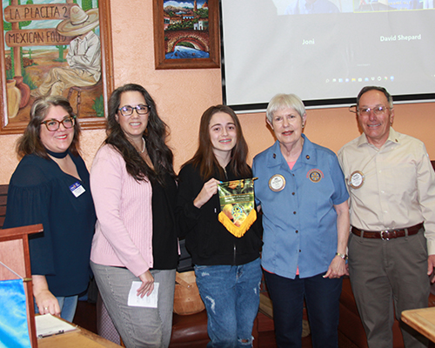
Announcements
Prez reminded everyone there will be a vocational tour at 9 am with botanist Jim Grove explaining fine points about plant life growing at Orangevale Community Park. It will be our turn to serve at the Food Bank next Friday, April 1st, 9 am to 12:30 pm.
Community Service: Steve Blair thanked those who helped laying forms and setting concrete for a 20’ X 20’ pad for the outdoor fitness installation project at Orangevale Community Park. After concrete the properly sets, the fitness equipment will be installed. The installation is slated for Saturday, April 23rd.
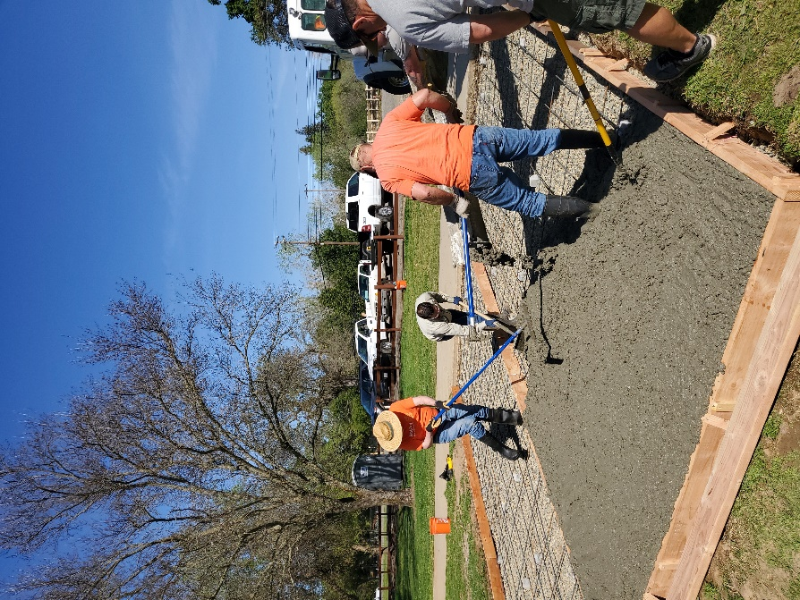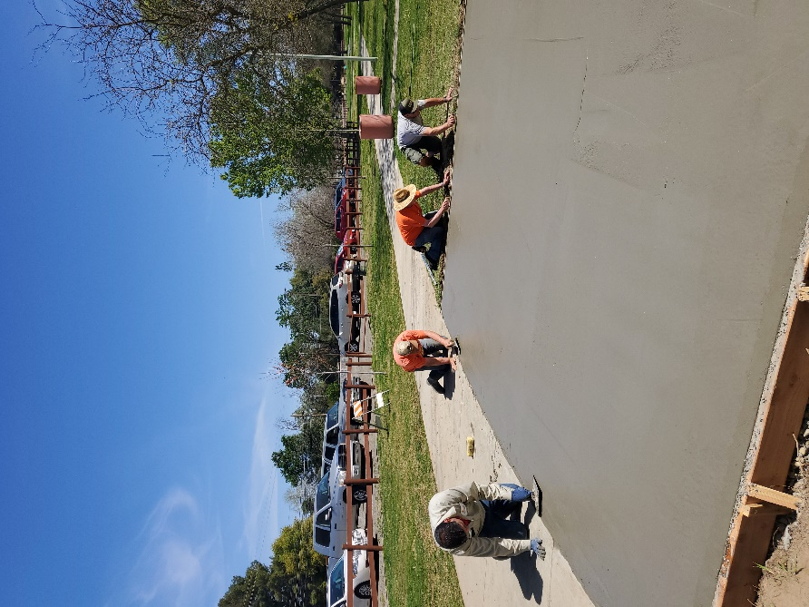

Club Service: Don Russell said he was seeking suggestions on where to go for our next dine-around. He reported that we have 43 bottles of wine for the cork draw component of the April 20th drive thru BBQ fundraiser; we could use more. Audrey mentioned that we only have three items for the sealed auction and asked club members to solicit more auction items (valued $100 or higher).
President-Elect David Shepard shared some new tools, using QR codes scanned with your smart phone for capturing meeting attendance, completing surveys, and signing up for community service and other activities. He urged next year’s board members to sign up for the Rotary District 5180 Assembly slated for Saturday, April 9th, 8:30 am – 12:30 pm, at Twelve Bridges High School in Lincoln.
Fundraising: Jim Buntin encouraged members to sell tickets for our April 20th drive-thru BBQ fundraiser. After selling tickets, be sure to give Jim the stubs with name and email address of purchaser as soon as possible, along with checks and cash received.
Ann Hively provided a reminder about Water Pasteurization Indicator (WAPI) assembly would be done Saturday, April 26th at Folsom High School with some Interact students and Rotary members taking part. She announced that the deadline for students to apply for the Rotary Youth Leadership Awakening (RYLA) camp has been extended to April 5th. She is getting the word out to Interact students and Casa Roble High School counselors about this special opportunity our club is funding for two students.
Prospector: Barry Ross completed his stint as prospector by using movie and sports trivia questions and other tactics for imposing penalties for incorrect responses, which outnumbered right answers by a wide margin. Jeff collected a plate full of dollar bills when it was all said and done. Then, Barry auctioned off prospector for the month of April. A couple of members put money down to have Catrina handle prospecting. Once, twice, sold! Catrina is returning to serve as our prospector next month.
Guest speaker: George Myers, an assistant director of the Sacramento Family Search Library spoke to the club remotely via Zoom. The library seeks to help individuals discover their ancestors, gather stories and information, and connect with loved ones through FamilySearch.
George explained that the Family Search Library is available for both in-person and remote assistance, free of charge to individuals seeking to learn more about their ancestry. Do to space limitations, George recommended calling to make an appointment for visiting their library. He recommended bringing a USB 3 flash drive to use on their computers. They also provide individual consulting via Zoom, as well as in-person. The Family Search Library also has weekly classes one can attend remotely via Zoom.
George shared a page excerpt from his family tree, featuring an Irish woman who past away in 1880 at the age of 85. He pointed out the level of detail that can be discovered using research tools available. His example showed the names and birthdates of the woman’s parents, siblings, spouse and children.
For more information on the Family Search Library, their website is:
https://www.familysearch.org/en/wiki/Sacramento_FamilySearch_Library
Raffle: Nearly causing an uprising for overlooking the raffle, Dennis was reminded by a kind gentleman waving his string of tickets in the back of the room. With clue light finally illuminated, he had guest Jeannine pick a ticket and the number happened to correspond with one Barry Ross had in his possession. With confidence Barry came forth, stuck his right hand in the basket, and drew a white ball. Nice try.

Upcoming guest speakers:
April 1 Mike McKibbin SJUSD pandemic to endemic experience
April 8 Suzanne Gostovich Growing Past Today, aiding unhoused children
April 15 Mark Aring Orangevale History Project
After the meeting, a dozen club members enjoyed a vocational tour with botanist, Jim Grove leading us on a trail around Orangevale Community Park, explaining the wide variety of trees, bushes, and wildflowers. A retired educator, Jim is quite knowledgeable and did a wonderful job of pointing out and explaining unique features of the plant life on display.
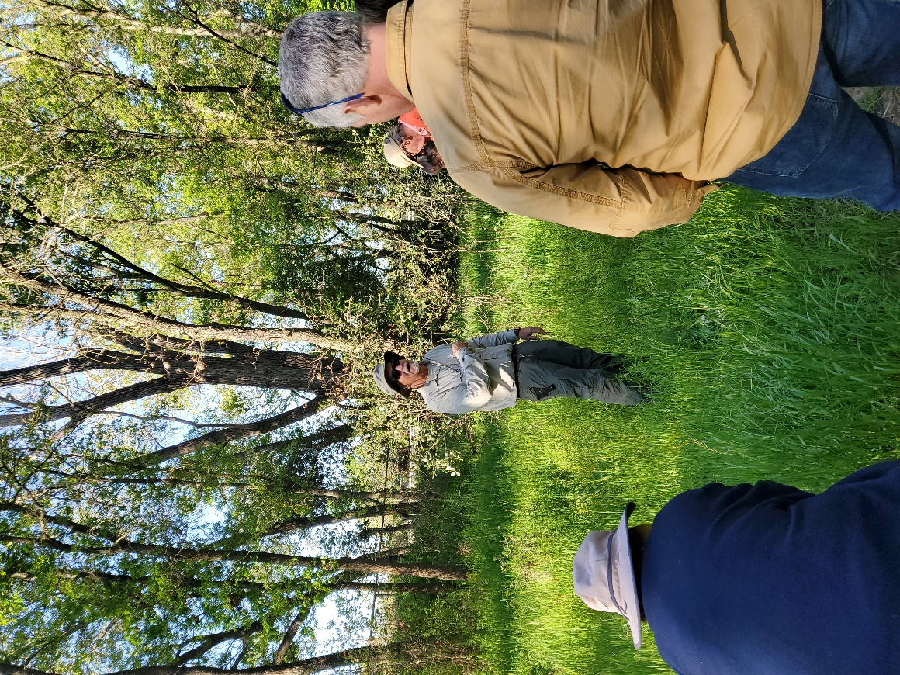

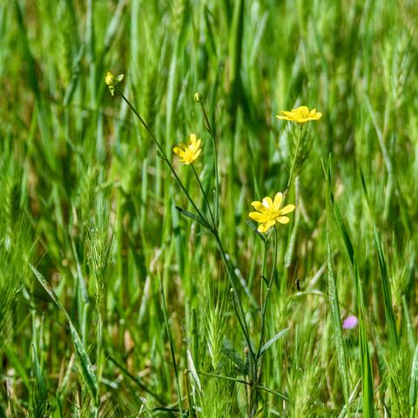

Pictures for this Orange Peel edition were provided by Bob Kurtz, Jim Buntin, and Dennis S.

