Orange Peel
Rotary Club of Orangevale
District 5180
March 11th, 2022, Club Meeting
Photos provided by Bob Kurtz
Club members and guests were greeted by Bill Wagner and Jim Buntin. Bill led the club in the pledge of allegiance to the US flag. Jim Buntin provided an invocation.
Guests: Jim Cassio of Friends of Lakes Folsom and Natoma.
Prez thanked David Shepard for contacting Mia and inviting her to share ways individual club members can contribute to the people of Ukraine. He also noted The Rotary Foundation Disaster Response Fund will help fund those efforts as well. Prez reminded all of Food Bank duty this morning, 9 – 12:30 pm.
Ann Hively prepped everyone about the speech contest for 6 high school contestants, slated for Tuesday, March 8th at Round Table Restaurant, 9500 Greenback Lane in Folsom (near Ace Hardware) Those assisting the show-time is 5:15 pm, others 5:45 pm.
Steve sent out a message yesterday seeking volunteers to help install a concrete slab at OV Community Park for later installation of outdoor fitness equipment.
Don Russell encouraged club members to donate bottles of wine for a cork pull component of the upcoming drive-thru BBQ fundraiser. He also reminded us this is our major fundraiser and volunteers are needed, plan accordingly.
Barry Ross debuted as prospector in grand style, finding vulnerabilities and exploiting them for our common good. He will be out of town March11th but will return the following week. Come prepared.
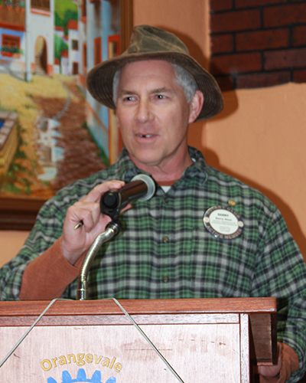
The President of Friends of Lakes Folsom & Natoma, Jim Cassio was our guest speaker. He is a former park ranger and currently a workforce development professional specializing in training people for work in conservation, fire prevention and eco restoration work. He and his wife, Deb, live in Folsom. They have two adult daughters, one an environmental attorney and one a recent graduate in environmental science and anthropology.
Jim Cassio enlightened us on the community service of Friends of Lakes Folsom and Natoma (FOLFAN). They are a nonprofit organization and the state park cooperating association for the Folsom Lake State Recreation Area. FOLFAN does work on maintaining trails and they operate the Adopt the Parkway program for cleanup events, such as Orangevale Rotary’s periodic bike trail cleanup service. FOLFAN members do some behind the scenes work, keeping visitors from disrupting the rare bald eagle habitat in one area along Lake Natoma. Through donations, FOLFAN provides life vests for visitors to borrow on the honor system, a wonderful public safety service. They also prepare various brochures and handouts to enhance visitor appreciation of the park and help keep it the local area treasure it is. Through his presentation, we gained a greater appreciation of the Friends of Lakes Folsom and Natoma.
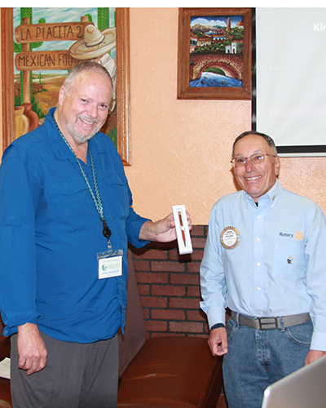

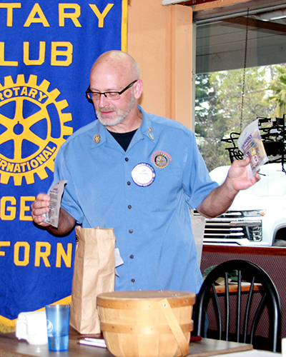
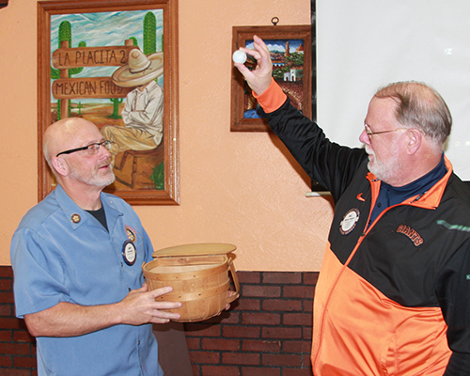
Raffle: The potentially lucky ticket number was drawn, and it happened to correspond with a ticket purchased by none other than Bill Wagner. With great crowd anticipation, he put a hand in the basket and plucked a white ball out.

This week there was a consolation prize, a bag of goodies for a second raffle ticket drawn; winner, Jeff Valtman.
Next Meeting: March 11th Greeters: Bob and Brad Invocation: Brad
Vocational Speaker: Brad Squires
Upcoming Guest Speakers:
March 11th Nick Anderson of Orangevale Food Bank Farm (later changed)
March 18th Bob Clouse of Orangevale Grange
March 25th George Myers of Family Search
Lacking any witty or thought-provoking quote, Prez oddly closed meeting by griping about having to memorize so many log-in and passwords for accessing various online functions. Clearly a senior citizen with a bad attitude, he lamented that just once after failing to get it exactly right, he would like a username and password prompt to say: “Close enough...”

