

Orange Peel
Rotary Club of Orangevale
District 5180
Club Meeting – March 7, 2025

Licia Green and Bill Wagner greeted our members and guests. Club President Catrina Womack rang the bell to start the meeting. Licia led the Pledge of Allegiance. Jim Buntin delivered the invocation.
Our guests included two distinguished gents, Ernie Womack and Derek Maldonado, as well as three young women from Orangevale Future Farmers of America: Aliyah, Payton, and Tayler.
Announcements
Prez Catrina made several announcements:
With solid support from the club board and the OV Rotary Charitable Fund board, we funded and processed this year’s 25 classroom grant requests, providing reimbursements to local educators totaling $16,097. Catrina thanked Michelle, Phyllis, and Dennis for managing this impactful project.
The club board met on March 3rd and had a fantastic and informative meeting with District 5180 Governor Steve Turner. He will be attending our March 28th club meeting. We are grateful for Steve’s support in helping us market the upcoming (May 17th) Big Day of Service as Title Sponsors.
Thank you to those who served at the Rotary House clean up. See our social media post on Facebook!
Deanna Maddock is attending the President-Elect Training Seminar (PETS) this weekend, preparing for next year (starting July 1st), when she will take the reins as our club president.
Catrina will be teaching a belly dancing class at the Fair Oaks Rotary Club meeting on Monday, March 31 at the VFW Hall, 8990 Kruitof Way in Fair Oaks. The meeting starts at 7 pm.
Community Service: David Shepard mentioned that four club members performed cleanup work at the Oak Park Rotary House last Saturday, March 1st. They served with counterparts from other clubs, preparing the house for its next occupants. Rotary House provides a comfortable home away from home for a family with a child receiving extensive medical care at nearby UC Davis Medical Center.
Coming up, March 15, we have American River Girls Softball Opening Day at Oakview School, 7229 Beech Ave. We supported the Girls Softball League, funding a CONEX box, used as a snack bar for their games. We need club volunteers to serve one of two 2-hour shifts, managing a bounce house.
After that, Growing Past Today on April 5th. Not sure at this point whether we will be participating, other than possibly Diana Newman making cotton candy for the kids.
Dennis announced that we have 10 Food Bank volunteers signed up to serve today.
Club Service: Don Russell introduced himself and enlightened us by mentioning it’s National Cereal Day. He reminded us that our next dine-around is set for Tuesday, March 11th (Ernie’s B-Day) at 5:30 pm. The location will be Pitch & Fiddle, 8525 Madison Ave. Please RSVP Don Russell, if you plan to attend.
Mark your calendar for the evening of Saturday, June 28th for the Demotion. Details forthcoming.
Brad Squires announced Sacramento Venture Philanthropy was hosting a lunch and learn event 11 am – 1 pm on March 18th at the Children’s Choice for Hearing and Talking (CCHAT) Center, 11100 Coloma Road in Rancho Cordova. Licia passed out flyers for the event with a QR Code to RSVP.
Vocational Speaker
Bob Kurtz shared his collection of US flags, with each flag having a story. He displayed the folded flag presented to his mom at his father’s funeral in 1959. It had 48 stars. Alaska and Hawaii became states that year. Next, Bob showed a flag he received that was flown over the US Capitol on September 11th, his father’s birthday. It came with a certificate of authenticity. Another special flag Bob displayed was one he acquired while in Boston, visiting the USS Constitution Museum. It was a US flag that had been flown over the USS Constitution. Launched in 1797, the USS Constitution is the world’s oldest commissioned naval warship still afloat. Thank you for sharing your flags with us, Bob.
Prospector: With our duly appointed prospector for March, Deanna Maddock, off at PETS, Jeff Valtman stepped up and did a stellar job filling in. Brain teasers on US presidents, sports, movies, and music stumped most of us and we were fined. Mike, Licia, and Jim self-imposed happy fines on themselves.

Guest Speakers
Our speakers were three young women, Casa Roble High School students and active members of the Orangevale chapter of Future Farmers of America (FFA): Aliyah, Payton, and Tayler.
Taken from the national FFA website, the organization was “founded by a group of young farmers in 1928. Their mission was to prepare future generations for the challenges of feeding a growing population. They taught FFA members that agriculture is more than planting and harvesting – it’s a science, it’s a business and it’s an art.”
Our guest speakers explained that FFA is a national association with state organizations, with regions within the state, and local chapters, like theirs at Casa Roble High School. In addition to learning about raising livestock and growing food crops, FFA members learn how to shoulder responsibility, acquire team building skills, and develop as leaders.

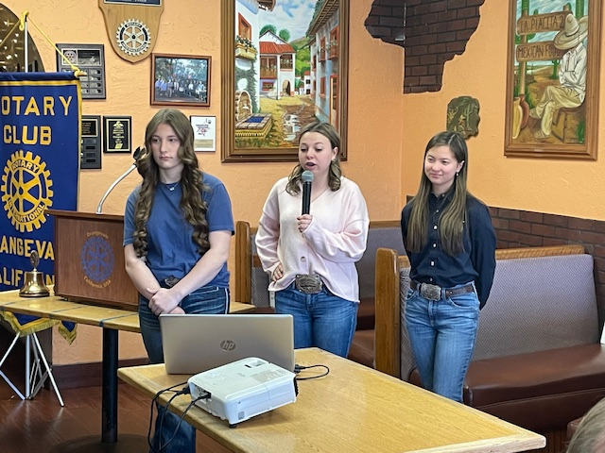

Tayler mentioned that one of their main goals is to educate others about the importance of agriculture. She explained that they are the future of agriculture, and it is their job to keep fundamental values of teamwork, leadership and advocacy alive.
Aliyah informed us that last October, they attended the National FFA convention in Indianapolis. They have also attended the California FFA Conference, as well as regional meetings and events.
Payton announced their FFA chapter has an upcoming fundraiser March 28th, a Spaghetti Dinner and Western Dance at the Orangevale Grange, $25 per person.
While some FFA members aspire to become farmers and ranchers, others follow an educational path toward becoming scientists, veterinarians, and business professionals. Clearly, the experience these young people gain through FFA helps posture them for success in any endeavor.
After their excellent presentation, Prez Catrina presented a $200 check from our club to the Casa Roble High School FFA.

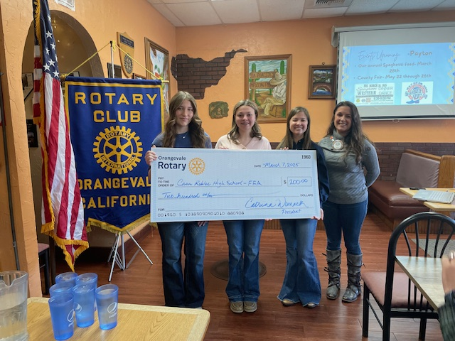

Raffle
Rob Auernig purchased the ticket corresponding with the one drawn for a chance to win the prize. He made his way up to the podium area, where Prez Catrina was holding the basket with 9 white balls and one orange ball. He stuck his hand in the basket seeking the lucky orange ball and pulled out . . . a white ball. Nice try, Rob.
Next Meeting, March 14:
Greeters: Bob Kurtz and Mairy’s substitute
Invocation: Phyllis MacDonald
Vocational Speaker: David Shepard
Guest speaker: Jeanne Shurman of Jake’s Journey Home
Prez Catrina closed by thanking our guests for attending and offering a thought of the day: “As we kick off March, let’s remember that growth takes time, effort, and sometimes a little mess. Whether in our community or our own lives, the seeds we plant now will bring great things later – so let’s keep digging in.” Then, cheerfully, yet with proper decorum, Catrina rang the bell, saying “Have a wonderful weekend, and go out and share Rotary with your favorite people”.

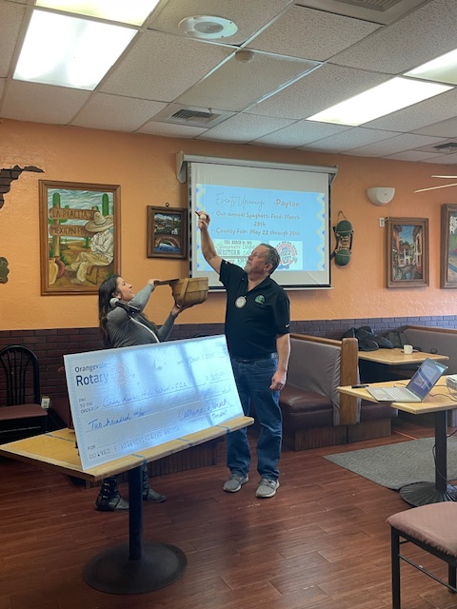
Photographs provided by
Bob Kurtz

SERVICE ABOVE SELF





