Orange Peel
Rotary Club of Orangevale
District 5180
May 13th, 2022, Club Meeting

Club members and guests were greeted by Sean Palmer and Don Russell. Sean led the club in reciting the pledge of allegiance. Audrey eloquently delivered the invocation.
Guests: There were no guests in attendance at this club meeting, not one.
Prez Dennis thanked all who served at the Food Bank on May 6th. In addition to bagging and boxing up groceries for future distribution, our volunteers provided groceries to 39 families in need, with 8 being new sign-ups. The last sign-up was for a large family with 5 children (youngest 6-months old) that just arrived in the USA 3 weeks ago after fleeing Ukraine. Indeed, serving our community is a privilege.
Two display boards were circulated, providing pictures, thank you notes, and drawings from young school kids who are enjoying resources provided by our club’s classroom grants. One was for Ottoman Elementary School, combined kindergarten and first grade class, showing them using the materials purchased with grant funds for assessing and developing reading skills. The other was for Golden Valley River School, showing kindergarten students using yard tools and playthings for practical work and play at their outdoor classroom. A thank you card from California Montessori Project was circulated as well. They expressed gratitude for special education classroom wobble chairs our club funded.
Club Service: Don Russell announced that the next dine-around will be Tuesday, May 17th at Boston Pizza Restaurant, 5511 Sunrise Blvd in Citrus Heights.
Foundation: Bill Wagner mentioned May 13th is the last day to purchase tickets for the May 22nd Rotary Day at the Sacramento River Cats with a portion of proceeds supporting End Polio Now! He provided pertinent details and explained he will be coordinating with Tom Cicchini, District Polio Plus Chair on having e-tickets emailed to those who signed up and paid.
Community Service: Steve Blair updated the club on our Saturday, May 21st, Big Day of Service project. We will be painting the youth services building behind the little league field which is across the street from the Orangevale Recreation and Parks main facility. We will start at 8 am in order to complete work by noon. All supplies should be provided. Wear clothes on which you don’t mind getting some paint. The building will be power washed early next week. All supplies should be provided for our work. Steve will have a spray rig. Our volunteers will be back rolling, brushing, etc. for the walls and trim. Refer to the email from Steve and sign up on bigdayofservice.com.
Vocational Speaker: Sean Palmer shared his background, growing up in Stockton, CA and moving to Sacramento for his college education at California State University, Sacramento. He obtained a real estate brokers license and worked for a large home building company. About 3 years later, he transitioned into the mortgage industry, where he gained experience helping people finance home loans. He bought a home in Orangevale with a friend. Sean mentioned that he met Colette while working at the same company. They went on to establish their own independent real estate brokerage business in Orangevale and have found their niche helping people in our community with their real estate needs. Sean fielded questions from club members. Thank you, Sean.

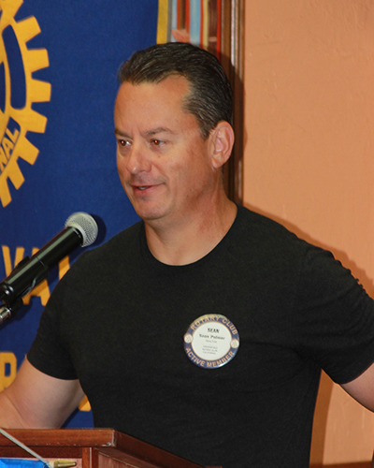

Prospector Time: Brad Squires seemed easy-going as usual when stepping up to the podium, however, his deportment barely disguised his intentions - levy fines on club members right and left, particularly those who nominated him for the gig. Brad’s trivia questions stumped most. Happy fines followed.
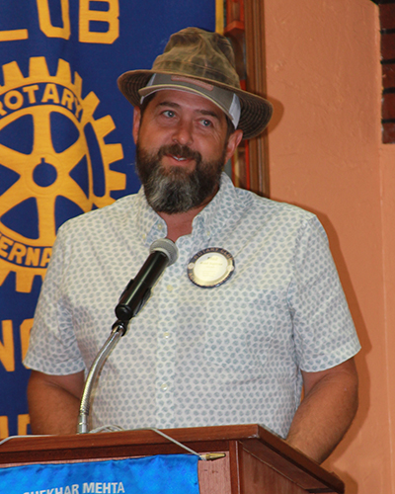 Good job, Mr. Prospector.
Guest Speakers: Mike McKibbin and Steve Blair spoke about the Oak Park Rotary house and our club's involvement building and maintaining it. The Rotary house is a single-family home located just a few blocks from the Shriner Hospital and UC Davis children's hospital. It serves as a home, provided free of charge, for the parents of a child receiving extensive medical care at UC Davis. On average, the house serves as a home for two families a year.
The year Karis Walmer was the president of Orangevale Rotary Club (2005-2006), the idea of building a Rotary House in the district was first discussed. The Orangevale Rotary club along with six other Rotary clubs took on the project.

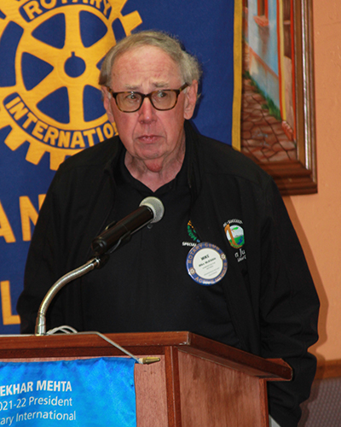

In the Oak Park neighborhood near the hospitals, the city of Sacramento owned an empty house lot. Working with the city, the clubs were able to purchase the corner lot for $1. It took the seven clubs two years of planning and building to complete the house and the cost was about $50,000. Many of the building materials were donated, such as the windows and roofing. Orangevale Rotarians did a lot of the hands-on work. Audrey remembers helping dig ditches; it was her first club activity.

The cute one-story 825-square foot house has a living room, kitchen-dining room, two bedrooms, a full bath and a small laundry. There is a small front porch over which hangs the Rotary Wheel. There is no garage because the lot is too small.

The initial vision was to help the families of Shriners patients, but the hospital administration didn't engage very much with Rotary. Nearby, the administrators at the UC Davis Children's hospital embraced the Rotary resource and have used it continually.

The seven Rotary clubs continue to maintain and support the Rotary House which has a 501c (3) nonprofit designation. Two representatives from each club makes up a board that meets quarterly. The annual budget is $8,200 which pays for the taxes, utilities, and insurance. Each club is assessed $750 a year and donations on the Big Day of Giving add to the budget. There is a reserve fund of $50,000 set aside for future repairs, such as when a new roof when needed.

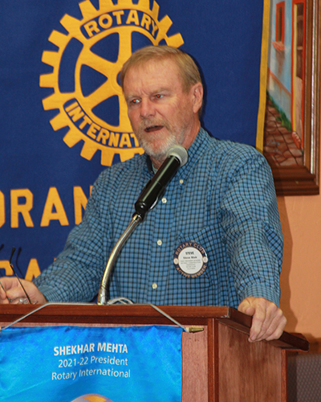

Steve played a video, produced by UC Davis Medical Center, showing and describing the Oak Park Rotary house and the comforting impact it has on families.

https://www.youtube.com/watch?v=ivCxEYOkYVU

Raffle: Suspense mounted as a single ticket would be randomly selected from the orange bowl. The selected ticket number was announced and after a dramatic pause, Joni reported she had that ticket. Optimistically, Joni drew a ball from the basket, and it happened to be a white one. Shucks!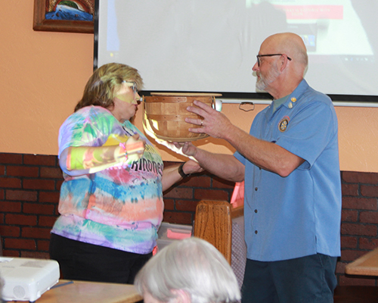

Next Meeting will be May 20th
Guest Speaker will be Nick Anderson of Orangevale Food Bank Farm
Greeters: Deanna & David Shepard
Invocation: Patty

Service Above Self

