Orange Peel
Rotary Club of Orangevale
District 5180
May 20th, 2022, Club Meeting

Members and guests were welcomed by cheerful greeters, Deanna and David. The Sergeant-at-Arms, Jeff, got things rolling with a spirited “Good Morning, Orangevale”. The bell rang and the meeting commenced with Deanna leading the flag salute and Patty delivering an eloquent invocation.
We had four guests: Steve Turner, our Area 4 assistant district governor from the Arden Arcade Rotary Club; our guest speaker, Nick Anderson of Orangevale Farm; Jim Moore, owner of Moore’s Garage; and Mairy’s traveling companion and husband, Richard Droese.
Prez announced scholarship presentations are happening. Bert presented a $1,000 Laird Smith Memorial scholarship at Bella Vista yesterday to Nicole Davidoff. Dennis will be presenting Laird Smith and Career Technical Education (CTE) scholarships at Casa Roble on May 24th. He informed the club that he spoke with David Paige and that David and Waldi are doing fine in Sherman, Texas. David misses our club, would like to someday join a local club, but will be leaving Rotary for now. The next Board meeting is slated for 6 pm on Monday, June 6th at David’s place, this year’s and next year’s board members should plan to be there. Prez handout Rotary note binders Lorie donated for newer members to Deanna and Horacio. In recognition of her good work improving our club’s website, Prez presented Catrina with a District 5180 Super Hero insulated beverage tumbler.
Community Service: Steve Blair provided directions and instructions for volunteers signed up to work on our Big Day of Service project, painting the Youth Center building at Orangevale Community Park on Saturday, May 21st. He also spoke about upcoming work on the Joe Surra track at Pasteur Middle School, scheduled for Saturday, June 4th at 9 am. Refer to the May 6th Clubrunner email message you received from Steve for details on signing up.
Club Service: Don Russell announced our next dine around will be held on June 21st, location TBD. Rotary Day at the Sacramento Rivercats for those who purchased ball game tickets is Sunday, May 22nd, at 1 pm. Kirk Camunez arranged an evening at the Top Golf facility in Roseville for interested club members on Monday, May 23rd.
President-elect: David Shepard mentioned that the upcoming board meeting will be a transitional meeting, bridging this year’s board with our incoming board.
Ann Hively enthusiastically announced that the Flying Samaritans were resuming their humanitarian service flights to Mexico this year. She shared an experience from a previous trip, watching a young girl’s joyful expression after putting on a much-needed pair of glasses. Ann encouraged club members to rummage through their homes for old eyeglasses to donate. You can give them to Ann at club meetings.
Prospector: Jeff Valtman did a stellar job pinch-hitting for May’s selected prospector. Late to meeting? Didn’t attend last dine-round? Pay up! In his easy-going style, Jeff exploited vulnerabilities and brought some needed cash into the club’s coffers. It was also nice having happy people in attendance; their self-imposed fines are also help the club.
Guest Speaker: Nick Anderson of Orangevale Farm
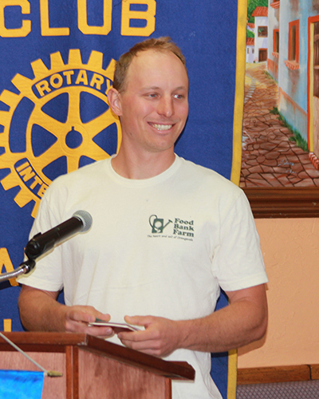
Nick began by mentioning that the one-acre Orangevale Farm is located beside the local food bank and is in its second growing season. It was started by Brad Squires and is funded by the Orangevale-Fair Oaks Community Foundation. Last year 14,000 pounds of produce were grown on the farm.
The nonprofit farm grows fruit and vegetables for the Orangevale-Fair Oaks Food Bank. Volunteers are key to the farm’s success, working two times a week - planting, weeding, and harvesting. This month the harvest has begun, and the volunteers pick, wash and pack the produce that is stored in the food bank’s walk-in coolers.

The farm’s mission growing healthy and delicious food for the food bank. Before the farm was started, the food bank received the leftover vegetables and fruit from the grocery stores. It was not very appetizing. Nick explained that the home-grown vegetables are fresh and tasty and the clients are excited about the healthy choices.

The farm helps to educate children and families about agriculture with field trips and farm camp. Farm visitors are encouraged to try growing their own vegetables. The farm is a hybrid of row crops and permanent raised boxes. The farm grows a little bit of everything, such as lettuce, cucumbers, beans, onions, potatoes and squash.

One third of the funds for running the farm come from Community Supported Agriculture (CSA), which is a subscription program for a box of fresh veggies. Subscribers pick up a box of vegetables once a week or every other week. This is easier than having a fruit and vegetable stand. The same boxes are given to the food bank to hand out.

The weekly donation is $30 for 20 weeks of food with half going to the farm and the rest going to the food bank. Sign up to support the farm with a bi-weekly donation of $30 and receive one full box every other week for 20 weeks. Visit https://foodbank.farm/weekly-veggie-box for more information.

The main challenge for the farm is getting volunteers to keep it going. The work is performed during Tuesday and Saturday sessions and there is a learning curve. Ten to twenty volunteers usually show up. Repeat volunteers take on more responsibilities; they are crucial for making the farm possible. The biggest focus is removing the invasive Bermuda grass!

There wasn't much of a startup cost. The farm has received donations of farm equipment and irrigation gear. The farm is not certified organic but uses organic practices.

Nick learned about farming through working internships on farms for 5 years. He works 20 to 30 hours a week on the Food Bank farm. He plans the schedule of planting, watering, and harvesting. Crops are replanted regularly thru the growing season.

The farm is hooked up to a one-inch diameter city water line. Low flow drip irrigation is run with battery operated timers. The water cost is $70 per month.

Nick fielded questions throughout the presentation and was well received by the members and guests.

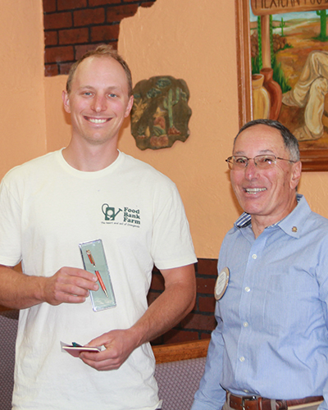

Raffle: Our guest, Jim Moore randomly picked the ticket and its number surprisingly turned out corresponding with one he had. What are the odds? His draw from the basket was not quite as lucky, it was a white ball. Nice try, Jim.

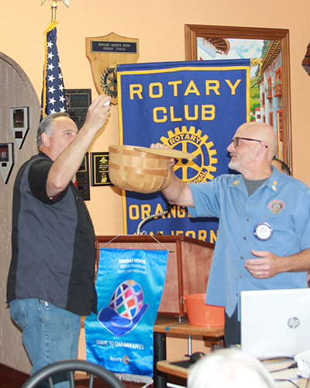

Next Meeting, May 27
Guest Speaker will be Aileen Hidalgo of one of the Orangevale Toastmasters clubs
Greeters: Catrina and Audrey
Invocation: Audrey
Vocational Speaker: Catrina

The meeting ended with Prez subjecting members and guests to yet another quote he dug up. From an unknow author, essential advice for the Gardner:
“Grow peas of mind, lettuce be thankful, squash selfishness, turnip to help thy neighbor, and always make thyme for loved ones.”

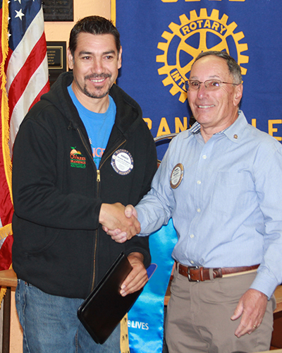

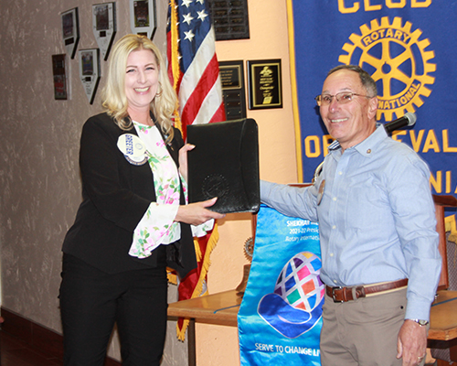
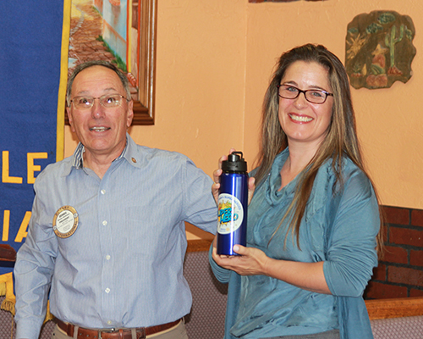

Thank you Mairy Droese for sharing her detailed notes on our guest speaker’s interesting talk.
Many thanks as well to Bob Kurtz for the photos.

SERVICE ABOVE SELF



