

**Orange Peel**

**Rotary Club of Orangevale**

**District 5180**

Club Meeting - August 9, 2024

Members and guests were warmly welcomed by greeters, Jim Buntin and Don Russell. Club President Catrina Womack rang the bell to kick off the meeting. Don Russell led us in the Pledge of Allegiance and Jim delivered the invocation.

We had one guest introduced by Brad Squires: Beth Wonson, our guest speaker.

Prez Catrina made some announcements, mentioning August is Membership Month and to bring guests who would fit with the”Service Above Self” motto of the club. The Farmers Market Thursday was fun and entertaining. Tonight, August 9th is Orangevale Summer Nights at the Grange, where the musical group Red Voo Doo will be performing. Lastly, she mentioned Helping Hands Orangevale’s Salsa Cook-off fundraiser, August 17th at the Grange Hall.

Community Service: Dennis mentioned that we had a great turn out for volunteers at the Food Bank last Friday… we served 90 families with a total of 296 people which included 12 new applicants!

Club Service: Don Russell announced our next dine around will be held on Wednesday, Aug 14th, location to be Crawdad’s on the Lake. He mentioned a charge for parking and recommended an Uber or carpool be arranged. Also, mark your calendar for our next ice cream social, slated for 6 pm, Friday, August 23rd at Audrey’s and Don Wiberg’s place.

International: Bryan Daniel raised awareness that the next Rotary International Convention will be held in Calgary, Canada, June 21 – 25, 2025. Since it is relatively close, he encouraged club members to consider attending, particularly those who have not previously attended an international conference.

Vocational Speaker: Janice Howarth spoke about his interest in cats and the rescue organizations that help with adoptions.

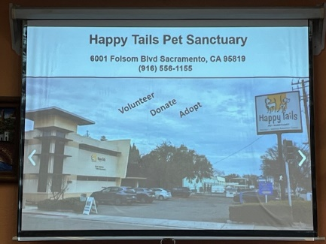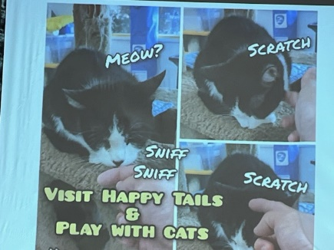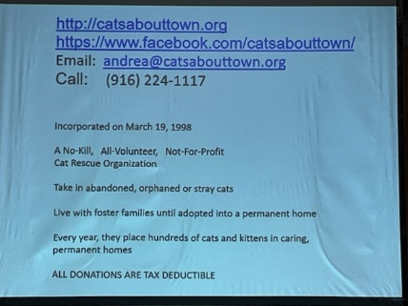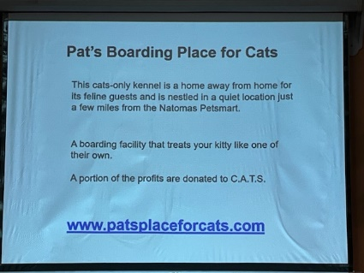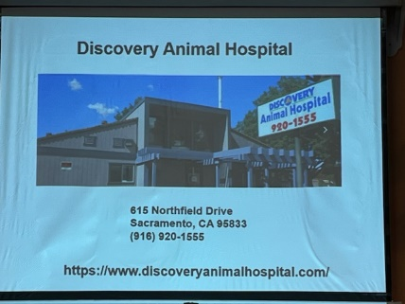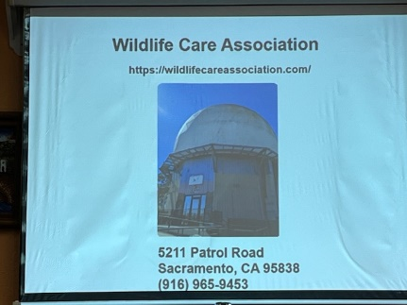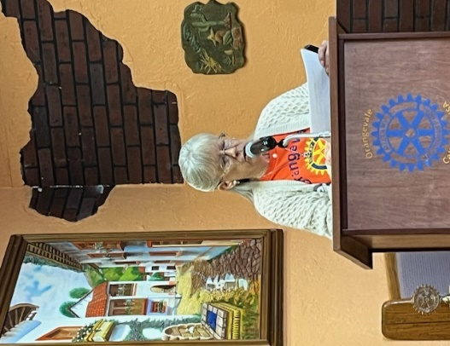

Prospector: Before introducing the prospector, Prez Catrina reminded those in attendance that we do prospecting for fundraising purposes. It helps us defray costs associated with our social activities, which she would like to see us do more frequently.

Janet Cahill as prospector and did an amazing job!

She started by offering to sell her homemade plum jelly to be *fine-free* for the day. She had several takers! Next, she called out those standards like, missing badges and pins, and scooter fines and then fined Don Morris for appointing her to his position to begin with. Then, Janet deftly pivoted to questioning club members about the Olympics, and how many times she cried while watching them stumping several and raking in Federal Reserve notes. Then, of course on to Happy fines! We are looking forward to see what she has in store for us this week!

Guest Speaker: Our featured speaker, Beth Wonson, founder of Navigating Challenging Dialog, Leadership Coach and Communication Expert. She spoke to us about Navigating Resistance to Feedback.

Some of the takeaways were:

* Be responsible for the energy you bring to the room
* The only person you can manage is yourself, have some grace.
* Why do we resist giving feedback
  + People are already sensitive
  + Hiring and retaining staff is difficult
  + Our culture where feedback is not expected, accepted and valued.
  + We are afraid to hurt peoples feelings
* Feedback is an essential tool for communication
  + It fosters growth, development and empowerment

Beth Wonson gave us some valuable information as to why feedback is important and how to handle ourselves in this type of situation.

**Raffle:** With a 1 out of 8 chance of picking the orange ball and winning the $62 prize, it was one of Patty’s tickets randomly picked by our guest, Beth. Suspense mounted as Janet stuck a hand in the basket and picked out . . . a white ball. Better luck next time!

Next Meeting, August 15th:

Greeters: Brian Daniels & Bob Kurtz

Invocation: Phyllis

Vocational Speaker: Janet Cahill

Catrina capped the meeting off with a quote from Mark Twain: “The two most important days in your life are the day you were born and the day you figured out why”.

And from Bert Jacobs – Life is Good T-shirt Company “Life is not easy. Life is not perfect, but life is Good.”

Before ringing the bell to close the meeting, Catrina urged club members “Share Rotary with your favorite people”.

**SERVICE ABOVE SELF**

