MINUTES OF THE LUNCH MEETING
HELD ON 20th APRIL 2015
THE TRANS RESORT

Present: President Barbara, PP. Raphael, PE. Marie-Francoise, IPP. Doris, 2nd VP. Florian, PN. Alex, AG. Patrick and Rtns. Tim, Sally, Dr. Juergen, Oliver, Manfred, Jeni, Christian, Steffen, Jorg, Helmut, Yuki, Lusi, Tineke, Detlev and Udo.

Rotary Visitors: -
Guests: Ketut Ariani, Margarita, Sebastian and Guest Speaker Lauren Bruggemans.

President Barbara opened the meeting at 12.30pm and -
- Greeted all fellow Rotarians and Guests in the diverse languages of club membership - Good afternoon, G’day, Selamat Siang, Gudemiddag, Bon Apres midi, Buon Pomeriggio, Guten Tag, Konichiwa, Dobar dan, Fuen-ying.
- Welcomed Rtn. Sally, Rtn. Steffen and Rtn. Manfred back after their long absences.
- Asked all present to turn and say a BIG ROTARY HELLO to their neighbours, as there are no strangers in our meetings, only Rotarian friends we are yet to meet.
- Gave apologies for: PP. Anita, PAG. Marilyn, 1st VP. Dr. Leith and Rtns. Peter E, Pamela, Georgio, David, Alex P. and Maree.
- Informed members that PP. Anita was writing a book upon the Women of Bali.
- Asked Rtn. Manfred to read the ‘4-Way Test’.
- Asked SaA Yuki (who was kindly standing in for 1st VP. Dr Leith) to introduce Visiting Rotarians and Guests.
- Announced that a schedule for payment of club dues will be sent out to all members soon (the club dues have not been increased from last year).
- Announced that the Raffle prize this week was a ‘book safe’ kindly donated by PP. Anita. She also reminded everyone that Raffle tickets were still for sale.
- Announced that club Rotary t-shirts were available at IDR. 75,000 each in 4 sizes.
- Congratulated Rtns. Deltev and Lusi for raising IDR 1,000,000 for the Smile Foundation at their last Sunday brunch.
- Introduced Rtn. Steffen (who normally lives in Germany). Rtn. Steffen reminded members that he had raised Euro 50,000 in 2014 for the Smile Foundation, but had not been able to raise funds last year. This year he had been asked by Hon. Rtn. Mary Northmore of the Smile Foundation to raise more money for her foundation, as it was short of funds, and he was pleased to report that he had secured US$80,000 from a big children’s foundation in Germany. The funds will be paid directly into the Smile Foundation account.

- Reported upon some of the Rotary legislation that has been passed in The Council on Legislation meeting in Chicago.
- There has been a US$4.00 dues increase.
- The Council have now removed the distinction between traditional Rotary clubs and E-clubs. There are currently 275 clubs labelled E-clubs with 5900 members. Those clubs are now just considered clubs that meet more frequently online than other clubs. (Rotary has come a long way since the 2010 Council decision which allowed clubs to meet principally online.)
- The Council decided not to increase the Rotaract Age limit to 35 years old and so the age remains at 30 years of age.
- Continuing yesterday's theme of flexibility, the Council agreed on Tuesday to simplify the qualifications for membership in a Rotary club. The measure removes six membership criteria from the RI Constitution, replacing them with the simple requirement that a member be a person of good character, who has a good reputation in their business or community, and is willing to serve the community. Proponents argued that the change will give power back to clubs to "choose their own members without a checklist" and encourage membership growth.
- The Council deferred until Thursday proposals to create a new membership type, ‘Associate Membership’, and to allow Rotaractors to join a Rotary club.
- The Council approved on Monday two key measures that would give clubs greater flexibility in their meetings and membership. Both were backed by the RI Board of Directors and passed overwhelmingly after a lively debate. The first measure gives clubs greater leeway upon when and how often they meet, how often they cancel meetings and what constitutes a meeting, as long as they meet at least twice a month. The second measure grants all clubs flexibility to experiment with membership models. Proponents argued that clubs need enhanced freedom in order to determine what works best in their communities, noting that "one size does not fit all."
- The Council overwhelmingly approved allowing members of Rotaract to simultaneously be a member of a Rotary club. Proponents argued that this will pave the way for more Rotaractors with proven leadership skills to make the transition into Rotary. Some Rotaractors have been reluctant to leave their Rotaract club before they reach the age of 30 years, the maximum age, because they don't want to sever ties with friends. Similarly, some former Rotaractors have found it difficult to get a Rotary club to invite them as a member. Only around 5 percent currently make the transition. Proponents say this will move that number closer to 50 percent.
- Starting a new club - the council approved adding to the bylaws a provision that new clubs need 20 members for a charter. Proponents said that number was needed for a healthy club to get up and running. The Board had a policy for the minimum needed, but the bylaws had previously been silent on the subject.
- Reported for PP Anita (who was absent) upon our club’s Goat Pilot Project – PP. Anita had recently visited the main office of Friends of the National Parks Foundation in Pejeng to meet with Dr. Bayu and Damai. There have been set backs in the project due to unknown causes of illness with the goats. The dead goats have been replaced by Dr. Bayu at his own expense and he does not wish to receive any more funds from RCBS until the goat population has climbed back to the total number at the beginning of our club’s goat program (34 goats). The goats are now distributed in Nusa Penida and 4 goats are being closely monitored at the main office of FNPF in Pejeng. Dr. Bayu is working on the causes of the goat diarrhoea cases and he has also instructed goat farmers upon how to keep the goats in their shelters safely away from being attacked by wild dogs, which had caused the death of 7 goats. He is still certain that in time the setbacks by goat illness will be rectified and that the project breeding program will be successful.
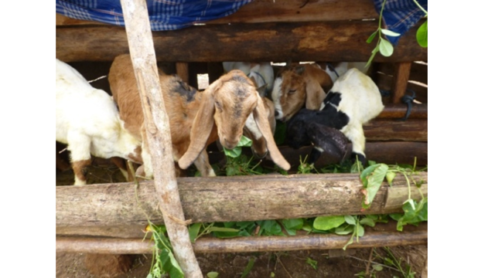

- Reported on the Low Cost Housing Project: Since there has been little response from Rena (Yayasan Putri Bali) and the donor, Don Havig, she suggested that this project is ready to be closed as it needs our club to establish funds to cover the next 5 years. This will be discussed at the next Board meeting.
- Introduced Ketut Ariani and Sebastian of the Akasa Yayasan (Foundation).
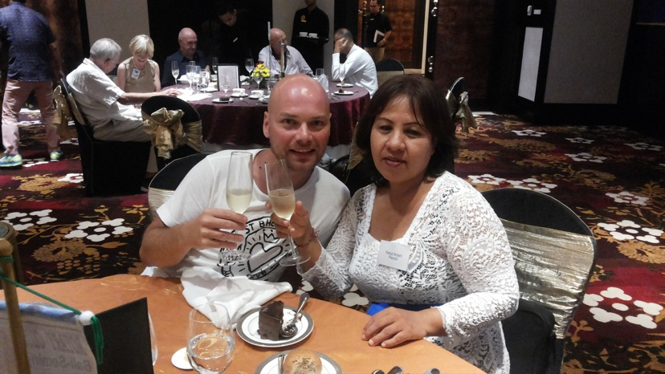

The Foundation, which has about 50 children who are between 1st and 6th grade school age, has a school that works in cooperation with local schools, the Mapindo Tourist College (where hotel staff are educated), and the Tabanan University (for training teachers).
The Foundation basically gives poor children a second chance to undergo further education for free. English is one of the main subjects taught at the Foundation’s school as most of the poor children have no English skills. They also do a once-a-month Yoga class to give them some recreational type activity.
Unfortunately, the Foundation lost its benefactor last year when she died and therefore the school is short of funds. The school urgently needs some fans, as the classes are very hot, and some second hand computers and furniture for building an IT class, as the children have no IT knowledge. It would also like to build some sort of playground for the children’s recreation.
Sebastian also mentioned his concern for the children’s unhealthy diets as they eat a lot of fast foods. He would like to set up a small kitchen area in the school to provide the children with nutritious meals and to teach them about healthy eating.

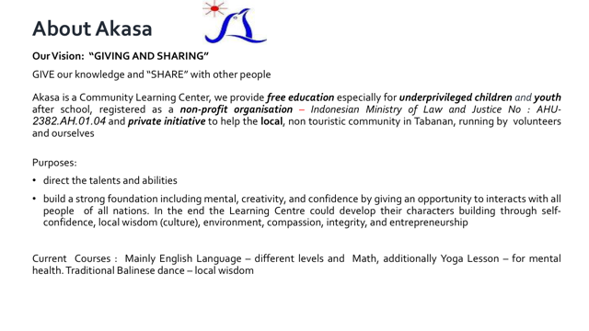

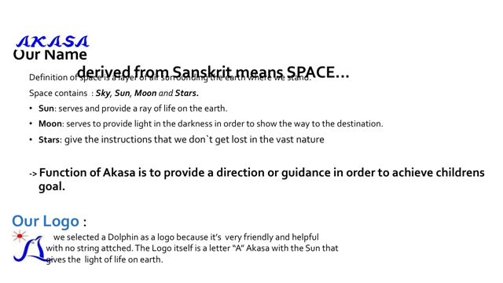

The school curriculum

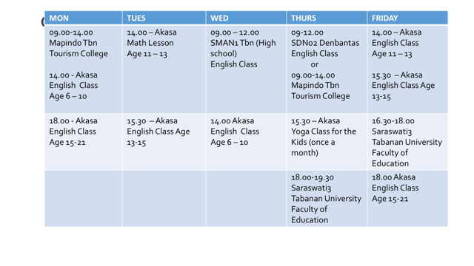
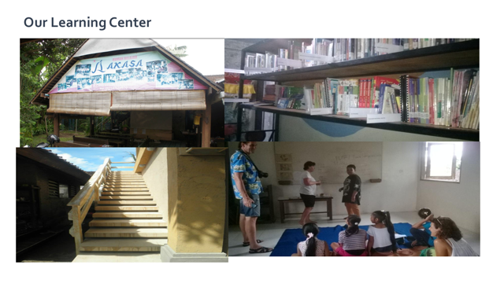
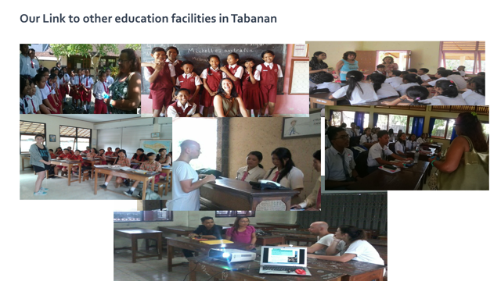

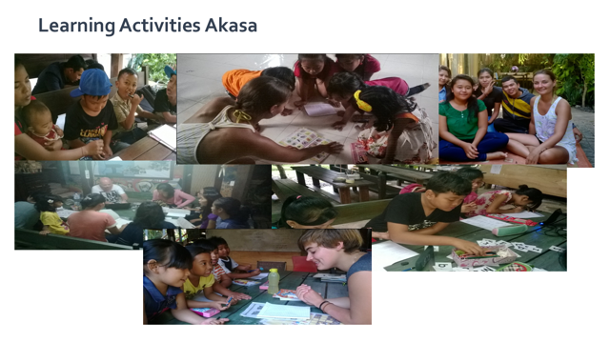

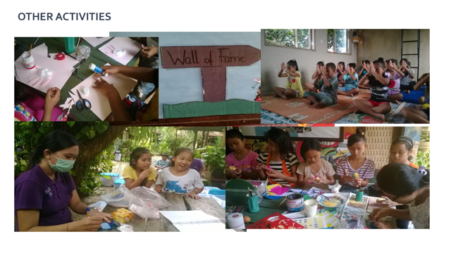
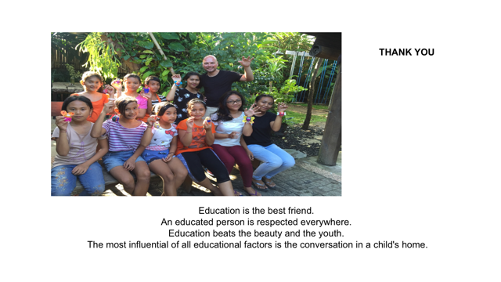

- Introduced PP. Raphael, who apologised for the planned speaker, Giles Raymond’s, absence as he was called to a very important meeting at the very last minute and could not fly to Bali. It was hoped that Giles would visit our Club on his way Back from Canada.

Giles is our contact for Global Grant #152739 - The Otonomi Water Project in Flores.
Our club is the host club for this GG with the RC of Sainte-Foy in Quebec. The project has a value of of US$53,000 and will give water to 10 villages in the Kabupaten of Nagda.

The mission is to provide clean water to as many villages as possible on the Island of Flores Indonesia.

- Asked PN. Alex to introduce his Guest Speaker Lauren Bruggemans, who had very kindly agreed to stand in at short notice.

Lauren has been 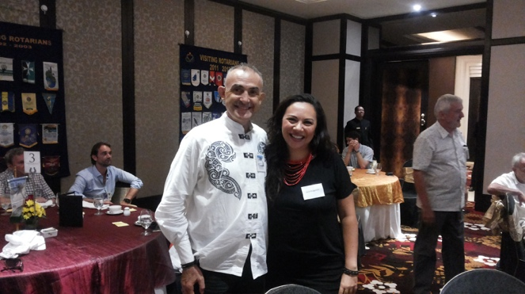working in the hospitality industry for more than 12 years and has trained in many areas of the hotel business in various positions such as Housekeeping Supervisor, Front Desk Manager, Restaurant Manager, and Catering & Conference Services Manager. Her last position as a Food and Beverage Manager included oversight of two departments with more than 50 employees under her leadership. Furthermore, she attended Glion Hotel School in Switzerland and completed a Management Training internship as part of this program. Lauren has lived in Indonesia for 10 years and has a unique appreciation and understanding of Indonesian culture. She has a moderate understanding of Bahasa Indonesia and is currently taking an intensive language course to hone her skills. Finally, Lauren’s Bachelor’s Degree in International Politics prepares her for the complexity of working in an international setting.

Lauren spoke about the Sumba Hospitality Foundation, a non-profit organization, that is building a hospitality school and permaculture farm on the island of Sumba, in Eastern Indonesia.

Sumba is one of the most underdeveloped islands in Indonesia and yet at the same time is beautiful, unspoiled and has a very strong and interesting animist culture. It is only 50 minutes flying time from Bali and close to Komodo island. It is twice the size of Bali, but only has 800,000 inhabitants.

The school’s founder was struck by the island’s natural beauty, its unique culture and the abject poverty she saw, so she bought some land and decided to build the school.
Through hospitality, farming education and career counseling, this school hopes to break the pervasive circle of poverty on the island and to offer the students an opportunity to provide for themselves and ultimately their communities.

Sumba is poised for a surge in tourism development, and with this development will come an influx of job opportunities. Whilst this is an exciting proposition, many Sumbanese youth are underprivileged and do not have access to the relevant education and training that is required to occupy these positions.

The school’s one-year program in hospitality education will start by placing students in one of four tracks – culinary, food and beverage service, housekeeping or front office. The campus will also include 5 guest cottages and a restaurant & bar for the students to practically apply their knowledge. To round out their hospitality education, the school will also teach courses in life skills, critical thinking and entrepreneurship with the aim of producing career-minded individuals who possess the optimal balance of skills, knowledge and attitude.

Furthermore, the School would like to address the problems of poverty and malnutrition on Sumba by setting an example of responsible sustainable farming by introducing permaculture techniques to the island. Organic produce from the land will be served in the restaurant, and the students will be taught current farming methods with guidelines to better cultivate their land. The campus is built entirely in bamboo and other sustainable materials, and it is hoped that it will be a model of conservation and green energy on the island.

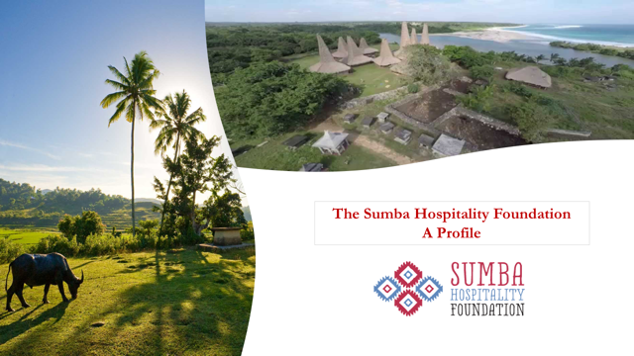

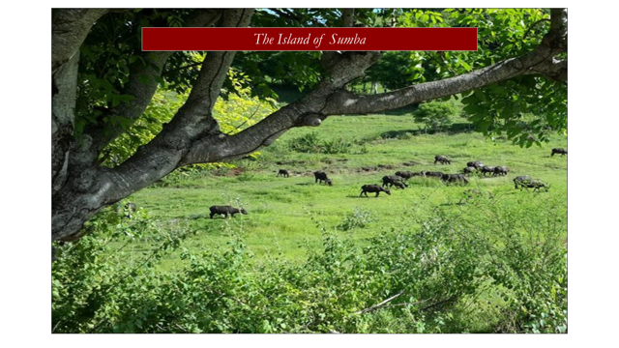

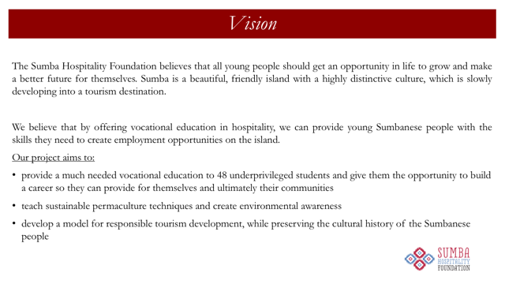
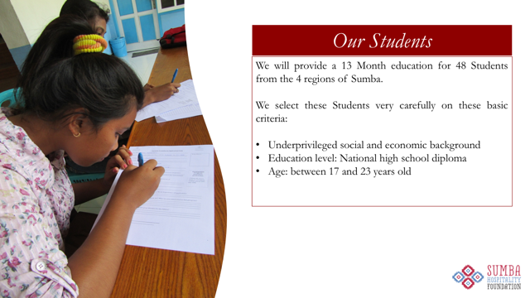

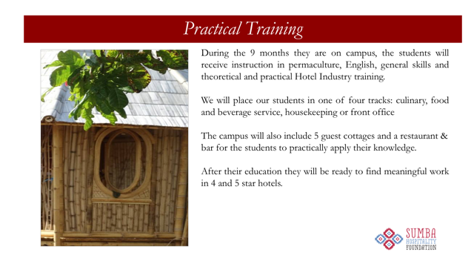
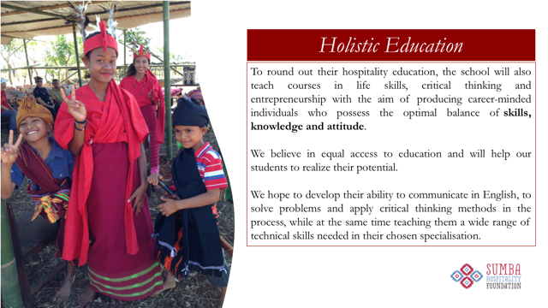

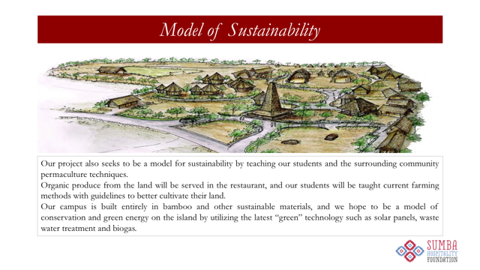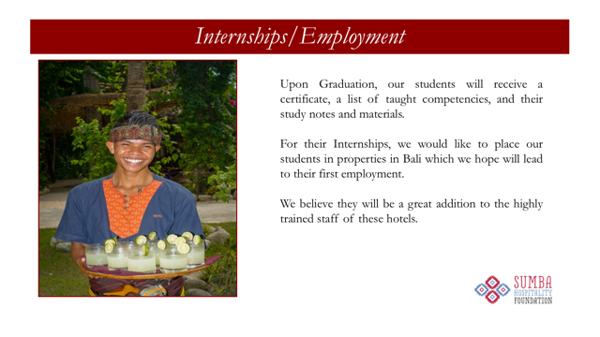

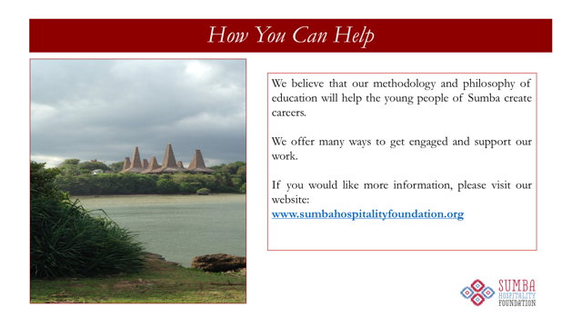

President Barbara thanked Lauren her most interesting talk and for kindly coming to our club to speak at the very last minute. She then presented Lauren with a club t-shirt as a token of our club’s appreciation.

- The raffle was won by Rtn. Lusi.

- Total Raffle income was IDR900,000. Happy/Sad stories and fines totalled IDR 280,000.

- President Barbara then closed the Lunch Meeting a few minutes early due to a ‘SPECIAL SURPRISE”. She thanked Rtn. Tim for organising the Lunch Registration, Rtn. Oliver for operating the computer, Sec. John for doing the Lunch Minutes and Rtn. Yuki for acting as SaA.

- The meeting then enjoyed a surprise birthday cake to celebrate PP. Raphael’s 70th birthday this month.
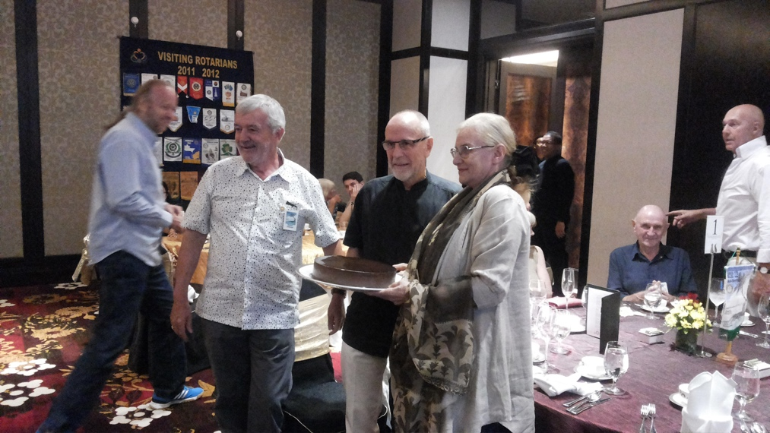
PP. John.T.Glass,
Club Secretary,
2015-16.

