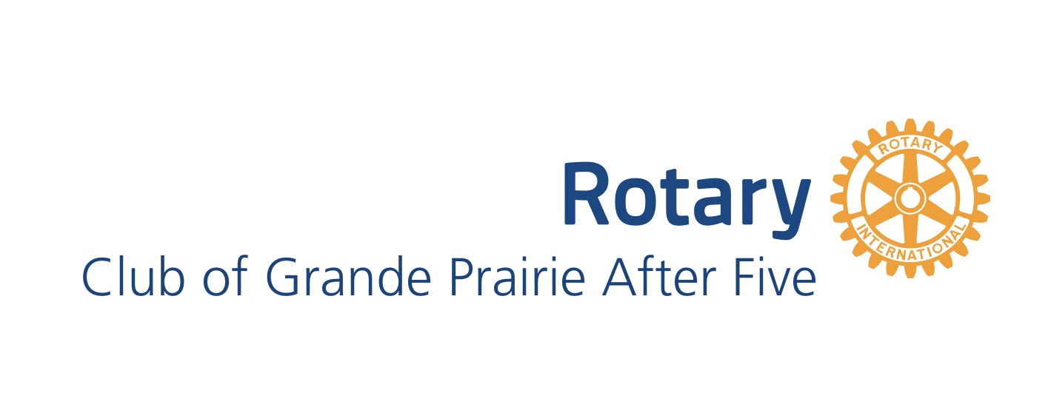
Allocation/Small Donations – General Guidelines
All applications will be considered. These are general guidelines only.
- Generally, the allocations committee does not support funds for an individual.
- Generally, the allocations committee does not fund core operational costs for groups.
- No funding of other service clubs or groups.
- No funding of anything that goes against the principles that guide Rotary.
- No funding of political parties or events.
- All requests must be submitted in writing.
- We support projects and organizations directly. As a club we typically don’t sponsor or buy tickets to fundraising events. To extend an invitation to Rotary members for an event, contact the President and they will outline how/if that will be possible.
- We would appreciate thank you letters, pictures, marketing/media material – and if appropriate, a quick overview of the project at a regularly scheduled Rotary meeting, possibly with a cheque presentation.

