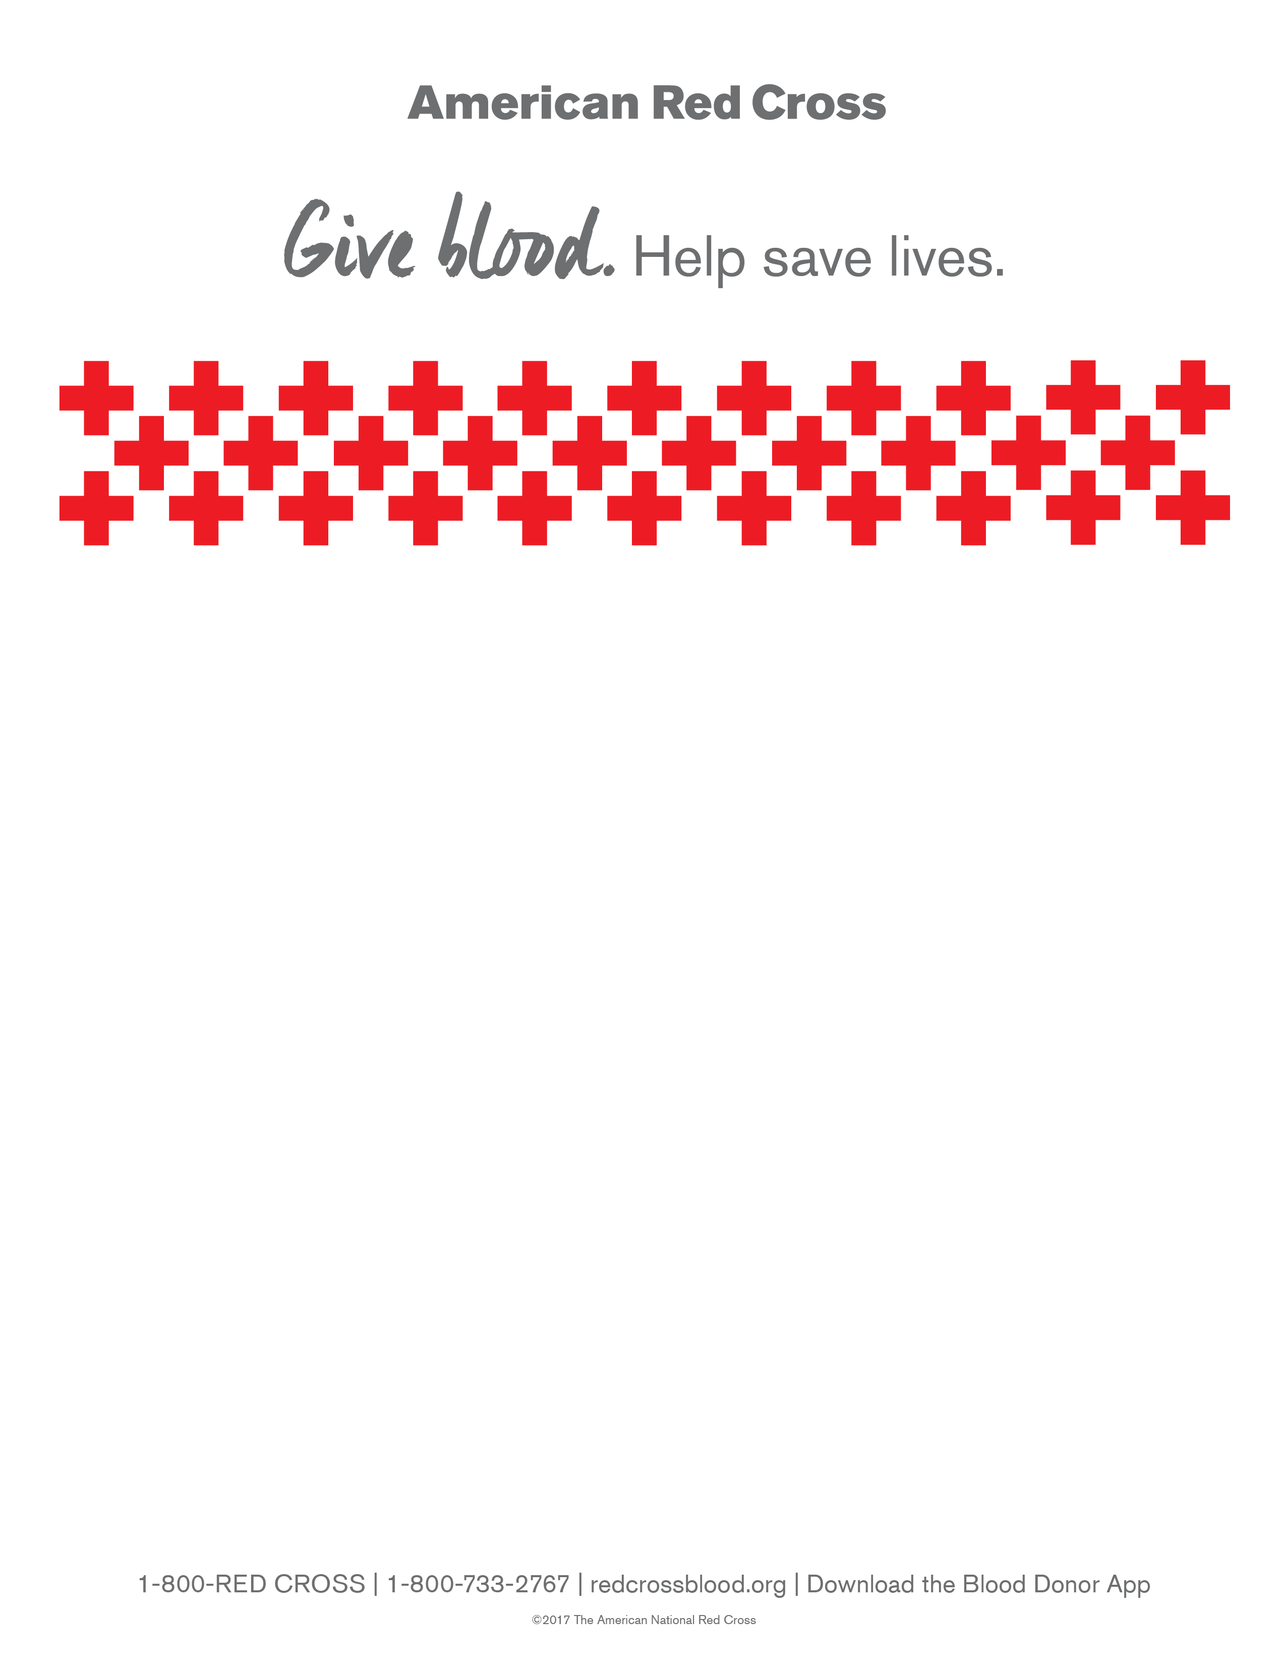
Rotary of Edgewater
Blood Drive
Edgewater Mall

Friday, November 6th, 2020
12PM to 6PM

Located outside of Belk
Please come help us save as many lives as possible!
For an appointment go online to
www.redcrossblood.org
(enter sponsor code: ROTARY)
OR Download Red Cross Donor App

Please bring your Driver’s License OR American Red Cross Donor ID Card

