Please list your attendees’ names:
- _________________________
- _________________________
- _________________________
- _________________________
- _________________________
- _________________________
- _________________________
- _________________________
- _________________________
- _________________________

13th Annual
DeGroot-Akins Scholarship

Dinner

The Rotary Club of Rio Rancho Sunrise awards scholarships to Nursing Students who intend to return to Rio Rancho after they complete their studies. Through the gracious support of local businesses, individuals, medical groups, and higher learning organizations nearly $145,000 in scholarships have been awarded so far. The goal for this year is to award $30,000.

Candidates submit applications and meet specific criteria. Qualifying applications are reviewed and those selected are interviewed by a panel of club members, medical professionals and previous award winners. The panel then recommends scholarship amounts based on the results.

Please join us in recognizing these fine students at our Gala Dinner!

Gala Events
April 30, 2022
6 p.m. – Gala Socializing
Silent Auction Bidding Begins
7 p.m. – Dinner, Program, Scholarship Presentation & Auction Results

Raising funds for Nursing Students from Rio Rancho
April 30, 2022

Santa Ana Star
Casino Hotel

Silent Auction Bidding,
Cash Bar and Socializing
begin at 6 pm

Dinner and Program
begin at 7 pm

Rio Rancho Sunrise Rotary
RioRanchoRotarySunrise.Org

ATT TAMAYA RESORT & SPA
HYATT TAMAYA RESORT & SPA

Gala

Rotary Club of Rio Rancho Sunrise
PO Box 44606
Rio Rancho NM 87174
www.rioranchorotarysunrise.org

Recent Banquet Photos

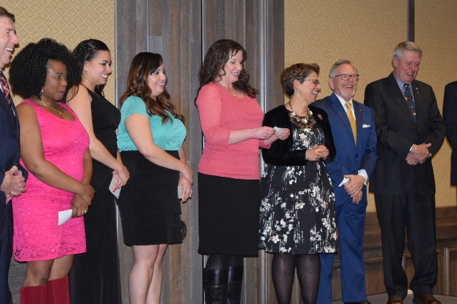

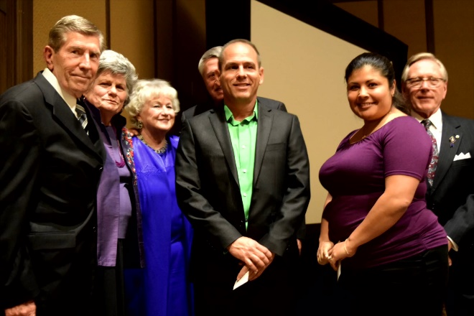

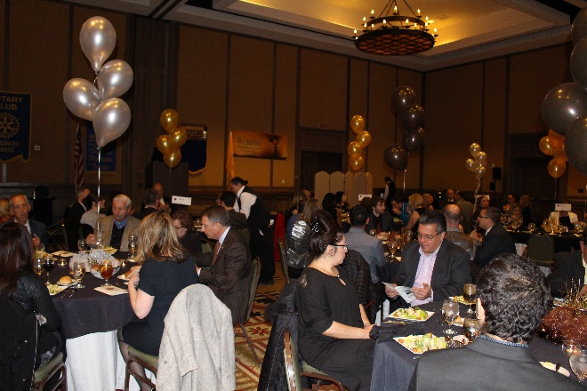

Sponsorship Opportunities & Ticket Information
PLATINUM LEVEL $5,000 ___
Sponsorship includes a table for eight with sponsor designation and premier table placement; full page logo recognition in printed program; visual/verbal recognition during the gala; all marketing materials recognize you as a major sponsor; your logo and sponsorship level displayed throughout the year on club’s website.

GOLD LEVEL $2500 ___
Sponsorship includes a table for eight with sponsor designation and premier table placement, half page logo recognition in printed program and verbal recognition during the gala.

SILVER LEVEL $1500 ___
Sponsorship includes seating for six with sponsor designation and preferred table placement, quarter page logo recognition in printed program and verbal recognition during the gala.

BRONZE LEVEL $750 ___
Four individual tickets with special table placement, company/ name recognition in printed program/ verbal recognition during gala.

TURQUOISE $500___
Two tickets. Business card in program.

BUSINESS CARD AD $150 ___
Your business card in program.

INDIVIDUAL TICKETS $100 EACH ___

Please list on back attendees’ names.

Payment Information

Printed Name: _________________________________
Title: _________________________________________
Company Name: ________________________________
Mailing Address: ________________________________
City / State: ____________________________________
Zip: ___________ Phone: _________________________
Email: ________________________________________
Please use this form for invoicing purposes, no other invoice will be sent. Please return the original copy with your check payable to Rotary Club of Rio Rancho Sunrise or provide credit card information and signature below. Make and keep a copy for your files. Mail check and form to Rotary Club of RR Sunrise, PO Box 44606, Rio Rancho, NM 87174. Sponsorships will be confirmed upon receipt of payment and signed agreement. Sponsorships and logos must be submitted not later than January 18, 2019 in order to guarantee insertion of printed information in program materials. Names of attendees at your table must be listed on the reverse side of this brochure to facilitate table assignments, check-in process and bidder number.

Please charge credit card:

___MC ___ Visa ___ AmEx

Billing Zip Code: ________________

Account number: ____________________________________

Card expiration date: ___________ CVV code: ____________

Signature: __________________________________________

Date: ________________
.
For Credit Card Payments, form can also be faxed to 505 892-4320

For additional information, please contact Richard Bruce at (505) 803-8750, via email at rrrsunrise@gmail.com or visit the club website at www.rioranchorotarysunrise.org.

