Harmony Project Nepal Update
Helen Lilley

Recently, the RC of Box Hill Central organised an update via Zoom on the Harmony Project in Nepal. James Montgomery of TEAR was the presenter and four of our Club members and a Rotarian from the UK joined the meeting. For the benefit of new members, a summary of the project is below. The RC Woden Daybreak partnered with the RC of Box Hill Central (Victoria) in a successful application for a District Grant for this project.
March, TEAR Australia provided an update to let us know that the government in Nepal had cancelled the International Women's Day (IWD) gathering that had been planned for this project, in response to the risk of COVID 19 spreading in Nepal. A focus of the project is a gathering to celebrate International Women’s Day, organised by two local women’s group, with input from an adolescent girls group. It was expected that people from surrounding villages would attend with dancing and a speech making competition focusing on trafficking and child marriage.
In addition, the Community Development Management training has been postponed until further notice of permission from the Nepal government.

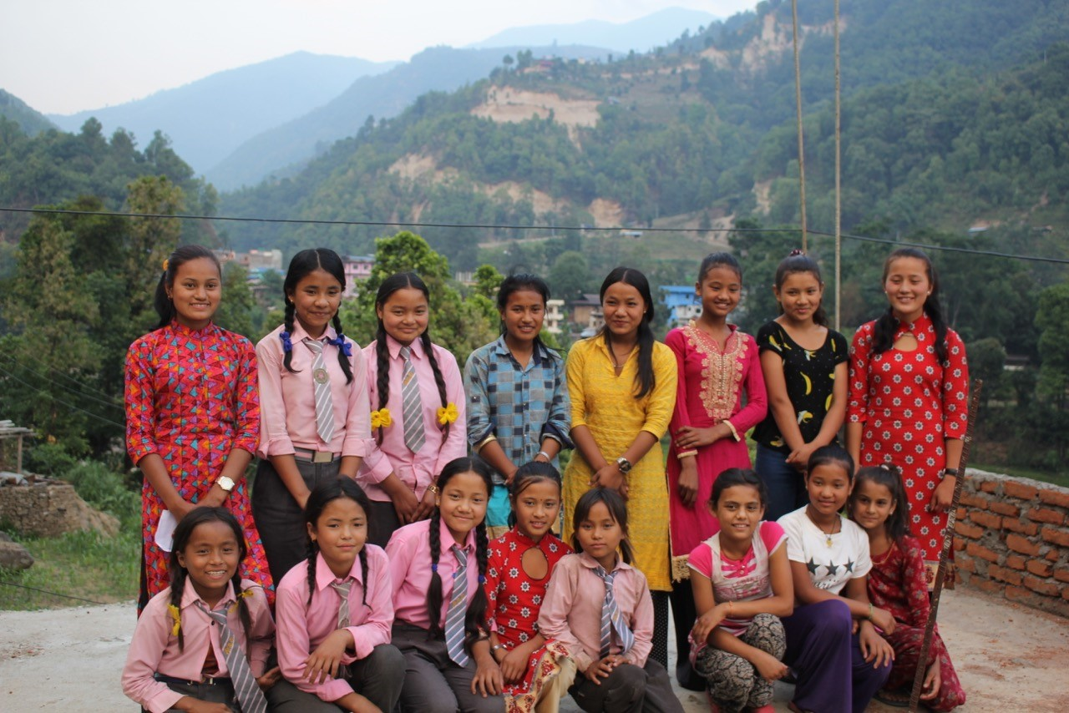

Girls’ Choir

According to TEAR, from an anti-trafficking awareness perspective and our grant application, there isn’t a cause for concern, as much of the funding was directed toward the monthly visits to 40 groups of 18-30-year-old adolescent girls in advance of the IWD meetings. These visits were to teach the groups of girls about trafficking awareness and facilitate their preparation for a choir presentation and the speech contest on the topic at the IWD event. The big event hasn’t happened, but the lead up smaller events have substantially helped to raise anti-trafficking awareness.

At present there are COVID-19 cases in all provinces in Nepal, province borders are closed and public gatherings banned. Project workers are keeping in touch with those taking part in the Harmony project through WhatsApp, as numerous families have smart phones. Thanks to cheap production in India a smart phone can be bought for $6!

James answered a number of questions about the Harmony project. Members were keen to know how the project links to broader government policy. The project works at a municipal level and needs municipal approval to progress. Women’s groups work with government agencies, particularly when they suspect a girl has been trafficked. James gave an example of two girls who had been returned to their villages after collaboration with the women’s groups and the Government Trafficking Office, with one father prosecuted for trafficking his daughter.
The Harmony project was due to wind up in the current community in July 2020. Care and Share Nepal usually works in a community for a set time, with Harmony due to run for 3 years finishing July 2020 then moving to another area. As the activities planned over the last three months were cancelled, the time for this project has been extended and they hope to hold 2021 IWD celebrations. Community consultation work for neighbouring communities will commence once border restrictions are lifted.

The Zoom meeting was recorded and you can access it at:
https://m.youtube.com/watch?v=pZgR1VtAL-E&feature=youtu.be&d=n

