Homeopaths Without Borders

http://www.hwbna.org

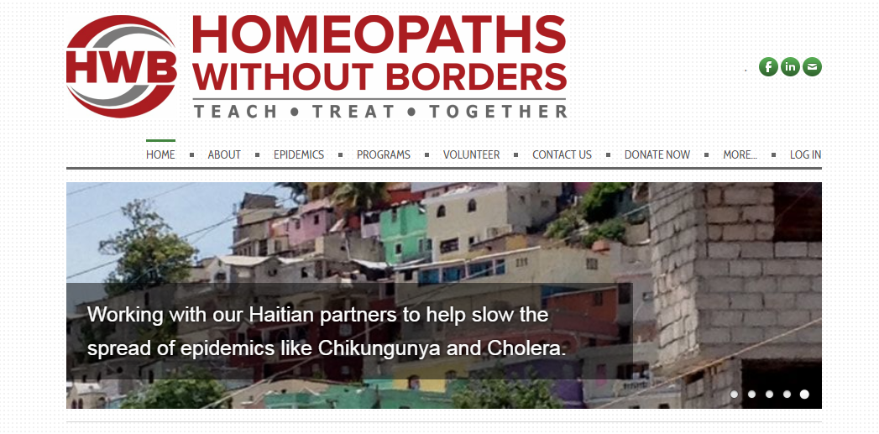

Homeopaths Without Borders

http://www.hwbna.org
Click this link for more information and to access the website.

