

**Once in a lifetime you meet an extraordinary human being and yesterday, March 11 2017 we lost one of the best.**

**Past District Governor Bart Richardson OAM, Paul Harris Fellow passed away peacefully at Harbourside Haven, aged 97.**

**“Young Bart” as he was affectionately known in his later years was loved by all those he came into contact with (and there are many) has left an indelible mark on us all.**

**His life story is known to many of us, not only was he a Rotarian of 53 years with a PHF and 4 sapphire pins, he also served with Legacy for a staggering 63 years, was a member of the Masonic Lodge, an author at 94, and committed community volunteer right up till a few weeks ago, still helping others.**

**In the coming days and weeks, Bart’s loss, not only to his family, Rotary but the wider community will be deeply felt. Rest Easy Bart**

**FAREWELL BART**

This is one edition of the Bulletin I was hoping not to write, however with a heavy heart I have put this Special edition together. While mourning Bart’s passing, I recall a conversation I had earlier in the week, with a fellow Rotarian, after a visit with Bart…

**We need to celebrate his life, his achievements and join with others who have been blessed to have known him and I am sure this will be the case**.

At 97 he had a wonderful innings, impacting on so many people’s lives, showing us all ,the power of reconciliation with his war time captors at the age of 93. Until a few weeks ago he was still volunteering as a Rotary reader to children 90 years younger than him. He was also a currently Licence holder, and regularly picked up other Residents from Harbourside for a monthly afternoon outing. There is more, much much more to this wonderful, caring man, who is now with his beloved June catching up on “the good old days”.

In this special edition, I would like to thank our Club Historian Richard Turner and photographer Henk Tobbefor his contribution. It is planned a more comprehensive overview of Bart’s Rotary service and his life will be published in full in the near future, in conjunction with Richard, Henk Tobbe and others who will no doubt wish to contribute to Bart’s life.

**Chris Bartlett- This week’s Editor.**

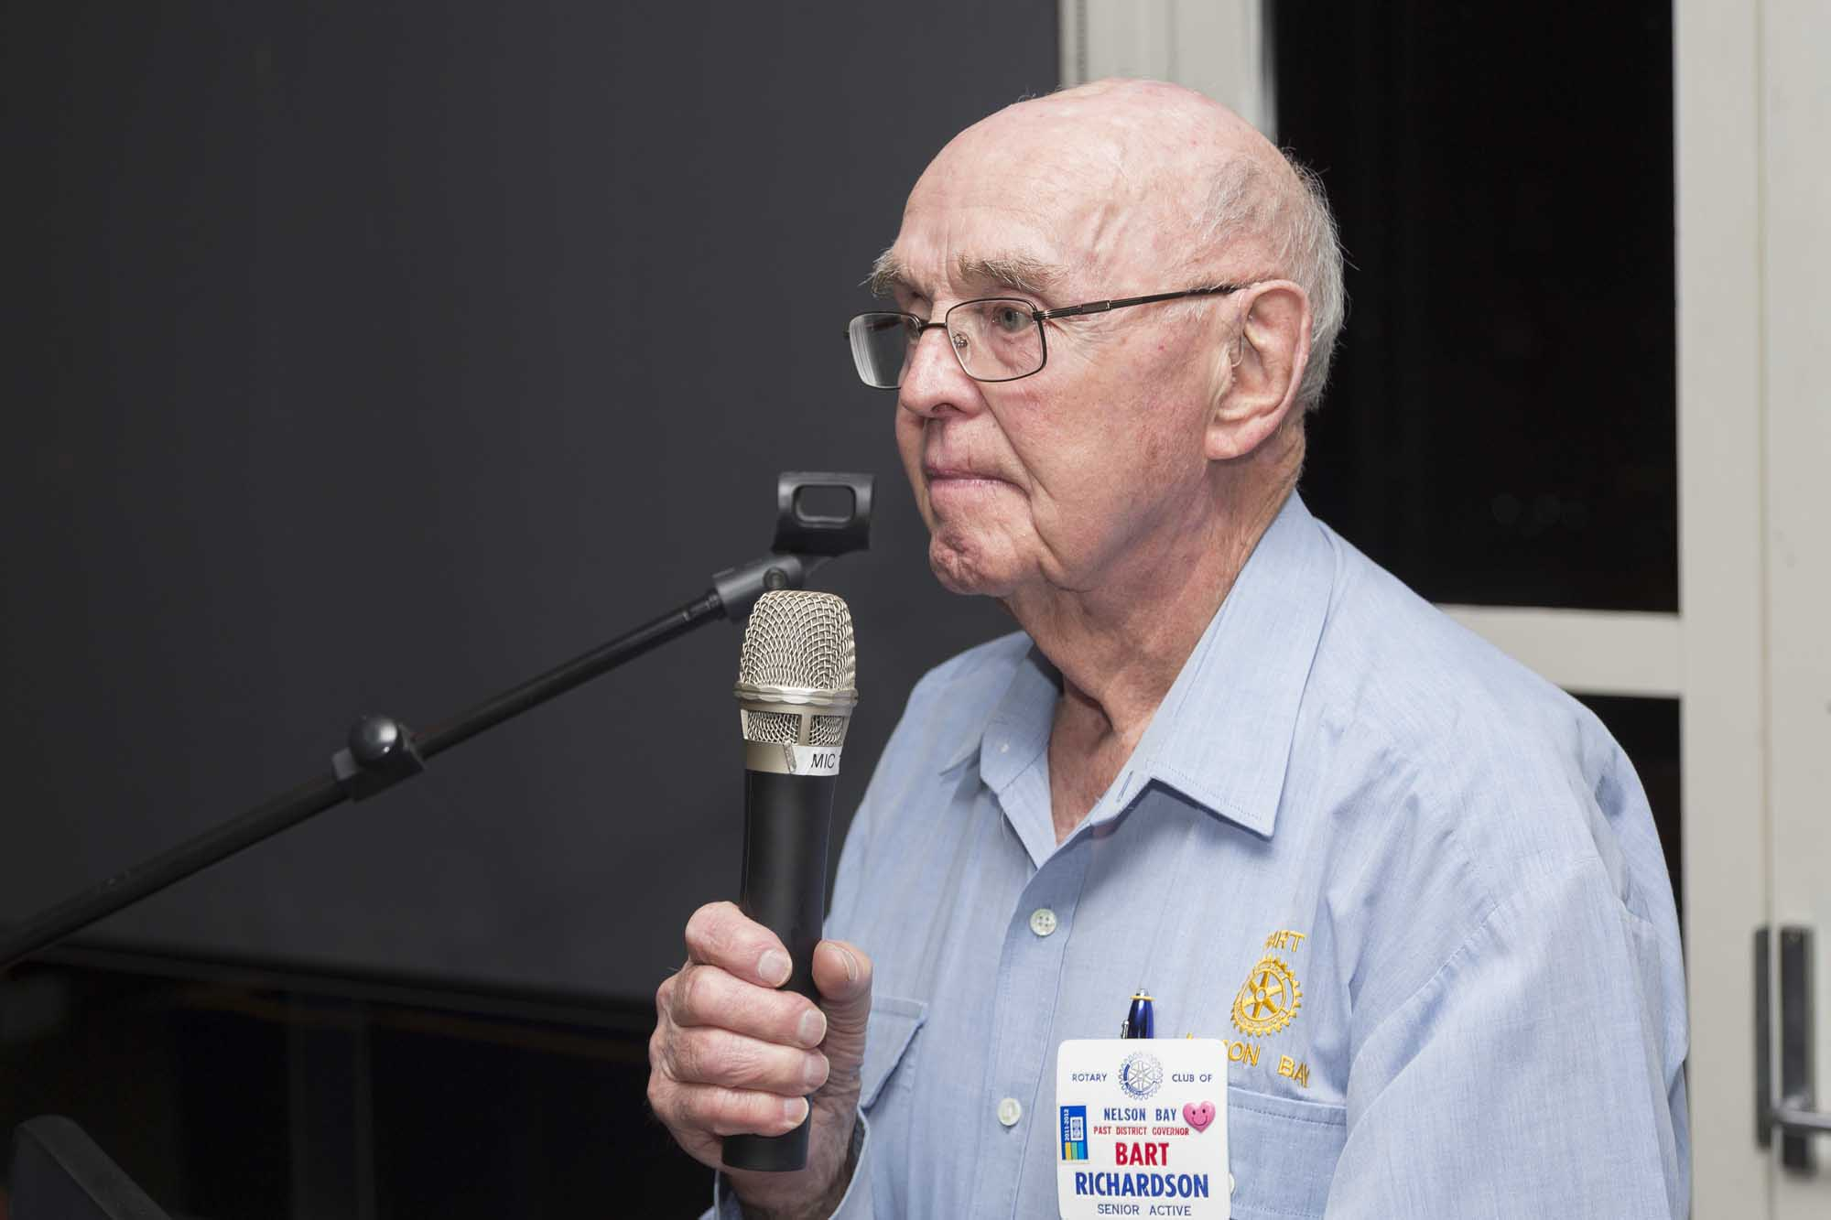

## Bulletin No 33A SPECIAL EDITION- March 12 2017

**BART’S LEGACY**

One of Bart’s ongoing commitments to Nelson Bay Rotary Club was his annual presentation of a year book to the President of the club at our Changeover functions, which helped us kept a very accurate history of activities during any given year. Club Historian Richard Turner was able to give Bart No 1 copy of 3 score years last week, something that he appreciated.

**VALE BART RICHARDSON**

It is with great regret that I advise that Past District Governor Barton Dalyell Richardson have OAM, universally known in the District as Bart Richardson, of the Rotary Club of Nelson Bay, died on 11th March, 2017, after a short illness.

Bart was a long-term member of Rotary and was the District Governor of the then District 967 in 1986-87.

At this time no funeral arrangements are known, but it is expected that those details will be published in the Newcastle Herald in the next few days.

Stephen Jackson  
District Governor  
Rotary International District 9670 Inc.

**BART’S 50TH SURPRISE PARTY**

In 2014 I had the honour of assisting in the organisation of a “surprise” 50 Years in Rotary Birthday Celebration for Bart at the Nelson Bay Bowling Club. He told me afterwards it was one of the few times he had ever been surprised in Rotary. Those who attended along with 120 others will long remember this evening. Not only were his many Rotary friends present, his friends from all of the organisations that he freely gave his time to attended to witness Bart acknowledged for his lifelong community service. Also present on this evening was the Japanese Consul who added a special touch to the evening, highlighting Bart’s reconciliation with Japan.

I am very proud to have known Bart and indeed honoured he referred to me as a friend.- Richard Turner

This quote sums up how many of us thought about Bart……

Bart with Past President Ann Evans presenting Bart with his 3rd Sapphire PHF Pin on the occasion of our 60th Birthday celebrations in June 2016. Bart was a great supporter of the Rotary Foundation, and other Rotary projects, always doing so quietly. Another of his great attributes

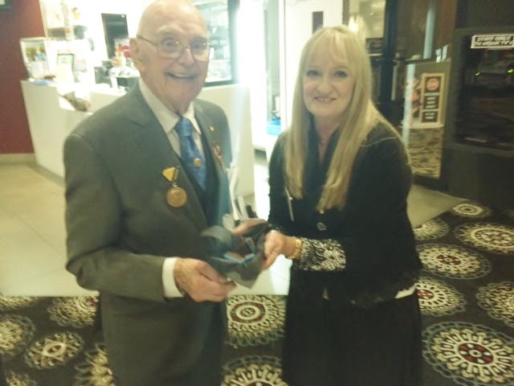

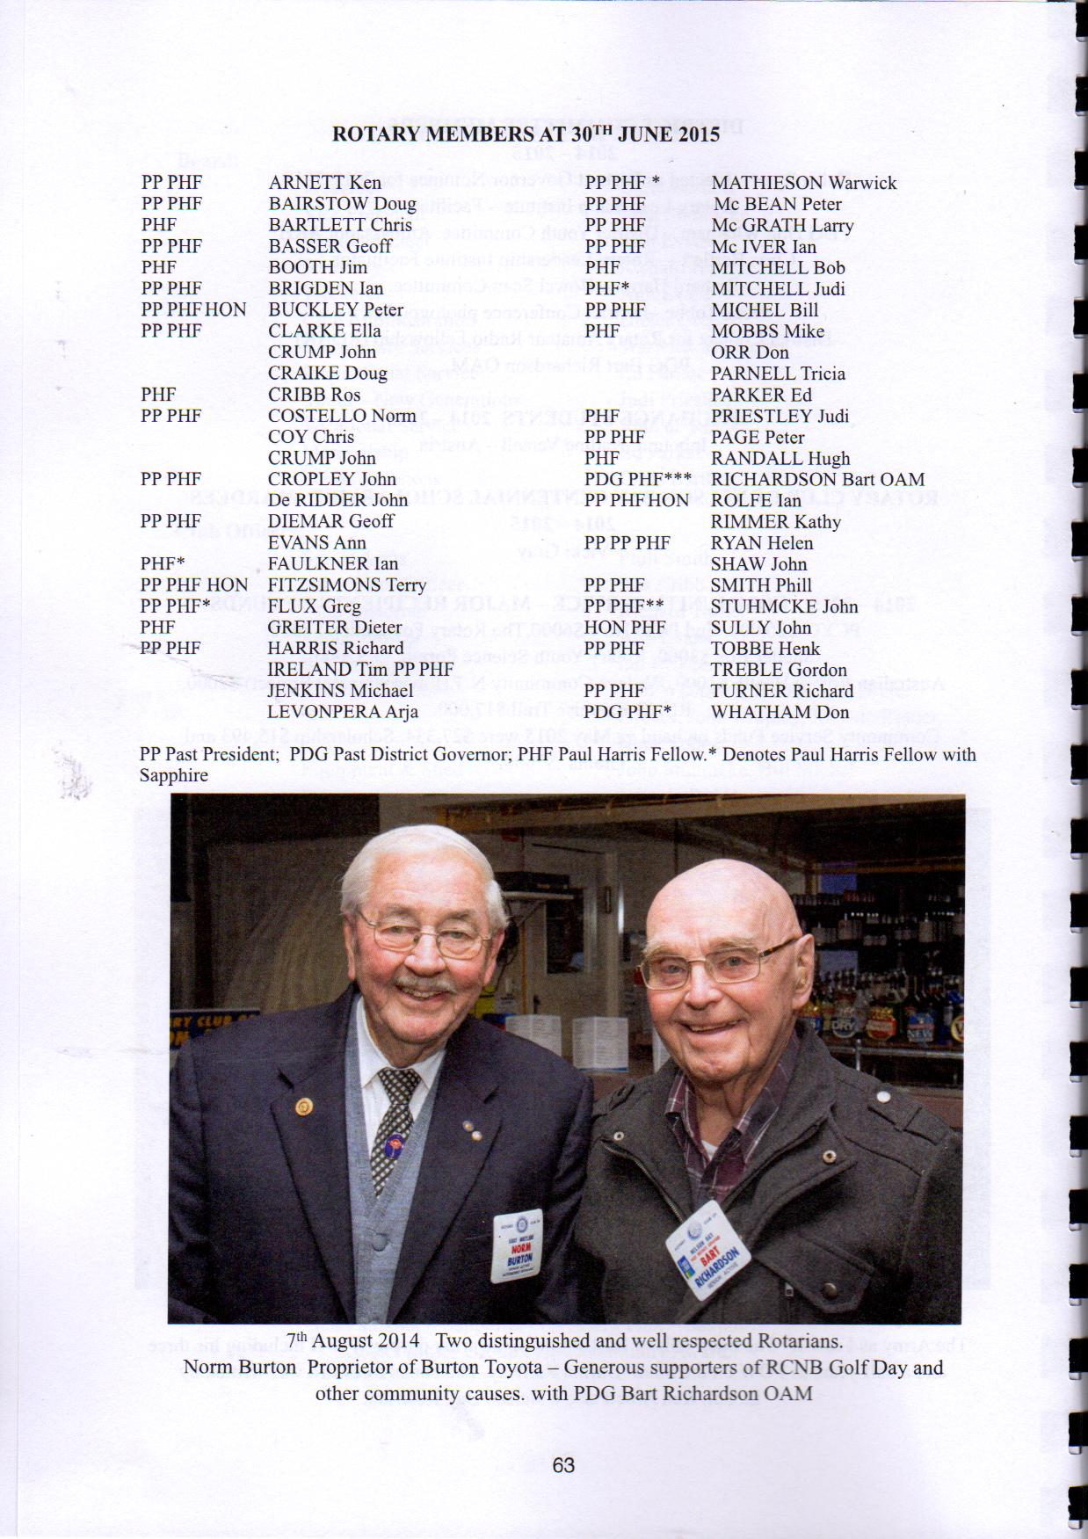

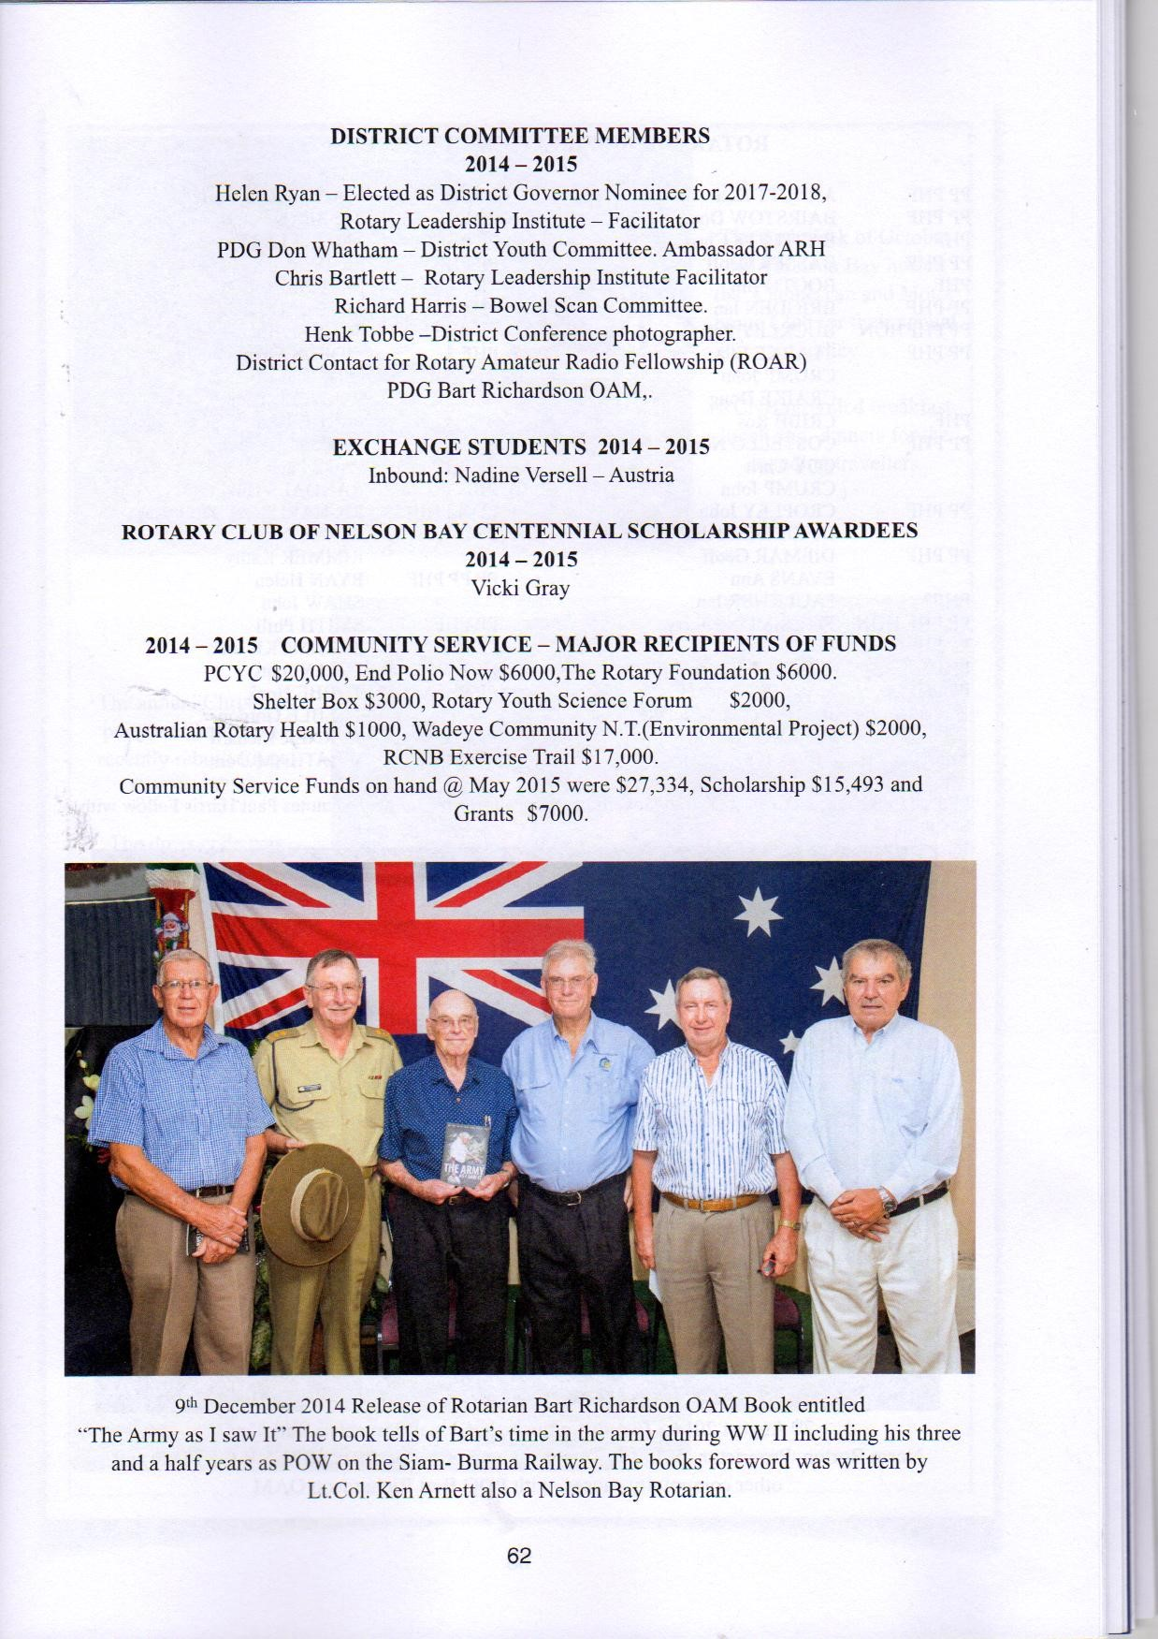

## Bulletin No 33A- Special Edition March 12 2017

## Page 2

**A CAMEO OF BART’S RECENT LIFE IN PICTURES- KINDLY SUPPLIED BY HENK TOBBE**

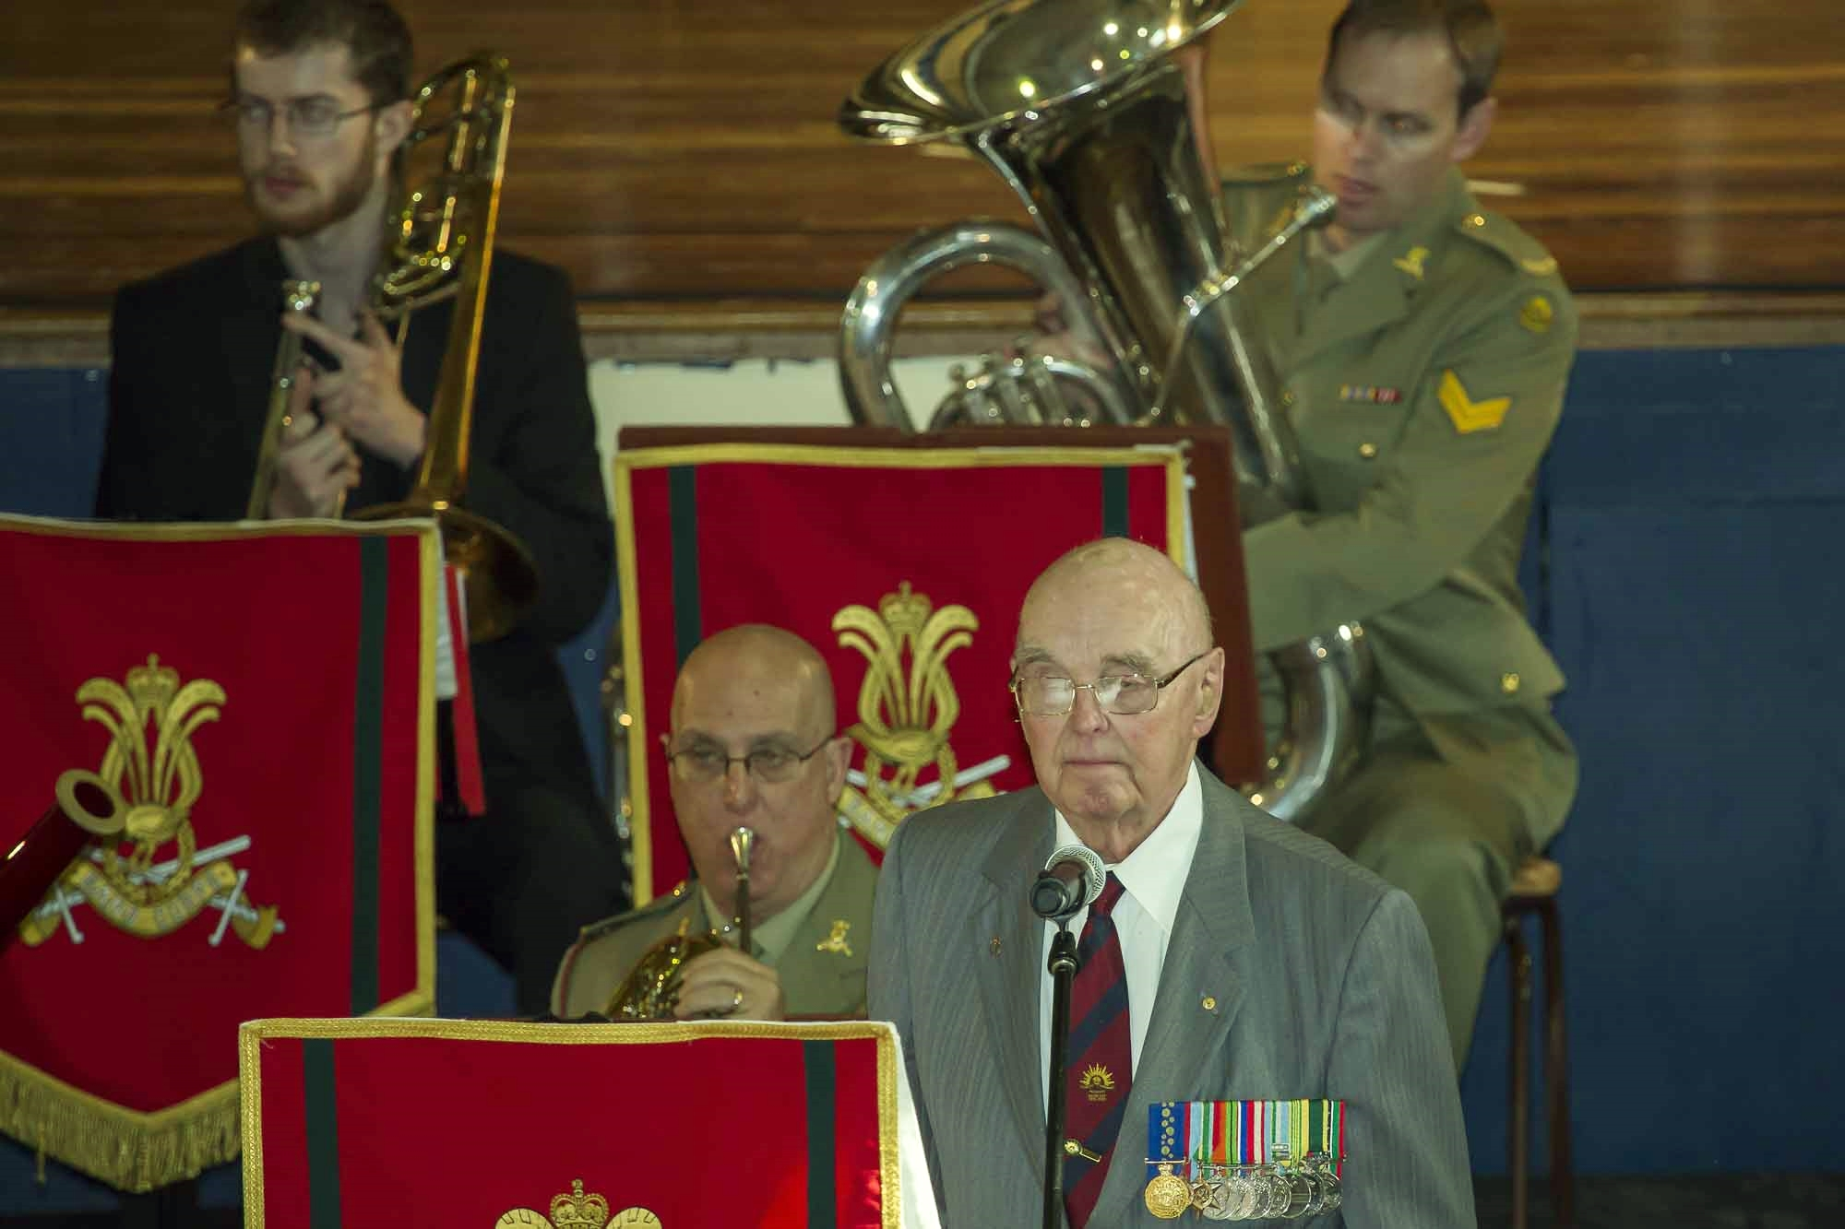

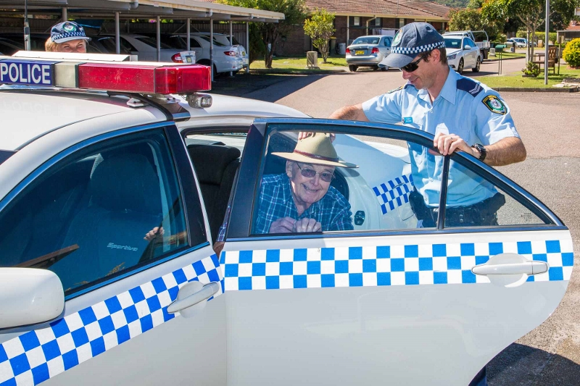

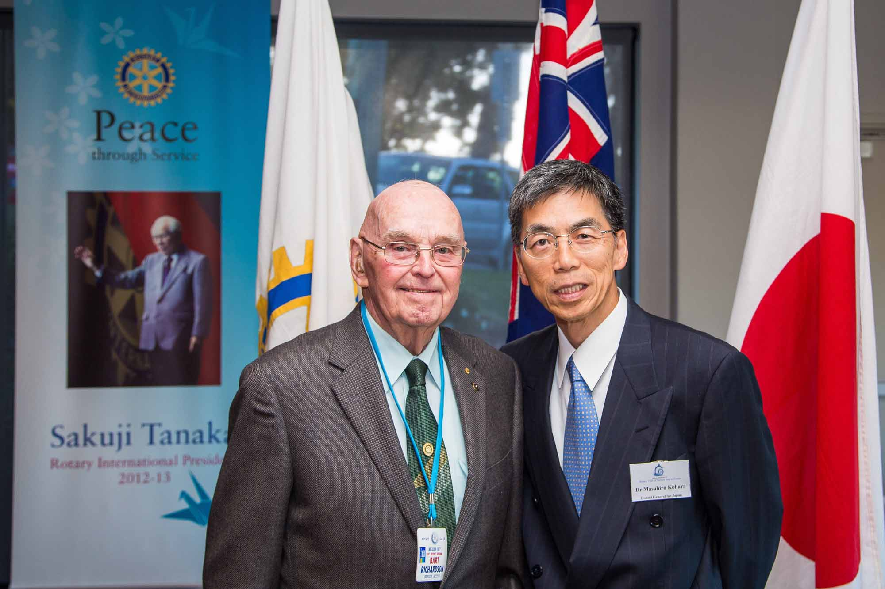

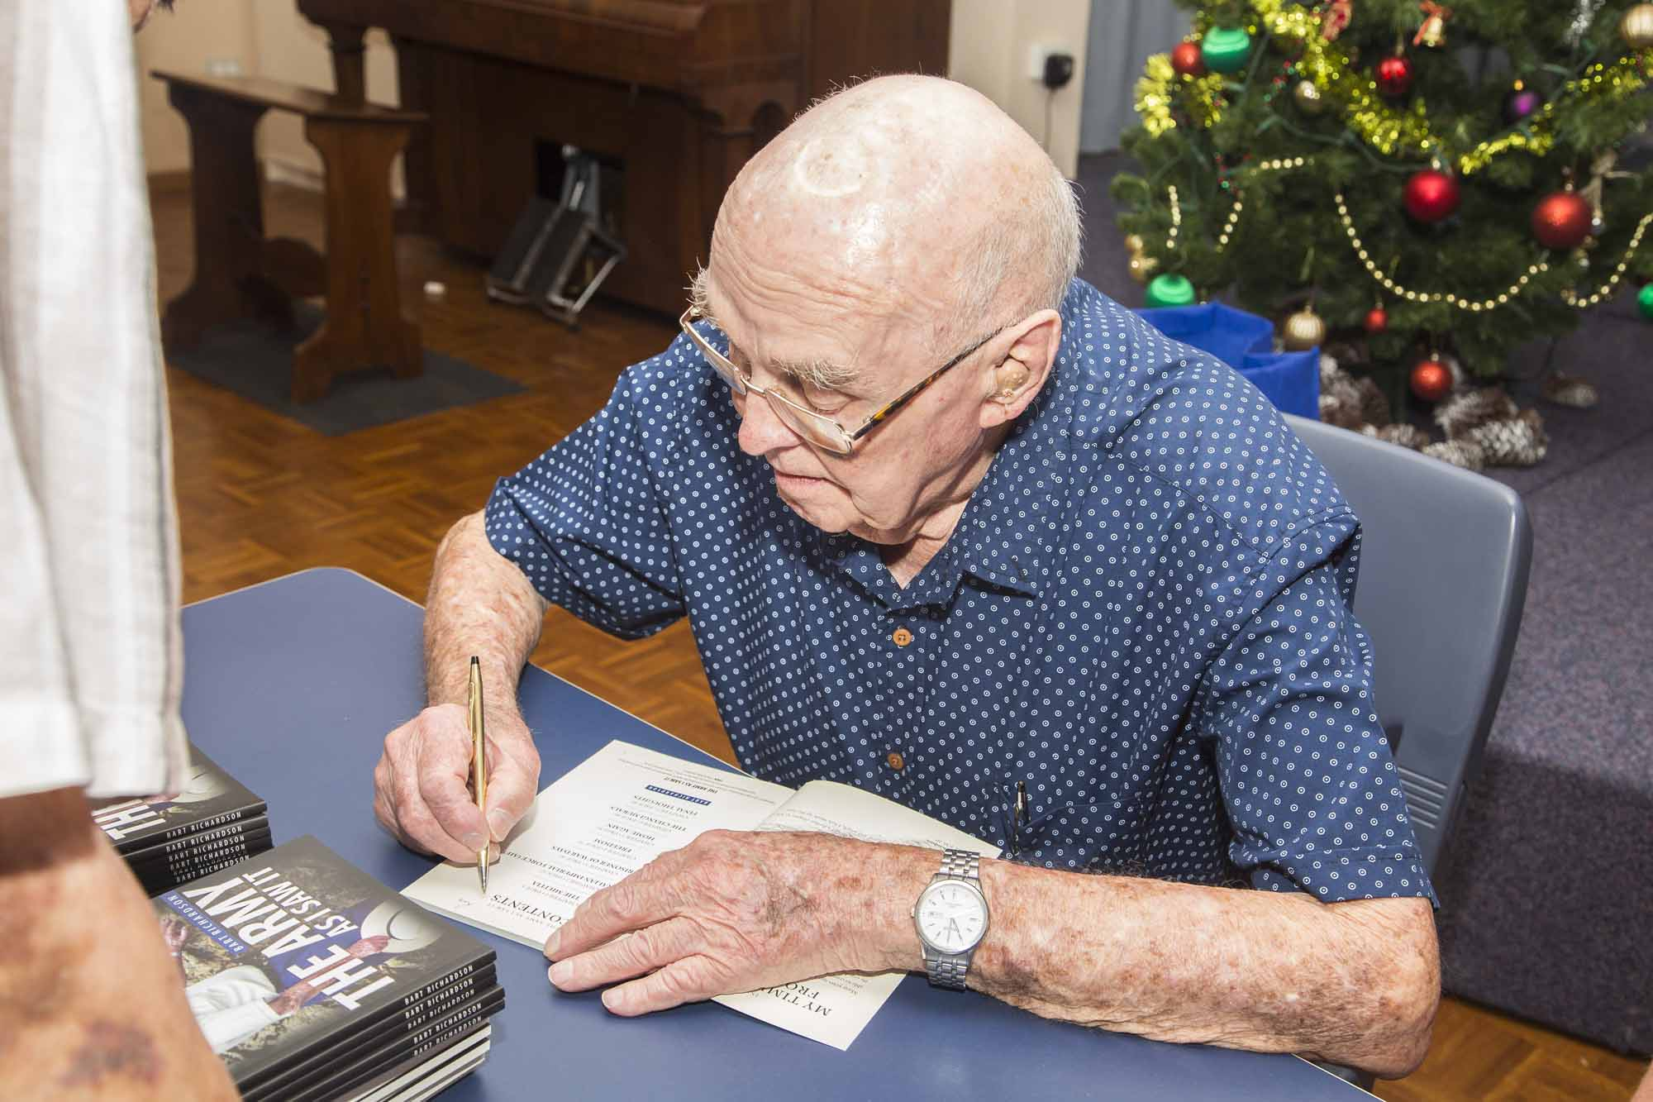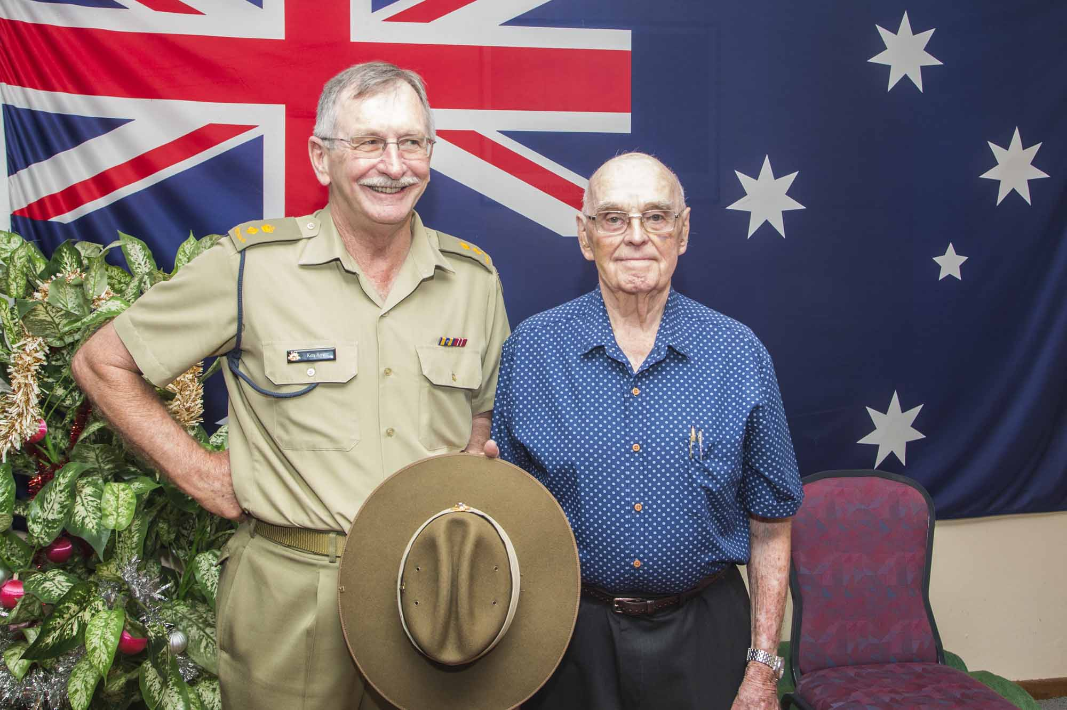

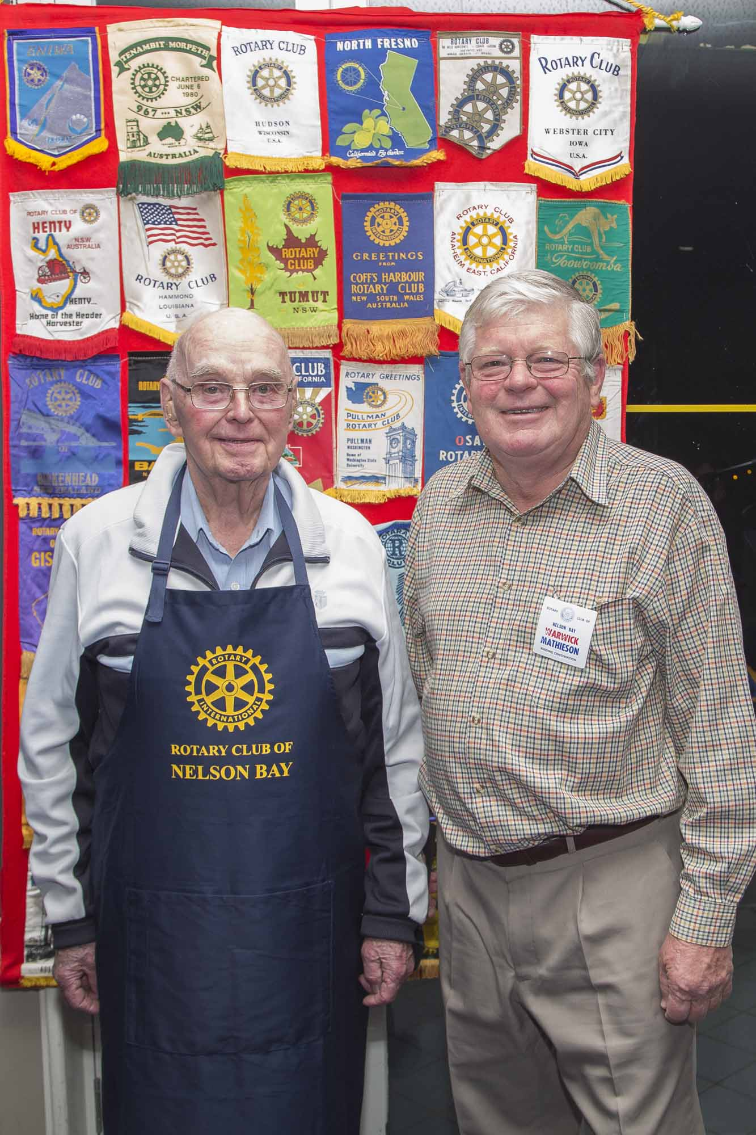

**Bulletin 33A-Special Edition March 12 2017 –Page 3**

## Bulletin No 33 March 2 2017 Page 3

## Page 2

MEMBERSHIP, CLUB ADMIN, INTERNATIONAL

and all of us should be looking to others to join our Club. Members will be kept informed of progress.

**CLUB ADMINISTRATION-** Director John DeRidder has been providing the Club with some excellent speakers for the past 2 years and we have a pretty full program up to our Club/District Changeover on July 1 2017. One special change to our Program is a special evening on May 25 where the 10 History, lovingly prepared by Richard Turner and Henk Tobbe will be “launched”. Members will be able to purchase this great publication at a vastly subsidised rate. Treat this as an early warning with more to follow

**INTERNATIONAL-** Director John Cropley, now famous for his Chinese Night and the $200 raised for the DG Partner appeal, thanked the members for their participation. John also has a couple of speakers organised to speak on the terrific Interplast Program and also ROMAC before the end of this Rotary year.

All of your Directors and Board members put in a considerable amount of their own time to ensure we remain an active, vibrant and well informed club.