Upcoming Events and Speakers
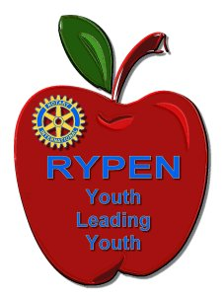 | 16 May | Report back from our nominee at Rotary Youth Program of ENrichment
 | 23 May | Janet Hay RC Canterbury – Micro Loans
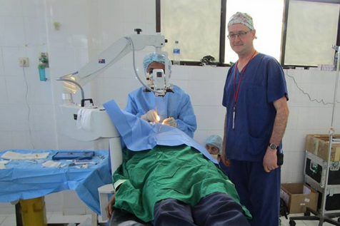 | 30 May | Mark Ellis RC Glenferrie – The Ageing Eye
 | 6 June | tbc
 | 13 June | tbc
 | 20 June | tbc
 | 27 June | tbc
2018/2019 Theme | 4 July | Changeover Dinner. Farewell President Ken and his team, celebrate the achievements of 2017/8 and welcome President Edda and her team. (Dinner cost may exceed usual weekly meeting cost)

Unless otherwise specified, events are held at The Amora Riverwalk Hotel in Richmond. Meet at 6.30pm for a 7.00pm start. Dinner cost is $35.00 which includes a ticket in a small door prize. Drinks at bar prices.
The hotel needs firm numbers by the Monday prior to these Wednesday meetings so bookings are essential. Unless otherwise described above, the primary contact is Club Secretary Anne Brown who can be reached on 0404 029 165 or at yarrabendrotary@gmail.com

