Jerraganda
07/11/ 2017

The Newsletter of Jerrabomberra Rotary
RI District 9710

Dear Everyone,

PLEASE Don’t forget! I Would love market reports to be sent to me by Sunday afternoon so I can complete the Jerraganda by Monday each week.

Also any photos or interesting content you would like to share with the club will help me create an interesting weekly read and would be greatly appreciated– just email to me on:
david.parkinson@cordelta.com

Welcome to another edition of the Club’s newsletter. We had a good meeting last week with the number of attendees present on the rise. It was a great opportunity to toast the newly engaged couple Wendy and John. Once again congratulations to you both.
Last Meeting

Charge to Australia was expertly delivered by David Stephens.
Apologies –Mez, Liz, Bruce, Carolyn,Peter Collis, Veena
Please remember folks, to let John Askew know if you are an apology no later than Tuesday as he orders food for you!
Guests – Nil
Reports – (Please note reports are by exception only – Directors should notify Cathy prior to meetings if they have a report)
President’s Report – NTR
Secretaries Report – NTR
Treasurer’s Report – NTR
Club Service –
The Club Christmas party has been scheduled for 2 December.
On 7 December we will be trialling our new BBQ trailer with a BBQ meeting (at the school)
please note the last meeting for 2017 will be the 14 December and the first meeting back will be 11 January 2018.
18 January (or that week on a date to be agreed) we will be having a tennis evening, kindly facilitated by John Talbot.
Community Service – Peter J shoed a certificate of appreciation from ‘lift the lid’ which was presented to the Club following out fundraising efforts at the meeting a few weeks ago.
Peter informed the club of the following upcoming BBQ events:
Post Natal Depression Walking Group – 16 November;
JRA 9 December;
Probis 20 December; and
Australia Day 26 January.
Peter also informed members that John Talbot will be taking over the management of the market roster from January. Would any members who have dates they are unavailable please email John asap. (I don’t do weekends is not an acceptable response- apparently)
Youth Service – NTR
International Service – Chilly met with Gungahlin Club, Hall Club and the people from Abundant Water. Who are looking to raise $30K. Chilly to keep us up to date with intended support for this great program.
General Business –
1. Paul Rodger informed members -Trailer artwork should be completed by 20 November.
2. Anton informed members that Both Liz and Mez have tendered their resignation from the club effective end of year (Rotary year). We wish them well and thank them both for their tremendous efforts for the Club over the years and I’m sure all members will join me in letting them know they will always be welcome at the JRC. I’m sure we will see them soon and we all look forward to that.
Sergeant Session – John Askew ran a very informative sergeant session which taught us a lot about the Mint. John posed a number of challenging questions regarding decimal currency, which allowed him to rob us all blind of our loose change.
Joker – still intact!

Market Report

Weekly Jerra Joke

The market team this week consisted of Jan, Bruce and Dave P.
It was a beautiful day and crowds built early. Bruce and Dave managed to put the wrong pop up roof over the stand but decided to leave it ad it gave them a little more leg room. We all did our turn on the front gate and as usual took great delight in trying to get a hello out of all those who passed.
David was forced to use his stern policeman’s voice to scare the life out of a couple of sneaky people trying to drive through the gate and score some prime parking. Fortunately nobody was arrested.
Our take was little down on the last two weeks ($160) but it was a pretty good day.
Stock levels are all ok with about ¾ of a slab of water still there. If it is hot next Saturday perhaps just grab an extra slab.
Weekly Joke Stanley died in a fire and his body was burned badly.
The morgue needed someone to identify the body, so they sent for his two best deer-hunting friends, Cooter and Gomer. The three men had always hunted and fished together and were longtime members of a hunting camp.
Cooter arrived first, and when the mortician pulled back the sheet, Cooter said, “Yup, his face is burned up pretty bad. You better roll him over.”
The mortician rolled him over and Cooter said, “Nope, ain’t Stanley.”
The mortician thought this was rather strange, so he brought Gomer in to confirm the identity of the body. Gomer looked at the body and said, “Yup, he’s pretty well burnt up. Roll him over.”
The mortician rolled him over and Gomer said, “No, it ain’t Stanley.”
The mortician asked, “How can you tell?”
Gomer said, “Well, Stanley had two assholes.”
“What! Two assholes?” asked the mortician.
“Yup, we never seen ’em, but everybody used to say, there’s Stanley with them two assholes.”
ttfn

Stanley died in a fire and his body was burned badly.
The morgue needed someone to identify the body, so they sent for his two best deer-hunting friends, Cooter and Gomer. The three men had always hunted and fished together and were longtime members of a hunting camp.
Cooter arrived first, and when the mortician pulled back the sheet, Cooter said, “Yup, his face is burned up pretty bad. You better roll him over.”
The mortician rolled him over and Cooter said, “Nope, ain’t Stanley.”
The mortician thought this was rather strange, so he brought Gomer in to confirm the identity of the body. Gomer looked at the body and said, “Yup, he’s pretty well burnt up. Roll him over.”
The mortician rolled him over and Gomer said, “No, it ain’t Stanley.”
The mortician asked, “How can you tell?”
Gomer said, “Well, Stanley had two assholes.”
“What! Two assholes?” asked the mortician.
“Yup, we never seen ’em, but everybody used to say, there’s Stanley with them two assholes.”
Blast from the past

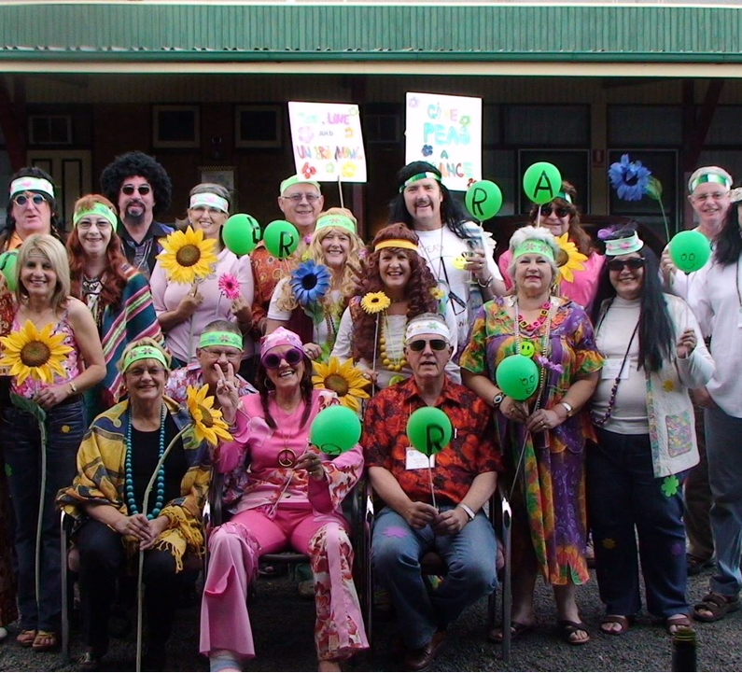
This little piece of history was sent in by Paul Roger. How many members past or present can you pick?

