ANNUAL REPORT

2017-2018

TABLE OF CONTENTS

Rotary International President’s message……………………………….. 3
President’s Report …………………………………………………………………... 4
Treasurer’s Report ………………………………………………………………….. 8
Club Administration…………..……………………………………………….... 10
Rotary Foundation …………..…………………………………………………… 10
Community Service ……………………………………………………………….. 12
Apple and Grape Ambassador ………………………………………………...12
Vocational Service …………………………………………………………………. 13
International Service …………………………………………………………….. 14
Youth Service ………………………………………………………………………... 15
Membership ………………………………………………………………………….. 17
Busking@Stanthorpe ……………………………………………………………. 17
Opera in the Vineyard …………………………………………………………… 18
Satellite Club ……………………………………………………………………….... 19
2018-19 Directors ………………………………………………………………… 21

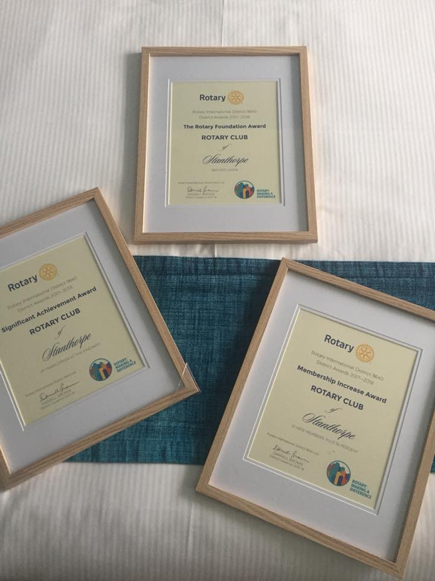

From the Rotary International President 2018-19
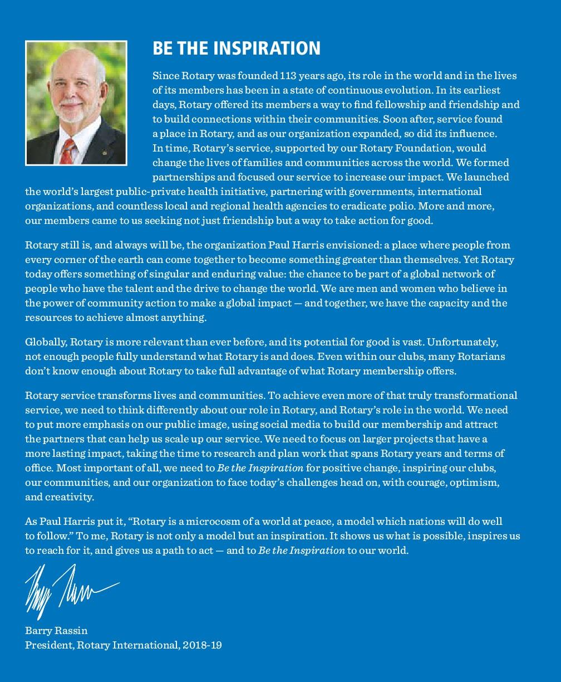
PRESIDENT’S REPORT
Morwenna Harslett

Twelve months ago I said that in my year as President of the Rotary Club of Stanthorpe, I wanted to challenge the reputation that Rotary has of being a staid and old-fashioned “gentleman’s club”. My major focus has been to challenge what might be considered a traditional Rotary meeting. I therefore took on the role of arranging our weekly programs. I set aside one meeting each month as a committee or business meeting with no guest speakers or alternate activities, with the hope that this would allow all Rotarians to participate in the decision making of the Club. A second meeting each month was scheduled in the traditional style with a formal meal and a guest speaker in our Rotary Room at the International Club. One meeting each month was dedicated to a service activity of some type and the final meeting for the month was designed to encourage fellowship and friendship among Rotarians as a social evening with a game or activity as the focus. Table 1 is a list of programs from the 2017-18 Rotary year. I have not included committee meetings, which were held regularly on Monday evenings with the option of individual committees meeting at alternate times and venues of their choosing. Service activities are also not included as these are listed specifically in the Community Service Report.

The programming of our Club’s meetings has been both the most enjoyable and the most challenging aspect of my year. We have been treated to some excellent guest speakers on a range of topics from physical and mental health (Charlotte Battle and Kath Ives) to International projects and travel (Sally Rowen, Jolene McLellan and our own Fran Hodgson). Through our weekly meetings we have financially supported other local community organizations by giving them the opportunity to cater our meal (with no additional strain on Rotarians’ hip-pockets as we pay for dinner each week anyway) and in return we get an interesting guest speaker and learn about what is happening in our area.

Rotary District 9640 Governor Darryll Brown challenged Rotary Clubs to focus their support on Rotary initiatives ahead of other charities so that as an organization, we might gain better recognition for our service efforts. I have kept this in mind throughout the year and a major change for our Club was to make the Rotary Foundation and Australian Rotary Health the major beneficiaries of our signature event, Opera in the Vineyard. In particular, I am very proud to report that Stanthorpe Rotarians have contributed almost AU$12,500 to the EndPolio Campaign. This money will be matched 2:1 by the Bill and Melinda Gates Foundation totaling $37,500. More detailed information on our charitable contributions is listed in the Treasurer’s Report.

DG Darryll also challenged Clubs to have “fun with Rotary”. We have had meetings involving whist, comedy, movies, and trivia. We have shared fellowship on several occasions with Stanthorpe Lions and other Rotary Clubs; Tenterfield, Warwick, Goondiwindi and Stanthorpe Satellite. I have enjoyed these evenings thoroughly, I hope that you have too and I hope that we can do more of this in years to come.

Rotary International President Ian Riseley set improving environmental awareness as one of his focus areas. In support of this aim, Stanthorpe Rotary Club has contributed to the planting of almost 80 trees (one for each Rotarian and partner) at the Amiens History Association site.
My Vice President, Denise Harslett, has throughout the year deposited roughly 40 “Lonely Plants” in public areas around the district. These have been accompanied by a short note promoting Rotary and encouraging the “pay it forward” idea of sharing peace and goodwill with our fellow humans.

Our Club has supported Boomerang Bags in their quest to assist the people of the Granite Belt to do away with plastic shopping bags in favor of reusable fabric bags. Also in the spirit of environmental awareness, I have made a concerted effort throughout the year to reduce the amount of paper used during meetings by emailing such things as bulletins and this Annual Report.

There are some community services that our Rotarians perform every year and these can often times be overlooked as they have become a part of our regular routine. Meals on Wheels is one such activity. Throughout the past year Stanthorpe Rotarians have devoted over 200 hours and delivered more than 600 meals to the elderly. Thank you to Julie Beddow for coordinating this.

The Stanthorpe Rotary Club sponsored Bridget Campbell in the Apple and Grape Young Ambassador Quest and for the second time in a row, Rotary’s entrant was crowned the overall winner.

It was with sadness that our Rotary Club said farewell to three Past Stanthorpe Rotary Presidents in recent months. Our thoughts are with the families of John Van Klaveren, Neville Jones and Adrian Findlay.

On a personal level, the past year has been a steep learning curve with a considerable number of tears and sleepless nights. I would not have survived the year in the President’s role without the help and support of some key people. Firstly to my Vice President and Mother, Denise Harslett, my Treasurer and Uncle, Peter Klemm and my Secretary and Friend, Kim Thorburn. If they had a dollar for every rant I have subjected them to this year, they would all be wealthy folk! Thank you for listening. I would also like to acknowledge the constant advice and counseling of both Stephen Tancred and Tony Heading. Their wealth of experience and knowledge in how the Rotary Machine functions has been invaluable. The Twin Jim B’s (Barnes and Baxter), Fran Hodgson, Leeanne Gangemi and Melissa Pascoe have been wonderful supports, making sure their respective committees run smoothly and efficiently. Finally my most warm and heartfelt gratitude to Julie Beddow who is one of the most genuine, caring and selfless people I know, thank you for always being there when called upon.

I have had two stand-out moments of personal growth this year, two events where I delved into my very deepest reserves of courage. Without Rotary I would never have had these opportunities so thank you for allowing me to represent you as the third speaker for the victorious negative team in the Great Debate v Lions and for the privilege of performing Beethoven’s Violin Romance in F Major at Opera in the Vineyard.
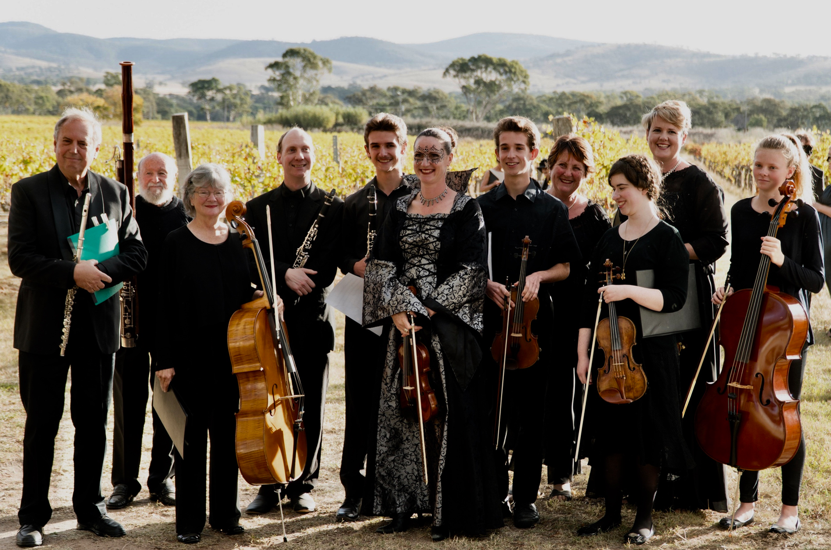
Have I enjoyed the past twelve months? Not particularly. Am I proud to have achieved a year as President? Yes. I am a stronger and hopefully wiser person for having put myself on your chopping block. I hope that incoming President Kim and his new Board will have the same support that most of you have shown to me. We make a pledge at the commencement of every Rotary meeting and I have tried my very best to act by these words throughout the past year;

In all we say and do;
Is it the truth?
Is it fair to all concerned?
Will it build goodwill and better friendships?
Will it be beneficial to all concerned?

I hope that in the years to come, as our Club continues through the modernizing process, you will remember our 4-way test in all your dealings with others but particularly with your fellow Rotarians.

I would like to end my year with this quote:
We can't be afraid of change. You may feel very secure in the pond that you are in, but if you never venture out of it, you will never know that there is such a thing as an ocean. Holding onto something that is good for you now, may be the very reason why you don't have something better.
C. JoyBell C. (Author)

Table 1.
2017-18 Rotary Programs
Topic/Event (What?) | Guest Speaker/Organisation (Why?) | Venue (Where)
Changeover |  | International Club
Whist with a Twist | Just for fun | International Club
Italian Immersion Dinner | Immersion Students | International Club
Navigating technology | Facebook, Clubrunner, Website | SSHS Library
Tim Bradford Roll About Comedy | Beyond Blue | International Club
Christmas in Winter | Satellite Club | International Club
Austrian Exchange Student | Helene Jaeger | International Club
Gourmet in Gundy | Rotary Club of Goondiwindi | Goondiwindi
District Governor's Official Visit | Darryll Brown | International Club
Boomerang Bags | Brooke Summerville | The Summit
Hat Day/Movie Night | Australian Rotary Health | Arcadia Theatre
Kokoda trek | Sally Rowan | International Club
The Rotary Foundation | Tony Heading | International Club
Murder on the Orient Express | Polio Eradication | Warwick Cinema
Junior Craft Awards | Recognition of student skills | St Josephs
Amiens History Association | Roger Willis | Amiens
The Great Debate Rotary V Lions | Melissa, Leeanne, Morwenna | International Club
Rotary Christmas Party | Joint celebration with Tenterfield | Ballandean
Red Rooster Vocational | Red Rooster staff | Red Rooster
Storm King Boat Club - Rowing | Kate Dearden | Storm King Dam
Working in Afghanistan | Robert Arcidiacono | International Club
Wood Fired Pizza at Campbells | Apple and Grape Ambassador | Dalcouth
GCE Presentation | Delegation from Florida, USA | International Club
A year in Italy | Lily Banasiak | International Club
Easter Bonnet Party | Pride of Workmanship | CWA Rooms
Healthy living | Charlotte Battle | International Club
Mental Health services | Kath Ives | International Club
Foxbar Falls Campground Vocational | Tim Harslett | Amiens
Red Shirts on Tour | Rotary Youth Programs | International Club
Trivia night | Joint meeting with Lions | International Club
The Mingoola Project with Tenterfield | Gino Cabria | Wallangarra
Pride of Workmanship | Recognition of Employees | QCWT
Park Rangers in the Soloman Islands | Jolene McLellan | International Club
The year that was! | Helene Jaeger | International Club
Changeover |  | International Club

TREASURER’S REPORT
Peter Klemm

The following figures are a draft financial statement as of 30th June 2018 of the club’s major fundraising activities and donations for the financial year.
Activity | $ | Notes
Opera : operating profit | 13,572
Opera : Giving Tree | 5,000 | Directed to JDRF
Opera : Chance Draw profit | 1951 | Directed to PolioPlus
Opera : Presidential Busking | 1,793 | Directed to Australian Rotary Health
Opera : Raffle of cushion & rug | 810 | Directed to ROMAC
Opera : Wine auction | 3,300 | Direct to Salvation Army at request of patron
Centurion Towers | 1,500 | Directed to Polio/Annual Fund at request of member
“Bird” at Club Meetings | 450 | Directed to Scouts
Happy coins | 415 | Directed to Life Education
Australia Day & Show Catering | 2,644
Ham Wheel | 618
Busking : operating profit | 893 | After sharing 20% of profits with the Apple & Grape
Busking : BBQ | 835
Purple Pinkies | 71 | Directed to PolioPlus
Movie Night | 556 | Directed to Australian Rotary Health
Spooky Walk | 1,121
Satellite cushion raffle | 522 | Directed to ROMAC
Satellite Xmas Dinner | 520
NET FUNDRAISING TOTAL | 36,571

2017-18 FUNDRAISING ACTIVITIES

2017-18 DONATIONS
Rotary Foundation | 5,280 | Club’s 100USD per member
Polio | 6,400 | Purple Pinkies, Chance Draw, Opera, Centurion Towers
Australian Rotary Health | 5,000 | $2000 specifically to PhD Scholarship for Mental Health Research. $3000 to ARH in general.
ROMAC | 1,500 | Opera & Satellite Club raffles
Salvation Army | 3,300 | Patron’s choice from Wine Auction
JDRF (Junior Diabetes Research Foundation) | 5,000 | Puglisi family’s choice from Giving Tree
Amiens History Association | 1,500 | Dinner proceeds* + Donation of avenue trees
Storm King Boat Club | 560 | Dinner proceeds*
Lecturette Competition | 100 | Donation (Applethorpe State School)
SSHS Italian Immersion | 800 | Dinner proceeds*
Boomerang Bags | 500 | Donation
AgriTourism NZ Study Trip | 800 | Dinner Proceeds* + Opera contribution
Little Athletics | 50 | BBQ for Breakup
Light the Night St Josephs | 100 | Donation
Scouts | 500 | Bird
Life Education | 400 | Happy Coins
Fiji | 3,768 | Stanthorpe Club contribution to Fiji
YEP Student: | 2,350 | School fees + Pocket money + meals
RYPEN Students | 300 | 2 students 50% cost of camp
RYTS Student | 590 | 1 student
Pride of Workmanship: | 681
Awards | 402 | St Josephs + SSHS Awards
Medan Girls Home (Indonesia) | 220 | Annual contribution for 2 girls
TOTAL DONATIONS | 40,101

OTHER FINANCIAL ASSISTANCE by STANTHORPE ROTARY CLUB
One of our Club’s guest speakers this year was Brooke Summerville, chairperson of Boomerang Bags. This organisation is not an incorporated association and was therefore unable to apply for a grant for new sewing and overlocking machines. They asked Stanthorpe Rotary to auspice their application which was then successful. This money was paid into Rotary’s accounts and the transferred directly to Boomerang Bags for their machinery purchases.

Bridget Campbell represented Stanthorpe Rotary as the 2018 Apple and Grape Ambassador. This money was transferred to the Apple and Grape Account.
Boomerang Bags | 9,310 | SDRC Grant auspice
Apple & Grape Harvest Festival | 6,332 | Ambassador contribution

BANK BALANCES as of June 30th 2018
General | Community | Opera | Project Reserve
$9340 | $4,000 | $10,000 | $41,541

The Stanthorpe Rotary Club, over several years but particularly during the 2016-17 financial year, has gradually accumulated funds which have not all been allocated in annual donations. These funds were spread across several accounts. The 2017-18 Board has made the decision to retain $10000 in the Opera Account and $4000 in the Community Service Account, with a recommendation that this practice continues at the end of each Rotary year, for possible expenses early in the coming year. The remaining funds will be transferred into a Project Reserve Account. This will create a clear starting point for the Treasurer for the coming financial year and the reserve fund can be used by the Rotary Club at an appropriate time in the future.

CLUB ADMINISTRATION REPORT
PP Peter Watters
Bulletins: A much more demanding job than is obvious but Julia Hassall has produced the weekly bulletin, always with appropriate information, distributed electronically and always on time.

Programs: Some variations compared to other years, with monthly in-house committee meetings, alternate meeting places sometimes involving self catering and several very interesting and informative speakers at our very suitable International Club venue.

Meals: All credit to the volunteers from and at the International Club who have maintained a very good standard of both quality and service.

Happy Coins has replaced the former sergeant’s sessions by inviting members to pay to relate an experience or something of interest. A handy fund raiser.

Attendance: It appears that this important aspect has reduced in priority, but Julie Beddow has received the dinner subs and kept the details.

Compliments: to Exchange Student Helene from Austria who happily has attended most meetings and together with Satellite Members occasional attendance at special nights and programs we are reminded that Rotary is relevant to all ages.

ROTARY FOUNDATION REPORT
PDG Tony Heading
- Grants
The club successfully applied for a district grant of A$800 to help fund a shipping container of school goods to schools on Lakeba Is, Fiji in conjunction with the six other clubs in AG Cluster 9. Cluster district grants totaled A$4,200 towards the project cost of $12,568.

- Foundation Fundraising/Awareness
The club set a goal of US$5,000 to the Annual Fund and with 3 members making personal contributions totaling $1233, achieved a total of US$5,233.
The PolioPlus Fund Goal was set at US$2,000. Club members, partners and friends supported the Polio movie night conducted by the Warwick clubs in November. Six members/partners personally gave US$4,646 towards a total contribution of US$9,446. With Gates Foundation support, this will become US$28,338 for polio eradication.
This year, The Rotary Foundation was identified as a major beneficiary of our signature Opera in the Vineyard charity fundraiser. We also had a club presentation on the Foundation on 30 October and distributed Centurion Towers to encourage members to personally contribute A$100 each year and become Centurions.
Currently we have 24 Paul Harris Fellow (PHF) members, 4 members of the Paul Harris Society including 1 new member this year, 2 Major Donors, 12 Centurions and 3 Benefactors of the Foundation. This year, we recognised 11 Rotary partners as PHFs for their long-standing (17+ years) support of club activities. Mario Gangemi and Ian Henderson were also recognised as PHFs for their many years of work at our Opera in the Vineyard.
Rotary Foundation cakes/puddings were again purchased and distributed to Rotary widows for Christmas, raising $229 for the club and contributing $308 to the Foundation.
The club purchased 6 pull-up banners of the Foundation Areas of Focus and these have been used so far at the Opera in the Vineyard and the Pride of Workmanship Awards.

- Group Cultural Exchange (GCE) with D6980 Florida
The club hosted the inbound GCE team from Wednesday 28 February to Sunday 4 March. The packed program showcased apples, strawberries, vegetables, Granite Belt Brewery, Girraween National Park, The Bramble Patch, Ballandean Estate, Australian Vinegar and the QCWT. Their visit coincided with the Apple and Grape Harvest Festival which added to the success of the program. Club members organised, hosted, transported, accommodated and enjoyed the club presentation night. We also had great support and sponsorship from local businesses. Team member hosts were Morwenna Harslett, Alec and Denise Harslett, Peter and Karen Klemm, David and Judy Lee, Stephen and Peta Tancred, Kim and Jamaine Thorburn.
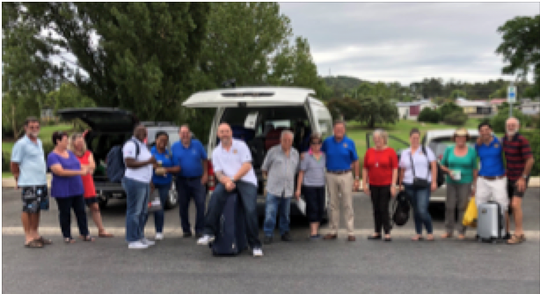

Thank you to members and partners for your ongoing support ‘to do good in the world’.
COMMUNITY SERVICE REPORT
PP Jim Baxter

The Community Service team (or should I say the whole Club) has been very busy this year. All members helped out at functions throughout the year.
We volunteered our services to at least twelve functions and projects throughout the Rotary Year.
- Humble’s Way Walking Path
- Australian Rotary Health Movie Night
- Halloween Spooky Walk
- The Big Thermometer
- Amiens History Association Soldier Settler Project
- Little Athletics Christmas Breakup
- Christmas Carnival - Ham Wheel
- Villa Carramar Open Day
- Stanthorpe Show Lamb Burger
- Busking@Stanthorpe Championships
- 26th Opera in the Vineyard
- Pride of Workmanship
The weather was very unkind to us at some of the catering jobs; but we can do little about that- except complain. (Thank Mark Twain for this quote!)

The Stanthorpe Show is a very big job where lots of volunteers are needed for the three days. We are locked into the catering again for another year. After this, it may need to be reviewed as a lot of our members are involved in many different areas of the Show; making the number of volunteers available for the Lamb burger stall limited.

I would like to thank everybody who helped out throughout the year. It’s been wonderful to work with such dedicated community service volunteers.

APPLE AND GRAPE AMBASSADOR REPORT
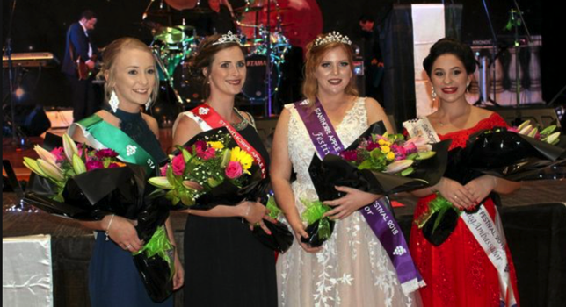
In 2017-18 the Stanthorpe Rotary Club sponsored an entrant in the Young Ambassador Quest for the Apple and Grape Harvest Festival. Bridget Campbell aquitted herself with poise and class. Her fundraisers included street stalls, catered dinners, raffles, and open gardens. Representing the Rotary Club of Stanthorpe, she attended the Stanthorpe Races, local events, fundraisers, numerous Club dinners and meetings, a deportment course, a public speaking course, local history lessons and much more. At the Apple and Grape Ball, Bridget was awarded the highest honour, Festival Ambassador. Congratulations Bridget.

VOCATIONAL SERVICE REPORT
Jim Barnes

The Rotary Club of Stanthorpe again sponsored prizes for the Senior Craft Awards at Stanthorpe State High School. Prizes were awarded to students at the school’s annual Awards Night.

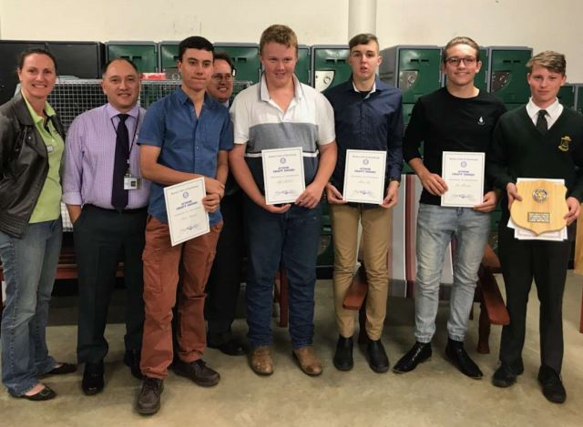
Students in year 10 at St Josephs School participated in the Junior Craft Awards. A high standard of project work was exhibited by these students. A presentation barbeque was held at the school where parents, students and Rotarians recognized the efforts of these students. Jared Hitchener was presented with a trophy and prize for his project - a squatter’s chair.

The Pride of Workmanship Awards Presentation Dinner was held at the Queensland College of Wine Tourism in May. Eight local workers, nominated by their employers, were each awarded with a plaque recognizing the good service provided and the contribution made to the success of the relevant business. The dinner was attended by family, colleagues, employers and Rotarians. An inspiring speech was delivered by guest speaker Ian Henderson of Australian Vinegar.
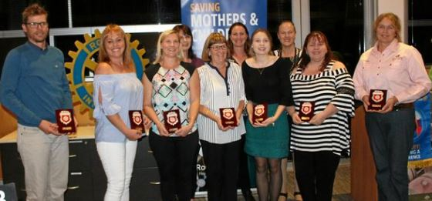
Rotarians enjoyed a vocational visit to the Foxbar Falls Camping Grounds to view the great scenery and to hear about the progress of this new venture of Tim and Tracey Harslett at Amiens. Over a barbeque dinner Tim shared the obstacles in establishing the camping grounds and his hopes for its future.

As part of the vocational service portfolio, Rotary assisted with the delivery of meals to Stanthorpe residents through the local Meals on Wheels program. The coordination of Rotary’s participation was admirably undertaken by fellow Rotarian Julie Beddow.

Stanthorpe Rotary Club has a long history with Meals on Wheels. Rotarians involved over the years include Stephen Tancred, Bill Bonner, Fran Hodgson, David Hansen, Kylie Linton and Julie Beddow. In the past year Stanthorpe Rotarians have delivered around 700 meals to the elderly of our town. Thank you to all the Rotarians, partners and friends who have helped to deliver this wonderful service. The Meals on Wheels committee is currently seeking a new secretary. Should you be interested in this position, please contact the Meals on Wheels Committee.
Julie Beddow

INTERNATIONAL SERVICE REPORT
PDG David Lee

Plans for the 2017-18 Rotary year were for the planning and preparation for our Club’s next RAWCS Project in Fiji in August 2018 - the building of a school library on Mololo Island off the west coast of the main island in Fiji. Unfortunately, as is often the case in Fiji, the wheels turn slowly and this project has been delayed. Plans and details for this building are being provided by school management presently involved in another project.

In August 2017 our Club was involved with the Cluster 9 International Project organized and driven by AG Stephen Tancred. This project involved sending a 40ft. container of school related items to the island of Lakeba, 300km east of Suva. Because of the distance from the mainland the schools on this island receive little support from the Fiji Government for students and teachers and in particular the supply of educational material and items. The goods in the container were shared between three Primary Schools and the High School on the island. There was great excitement amongst teachers, students and parents when the goods from the container finally arrived on the island - just in time for the start of the new 2018 school year.

For this project our Club received a District Grant of $800 and outlaid a further $3,768 most of which will be recouped with the sale in due course of the container.

On-going support for our Club for needy items in Fiji continues at an ever increasing rate.

The items listed below are just some of the donations that have been given this Rotary year with the request that they be forwarded to Fiji.

St. Joseph’s School:
Sports equipment including new soccer balls, sports clothing, jerseys (short & long sleeve) and shorts.
Teachers’ desks and school furniture.
Library books and text books.
Teachers’ aids.

Broadwater Primary School:

Library books.

Woolworths:
30 + cartons of toys and teaching aids (Inflatable Globe Beach Balls, Interactive World Maps and World Explorers Activity and Collector’s Albums).

Local Vet:

Large plastic storage box of bandages - 300 + all packaged and individually sealed.

Private donations:
A large bag of biros weighing a total of 6kg - some biros new and still in their original packaging.
Large quantity of new men’s clothing - (Donated from the Gold Coast).
Linen and clothing - (Children’s and adults) - a number of cushions..
Large box of fabric.
Bags of shoes.
Kitchenware.

The sale in Fiji of three 40ft. containers, purchased by our Club to forward goods to Fiji, is on-going. Members in the International Service Avenue of our Club strive to do what they can to assist the educational needs of students and teachers in Fiji - a Third World developing country. Two of the containers have, or are, being used with great benefits. The container at the Naiyala High School was used to store equipment and resources from the Home Ec. Room when the school suffered an emergency when the roof, unexpectedly, had to be replaced. The container at the Korovou Hospital has been fitted out as a pharmacy at the hospital. While the Ministry of Education and the Ministry of Health are both anxious to purchase and make payment for these containers neither departments have had the ready cash to do so up to this point of time. Having said that, I believe, and am hopeful, that the Naiyala High School will be transferring 50% of their invoice and the Ministry of Health the total of their invoice by the end of this financial year.

My sincere thanks to all who have assisted International Service in any way during this Rotary year.

YOUTH SERVICE REPORT
Melissa Pascoe

It has been another busy year in Youth with Helene Jaeger from Austria joining us this year. She has been such fun and her willingness to give anything a go is so refreshing! Thanks Helene for telling us of your ventures both near and far and always keep us in your heart.

Fletcher Pascoe and Angus Banasiak attended RYPEN in May. The boys loved the camp and came back sharing funny stories about events and guest speakers. Angus and Fletcher visited the Monday club to thank them for their sponsorship and tell them a little about what they got out of the camp and Fletcher visited the Satellite Club to inform them about what RYPEN is all about. I think we have started a trend now as both boys can’t wait until they are old enough to attend RYTS at the end of Year 12 and RYLA after that. But isn’t that what Rotary is all about? Changing lives a little bit at a time?

The Interact Club (based at Stanthorpe State High School) has restarted this year and member numbers are high! Under the guidance of Kaylah Adams and Ann Richardson, Interact members have played lots of “get to know you” games, learnt about refugees and assisted with local events, including Opera. They meet every 2nd Tuesday at the Granite Belt Learning Centre.
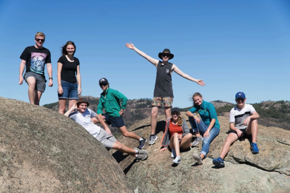
I would like to thank Leanne Wilkinson for being Counsellor to Helene this year and always being available for a chat and a cuppa. I know she has really appreciated you being there for her. Thanks to Ann and Kaylah for getting Interact back on its feet this year. Lastly thanks to the host families past, present and future – without you YEP (Youth Exchange Program) just doesn’t exist. You make such a difference in someone’s life by opening your home and your heart to them. It is the little things that can make a big difference and I know the Exchange students do appreciate it – they tell me so! If you haven’t put your hand up and hosted a YEP student before – do it now. You don’t know what you are missing out on!
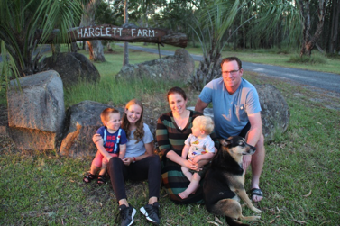
YEP (Youth Exchange Program) Report
Helen Jaeger
During the last 10 months I have not once regretted my decision to take part in the Rotary Youth Exchange Program in Australia. Travelling around both with host families, friends and my fellow Exchange students has granted me so many new experiences. It is with great excitement that I admired the beautiful nature and sights of this country during my four week trip around Australia, covering Sydney, Melbourne, the hot centre – Uluru and the tropical North – The Great Barrier Reef. I’m sure that some of the friendships I formed during my time here will last a long time. And my Exchange student friends living all over the place will force me to keep travelling the world. But these valuable bonds with friends and host families are not the only thing I will take back home. I have also gained more self-confidence during this year and became more relaxed about life in general. The Granite Belt has found a place in my heart and although I said I won’t cry, because I’m too tough, I will probably shed a tear or two when leaving this place.
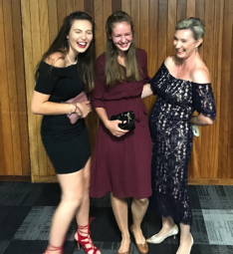

MEMBERSHIP REPORT
PP Angelo Puglisi

Despite many requests throughout the year for the nomination of new members, no names were forthcoming from our members. A list of five names was given to me by President Morwenna and out of this list two new members have joined the club. I have approached several members of the community and have not had any success. I wish the new board all the best for the new year.

BUSKING@STANTHORPE REPORT
PP Frances Hodgson
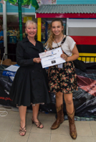
Busking@Stanthorpe 2018 was the first major event for this year’s Apple and Grape Harvest Festival. On a rather overcast Saturday 24th February large crowds braved the sporadic rain showers and threatening thunderstorms to once again enjoy a wide variety of busking performances along Maryland and High Street. This was the 3rd South East Qld Regional Final hosted by the Stanthorpe Rotary under the auspice of the Australian National Busking Championships (ANBC) Cooma.

Busking@Stanthorpe showcased the work of Rotary, the amazing talent of a large number of professional and amateur musicians, entertained crowds of locals and visitors and provided a financial boost to the many shop owners in the Stanthorpe CBD.

The Stanthorpe Business Community was again very generous with their support which enabled Busking@Stanthorpe to offer attractive prize packages totalling over $6000. POWERCAT provided the major sponsorship of the overall Open winner prize; McDonalds – the People’s Choice, Savina Lane – the Senior Section, M&D Auto – the Primary Section and Power Tynan – the Best Band.

Sponsors of the Special Judges Awards included: Argyle Jewellers; Carnarvon Funeral Services; Domino’s Pizza; Gino’s Floorcoverings; Helloworld; Mal Jackson Physiotherapy; Outrite Computers; Country Club Hotel; Stanthorpe RSL; Suttons. As well 17 local main street businesses sponsored the 15 busking sites set up outside their shop front.

29 busking acts arrived in Stanthorpe from areas such as the Sunshine Coast, Tambourine, Brisbane, Warwick, Tenterfield and of course the Granite Belt. In total there were around 70 participants performing at various times between 9 and 3.00pm. The judges Allan Spencer and Graham French from Cooma and Peter Robinson from Tenterfield were kept very busy all day observing each busker’s performance.

Due to the very inclement weather the Finals Concert was held at The Alley. Many thanks to Melissa and Shane Williams for allowing us to use the space and to Deb from the Community Op shop for supporting us with the set up. The acoustics were excellent and despite the warm conditions inside the Alley the crowd thoroughly enjoyed the smoothly organised concert. The Haystack Mountain Hermits were once again the overall winner and clear crowd favourite.
An amazing event such as Busking@Stanthorpe does not happen without the wide support of many groups of people. Very special thanks to the Busking Committee members- Rotarians: Stephen Tancred, Julie Beddow, Melissa Pascoe, Peter Klemm, Paul Campbell and members of the Apple and Grape Committee: President Greg Thouard, Rosey and Peter Harslett; Mary McLucas, Michelle Conkas for their hard work and commitment over many months. The Scouts and their leaders collected the People’s Choice slips all day and many Rotarians, Apple and Grape members and their families and friends worked tirelessly throughout the whole day.

Our Rotary profit margin was very small and down on previous years. However the committee has agreed that Busking@Stanthorpe is well worth continuing, particularly in connection with the Apple and Grape Harvest Festival.
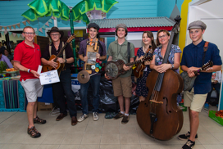

For updates on the next Busking@Stanthorpe in February 2020 keep an eye on http://www.buskingstanthorpe.org.au/
https://www.facebook.com/buskingstanthorpe/

OPERA IN THE VINEYARD REPORT
Wayne Mathers

The 26th annual “Opera in the Vineyard” was successfully held on Sunday 6th May 2018. The opera theme for 2018 was “Carnival of Venice” with many patrons wearing masks and costume dress to support the theme. The venue was Ballandean Estate. The event provided Lunch, Opera and a Dinner dance for those patrons who wished to participate and pay/donate for any one/two or all that the event provided. Qld Opera were again the performing artists. The singers were Ms Emily Burke and Mr Jason Barry-Smith with Ms Narelle French on piano. The performance was exceptional with several encores being performed. The number of patrons attending were 650 with 201 attending lunch and 297 the dinner/dance. The catering for the lunch and dinner was provided by Mr Jason Costanzo and his team and the feedback from patrons was that the quality of the food was exceptional. The band (Ginos’ band) used for the dinner/dance was again of high standard and the feedback from patrons was excellent. At interval the Rotary President Ms Morwenna Harslett accompanied by talented local musicians played Beethoven’s Romance in F Major whilst students collected loose change totaling almost $1800. Meals for Rotarians and volunteers were provided by Ms Ann Richardson and her team and were of an excellent standard. Buses to and from Stanthorpe for the venue were again provided by Crisp Coaches and a Tenterfield Bus Line who bought patrons to/from Tenterfield. Security was provided by Stanthorpe Security Services. The new hessian walkways/signage and toilets strategically placed in both northern and southern zones were a great success and overcame previous issues regarding safety and walking distance. The use of two EFT machines for providing cash was received well by patrons. The piano for use at the opera was donated by the SDRC with the only costs being removal, insurance and tuning. Many thanks to SDRC. This year a $10 per day charge was applied for Rotarians and Volunteers to cover meals/ drinks. This was instead of charging a blanket $30 charge to all whether you worked 1 day or all days. Rotarian and volunteer activity for the opera commenced on Wednesday 2nd May 2018 and concluded in force with the clean up on Monday 7th May 2018.

Issues arising from the 2018 Opera in the Vineyard.
-We had one injury to a Rotarian (Mr Jim Barnes) when he fell from a truck of truck when a load of chairs moved. This has been reported to Rotary Insurance, a report raised and corrective actions implemented for 2019.
-Ms Ann Richardson requires more lighting for the volunteer area. It is recommended that portable lights be purchased and these can also be used at the up-coming “Spooky Walk”
-Suggestion that instead of 2 EFT machines, it be increased to 4.
-Better system implemented for those groups running a bar tab.
-That a Chart be implemented for the 2019 opera which will detail timetables etc. for those individual operations that importantly need to be completed when holding an event.
-A staff roster be provided to all Rotarians early advising duties, timetables etc.
-A total review be held by the Board and Opera committee of the costs to hold the event and individual components of the opera. For all intents and purposes the 2018 Opera was very successful, but if you appraise the Treasurer’s report the dinner/dance component does not make money.
-Bus travel and fares charged need to be addressed. The costs from the two bus companies used this year totaled approx. $7000. We have recovered only $5300 from patrons thus a shortfall of $1700.We need to address costs, fares charged, bus operators used, whether all persons using the buses had paid.
-It is recommended that the opera committee meet one month earlier this year ie the first Wednesday in October to discuss the 2019 Opera.
-The opera committee invites suggestions from all Rotarians regarding a theme and means to make our opera more profitable.

SATELLITE REPORT
Kylie Linton

We started the Satellite Club with 10 enthusiastic members that had less time and more go. With the aim in mind to be MORE, more flexible with where, when, how long we meet and what our goals are, more community, more youth and more Rotary being seen in Stanthorpe.

We charted on the 18th January 2017 at the Queensland Wine and Tourism College unconventionally just like us. Our 10 members who support each other have been working on developing our club and with 3 of us attending RLI at the Gold Coast and starting the club development committee (CDC) to work out our bugs and set the satellite club up slowly but steadily with baby steps and strong foundations. The CDC has built the club structure around 5 elements:
- One monthly business meeting where we meet for one and a half hours to keep the club running
- An email education about our Rotary which is teaching us how and what Rotary is and how we are a part of it
- A social gathering where we get acquainted with each other and the host club members
- Personal community service whether this is under the Rotary banner with MOW, Busking or BBQ or being on a committee or on our own with helping with raffles, collection of bras or with CDS driving and food drives.
- Club community service focused on supporting local youth and we did this with our inaugural Spooky walk.
As members of the Stanthorpe Rotary Club we are happy to support of the sponsor club projects such as the Australia Day BBQ the Lamb Stall at the Show selling the busking dollars at the busking, and feeding the hoards of volunteers at the Opera the Christmas party and of course the DG visits and changeover.

This Year I have put something into place that I hope will not only be a good fundraiser for the Satellite Club but join the clubs together, Christmas in Winter Dinner, that we have taken on as our Christmas party with games and good food getting the two clubs together twice a year. Our Spooky walk which is a Stanthorpe youth and community minded Halloween event giving the parents somewhere to take their children and the kids a safe “off the streets” place to come and spook and scare each other. And with the DG visit and setting the two clubs up for some healthy competition with a pillow raffle competition to raise funds for ROMAC.

With pleasure I will now hand our baby Satellite Club over to Ann Richardson who has plans to grow a strong and active toddler over the next 2 years during her term as chair, but before that I would like to thank everyone who has supported our baby in the Rotary family, to Sandra and Sam Doumany, Stephen Tancred and David Hansen for getting us off the ground to Morwenna Harslett, Denise Harslett and Tony Heading for being our mentors this year and hope that the 2 clubs can grow together.
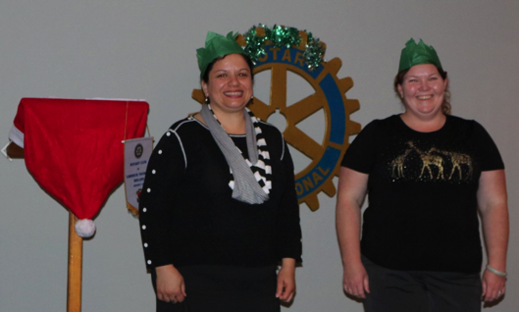

DIRECTORS for the 2018-19 Rotary Year

President Kim Thorburn
Vice President Tony Heading
President Elect Denise Harslett
President Nominee Julia Hassall
Immediate Past President Morwenna Harslett
Secretary Melissa Pascoe
Treasurer Peter Klemm
Satellite Chair Ann Richardson

Club Administration Julia Hassall/Julie Beddow
Membership Kim Thorburn
Public Relations Morwenna Harslett

Community Service Alec Harslett
Vocational Service Jim Barnes
International Service Bill Bonner
Youth Service Nicole Clark

