Login to ClubRunner at: www.ipswichrotary.org

From the Home screen, click on Member Area from the top menu

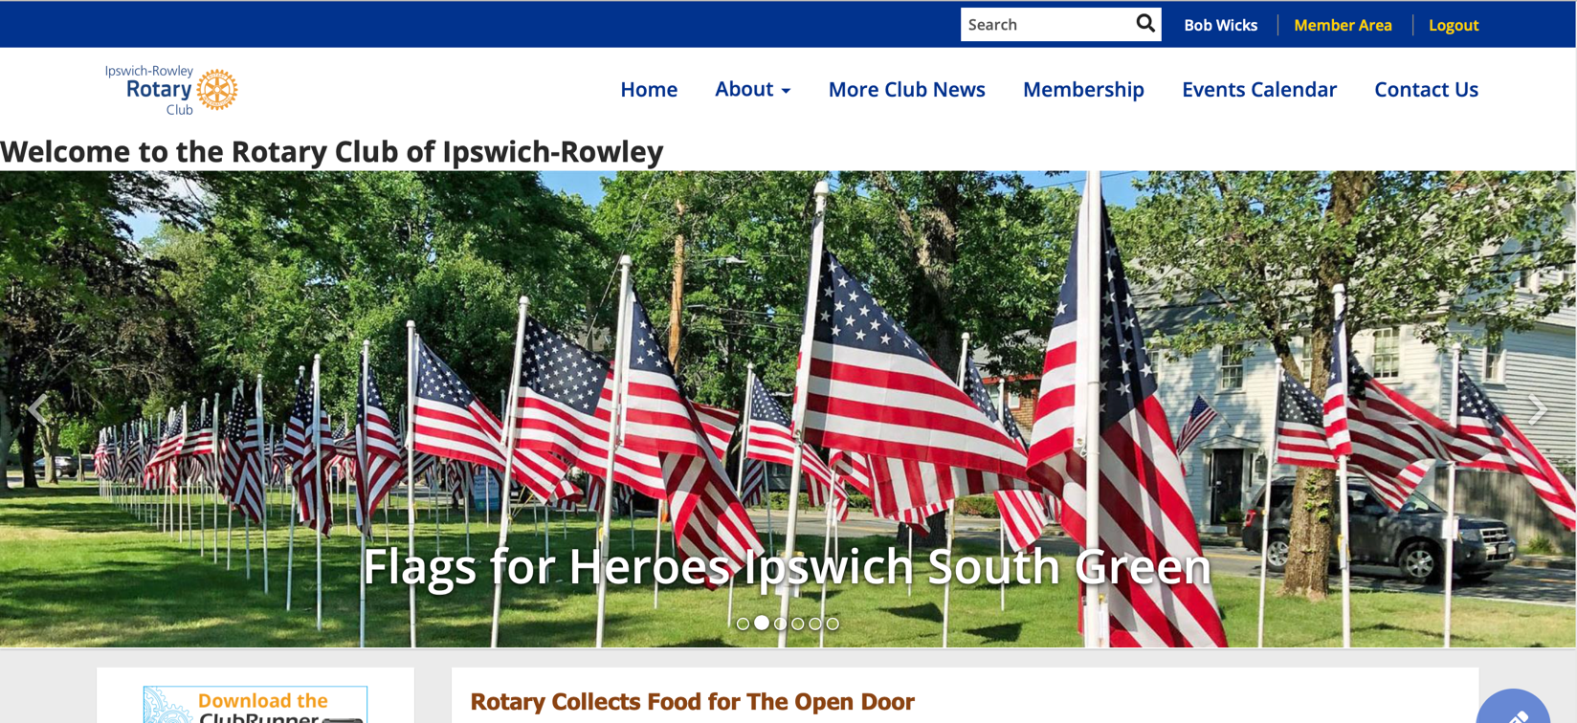

In the My ClubRunner menu, click on Email Services.

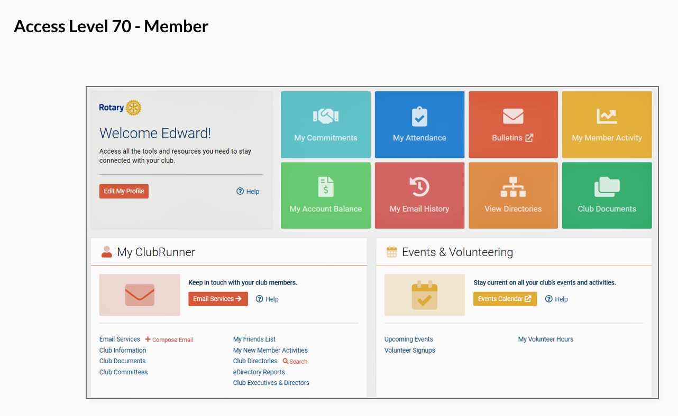
Note: the menu you see will depend on your access level in ClubRunner.

Under the Communication tab you will see Create Email.

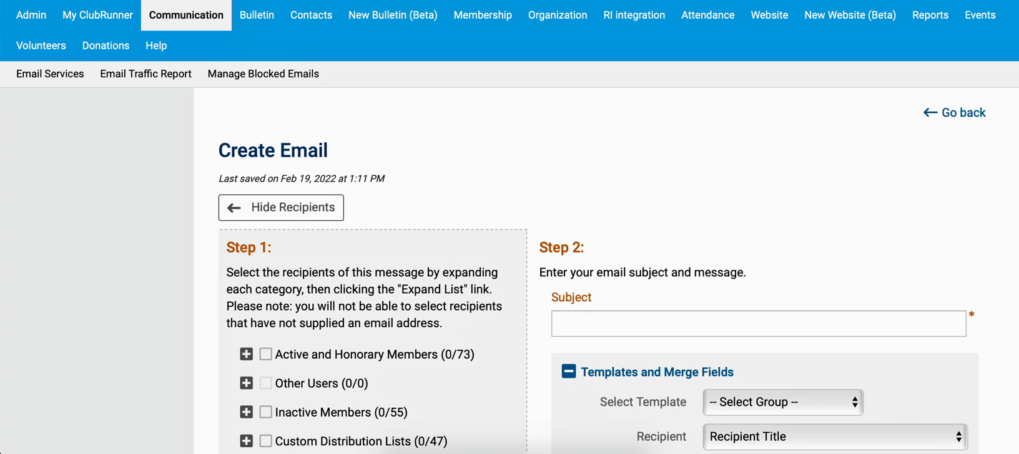

To continue, follow the step by step instructions in the following short video (8 minutes):

https://www.clubrunnersupport.com/kb/articles/video-how-do-i-send-an-email

This ClubRunner tutorial is another easy to use reference for creating and customizing your email:

https://www.clubrunnersupport.com/kb/articles/how-do-i-send-an-email

Recorded webinars, videos, and tutorials are available at any time in ClubRunner by clicking on the Help tab on the Admin menu in the Member Area.

