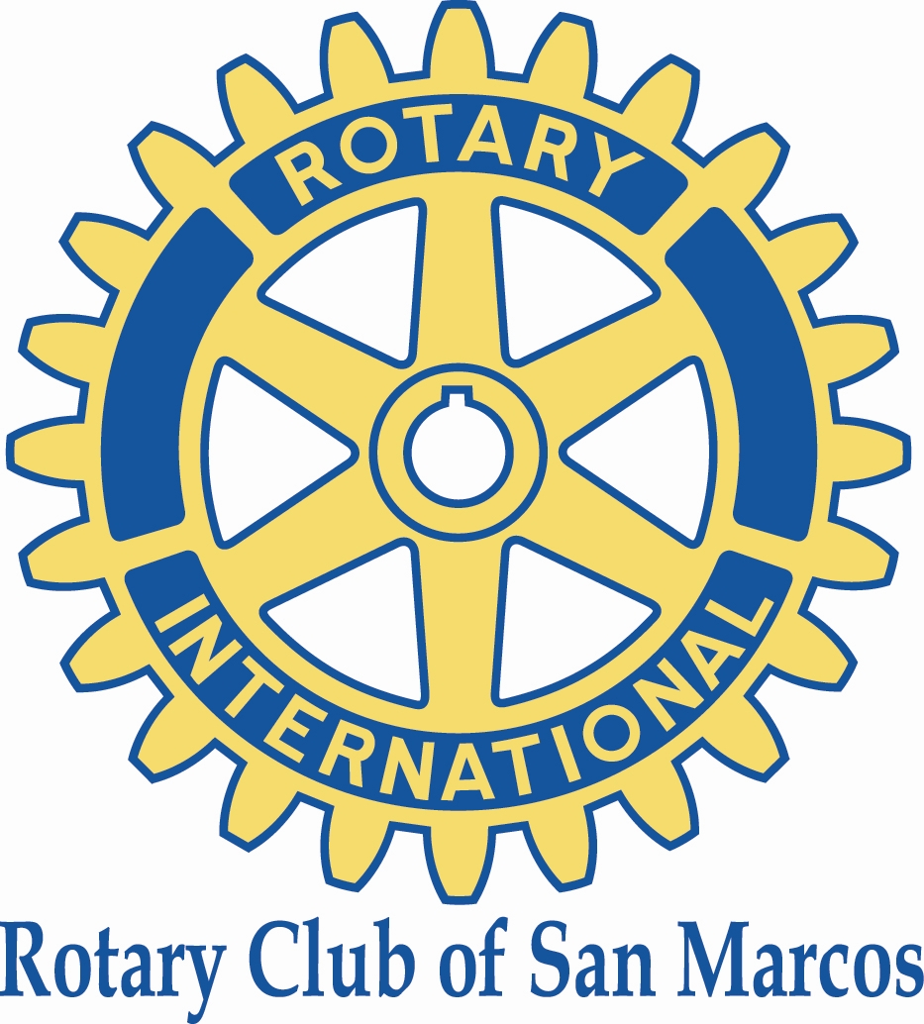

Rotary Club of San Marcos
2025 Scholarship Application

Application due Tuesday, April 1, 2025

The Rotary Club of San Marcos is a local chapter of Rotary International, a global organization of business and professional leaders who volunteer to address community needs. Our mission is to provide service to others, promote integrity, and advance world understanding, goodwill, and peace through our fellowship of members. Rotary’s motto is “Service Above Self”. The San Marcos Rotary Club Scholarship program has been developed to help students learn about Rotary and promote Rotary ideals. To learn more about Rotary, please visit www.rotary.org/en.

Rotary Club scholarships of $1,000 each will be awarded to eligible seniors from local high schools, including San Marcos, Mission Hills, Twin Oaks, and High Tech High, as well as students currently enrolled at Palomar College or Cal State San Marcos University. Students must have a minimum GPA of 2.5 and should demonstrate financial need in preparing for their next school year. A successful scholarship award recipient must emulate the culture and values of Rotary through volunteer work at his/her school or within the school’s service territory. Scholarships will be processed through the award recipient’s school of financial aid office, and must support specific educational expenses.

Date of application: _________________

First Name: ________________ Middle Initial: ___ Last Name: _________________________

Contact Information: Phone: __________________ e-mail: ____________________________

Mailing Address: _______________________________________________________________

______________________________________________________________

School Currently Attending: _____________________________________________________

Year in School: ________________________________________________________________

Student ID# ________________Proposed Field of Study: ________________GPA: ________

Reason(s) why you are applying for this scholarship? (250 word limit)

Have you been involved with any Rotary youth programs such as Interact, Rotaract or RYLA? Please explain (100 word limit)

Please outline your experience as a volunteer. Please highlight the charity/cause(s) that you supported and how the experience impacted your life? (250 word limit)

Please use the space below to indicate any other information you feel is important in consideration of your application: (200 word limit)

Please return application to: Rebecca Boyce at beckabk@msn.com
Deadline is Tuesday, April 1, 2025.

