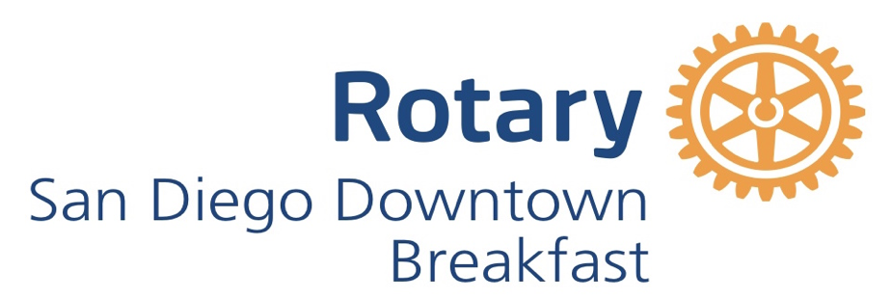

**SAN DIEGO DOWNTOWN BREAKFAST ROTARY CLUB**

**COMMUNITY SERVICE**

**GRANT REQUEST FORM**

APPLICATION DEADLINE **OCTOBER 15, 2024**

The San Diego Downtown Breakfast Rotary Club is soliciting grant proposals from non-profits that meet our criteria and that endeavor to make improvements in downtown San Diego and neighboring communities. We are especially interested in providing funds for specific items, or services that meet a particular need.

We are also looking for volunteer (hands-on) opportunities that may be available.

Parameters for grant approval:

* Must be a 501(c)(3) organization that has been in existence for at least two years.
* Must submit the non-profit's 2023 IRS Form 990 with the grant application.  If the 2023 Form 990 is not available, please explain why it has not been filed, and in its place please produce the most recent 990 filed by the non-profit.
* Programs or services must be delivered in our target area of downtown San Diego or neighboring communities. A site visit may be requested.
* No funding is available for capital campaigns, endowments, salaries, special events, or administrative expenses.
* Volunteer opportunities for our members are welcome, although not a requirement for funding.
* Grants typically range from $1,000 to $4,000.

**1. ORGANIZATION THAT CLUB MEMBER IS NOMINATING FOR A GRANT**:

**Name of Organization and the name and title of a contact person**. This should be someone who works for the nominated non-profit, and who can answer specific questions about the finances and operation of the charity.

Address of organization:

Phone number of contact person: E-mail address of contact person:

Organization Website: 501(c)(3) Tax ID Number:

page1image4214725088

Please provide a brief history of the organization and include its mission statement. Provide an explanation if the non-profit is part of a larger organization. (max. 100 words):

**2. PURPOSE AND AMOUNT OF GRANT REQUEST**

Project, or description of item(s) the funds are expected to pay for: Budget/expected cost of the item(s), or goods or services requested:

Amount Requested:  
Project Start Date or purchase date: Project End Date:

1. Describe the specific purpose of your project. (max. 100 words)
2. Describe specifically how the grant money is to be used. (max. 100 words)

(c) Describe your target population and number of people who will be served. (max. 50 words)

(d) List your project goals. (max. 50 words)

(e) How will you measure success? (max. 50 words)

**3. VOLUNTEER OPPORTUNITIES**

Members of our club would like the opportunity to volunteer with your organization. This could include, for example, preparing and serving a meal, acting as a mentor, running a clothing drive, painting a building, etc. Please list any potential volunteer projects that might benefit from our club’s involvement, including the dates of any specific volunteer opportunities.

**4. FORM 990 AND OTHER ATTACHMENTS**  
Required: **The organization must attach its two most recent Form 990s. (If these are not**

**available, please provide an explanation.)**

Sponsoring Rotary member’s name and e-mail address: Date submitted:

Please return this form and attachments to:

[CommunityService@sdrotary.org](mailto:CommunityService@sdrotary.org)

[rsemmer1@gmail.com](mailto:rsemmer1@gmail.com)

[dave@nokesandfox.com](mailto:dave@nokesandfox.com)