**Rotary INSTRUMENTAL MUSIC COMPETITION 2024-25**



**For High School Age Musicians**

**$2,000 Grand Prize**

**San Diego Downtown Breakfast Rotary Club Competition Weds Jan 29, 2025  
Regional Semi-finals Contests in February & March, 2025  
Finals in March or April 2025**

The purpose of the competition is to determine and recognize the student contestant demonstrating District 5340's greatest level of excellence in talent, training and love for music.  Prize money will be awarded at each level of competition: District 5340 Club Contests, Regional Semi-Final Contests, and at the District 5340 Finals Contest where a grand Prize of $2,000 will be awarded.  The applicants will be notified of dates and locations of the competition two weeks prior to the event. The Downtown Breakfast Rotary Club Contest (First Level) will be held Weds Jan 29, 2025 7:30-8:30am at the University Club, 750 B Street. For more information contact Janet White janetwhite99@hotmail.com

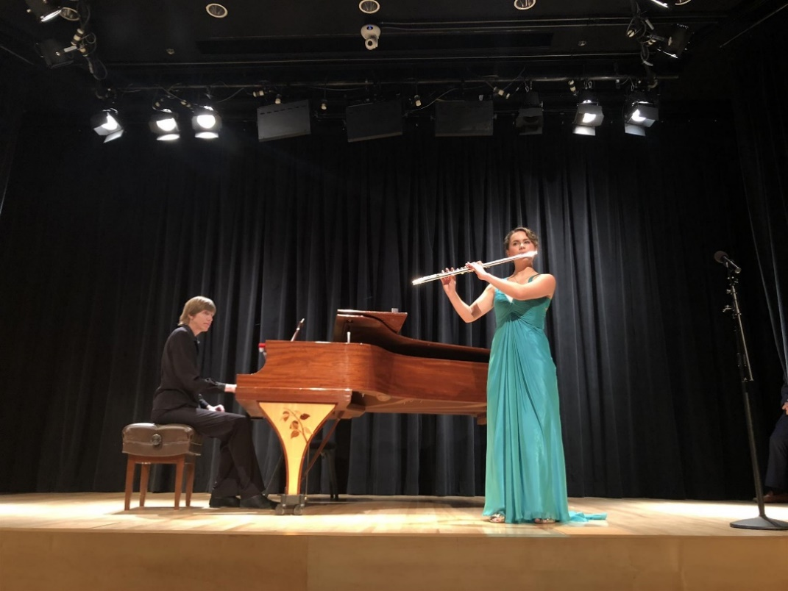

Page 1 of 2

**Rules**

1. Open to high school age students (14 to 18 years of age) residing in the District 5340 region. This regional eligibility encompasses all accredited high school curriculums geographically located within District 5340.
2. Limited to instrumentalists only. Any musical instrument is allowed.
3. Contestant must be sponsored by a Rotary Club within District 5340.
4. All contestants under the age of 18 must have a parent's or guardian's signature.
5. Performance time must be between 3 and 8 minutes, with judging penalties for going over or under the allotted time.
6. Winner of any level (Club or Area) must be able to compete in the next level to be eligible for the prize money.
7. Contestant is responsible for travel expenses.
8. Contestant is responsible for any accompaniment, if needed.
9. Must provide four (4) printed copies of music at each level of competition, for judges.
10. The decisions of the judges are final and are based on difficulty of the piece, command of the instrument, musical emotion, interpretation and stage presence. (see below)

**Judging**

* **Difficulty Level- 20%**  
  Difficulty of the piece. Is it easy? Very technical? Does it evidence an accomplished level of training? Is the piece memorized? ie: If the piece is easy, even if played perfectly, the performer may not get as high of a mark as a very difficult piece, which while not played perfectly, clearly took much more effort to prepare.
* **Command of the Instrument- 20%**  
  How familiar is the performer with his/her instrument, and do they demonstrate a technical mastery of the instrument being played?. This includes tone quality, command of lower and higher registers, note accuracy, attacks, articulations, rhythmic accuracy, breath control and intonation (with non-piano instruments)
* **Musical Emotion (20%)**  
  This includes tone, phrasing, dynamics and expression of emotion.
* **Interpretation (20%)**  
  While this aspect addresses the students’ understanding of the composer's original intent, style, tempo, phrasing and dynamics, we will also consider leaving room for an artist’s new interpretation, without marking the contestant down in the event of intentionally original, interesting and entertaining choices in their performance.
* **Stage Presence (20%)**  
  Does the contestant have command of the stage during their performance? Is there a sense of rapport with the audience, overall presentation, and some appropriate showmanship? This can be a positive, but not necessarily required.

Questions or would you like to learn more? Contact your local Rotary Club for information,

or Mary Taylor, 2023-24 District 5340 Chair of the Youth Instrumental Music Competition.