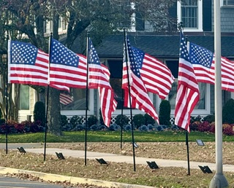
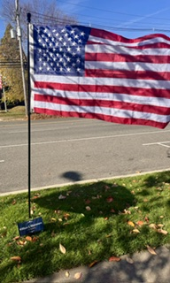
Flags for Heroes

Presented by the Rotary Club of Spring Lake-Brielle
Honor a hero. Celebrate their service. Fill our community with pride.
Flags for Heroes is an annual tribute to the men and women who are serving—or have served—in our military, living or deceased. Sponsor a flag in honor of someone special and help create a moving display of gratitude, unity, and remembrance.
These flags fly for all the people who have made a difference in our lives.
Rows of American flags will be installed at Divine Park in Spring Lake, New Jersey, and will fly for one full week:
November 9–16, 2026
Divine Park, Fifth Avenue, between Warren and Passaic Avenues
Spring Lake, NJ
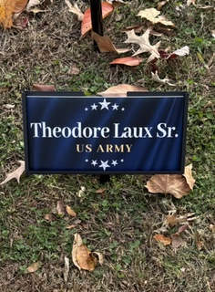
For some, the display is a quiet place for contemplation. For others, it is a sea of red, white, and blue to experience with family and friends. For everyone, it is an opportunity to reflect on the heroes in our lives.
Sponsor a Flag — $100
Your hero’s name and military branch will be proudly displayed with the flag throughout the week.
After Veterans Day, you may collect your hero’s commemorative plaque at a Rotary meeting. Visit our website for meeting times and details. springlakebriellerotary.org
Contact a Rotary Club of Spring Lake-Brielle member to sponsor a flag and help us fill the park with pride, honor, and love.
See the attached sponsorship form for additional information.

