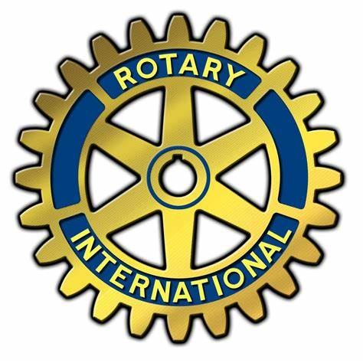
Point Pleasant Boro Rotary
invites you to our
Wine and Cheese Membership Drive

Wednesday, October 20, 2021
6:30 PM

The Rotary Club of Point Pleasant Boro is a volunteer service organization whose members donate their time and resources to help others in the community and throughout the world.

We meet on the first and third Wednesday of every month and we welcome all community minded people interested in learning more about our activities and the mission of Rotary.

If interested in attending, please RSVP by 10/15 to PtBoroRotary@gmail.com or call or text to 201-725-1499.

