eaglehawkrotary@gmail.com www.facebook.com/eaglehawkrotaryclub
www.eaglehawkrotary.org.au
Club No 18317
ABN 18279406625
Chartered 8th August 1966.

Volume 55 - Number 43 – May 6th 2020

Meet Wednesdays 6.00pm for 6.30pm start

at California Gully Mechanic’s Institute Eaglehawk.

Position | Name | Mobile | Email Address
President | John Jones | 0419 113 065 | jjones@netcon.net.au
Secretary | Alison Bacon | 0417 562 952 | eaglehawkrotary@gmail.com
Bulletin | Alison Bacon | 0417 562 952 | eaglehawkrc.newsletter@gmail.com
Treasurer | Ron Payne | 0419 946 994 | ronald_payne1952@outlook.com
R.I. President | Mark Maloney
District Governor | Grant Hocking
Assistant Governor | Cliff Downey

MAY
Birthdays
2nd Geoff Adcock
4th Sarah Wainwright
5th Maria Cogo
16th Graeme Lock
17th Howard Osborne
18th Gail Fitzpatrick

Inductions
15th Brian Fitzpatrick (2019)
22nd John Gurr (1974)
22nd Lindsay Roberts (1974)
28th John Jones (2003)
31st Gary Frank (2017)

Anniversaries
16th Rod & Jeanette Hanson

Our Rotary meetings are currently being held online via zoom.

See below for details on the program for each Club meeting.

Dates for Your Diaries
May 13th | Club General Meeting – Zoom – Log in using this link https://us02web.zoom.us/j/88102433477  Luisa Flinkmann (past Rotary Exchange Student) will be joining us from Germany to give us an update on her life since returning home.
May 20th | Club General Meeting – Zoom – Log in using this link https://us02web.zoom.us/j/88102433477
June 24th | RC Eaglehawk Changeover
June 27th | D9800 Changeover

President John was an apology for the meeting as he is a bit busy with family and grandparenting commitments this week.

Good to see plenty of members joining into this weeks online meeting. We welcomed our newest member Lindsay to his first official meeting and was pleased to have Geoff Adcock join us – the wonders of electronic meetings, Geoff is actually still in hospital and undergoing rehabilitation from his recent knee replacement surgery – great to know he is doing well.

Doug Harrison also joined us and advises that his health is now much better. Lyn remains in hospital and is becoming frustrated at how slowly her recovery is going. We send our best wishes to you Lyn, and look forward to when you are again able to join us.
Tara and Michael with their cute new bundles of joy - Georgia Claire and William John

Tracey Clarke – Eaglehawk Community House.

Tracey Clarke reports that the Eaglehawk Community House has discovered a ‘new normal’ as has many organisations at the moment. From catering for 50 meals a week covering approximately 30 addresses pre social isolation the community house is now catering for in excess of 500 meals being delivered to some 100 addresses.

A large pool of volunteers are working under strict conditions and are all doing a great job achieving what needs to be done for the community. The community house food support is possible by the donations from external organisations such as foodshare and foodbank along with others. Additional volunteers who now find themselves out of work have stepped in to assist with the meal preparations and this has been a wonderful and much appreciated addition.

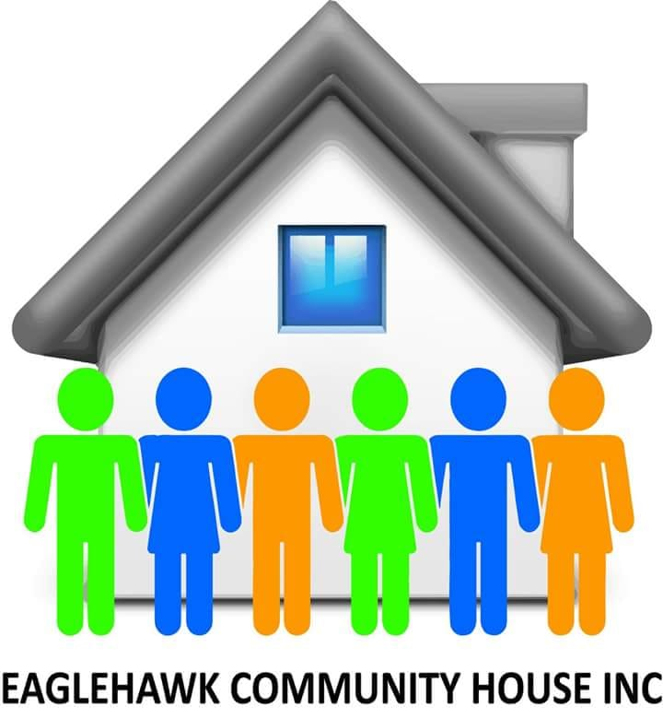
With the Community House being considered an essential service the role it is playing in the community is of utmost importance in identifying the unmet needs within the community and initiating a response. It is indeed a great example of ‘Connecting the Community’.

Under normal operating conditions it is normal for the house to see 200-250 people through the doors in any one week with the regular schedule of activities. Recent improvements to the facility that were initially undertaken to enhance the services being provided and to provide greater flexibility have indeed been very timely as it has enabled the volume of meals now being prepared.

Tracey spoke about the mental health aspects of the current situation and acknowledged that there is a need for increased awareness in this regard given the current social restrictions and the associated fears and stresses being felt within families.

Increased funding is high on the wish list for the centre, with current grant applications in the works there may be some success in this regard in the future but in the meantime, any financial assistance would be most welcome.

And in other news –

An offer to any Rotarian who is aware of any group or organisation that may benefit from some extra reading materials at the moment – simply contact Rita and arrange to collect what you need. Rita will be needing some additional help at the book shop too, as books will need to be sorted and some are ready for recycling. So, any members that have some spare time available and would be able to help with some of the jobs that need to be done, please call Rita and arrange when you are able to do this.

John Gurr reported that while Jack Millonig may be unable to participate in our meetings he sends his regards to the club and our members.

Member Announcements and Information

The Club’s Tattslotto Comp is now underway and we will list the winners each week here for you to see who won when you didn’t!

Winners to date are –
25/4/2020 Number 31 Geoff Gallagher
2/5/2020 Number 35 Leon Scott

From the Rotary Club of Canterbury

In the midst of the Covid-19 crisis, there is an opportunity to brighten the days of your family and friends by inspiring them to celebrate World Bee Day on 20 May.

As part of the celebration between now and then they can learn the ‘Waggle Dance’, video themselves doing it, and upload it to the World Bee Day website!

The main purpose of World Bee Day events is to spread awareness of the significance of bees and other pollinators for our survival. Simply proclaiming World Bee Day does not do much for bees and other pollinators; the main work of safeguarding their existence still needs to be undertaken. World Bee Day is an excellent opportunity to put bees at the centre of the national conversation for a day and encourage actions that create more bee-friendly landscapes.

Because of the lockdown, World Bee Day celebrations have been forced online, but they are energetic and full of fun. Besides the Waggle Dance, there is also a special screening of the most wonderful film ‘Honeyland’ on 20 May.

To find out more about World Bee Day click here.

The 2020 Global Online Waggle Dance Challenge is an attempt to achieve 20,000 waggle dance videos, from 20 countries, in 20 days, ending on the 20th May 2020. The figure 20,000 was chosen because that’s how many species of bees there are doing extraordinary work for the planet every day. The Waggle Dance music by Gus MacMillan and Jane McCracken, and which is owned by Rotary Club of Canterbury, can be downloaded from the iTunes store. You can watch the video online to learn the dance.

Register for the Global Waggle Dance Challenge here.

Please pass this information on and encourage all your contacts to embrace this unique event. And start planning your outfits! Zoom-ba Waggle dance lessons will be scheduled soon.

Kind regards

Lili-Ann Kriegler
President, Rotary Club of Canterbury

Club Face Book Page

https://www.facebook.com/EaglehawkRotaryClub/

Continuing our posts that are visiting the local landmarks and projects supported and/or provided by our club we head back down to Lake Neangar where on the shores you will find the McKern Skate Park. Funds raised by our club and a labour of love and extreme devotion by our Past President Howard Osborne, the skate park has long been regarded as one of the best in the State. A hive of activity on any given day, a brilliant facility that caters to the skaters, both young and not-so-young from far and wide. A truly amazing project that was years ahead of its time and remains as one of the standout achievements by our club.

Make sure you click the ‘like page’ and the ‘follow page’ buttons that appear directly under the page header so you get the best chance of seeing these stories as they are posted, and of course share them so all your friends can see them too!

FOR SALE *** Rotary Keep Cups *** FOR SALE

Our District 9800 Conference Committee has worked hard to minimise the impact of the cancellation of the conference, and we are extremely grateful to all who have supported and assisted us in this process.

We now have the opportunity to offer you a unique opportunity of a different kind. We have a supply of Rotary branded 'Keep Cups' that were designed and ordered for our conference that are now available for purchase.

They are easy to order by simply going to –
https://www.trybooking.com/BJKLH

All Prices include postage direct to your home.
1 cup $22, 2 cups $40, 3 cups $60 and 4 cups $80....

Ensure you secure your very special Rotary Keep Cup.

ORDER NOW!

Dealing With COVID-19 Anxiety
Many people will be feeling more anxiety than usual due to the COVID-19 situation. As well as the possibility of becoming infected, many people will face other possible threats, including loss of income, shortage of supplies, unemployment, and social isolation. It is important to remember in this situation that anxiety is to be expected and in most cases will be an adaptive response which prepares people for action and protects them from danger. Anxiety is generally a normal and useful emotion!
Anxiety only becomes a problem when it leads to maladaptive coping, such as interfering with sleep, leading to excessive time worrying and interfering with ability to carry out everyday tasks. Below are some tips to assist in dealing with COVID-19 anxiety.
If the anxiety problems are mild, then they can be managed with self-help methods. Here are some to consider, which are supported by experts as often useful in managing anxiety:
- Use Methods to Reduce Physical Tension. Times of high anxiety can be relieved by exercise or progressive muscle relaxation. Regular exercise, like daily walking or cycling, can reduce anxiety. Online instructions for progressive muscle relaxation can be found here. Mindfulness is also useful when feeling anxious: bring your attention to what you are experiencing at that moment, and non-judgementally observe your thoughts, feelings, and sensations. There are free online instructions for mindfulness, see example here. Meditation is good to do on a regular basis (i.e. not just as a way of coping at a time of anxiety) – whether it be mindfulness meditation or another form. A lot of anxiety is caused by thinking about future events that haven’t happened yet, and mindfulness can help with that. Also consider trying yoga, some forms of which include mindfulness.
- Seek Social Support. While some people can contribute to anxiety, other people can play a role in managing or overcoming anxiety. It is a good idea to seek support from friends, family, or others. More specifically, it can help to talk about problems and feelings with a trusted person who will listen and understand. In the current situation where social distancing is recommended to reduce the chances of infection, it is important that people do not become isolated. Phone, text and Skype contact may need to be increased.
- Adopt a Healthy Lifestyle. There are a number of lifestyle habits that can help anxiety. These include: engaging in regular aerobic exercise (e.g. walk, jog), spending time in contact with nature, maintaining a regular sleep pattern, having regular leisure time (e.g. pursuing a hobby), eating regular meals, and reducing or eliminating use of alcohol and other drugs.
- Cultivate Acceptance. With the COVID-19 situation, there is a lot of uncertainty, which can contribute to anxiety. In such situations, it can be helpful to accept that there will be uncertainty and questions without immediate answers. It is possible to practice accepting uncertainty, e.g. by not responding to the thoughts and feelings that go with it, recognizing it is part of life, bringing your attention to the present. All these efforts towards acceptance can make a difference to how much a person is bothered by anxiety.
If anxiety gets out of control and cannot be managed with self-help methods and support from others, then professional help is warranted. Because of the need for social distancing to prevent spread of COVID-19 and the increasing demands that will be placed on the health system, online therapies are a good point of initial professional help. Australia is fortunate to have some excellent online therapy that is freely available. The following services provide evidence-based treatment for anxiety disorders:
- MindSpot provides online therapy supported by a mental health professional. Treatment courses are available for PTSD, OCD and other disorders. It can be found here.
- Mental Health Online provides treatment for Generalized Anxiety Disorder, OCD, Social Anxiety Disorder, PTSD and Panic Disorder. It can be found here.
For other mental health advice during this time, visit this link. For 24/7 Crisis Support, call Lifeline: 13 11 14.
Written by Professor Anthony Jorm, Australian Rotary Health Research Committee Member and Rotarian (President RC Carlton).
https://australianrotaryhealth.org.au/dealing-with-covid-19-anxiety/
Keep in shape with five key exercises The 5BX program involves five basic exercises, takes just 11 minutes and does not need equipment.

In these self-isolating times, I have gone back to the future for my workouts, replacing my four times a week gym therapy with just five calisthenics exercises developed by the Royal Canadian Air Force.

Dubbed the 5BX program, it involves five basic exercises, takes just 11 minutes and needs absolutely no equipment. The program, launched in the 1950s, has also been credited with starting the fitness boom after it sold 25 million copies. Now, as we emerge from our chocolate egg comas, it offers a gentle way to kickstart our fitness routines.

Celebrity devotees include Helen Mirren and generations of British royals. I first came across it on my parent’s bookshelf when I was a kid. As someone who wouldn’t be seen dead in a gym, it suited me then, and now as someone who can’t do without gym, it suits me now. The five exercises boost flexibility , strength and aerobic fitness .

STRETCHING
At the start, this is simply touching your toes. But as you advance, add extra touches to your left and right. The advanced level calls for upright torso circle bends. I’ll never get there.

SIT-UP
This starts as merely raising your head and shoulders off the floor before progressing into a full blown sit-up . Keep your back straight.

BACK EXTENSION
Be still my middle-aged back! This is actually great for reducing lower back tightness. Lay on your front and raise your head and legs off the floor . (Vacuuming carpet beforehand is essential.)

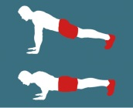
PUSH-UP
Builds arm and shoulder strength. Starts as a simple push-up from the knees. Graduate to a full pushup and then adds a forehead touch to the floor for extra difficulty .

RUNNING IN PLACE
This is the high intensity part. Start with just 100 steps in six minutes, before increasing steps. But every 75 steps, add another exercise, such as scissor jumps, knee bends or star jumps. Developed initially for men, 5BX was soon joined by the XBX program for women, which adapts the five original exercises and adds five more.

Each original exercise starts with a basic movement modified for women, before becoming progressively harder. Then five new exercises are designed to improve flexibility , strength and aerobic capacity. Two are performed while laying on the floor : side leg raises while lying sideways and alternative leg lifting while laying on the back.

The remaining three exercises are performed standing: front knee raises, lateral side bending while sliding the arm down the leg towards the ankle and circling arms forwards and backwards.Some criticise the program as old-fashioned and potentially unsafe in its advanced phases. But the instructions are clear. Start at the very bottom of the first chart, never skip a level, and don’t fast track.‘‘ My impression is that the 5BX is a very thorough program,’’ says Professor Emmanuel Stamatakis, from University of Sydney’s School of Health Sciences.

‘‘ Considering all the circumstances of COVID-19 this will be very suitable for some people because it requires no equipment.’’

Find the program on Amazon or online at fit450.com.
BY STEPHEN BROOK Copyright © 2020 The Age April 13 2020

