ROTARY HERITAGE WALL
Rotary Park Scenic Drive Wanneroo

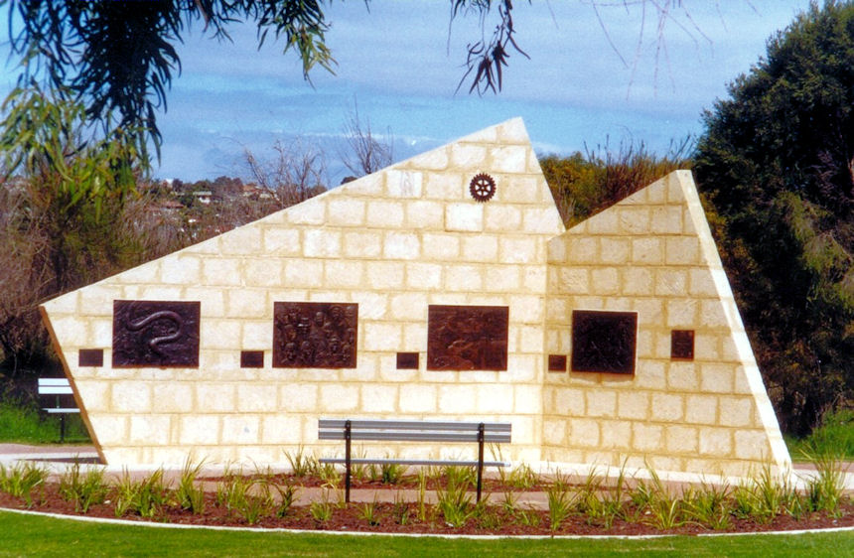

Dedicated Sunday 9th September 2001

The limestone sculptural wall can be interpreted as being two rectangular stone tablets seen to be rising from or pushing through the earth's surface. These tablets intercept each other and although they may appear to oppose one another in direction they actually support and benefit each other. It is in a similar manner that our country and our community has progressed, we have acted likewise, supporting each other as our multicultural society has moved forward, and although at times we may appear to oppose each other in various thoughts and actions, it has only been through our combined efforts that we have made such great progress during the first hundred years of Federation.
Bill Jeffrey,
Project Coordinator
Rotary Club of Wanneroo (Inc.) 2001.

HERITAGE WALL RELIEFS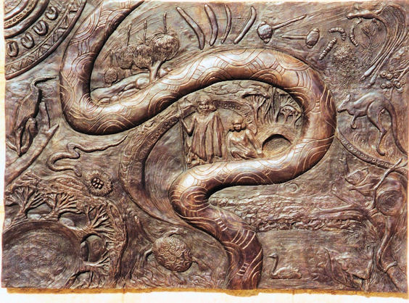
The Indigenous Australians
The local Nyoongar Aboriginal people living in spiritual harmony with the land traveled back and forth across the coastal plain according to their six seasons. With the change of these seasons their food resources changed as well. Places of fresh water bear special significance, not only for animal and plant communities, but also to the Nyoongar's spiritual connection to Boodja' (Earth Mother)

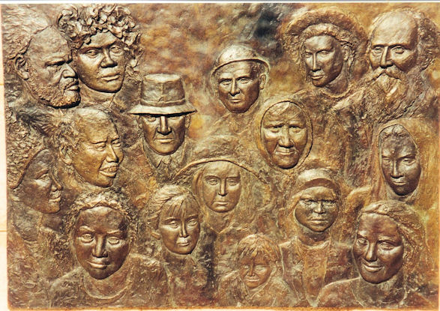
Early Settlers-Multiculturalism
A vital element of Australia’s successful democracy is the diversity of its multicultural populations depicted here by the many faces of different nationalities. The earlysettlers from Great Britain, together with people from the Italian and Slavonic nations and later with many other nationalities to arrive in our community have united in progress during the first hundred years of federation.
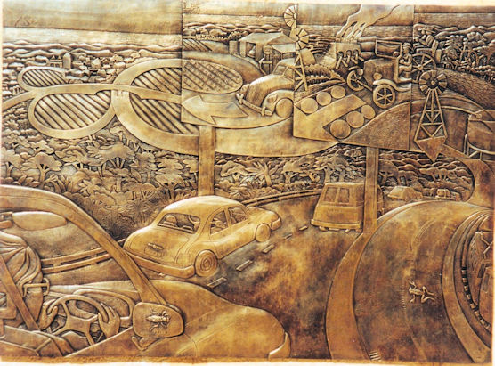

Transport
From the earliest bush tracks and jarrah block roads to bituminised highways freeways and electric trains, our transport industries have supported the needs of residents, industry and commerce as the northern corridor continues to develop and expand.

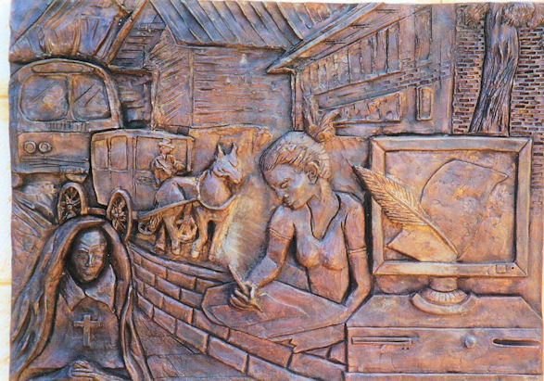

Education

The last hundred years of education in the City of Wanneroo are contrasted dramatically with the symbols presented. A juxtaposition of symbols of the past and present create an image which reflects our history and pride in our achievements. The development of technology has taken us from the quill to the computer. School buildings and transport have improved and the student, being central to the theme, represents the vast freedom of education and opportunity available today.

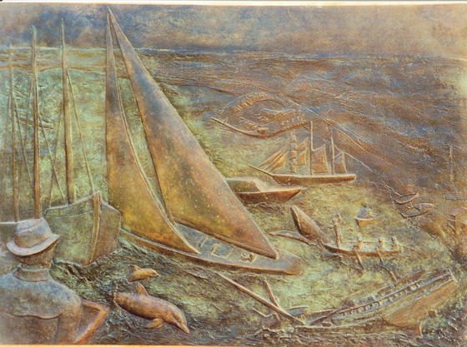

Coastline

The city boundary to the west, the coastline from Mindarie in the south toYanchep-Two Rocks in the north has always played an important role in the lives of all who enjoy its bounties. The ocean and beaches have been an important source of food and recreation to many communities. They also support commercial and recreational fishing, swimming, surfing, boating and camping as well as whale watching.

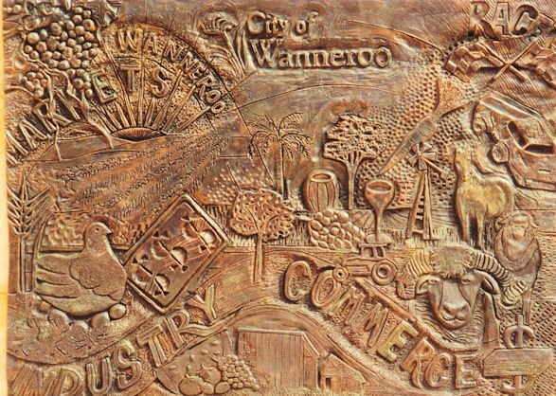

Industry and Commerce
From primary production and humble beginnings the City of Wanneroo now offers a wide variety of primary and secondary industries as well as commercial, financial, government agencies and services

.

Wanneroo Agricultural Society Show

Rotary Club President Ed Wall and Michael Aspinall, President of the Wanneroo Agricultural Society unveiled this relief on November 1st 2009. It depicts the annual social event where local families have met to display their produce, livestock and craft over the last 100 years.

Agricultural Society President Michael Aspinall
and Rotary President Ed Wall

