**THE ROTARY CLUB OF NUMURKAH Inc.**

**ANNUAL REPORT**

**&**

**FINANCIAL STATEMENTS**

**20**

**22**

**-**

**2023**





**CONTENTS**

2022 - 2023 Board Members 3

2023 - 2024 Board Members 4

CHANGEOVER PROGRAM 6.30pm 26/06/2023 4

PRESIDENTS REPORT 6

CLUB SERVICE REPORT 9

PUBLIC RELATIONS REPORT 10

ART & CRAFT EXHIBITION REPORT 11

COMMUNITY SERVICE REPORT 13

INTERNATIONAL REPORT 16

FOUNDATION REPORT 17

Mission Statement 17

***Share System*** 17

***To Donate*** 18

***Grants Subcommittee*** 18

***District Grants*** 18

***Peace Fellowships*** 19

***Alumni*** 19

***Every Rotarian, Every Year (EREY)*** 20

***The Paul Harris Society*** 20

***Polio Plus*** 21

YOUTH REPORT 21

VOCATIONAL SERVICE REPORT 22

RIDE TO CONFERENCE REPORT 23

FINANCIAL STATEMENTS 26

|  |  |
| --- | --- |
| 2022 – 2023 Board Members | |
| President | Rex Shields |
| President Elect | Julie Andrew |
| Past President | Gary Phillips |
| Secretary | Jennifer Rodger |
| Treasurer | Stephen Mills |
| Public Relations | Lou Hamon OAM |
| Club Service Director | Geoff Austin |
| Community Service Director | Julie Andrew |
| International Director | Kate Hodge |
| Youth / New Generations Director | Michelle (Squish) Davis |
| Vocational Service Director | Chris Hardham |

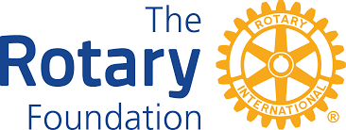

|  |  |
| --- | --- |
| 2023 – 2024 Board Members | |
| President | Julie Andrew |
| President Elect | Linda Boyd |
| Past President | Rex Shields |
| Secretary | Chris Sutton |
| Treasurer | Stephen Mills |
| Public Relations | Lou Hamon OAM |
| Club Service Director | Mark McNamara |
| Community Service Director | Geoff Holmes |
| International Director | Jennifer Rodger |
| Youth / New Generations Director | Michelle (Squish) Davis |
| Vocational Service Director | Jeff Buzza |

# CHANGEOVER PROGRAM

# Monday 26th June 2023 at 6:30pm

|  |  |
| --- | --- |
| Master of Ceremonies | John Watson AM |
| Acknowledgement of Country | Sally Rose |
| Master of Ceremonies | John Watson AM |
| Toast to Rotary & Rotarian Partners  Rotary Grace | Geoff Stewart  Terry Brennan |
| President’s Address  Annual Report 2022 -2023 | President Rex Shields |
| Presentation of Paul Harris Fellows | DG Neta Kirby |
| Community Service Award | Julie Andrew  Community Service Director |
| Vocational Service Award | Chris Hardham  Vocational Service Director |
| Induction of 2023-24 President | DG Neta Kirby |
| Incoming President’s Address | President Julie Andrew |
| Introduction of 2023-24 Board | President Julie Andrew |
| Sergeant’s Session | Linda Boyd |
| Close of Meeting - 4 Way Test | President Julie Andrew |



# PRESIDENTS REPORT

It has been an honour to lead the Rotary Club of Numurkah for the last 12 months. It was great to meet face to face for the last 12 months without any COVID restrictions.

This year we have inducted 4 new members, which I believe has changed the demographics of our club. It’s been a win/win situation for our Club.

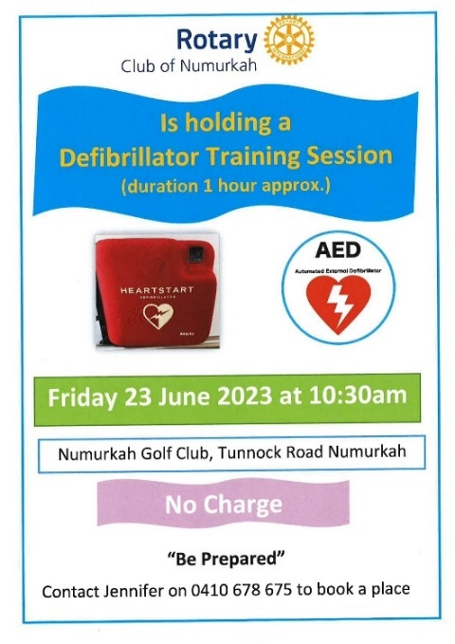We had a very successful 43rd Art & Craft Show – thanks to everyone involved, they do an amazing job every year. The proceeds from the Art Show Raffle went to help purchase 4 defibrillators for the town. These defibrillators are accessible 24 hours & will be serviced & maintained by the Rotary Club.

We still have the Breakfast Club at the Primary School. Since the Rotary Club has come on board, the teachers have reported a great improvement in the children’s attentiveness in class. The members that are volunteering are getting great satisfaction from it, well done to all.

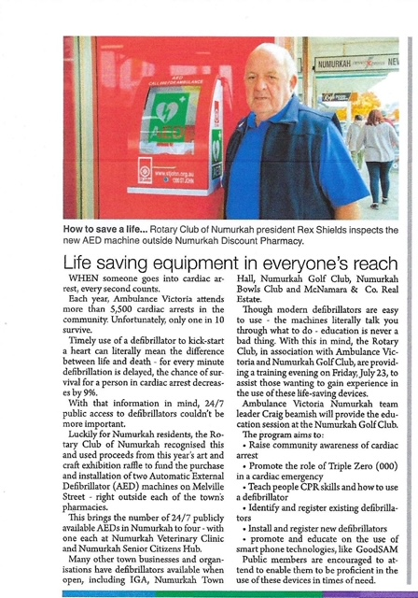

We had another very successful 4-wheel drive (environmentally) weekend. It was that successful, they had to limit the number of entries. Well done to the 4-wheel drive committee, you are going from strength to strength.

We had the inaugural Open Garden Weekend, which was a huge success. We need more gardens to put on display to make this a far better community project. Thanks to all the gardeners.

Sally Rose, Deputy Municipal Recovery Manager with Greater Shepparton Council & Trudi Pratt, Emergency Management Co-ordinator with Greater Shepparton City Council & Moira Shire, spoke to the club about the response, relief & recovery undertaken with the floods in Shepparton & Moira. Incident Control Centre (ICC) set up for such events & disasters as the emergency management control point.

Staffed 24 hours by all agencies with people skilled in the event, responding to intel. Council’s role is to support the agency, not respond until requested. Unless request to assist, Council is not funded. Next process is the establishment of MICC (Municipal Incident Control Centre), taking instructions from ICC to get systems in place to follow requests from ICC.

Flood different to previous floods, with overland flooding joining river flooding. Emergency Centres were set up in Shepparton & Tatura (either side of the Goulburn River), with up to 400 people housed. Staffed by council, St John’s Ambulance, Salvation Army & Service Clubs, providing needs & services to those displaced. Moira Shire has 31 relief centres. Learning from what we know, what we have done, & what we need to do to facilitate recovery. Moira minor to moderate flooding, a Murray River event.

During the floods we got a call from Kaarimba for sandbaggers, when we arrived, we discovered that there were 70 sandbaggers working hard that hadn’t been fed for quite some time. Rotary went into action, supplied & cooked food for the sandbaggers for the next 3 days.

The profits from the very successful Show Us Your Wheels BBQ in the main street of Numurkah – good to see the money going back into the community, from the community, well done all.

To our guest speakers, which I have listed below a very special thanks – it makes our weekly meeting interesting & informative.

* Craig Beamish Ambulance Australia
* Debbie Fowler Bohollow Wildlife Shelter – The Public Advocate
* Mark Peterson Dairy Bio-dynamic
* Robin & Paul Lindsay Farming enterprise
* Omen Volovu Malaga House Nathalia
* Wayne Limbrick Umoja Orphanage
* John Rhodes Country Fire Authority
* Garry McNamara Army Life
* Kushall Kishore Discount Chemist Numurkah
* Jason Stevenson Stevenson Fabrications
* Father Jophin Joy Catholic Priest, Numurkah & Nathalia Parishes
* Clive Deetlef GrainCorp
* Louise Hall Lebrunes Syndrome
* Ivan & Andrew Routley On-site inspection of a modern horticulture farm
* Cath Eddy Principal, Numurkah Secondary College
* Geoff Holmes Community Service at a club assembly
* Jeff Blackley Numurkah Historical Society
* Bec I’Anson Councillor, NCN Health
* Les Lawrence (Shield) Rotary Club of Nathalia
* Combined meeting with Lions in January
* David Hodge Vintage Tractor Exhibition
* Darcy Brennan Community Foundation
* Shelagh Curmi Trust for Nature at Kinnaird’s Wetlands
* Grant Power ex Army
* Faye Holmes Children learning to cook
* Squish Davis Led us in a different approach to trivia
* Mark Nordbye RFDS at the combined services dinner
* Phil Seager Antarctica
* Kevin Morland Numurkah Golf & Bowls Club
* Donny Sofra Aftermath of Kaarimba floods
* Craig Brown Aftermath of Kaarimba floods
* Lily Harrison Assistance dogs
* Jeff Buzza Men’s Health

If I had one wish as President it was to have more defibrillators available to the Numurkah community 24 hours a day and 7 days a week. In July there was one such defibrillator at the senior citizens club. I am happy to say there are 6 defibrillators in this category in Numurkah now. The Rotary club of Numurkah installed 2 in the main street outside the chemist shops. We have installed another in the BBQ trailer this was funded by the Golf club grant of $1,000 and another donation of $1,000 from Mark Bunny at Numurkah Bearings and Hydraulics.

The Numurkah Wunghnu Cemetery Trust has installed one at the cemetery, funded by a grant from local member for Nicholls Sam Birrell. The final defibrillator was installed at the Numurkah Vet clinic and the cost shared by them and Seiter’s Timber and Hardware.

On Friday June 23 our Rotary club in conjunction with the Numurkah Golf Club and Ambulance Victoria conducted a training session to make our community more familiar with defibrillators. These defibrillators are all the same brand which will make it easier to keep them up to date.

I would like to thank the people of Numurkah, the business houses of Numurkah and our members for making my term as president of the Rotary Club of Numurkah so rewarding. By working together so much more can be achieved.



Have a good year and my thanks.

**Rex Shields**

**President of the Rotary Club of Numurkah**

# CLUB SERVICE REPORT

The following persons were interviewed as prospective members of the Rotary Club of Numurkah:

* Wilma Crowther
* Rennie McDermott
* Colin Steel
* Susan Church

All four persons were approved by the membership and subsequently inducted into the Club.

**Geoff Austin**

**Club Service Director**

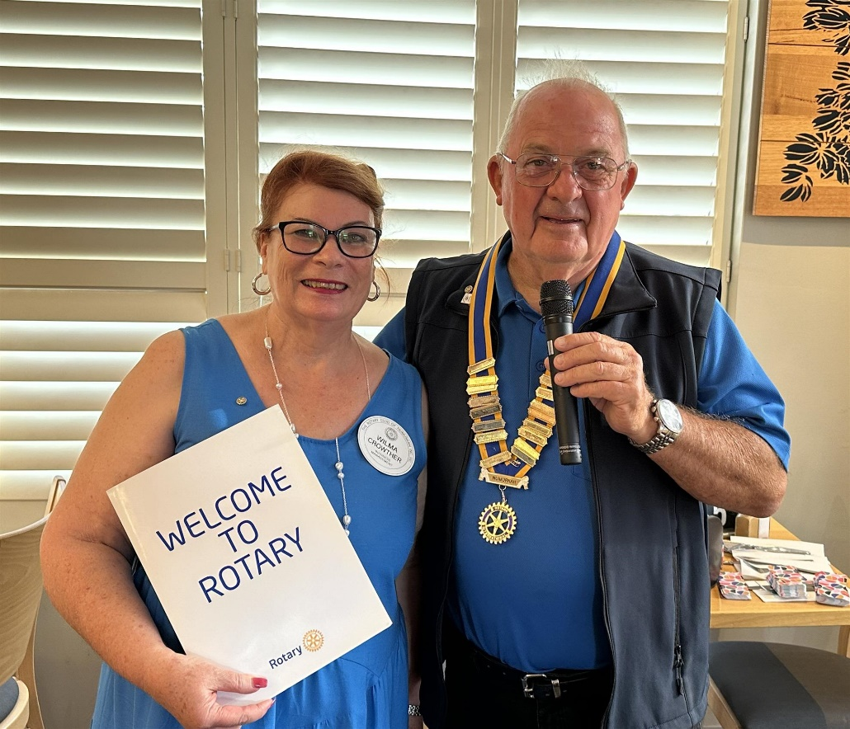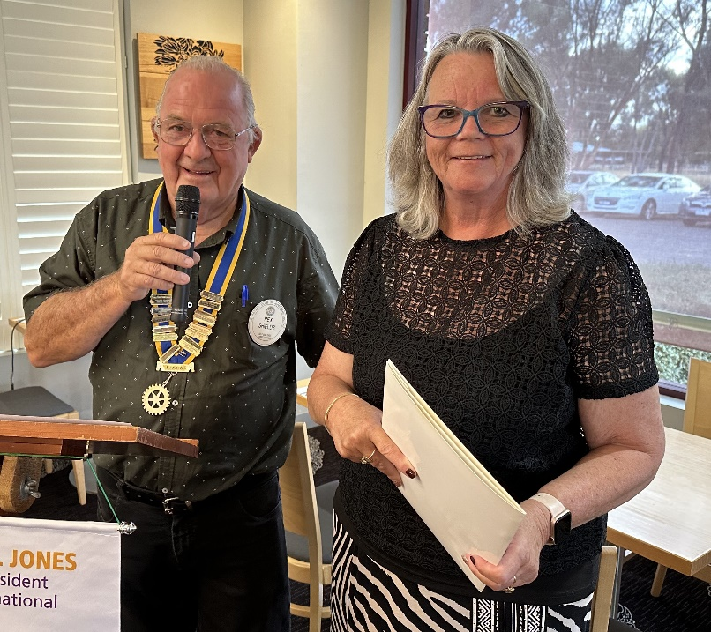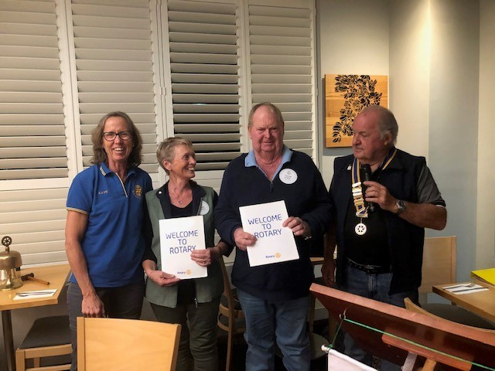

# PUBLIC RELATIONS REPORT

Thanks to the valuable support from the Numurkah Leader, the Rotary Club has enjoyed considerable success in having press releases, stories, articles, reports and photos submitted published in the Leader throughout the year, all publicising our activities to the community. Thankyou Numurkah Leader.

Major projects highlighted in media releases such as the Community Bus, Soldier Settler and Defibrillator projects have engendered much community interest and support.

Our website [www.numurkahrotary.org](http://www.numurkahrotary.org) provides a wonderful window on our club to the public, where office-bearers, up-coming events, stories on activities as well as a photo album section, full of photos depicting the club in action on its various activities. Annual reports and the weekly bulletin can also be viewed by the public. The stories on the home page are updated weekly.

Members have also, through the website, access to the club directory of our membership and members profiles, and the ability to email to all or some of our members. It is pleasing to see more and more members avail themselves of this email service. The website is used for tracking attendances, and can give a snapshot of the club membership by gender, age, length of service etc.

The weekly bulletin is emailed to each member, reporting on the weekly meeting, and advising of coming events and members responsibilities.

Social media has become a major distributer of news and views. The Rotary Club utilises Facebook and Instagram with weekly reports on meetings and activities. These appear in the Rotary Club Facebook page, Rotary District Facebook page and the Numurkah Group Facebook page. These posts have a growing following, and emphasise to the general public, the vibrancy of our club.

**Lou Hamon**

**PR Director/Webmaster/Bulletin Editor**

# ART & CRAFT EXHIBITION REPORT

The Rotary Club of Numurkah 43rd Annual Art & Craft­ exhibition was staged in the Numurkah Town Hall over the March long weekend, March 10th to 13th. with a display of excellent exhibits appreciated by a large public attendance. With 40 artworks sold, sales raised a total of $16,740, with an additional $1,000 raised from catering sales across the weekend. Raffle ticket sales raised a total of $5,500 which were put towards the Defibrillators Project.

The Opening Night Gala is always a much-anticipated highlight. Rotary Club President Rex Shield welcomed everyone at the official opening Friday night, thanking them for their attendance. Rex also thanked the exhibitors for such a wide and diverse collection of art and craft­, including photography, on display. Rex thanked the organising committee and acknowledged the contribution of Lou Hamon who served as chairman of the committee for 27 years, ensuring the longevity and high standard of the exhibition.

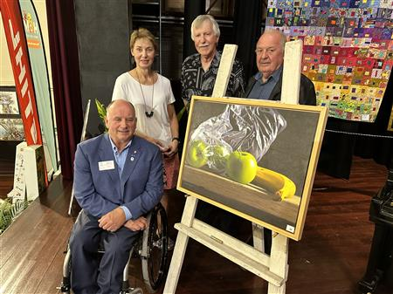The exhibition was officially opened by Rotary District Governor David McPherson who congratulated the Rotary Club for such an outstanding exhibition. Jeff Buzza from the event’s major sponsor Numurkah Home Hardware and Timber spoke on behalf of the sponsors saying once again he marvelled at the skill of the artists and their willingness to put themselves out there to face our criticism.

Art judge Ross Paterson, before announcing and commenting on the art entries, congratulated the Rotary Club on the longevity of the exhibition.

|  |
| --- |
| **Best in Show** |
| “Still Life with Fruit” by Glen Hoyle from Langwarrin |
| **Best Oil** |
| “Summer Colour, Harcourt” by Geoff Paynter from Bendigo |
| **Best Watercolour** |
| “Morning Light, Prague” by Glen Hoyle from Langwarrin |

|  |
| --- |
| **Best Acrylic** |
| “The Red Tea Pot” by Maryann Jenkins of Echuca |
| **The Kevin Davis Regional Artist Encouragement Award** |
| “Still Life” by Norma Bailey-Ramsay of Tocumwal |
| **The Moira Art & Culture Inc. Encouragement Award** |
| “The Lonely Dog” by Geoff Lugg from Numurkah |
| **The Photographic Award** |
| “The Bike” by Dennis Rickard of Numurkah |
| **The Runner Up Photography Award** |
| “After the Harvest - Numurkah” by local Gavin Parkinson |
| **Highly Commended Artworks** |
| Peter Moulton, Mulwala, “Summer Storm”  Bev Williams, Numurkah “The Colours of Autumn”  Jeanette Graham, Strathmerton “A Road to Somewhere” |

Craft­ Judge Claire Reid commented on the wide variety of craft­ forms in announcing the winners.

|  |
| --- |
| **Best Craft** |
| David Saxton’s “Singer Sewing Machine Tractor” |
| **Quilt Award** |
| Margaret Andrew for her piece “Rajah Arrived” |
| **General Craft­ Award** |
| Lorna Colmer of Nathalia for “Shire Horse” |
| **Knitting and Crochet Award** |
| Fiona Carruthers of Numurkah for “Between the Lines Diamonds” |
| **Ceramic and Pottery Award** |
| Wendy Lee of Briagolong won the for her “Small Vase” |

Thank you to the Committee and members of the Rotary Club of Numurkah, for again making this event a successful project, one the Club can be very proud off. Thank you, Lou, for your mentorship and continued support of this team effort.

The with the standard of work on display, the presentation of the display, the support of local sponsors, and the attendance numbers during the weekend and support of the Club, it is clear to see why our Show remains one of the best regional Victorian Shows.

**Chris Sutton**

**Art Show Committee Chair**

# COMMUNITY SERVICE REPORT

**Our Club continues to play an active role in our local community:**

The Open Gardens Scheme was finally held in November after COVID restrictions prevented it from going forward for nearly two years. Five gardens were on display. It was fantastic weather and well supported by the community.

The Community Bus Appeal was finalised with some large Community Group donations from Lions, Lady Lions and the Pioneers Lodge Auxiliary. Moira Shire Community Strengthening Grant, GrainCorp Community Grant and the Bendigo Community Grant all were major contributors to the fundraising. The new bus was ordered late last year and hope to be delivered in the 23/24 financial year.

Maloga House, in Nathalia, was acquired by the Salvation Army to be used to shelter women 55 years and above as six out of ten homeless are women. Women facing challenges from housing crisis, financial crisis, gender gap in wages, and marriage breakdown are offered one-year accommodation. We supported this fantastic initiative by purchasing two dining table and chair sets for the refurbishment.

Our area experienced widespread flooding in November and the club was active in volunteering to sandbag and provide BBQ and food for all volunteers at Kaarimba Hall. Over 10,000 sandbags were made and used locally and sent to Barmah as well.

**Assistance given to Service Clubs and Community Groups:**

* Volunteers from our club are assisting the Royal Flying Doctor Service to transport locals to medical appointments
* Cobram Show and Shine parking marshalls
* GV Car Club Swap Meet BBQ
* Nathalia Show and Shine marshalls
* Nathalia New Year’s Eve Carnival Spinning Wheel helpers
* St Joseph’s Numurkah Fun Run marshalls

**Community Service:**

* Support of Bowel Scan kits to locals through the pharmacy
* Lift the Lid on Mental Health Crazy Hat night fundraiser. Mental Health Week, with Hat Day today. Funds raised for Australian Rotary health who fund research projects in health and mental health.
* The Australia Day Ceremony and Rotary scooped the pool receiving Art, Culture, Environment Award for Community Bus Appeal, Community Event of the Year for 75th Anniversary Soldier Settlement Scheme and Certificate of Appreciation as the Organisation of the year.

**Our barbeque was well used around our local area:**

* Monthly BBQ’s in Newman Square
* Australia Day Awards Breakfast BBQ
* ANZAC Day breakfast with Numurkah RSL
* Pioneers Lodge Car Boot Sale BBQ
* Show Us Ya Wheels BBQ
* Election Day BBQ
* Flavorite BBQ
* Historical Society BBQ

A very big shout out to all the members, friends and family who give their time throughout the year to fundraise, volunteer and support those who are vulnerable and disadvantaged locally and internationally.

**Community Bus Project**

Saturday 26 February 2022 saw Gary Phillips then President of the Rotary Club of Numurkah launch a project to raise $95,000 for a new community bus for aged care. This project was launched in conjunction with NCN Health.

The Rotary Club of Numurkah launched the appeal with a donation of $25,000 from its reserves. The club also promised to donate the profits from its upcoming art show. This turned out to be further donation of $16,000, taking the clubs contribution to $41,000.

Further donations from individuals and corporate entities soon followed, the entire community getting behind this project, The Lions Club made two donations of $5,000 each. The lions Ladies after their high tea donated a further $3,000. The Pioneer lodge auxiliary donated $10,000 from their reserves. The Moira Shire Council, GrainCorp and the Bendigo Bank all made donations of $10,000 each.

The community has been very generous with lots of personal donations large and small but all very much appreciated. One Numurkah couple generously donated $10,000 and another couple $5,000. We learnt that many saw this project as one they might make use of in their later life.

The only problem with being so successful was significantly more money was raised than was required for one bus. The appeal was extended to raise funds for a second bus. NCN Health sought innovative ways to fund the balance and has gained support from their Board. The new buses will allow the older buses to be retired. A total of **$127,155.85** was raised by the community.

After an extended time since ordering the first bus, has now arrived and is currently in Melbourne being fitted out with all ability’s equipment. This fit out and will ensure older residents and clients who require mobility such as wheelchairs and other aids can enjoy outings.

NCN Health and Rotary are incredibly grateful for the generosity shown towards our aged people and ensuring they can maintain connection with their local community.

**Julie Andrew**

**Community Services Director**

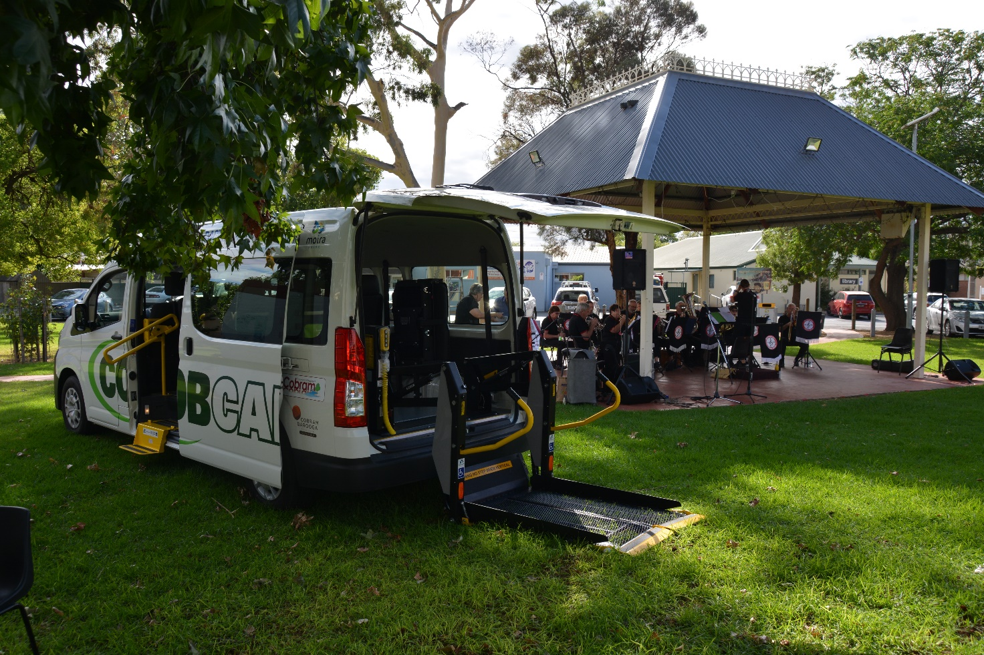

# INTERNATIONAL REPORT

The Rotary Club of Numurkah has had a relatively quiet year, on the international front, focusing more on local projects.

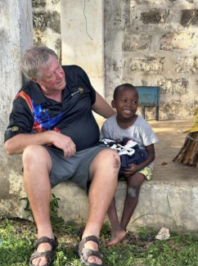The Club has, however continued their support of RAWCS project- Umoja Orphanage, near Mombasa, Kenya. The name Umoja means “the spirit of unity and togetherness” in Swahili. Cathy Booth from the Rotary Club of Bundaberg, Qld has completed multiple Australian trips this year, spreading the word of Umoja. She continues to gain sponsorship, to provide love, education and resources to children in dire need. Cathy has travelled to Umoja twice this year, once with a small group including Waaia’s Wayne and Pam Limbrick, and a larger group of volunteers in April.

We also continue our child sponsorship of Alare, one of the children, and receive monthly updates of his progress. He is healthy, enjoys school, is a hard worker, enjoys being on the farm with the animals, farm workers and planting crops. Our sponsorship of $100/month helps purchase food, clothing, schoolbooks, uniforms, medical assistance, medication and school fees.

***Alare with volunteer, Peter***

Julie Andrew is heading there in August and is looking forward to reliving the joy of the children, staff and local community. Julie is taking her daughter Charlotte with her, what a great opportunity that will be for Charlotte. They have so little but are happy. A very grounding experience. I would love to join her to see how the children and the farm have progressed, with the second home on the site opening very soon.

Esther, our Plan International girl in Ghana also receives our sponsorship and support, amounting to $153 per quarter. Our support helps ensure that her rights are respected and that she receives food, clean water, sanitary care, a safe and nurturing environment and most importantly, an education.

**Kate Hodge**

**International Director**

***Esther with her family***

# FOUNDATION REPORT

The Rotary Foundation is Rotary's own charitable fund and is operated exclusively for charitable and educational purposes throughout the world. The purpose of The Rotary Foundation can be found in its motto: "Doing good in the world."

Through its seven areas of focus, The Rotary Foundation seeks to fulfil its mission by awarding grants to Clubs to implement projects at both a local and an international level, projects that improve the lives of children, providing access to health care, education, adequate food, shelter and clean water, ensure peace and care for the environment.

The Rotary Foundation is OUR Foundation, YOUR Foundation.

***Mission Statement***

The mission of the Foundation is to enable Rotarians to advance world understanding, goodwill and peace through the improvement of health, the support of education and the alleviation of poverty.

***Foundation Income and Expenses***

Donations to the Annual Fund of the Foundation are invested for three years and the income earned pays for the Foundation's operating and administrative expenses. At the end of three years contributions to the Annual Fund become available for Foundation programs under the SHARE system (see below).

***Share System***

The Trustees of the Foundation developed the SHARE system to give each district a voice in how donations from their District are spent and to allow districts to participate in the programs that are of the most interest to them.

Using the SHARE system, our district's annual giving is divided into two funds: 47.5% is allocated to the District Designated Fund (DDF) of which up to 25% can be spent on District Grants and 47.5% to the World Fund. The remaining 5% is spent on administration of the Foundation. District Grants and Global Grants are administered by Clubs and Districts and may be used for humanitarian, vocational and educational programs either locally or globally. Districts using DDF to support Global grants may also see The Rotary Foundation award up to 80% of the DDF contribution to the Global Grant using funds from the World Fund.

***To Donate***

Donation by Clubs and individuals is encouraged to be online through EFT or direct transfer, use of credit or debit card. Do not email card details. Payments made in AUD (Australian Dollars) are automatically paid to The Australian Rotary Foundation Trust.

To donate to The Rotary Foundation by cheque, ensure that it is made payable to "**The Australia Rotary Foundation Trust"** to enable your donation to be tax deductible.

***Grants Subcommittee***

District Grants and Global Grants are managed by our Grants Subcommittee.

**Chair**

PP Marg Crisp

The Rotary Club of Wodonga Central  
Email: [grants@rotary9790.org.au](mailto:grants@rotary9790.org.au)

***District Grants***

District Grants fund smaller, short-term activities that address needs in both our local community and communities worldwide.

District Grants fund scholarships, projects and travel that align with the mission of The Rotary Foundation.

District Grants range between $1,000 and $2,500. District 9790 will match contributions to the project between $1 and $1 for every dollar contributed up to a maximum grant of $2,500. Thus, if a project has a total cost of $5,000, the District will contribute $2,500. If the project is worth $10,000, the District grant will remain $2,500.

The criteria to be used when applying for a District Grant can be found on the District Website.

All applications for District Grants must be submitted through the Grants Subcommittee.

***Global Grants***

Global Grants support large international activities with sustainable, measurable outcomes in one or more of the six areas of focus. Grant Programs are intended to assist a community in need through an international service project carried out in cooperation with Rotarians from another District in another country. There is expected to be active participation of Rotarians in both the sponsor and project countries.

Projects can be sourced from publications detailing World Community Service projects, from Project LINK on the RI Web site, from contacts your Club members may have made with overseas Rotarians, at International Assemblies and Conventions or through international exchange scholars. The minimum project for a Global Grant must have a USD$30,000 budget.

Both the international and host sponsors must work together to prepare and submit interim and final reports. Sponsors are required to submit an interim report every 6 months for the life of the project and a final report within two months of completing the project.

The Rotary Foundation will match contributions to the project between 50 cents and $1 for every dollar contributed.

All applications for Global Grants must be submitted through the Grants Subcommittee.

***Peace Fellowships***

Rotary Peace Fellowships are provided by The Rotary Foundation to fund either a master's degree or a professional development certificate study at one of the six [Rotary Peace Centres](http://www.rotary.org/en/StudentsAndYouth/EducationalPrograms/RotaryCentersForInternationalStudies/Pages/ridefault.aspx).

Rotary Peace Fellows promote national and international cooperation, peace, and the successful resolution of conflict throughout their lives, in their careers, and through service activities.

**Co-ordinator**

PP Robert Iles (Lesley)

Rotary Club of Sunbury

***Alumni***

The alumni is an association of former leaders and members of GSE teams, ambassadorial scholars, Rotary Volunteers and university teachers who were sponsored by the Foundation to teach in developing countries. They are also a great resource for guest speakers and assisting applicants for GSE and Scholarships.

**Co-ordinator**

PP Bob Matejcic (Genny)  
Rotary Club of Belvoir Wodonga  
Email: [alumni@rotary9790.org.au](mailto:alumni@rotary9790.org.au)

***Every Rotarian, Every Year (EREY)***

Your regular donation to the Annual Fund or Permanent Fund supports both local and global projects identified by Rotarians around the world. When you make a regular donation to The Rotary Foundation, you can be confident that 50% of that gift will come back to our district in three years’ time to be used for international education and humanitarian programs and for projects in your local community. The other 50% of your donation benefits the World Fund in support of our commitment to international service. The three-year SHARE investment cycle ensures that **100% of your contribution** is spent on Rotary programs and grants.

The following programs are examples of Rotarian efforts supported by our Annual Programs Fund:

* Scholarships
* District Grants
* Vocational Training Teams
* Global Grants
* Rotary Grants for University Teachers
* Rotary World Peace Fellowships

There are thousands of charitable organisations working throughout the world that make a positive impact on those in need. But the Rotary Foundation is the only charitable organisation funded by contributions from Rotarians, for programs and projects identified by Rotarians, and administered by Rotarians at the project site. The Rotary Foundation is YOU - EVERY ROTARIAN, EVERY YEAR.

***The Paul Harris Society***

The Paul Harris Society is a special district program designed to recognise Rotarians who wish to support The Rotary Foundation in a more substantial way each year.

The Paul Harris Society recognizes Rotarians and friends of The Rotary Foundation who annually donate $US1,000 or more to the Annual Program Fund or Polio Plus.

Joining the District 9790 Paul Harris Society is a great opportunity to grow your membership of Rotary in a tangible way by contributing to our charity - The Rotary Foundation - which is a special way of ‘*Doing Good in the World’.*

**Co-ordinator**

PDG John Gatt

Rotary Club of Diamond Creek

***Polio Plus***

Rotarians are making the end of Polio more than just a dream… they are ensuring that two billion children have been immunized and five million have been spared death or disability. Your support is required to ensure the eradication of the wild Polio virus and the world can be declared Polio free.

**Co-ordinator**

PP Maria Pantling

Rotary Club of Mount Beauty

**Chris Sutton**

**Foundation Chair**

# YOUTH REPORT

Throughout the Rotary Year our club has worked in collaboration with various local schools and organisations.

Although the Rotary Debating Competition was discontinued during the previous Rotary year, the Rotary Club of Nathalia have begun their own debating competition within Nathalia schools. Although this is something which hasn’t been acted on, there is the potential to involve our local schools with the debating competition presented through the Rotary Club of Nathalia.

This year through funding and transport we were able to send four students from Numurkah Secondary College to RYPEN. The RYPEN weekend was held at a campsite in Kinglake in March. Our students came away with new skills in communication, problem solving and leadership skills.

The Rotary Club of Numurkah and Numurkah Secondary College continue to work together. There has recently been consultation in working together on a ‘tractor’ program, aiming to pair NSC students with Rotary mentors skilled in this area.

Again, although not a Youth Project, the partnership between our Rotary Club and the Numurkah Primary School Breakfast Program has continued this year. The mutual benefits of healthy eating for learning, and relationships being built between Rotarians and school students throughout the community continue. Many thanks always goes to our hard-working volunteers for this program.

**Squish Davis**

**Youth Director**

# VOCATIONAL SERVICE REPORT

In 2022-23 our Club has continued with activities that demonstrate and educate our members in the concept of vocational service.

We continue to have the Chairperson of each week give a short talk on what is happening in their business and their vocation. This gives members an insight as to what happens in particular vocations and industries.

At our weekly meetings we have various speakers who speak about their vocation and development in them. These speakers are taken from both our members and from people sourced from outside our membership.

This year we have had Mark Nordbye from the Flying Doctors speak about patient transport and saw several our members become involved in this venture. Bec I’Anson spoke about being a counsellor for NCN Health and Kate Eddy our local Secondary School Principal spoke of her years involved in education and her goals for the future of the school.

As a group we visited the local Routley Orchard and heard of their ideas for future development and expansion. Local business people from GrainCorp, Stevenson Fabrications talked of their career development over the years and a local Pharmacist and a local Catholic Priest talked about their life transitions from other countries to settling in Australia.

Rotating our Chairs each meeting continues to be a huge strength of our club in bringing a great variety of speakers.

We continue to end our meetings by reciting the Four Way Test to remind us of our obligations to uphold our responsibilities in our vocations.

The Club is currently asking for volunteers for a mentoring program to work with Secondary School Students restoring a tractor which hopefully will start next term.

**Chris Hardham**

**Vocational Service Director**

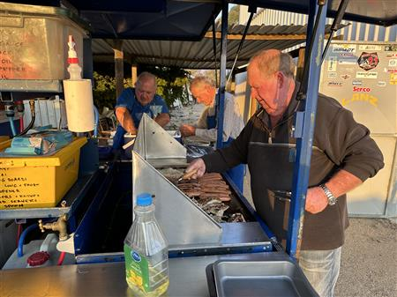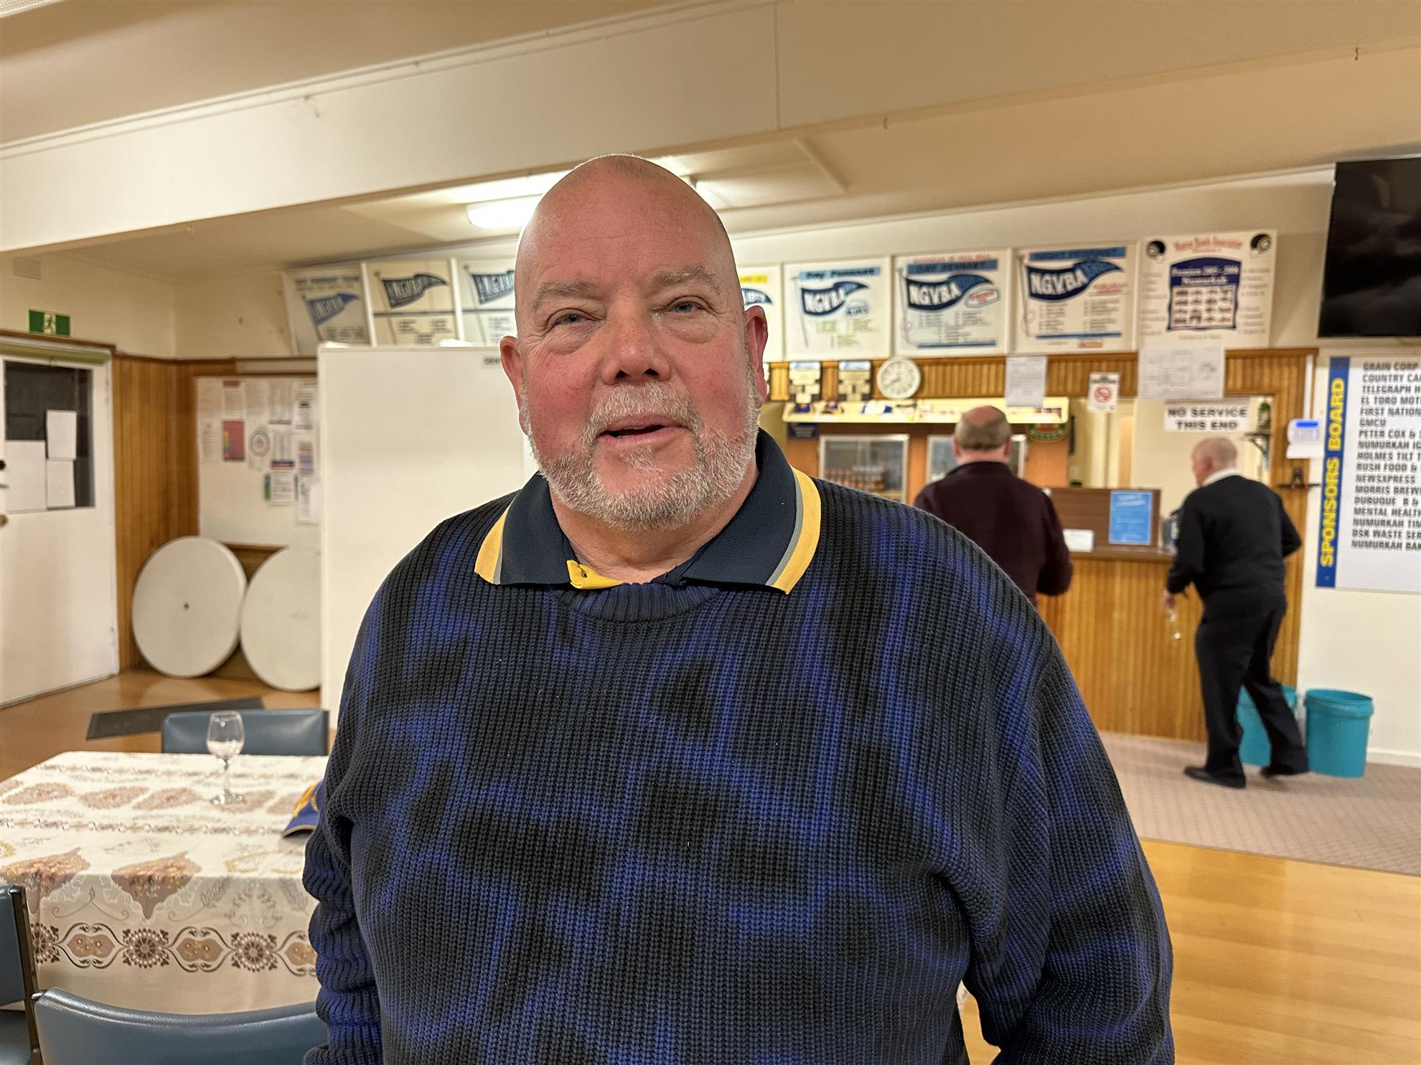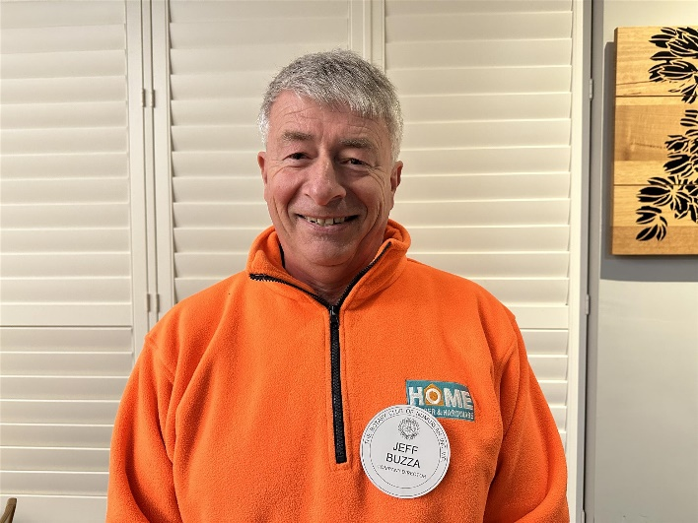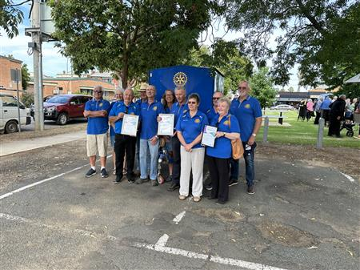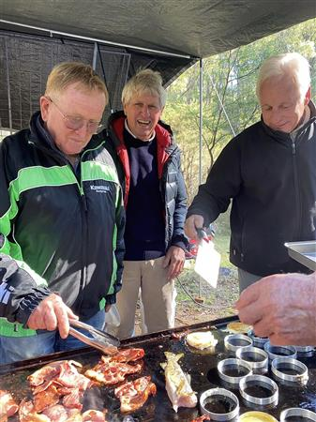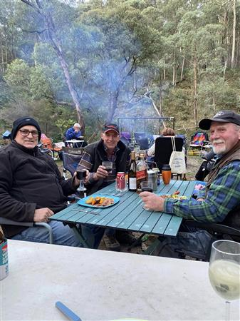

# 

# https://clubrunner.blob.core.windows.net/00000010743/thumb/PhotoAlbum/2023-bbq-with-lions/Rotary-Lions-BBQ.j4pg.jpg

# https://clubrunner.blob.core.windows.net/00000010743/thumb/PhotoAlbum/australia-day-2023/IMG_3230.jpg

# RIDE TO CONFERENCE REPORT

The D9790 Ride to Conference Deni Dash was staged on March 15th to 17th as part of this year’s social weekend. The short program seems to be suiting our riders availability and increasing ages. The RC of Numurkah continued this year to be the overarching sponsor club to for the Ride to Conference Event.

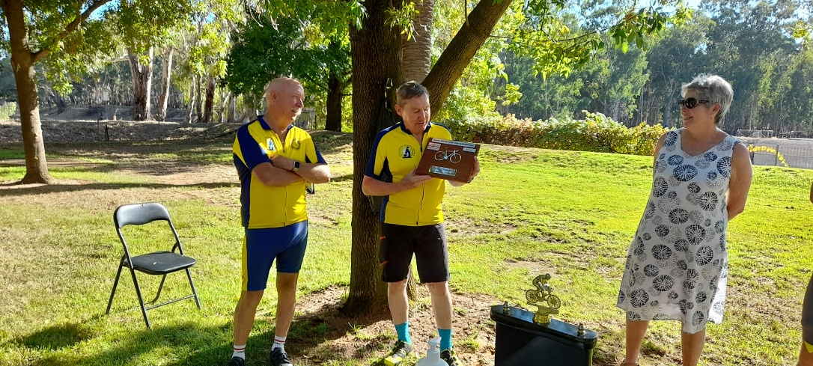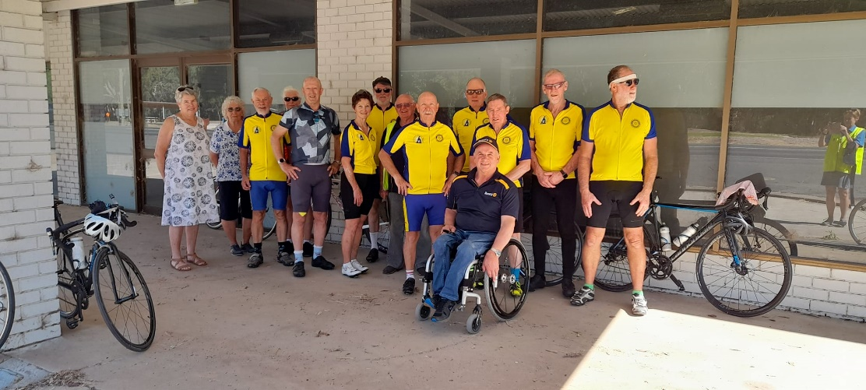The format consisted of loop rides, from a home base of Deniliquin. The first day consisted of Riders and their bikes being transported to Picnic Point in the afternoon and then riding back to the Deni Golf Resort where they were staying. Thursday the riders, rode to Pretty Pine, along the Billabong to Conargo and back to the resort via the Conargo Road. Friday the group rode to Steven’s Weir and back. Approximately 200 kms for the 3 days.

Although our numbers were down, our spirit and dedication to support ARH and our indigenous Scholar, was not. There were nine riders and four crew participating, representing 7 Clubs from D9790, Deniliquin, Numurkah, Cobram, Corowa, Eltham, Bright and Shepparton South. We also had continued support from the RC Clubs of Albury North and Seymour. It was wonderful to have Graham Brown RC of Corowa back with us this year, who originally started the D9790 riding event. And a new rider in Clay Doyle from the RC of Shepparton South.

Riders and crew commit to contributing sponsorship to participate in this ride. Even though there was a reduced contingent of riders they were still able to raise a phenomenal $9,500 for Australian Rotary Health, bringing the total raise for the Ride to Conference since its inception some 15 years ago to over $208,000. Congratulations to all riders and crew.

Congratulations to George Maddison RC Deniliquin who was awarded the Margaret and Graham Brown RTC Trophy and Alan McCleary RC Eltham for being awarded the Tony Thomas Captains Trophy.

Thank you to George Maddison & the RC of Deniliquin for putting together a great ride event. And a big thank you again to our riders and support crew. An amazing team.

See you all in Shepparton next year for DG Neta’s Conference.

**Chris Sutton**

# FINANCIAL STATEMENTS

**Treasurers Report to 26/06/2023**

**Account Balances**   **1 July 22 26 June 23**

Admin a/c $5,063.20 **$11,102.92**

Disbursement a/c $25,305.31 **$17,865.39**

Art Show a/c $2,892.83 **$1,804.64**

Term deposit a/c $27,391.49 **$27,473.66**

Koala A/C $0.38 **$0.00**

Cash **$200.00**

**Transactions to 26/06/23**

**Receipt**s

Australia Day Awards Moira Shire Council $2,000.00

Art Show A/C Transfer $13,000.00

Balance of Koala A/C $0.38

BBQ Hire $200.00

Bowel Scan Kit Sales $419.00

Christmas Appeal $565.00

Clearing Sale $982.50

Club Meetings Historical, Kinnaird’s, Hodge $1,807.00

Cobram Show n Shine $600.00

Community BBQ’s $2,529.35

Community Bus Project Fundraising $20,368.85

Flavorite Katunga $2,000.00

G/V Motor Club Swap Meeting $1,000.00

Interest $86.03

Membership Fees $6,400.00

Numurkah Bearings and Hydraulics $1,000.00

Numurkah Golf & Bowls Club $1,000.00

Numurkah Vet Clinic $1265.00

Numurkah Wunghnu Cemetery Trust $2,445.00

Open Gardens Weekend $1,610.00

Pioneer Lodge BBQ $425.65

Ritchies IGA $528.51

Seiter’s Timber & Hardware $1,265.00

Sergeants Fees (Fines) $3,756.35

Show Us Ya Wheels $2,898.05

4WD Weekend $3,000.00

**Total $71,152.24**

**Payments**

Australia Day Awards Breakfast Expenses:

* Groceries $249.91
* Butcher $158.00
* Publicity Advertising $72.00
* Flags & Bunting $186.95
* Cox Audio $250.00
* Frames $94.60
* Donation to Town Band $988.54

Sub Total $2,000.00

4WD Weekend Expenses $1,130.79

Bank Fees $118.96

BBQ Trailer Repairs & Rego $474.93

BBQ Supplies $4,844.74

Bowel Scan Kit Purchases $550.00

Cost of Disbursements $44,617.81

Defibrillator Purchases $4,980.00

Flowers $150.00

Guests Meals $250.45

Membership Costs $10,876.38

Nathalia Rotary Club (Manning Cobram Gate) $200.00

Repairs to Bain Marie $160.00

Rotary Foundation PHF $1,825.00

Numurkah Leader for Open Garden Weekend $108.00

Miscellaneous Expenses $80.50

**Total $72,117.00**

**Disbursements**

Australian Rotary health, Lift the Lid $252.75

Athletic Sponsorship for Georgia Robertson $500.00

Community Bus Payment to NCN Health $25,368.85

Defibrillators Project $7,165.00

DG’s Project, a RAWCS Project Wheelchairs for Java $1,000.00

Kaarimba Flood Support Project $515.16

KidzFix $250.00

Muloga House Nathalia - Furniture $1,800.00

Numurkah Laundrette - Tokens Program $300.00

Numurkah RSL - Support of the ANZAC Gunfire Breakfast $330.10

Numurkah Primary School- Repairs to the Memorial Gate $500.00

Numurkah Primary School - Grip Leadership Support $496.95

Outback Spectacular Show - Through Make a Wish Foundation $439.00

Plan International (Sponsorship of Esther in Ghana) $765.00

Pioneer Lodge - BBQ Proceeds $425.00

Ride to Conference Supporting Australian Rotary Health $1,000.00

Rotary Club of Shepparton South, RYPEN Travel Costs $280.00

Rotary International Polio Fund $180.00

School Awards $1050.00

St. Vincent de Paul, Numurkah - Christmas Appeal $800.00

Umoja Orphanage - Sponsorship of Alare $1,200.00

**Total $44,617.81**

