**THE ROTARY CLUB OF NUMURKAH Inc.**

**ANNUAL REPORT**

**&**

**FINANCIAL STATEMENTS**

**20**

**23**

**-**

**2024**





**CONTENTS**

**2023 – 2024 Board Members 3**

**2024 – 2025 Board Members 4**

**CHANGEOVER PROGRAM Monday 24.06.24 at 6:30pm 5**

**PRESIDENTS REPORT 6**

**CLUB SERVICE REPORT 8**

**PUBLIC RELATIONS REPORT 9**

**ART & CRAFT EXHIBITION REPORT 10**

**COMMUNITY SERVICE REPORT 12**

**INTERNATIONAL REPORT 15**

**FOUNDATION REPORT 15**

**YOUTH REPORT 17**

**VOCATIONAL SERVICE REPORT 17**

**RIDE TO CONFERENCE REPORT** **19**

**FINANCIAL STATEMENTS** **21**



|  |  |
| --- | --- |
| 2023 – 2024 Board Members | |
| President | Julie Andrew |
| President Elect | Linda Boyd |
| Past President | Rex Shields |
| Secretary | Chris Sutton |
| Treasurer | Stephen Mills |
| Public Relations | Lou Hamon OAM |
| Club Service Director | Mark McNamara |
| Community Service Director | Geoff Holmes |
| International Director /Foundation | Jennifer Rodger |
| Youth / New Generations Director | Michelle (Squish) Davis |
| Vocational Service Director | Jeff Buzza |



|  |  |
| --- | --- |
| 2024 – 2025 Board Members | |
| President | Linda Boyd |
| President Elect | Chris Hardham |
| Past President | Julie Andrew |
| Secretary | Chris Sutton |
| Treasurer | Stephen Mills |
| Public Relations | Julie Andrew |
| Club Service Director | Mark McNamara |
| Community Service Director | Geoff Holmes |
| International Director | Jennifer Rodger |
| Youth / New Generations Director | Michael Tymensen |
| Vocational Service Director | Jeff Buzza |
| Membership | Kate Hodge |

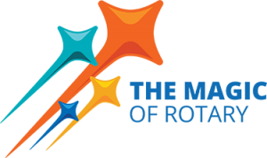

# CHANGEOVER PROGRAM

# Monday 24th June 2024 at 6:30pm

|  |  |
| --- | --- |
| Master of Ceremonies | Beverley Brooking |
| Toast to Rotary & Rotarian Partners | Terry Brennan |
| Rotary Grace | Allen Canobie |
| President’s Address  Annual Report 2023 -2024 | President Julie Andrew |
| Presentation of Paul Harris Fellow | DG Neta Kirby |
| Community Service Award | Geoff Holmes  Community Service Director |
| Vocational Service Award | Jeff Buzza  Vocational Service Director |
| Induction of 2024-25 President | DG Neta Kirby |
| Incoming President’s Address | Incoming President Linda Boyd |
| Introduction of 2024-25 Board | Incoming President Linda Boyd |
| 4 Way Test | President Julie Andrew |
| Close of Meeting - 4 Way Test | President Linda Boyd |

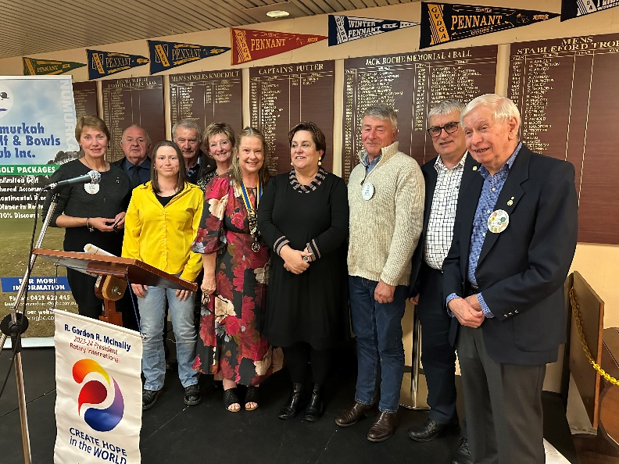

***2023 Board Members***

# PRESIDENTS REPORT

As I reflect on the past year as your president, I am filled with a sense of pride and gratitude. Together, we have made a meaningful impact in our community and beyond. It is my pleasure to present this end-of-year report, highlighting the accomplishments and milestones we achieved together.

Celebrating my year with a focus on my vocation of Nursing Educator, I was keen to incorporate weekly/monthly health promotion focuses for all members to consider for themselves and others around them. This ended up becoming pertinent during the year when a few members became unwell or required to go and get their worn parts replaced.

This year’s International Theme was ‘Create Hope in the World’. Whilst a lot of our service work was to improve our local community’s amenity the club continues to support international projects of Umoja Orphanage, Plan International and Rotary Foundation. At the start of my year, my daughter Charlotte and I were thrilled to get the opportunity to travel to Umoja Orphanage in Kenya to volunteer for two weeks. It is a life changing experience for us and positively creates hope in the world of those less fortunate than us.

Service Projects

Our commitment to "Service Above Self" was evident in the numerous service projects we completed this year. Some of the highlights include:

* Inaugural Lift the Lid Walk for Mental Health research
* Community Aged Care Bus Celebration for project completion
* Tractor project in partnership with Harry Ferguson Club and the Numurkah Secondary College
* 44th Art & Craft Show
* Funding of vital equipment for Moira Palliative Care

In total, we dedicated over a thousand volunteer hours, demonstrating our club's unwavering dedication to making a difference.

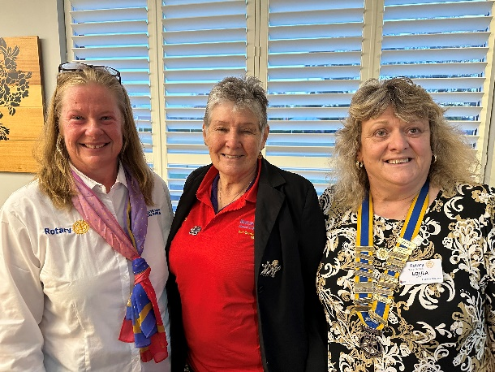

**President Julie with D9790 DG Neta Kirby, Nathalia President Loula *Oliver***

Fundraising and Financial Health

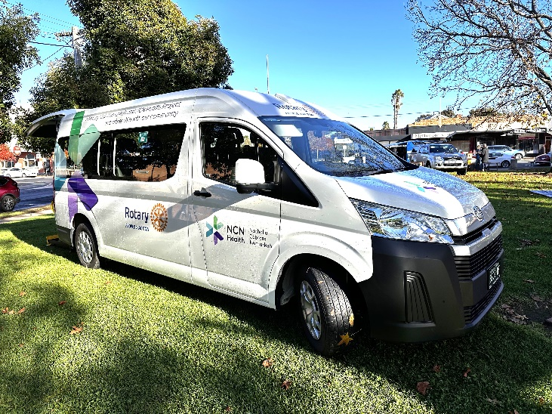Our fundraising efforts were a testament to our club's creativity and determination. We successfully raised funds in excess of $80,000 this year. These funds have been allocated to support local and international projects, ensuring that our contributions have a far-reaching impact.

***Community Bus***

Community Engagement and Partnerships

Building strong relationships within our community has been a key focus this year. We forged ongoing partnerships with NCN Health and Moira Palliative Care and Numurkah Secondary College allowing us to expand our reach and collaborate on projects of mutual interest. Our club also hosted a few community events, fostering a sense of unity and purpose.

Fellowship and Connectedness

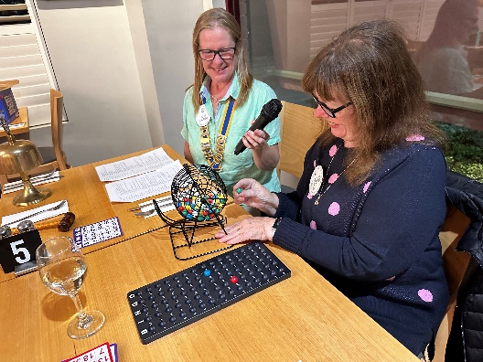This year I wanted to focus on celebrating us as volunteers and having fun with each other. This initially was demonstrated with the introduction of ‘Who is this Rotarian’? which was a guessing game in the form of a humorous piece of trivia about a club member that everyone had the opportunity to guess. This then changed direction in the form of a baby photo handed around at the weekly meeting for the members to guess the who the cute Rotary baby may be.

As part of the focus on Fellowship several social get togethers were organised off site at Rotarian Megsy Steele and Sue Church’s beautiful property to have fun and laughter and relax in a social setting.

**Bingo Callers President Julie & member Judy McDonald**

A fun night was had by all in a throwback night of Bingo fun. Prizes were donated by the Baulkamaugh CWA in the form of edible delights.

Looking Ahead

As we look to the future, I am confident that our club will continue to thrive. We have laid a strong foundation this year, and I am excited to see how we will build upon it. Our focus will remain on membership growth, community engagement, and impactful service projects.

With the Numurkah 150th year celebration I am sure our focus will be on celebration and projects that enhance this milestone.

In closing, I would like to extend my heartfelt thanks to each of you. Your dedication, enthusiasm, and generosity have been the driving force behind our success. I would like to acknowledge the contribution made by the Board of Chris Sutton, Stephen Mills, Jeff Buzza, Linda Boyd, Rex Shields, Jennifer Rodger, Lou Hamon and Mark McNamara & thank them for their efforts in being Directors. It has been an honour to serve as your president, and I look forward to supporting our incoming president, Linda Boyd, as she leads us into the next chapter.

Please take the time to read through the Club Directors reports for our detailed accomplishments in the Rotary Areas of Focus.

Thank you for a remarkable year.

Julie M Andrew

President 2023-2024

# CLUB SERVICE REPORT

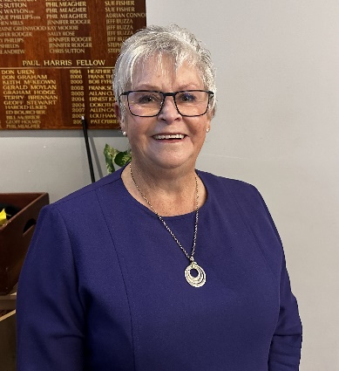The role of the Club Service Director encompasses both membership and the management of our chairman roster, as well as the sourcing of guest speakers as required, amongst other things. Although new members have been scarce on the ground this Rotary year, we have been very successful in attracting a diverse range of excellent speakers from far and wide, who have all made an impact on our members, as well as our broader community through our social media links.

***One of our many great speakers this year, local identity Jan Stevens***

The Rotary Club of Numurkah is now an accepted and respected platform for all types of professionals, business owners and down to earth locals, to come along to an attentive audience and explain their projects, enterprises, causes and in some cases their life story. These story tellers, who speak either at the Golf Club or on-site, provide an important stimulus for our members and create an immense amount of goodwill in our community.

In the coming years it is this reputation that we are forging now that will be the key to us attracting and holding onto new members. Club spirit and enthusiasm is the other essential ingredient, so make sure that we all have each other’s backs, keep on smiling, and lets all have real crack to build our numbers in 2024/2025.

Regards

Mark McNamara

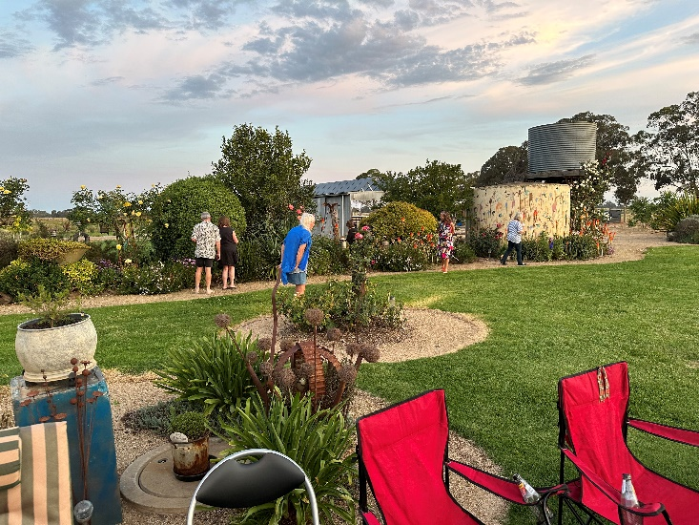

# 

# PUBLIC RELATIONS REPORT

Throughout the year Public Relations has endeavoured to inform and create public interest in the Rotary Club of Numurkah and its activities.

Various media have been used with the Numurkah Leader publishing our stories and activities.

Social media is growing with our own Facebook page with weekly reports, and publicising events on Numurkah, Cobram, Nathalia, Yarrawonga, and Shepparton Facebook pages.

Instagram is also utilised.

The bulletin has been published weekly with reports on meetings with other club information.

Our website [www.numurkahrotary.org](http://www.numurkahrotary.org) provides a window on our club to the public, where office-bearers, up-coming events, stories on activities updated weekly as well as photo albums depicting the club in action can be viewed.

The website is a wonderful resource for members with Annual Reports, Photo Albums, Club History, By-laws, Board Minutes, Bulletins from 2013 and much more available to be read as well as membership list, with members profiles, handy for contact purposes.

The website is providing a tool by which our office-bearers enlist volunteers for our activities and events, with members easily able to indicate their interest.

The website is used for tracking attendances and provide a snapshot of the club membership by gender, age, length of service. Members birthdays and anniversaries can also be viewed.

The email service enables members to email all or some of our members.

Thank you to the members for assisting in promoting the club through public relations.

Lou Hamon

P.R. Director

# ART & CRAFT EXHIBITION REPORT

The 44th Annual Art & Craft Exhibition of the Numurkah Rotary Club was once again successfully staged in the Numurkah Town Hall from Friday 8th March to Monday 11th March. We are fortunate to continue to be support by our artists, with a good number of entries and quality. Craft unfortunately was down, put did have extremely high-quality entries.

Guest enjoyed the sounds of The Broken Creek Band prior to the official opening of the show, while they enjoyed wine & cheese, as they viewed the exhibition. Rotary Club President Julie Andrew welcomed all in attendance at the official opening Friday night. The exhibition was officially opened by Phillipa Schapper, Chair GRAIN Store Nathalia.

Our Art Judge was Thel Cardwell, selected the following winners.

* *Best in Show* was awarded to Kasey Sealy for her painting “Macquarie River”.
* *Runner Up* was awarded to “Garden Reflections by Do Noble.
* *Best Watercolour* Ross Paterson’s “Tree and Sheep Mansfield”.
* *Best Oil* was awarded to “Gothic Arch, Barcelona” by Glen Hoyle.
* *Best Pastel* “Shady Glade” by Lynda Robinson. “
* Kevin Davis Regional Artist Encouragement Award awarded to Maryann Jenkins for “Three on a log”.
* *CAN Hub Encouragement* “Award Waiting to Work” by Jeanette Graham.

This year it was decided to have a judge specifically for the photography section. Leigh Teitz from the Shepparton Camera Club, was the photographic judge and announced the following awards.

* *Framed Photographic Award* - Shirley Colwell with “Wallaby”.
* *Framed Photographic Award* – Runner-up, went to “Morning Glory” by Joan Barker.
* D*igital Art Photographic Award -* “Suspended #2” by Dennis Rickard.
* *Themed Photographic Award* – A Touch of Red, Shirley Colwell with “Recap Robin”.

Once again we were fortunate to have Claire Reid as our craft judge and she announce the following award winners. *Best Craft Entry* Gary Phillips with “Windsor Chair”.

* *Best Knitting and Crochet* Justine Georges with “Looming Berries”.
* *Best Quilt Award* Anne Boase with “Nature’s Beauty”.
* *Best Woodwork*, Metalwork and Pottery was awarded to Gary Phillips with Windsor Chair.
* *Highly Commended* was Heather Campbell with “Silk Thread Embroidery Bag”.

Thank you once again to the Art Show Committee and all members of the Club for once, for coming together to stage this much-loved community event. With excellent sponsorship and record sales, $15,000 was raised from the Show which will go toward continuing our community projects.

Chris Sutton

Chair of the Art & Craft Committee

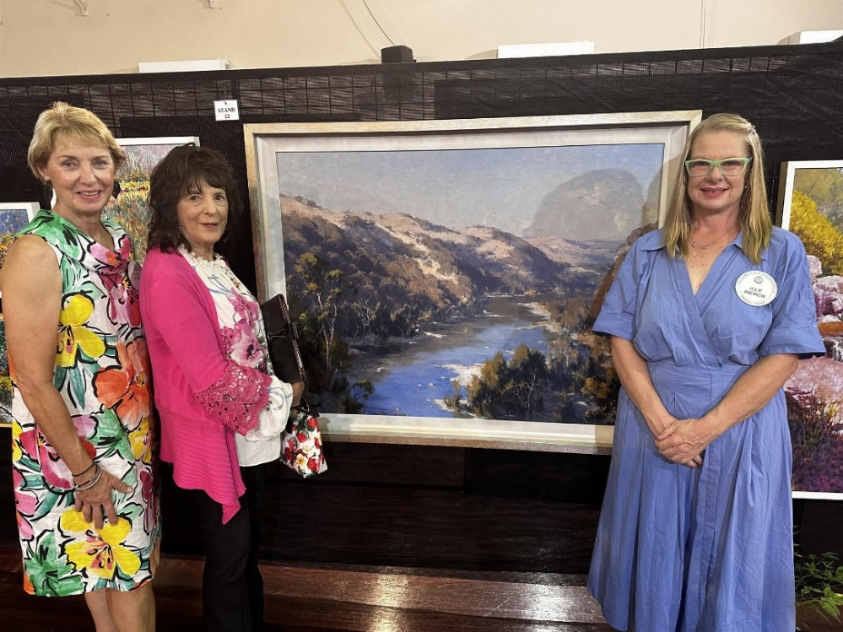

***Art Show Best in Show by Kasey Sealy with***

***Chris Sutton, Judge Thel Cardwell and President Julie***

# COMMUNITY SERVICE REPORT

Throughout the year the Rotary Club hosted numerous BBQs and our little trailer sure had a lot of use. IGA Ritchies, Newman Square were regular venues for most of the year. The Club also catered for clearing sales during this year.

Show Us Ya Wheels had a fantastic turn out for their weekend in the main street. The weather was equally magnificent which brought masses of people from near and far. Again, our catering entourage had had prime position at the Post Office site next to the stage truck. Needless to say, the sales were brisk

We also catered for the staff on site at the Flavorite hothouses for their Christmas end of year function. Over a hundred employees were fed and, maybe to their relief, there were no tomatoes in the salad.

At the start of 2024 we had our annual combined Numurkah Lions/Rotary dinner held at the Town Bowls club with Rotary’s turn to cater. A very pleasant time was had catching up with the Lions and their partners, nobody went home hungry.

On the 6th of January 2024 the Katamatite Lions hosted their second rodeo event and Rotarians helped out on the night. From reports it was a massive night and very successful for the Katy Lions.

During the year we had a small band of volunteers helping out with the St Joeys Fun Run braving the elements hot and cold. This has turned out to be a great community get together.

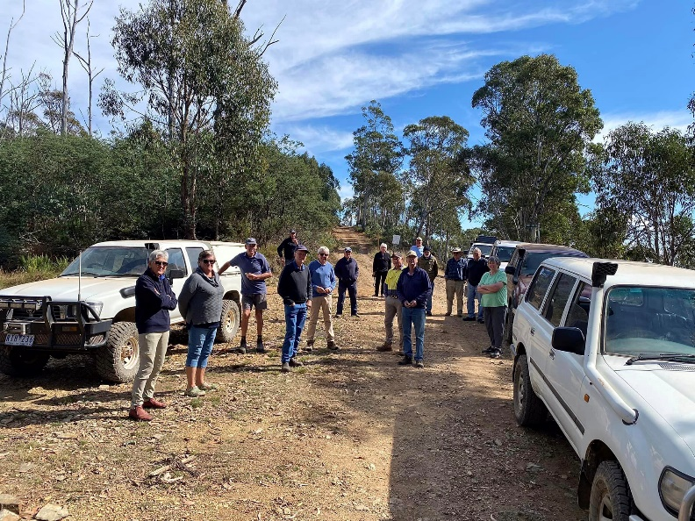March is always a busy month with our annual Art Show but to make it even more hectic our yearly 4WD trip was programmed just after. No rest for the wicked! Some of us (actually quite a few) got away a day early and off we went to Good Hope Flat reserve in the Buckland valley with 32 attendees and, yes, more cooking. Friday night steak and Saturday night spit roasts. Normal breakfasts consists of porridge, toast, jam, eggs and bacon etc (then Jenny Craig) We even had time for a convoy into the hills ably led by Ivan. Thanks to all the Rotarians and partners (and all the others who attended) for helping out and making it another successful weekend.

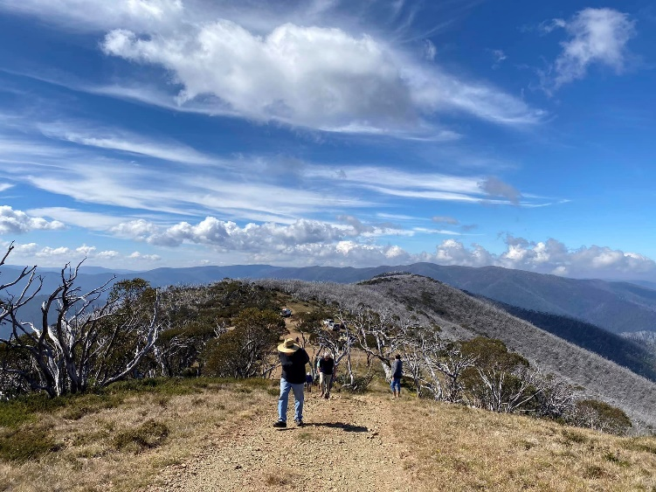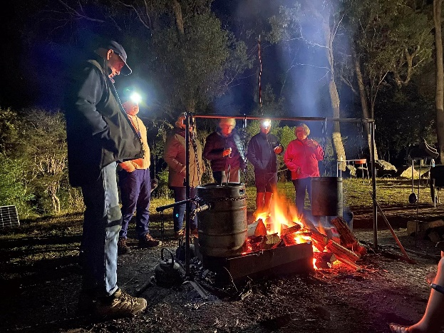

As part of our community service, each year we volunteer to assist the CFA in collecting donations for the Good Friday Appeal.

Similarly, ANZAC day is an auspicious occasion for the Numurkah community and as usual the Rotary Club were up very early cooking breakfast at the RSL hall for the huge crowd that attended the dawn service. Having the Secondary College and Primary Schools involved with the morning service has reinvigorated the local remembrance of the sacrifices made by service men and women during the various conflicts over the years.

Carrying on from last year’s fabulous effort in raising funds for new buses for NCN Health, we have seen the culmination of the Club’s effort with the arrival of not one but two new vehicles in the first half of this year. Saturday 1st of June will see a presentation (showing off) to the public at Newman Square and a BBQ as well. Congratulations everyone.

During most of the year Mark Mac has been busy getting in place proposals for the 150th celebrations. In consultation with the Historical Society, Mark has worked, in harmony, with their members to help organise successful event(s) for 2025. Mark has also initiated a project to have a footbridge built over the Broken Creek with the blessing of our Rotary Club. This would be a massive installation and draw card for the town.

Finally, our Community Service Award has gone to a very worthy recipient. Leanne Rawson who has been involved in many facets of our local community. Leanne is a teacher at St Joseph’s Primary School and, as her profession denotes, it would be nigh on impossible not to be an integral part of community development.

Even before Leanne’s career started as an adult, she has been involved with many sporting clubs as a young lass and then a teenager. Starting with Little Aths in Moe, coming first in lots of races and then competing in regional trials. Playing basketball and netball there as well, until moving to Naring with her family on a dairy farm and attending NSC. She played B grade netball for Katamatite F C at only 13 yo. Played for Numurkah District Netball, played basketball in school comps.

In 1996 at 20yo she entered the Murray River Marathon with her brother, 600 started, 300 finished, coming first in their section (in a Canadian 2-seater canoe).

While at Uni in Ballarat, of course, she played netball up to state level. After Uni she taught at Shepparton for a while then travelled, eventually working for P&O Cruises as a social director which allowed her to dine at the captain’s table.

After taking a position at St Joseph’s she returned to the sports arena, playing A grade netball, touch football and soccer. Also involved with Netta. She was on the committee that started a fun run as a fundraiser. On 2020 she wanted to start a Park Run which included applying for permission to the Moira Shire. Due to COVID the first run was in Jan 2021. She had to find 9 volunteers including her mum as the tail walker for the first run.

Geoff Holmes

Community Service Chair

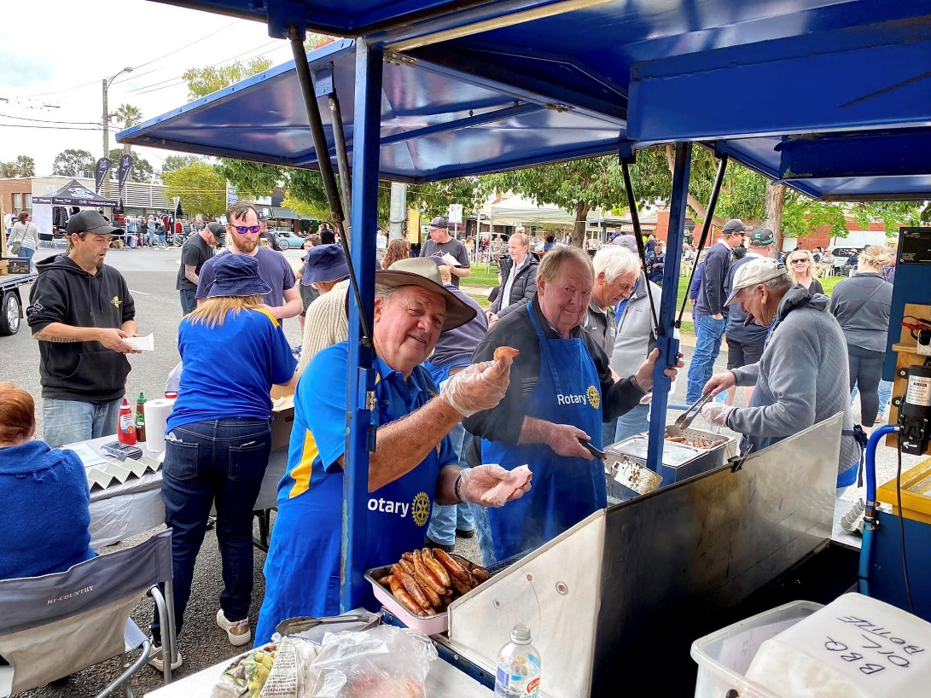

# INTERNATIONAL REPORT

Our Club has continued their long-time support of the RAWCS project- Umoja Orphanage, near Mombassa, Kenya. The name Umoja means “the spirit of unity and togetherness” in Swahili.

Cathy Booth from the Rotary Club of Bundaberg, Qld founded the orphanage.

Cathy continues to gain sponsorship, to provide love, education and resources to children in dire need.

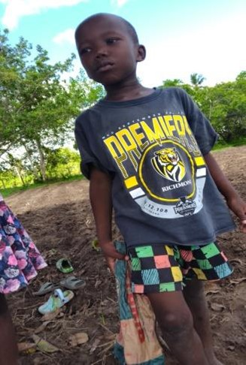President Julie attended in August & accompanied her daughter Charlotte which was no doubt a life changing experience for an impressionable teenager.

We continue our child sponsorship of Alare, and we receive monthly updates of his progress. He is healthy, enjoys school, is a hard worker, enjoys being on the farm with the animals, farm workers and planting crops. Our sponsorship of $100/month helps purchase food, clothing, schoolbooks, uniforms, medical assistance, medication and school fees.

***Alare***

Esther, our Plan International girl in Ghana also receives our sponsorship and support. Our support helps ensure that her rights are respected and that she receives food, clean water, sanitary care, a safe and nurturing environment and most importantly, an education.

Jennifer Rodger

International Chair

# FOUNDATION REPORT

The Rotary Foundation is Rotary's own charitable fund and is operated exclusively for charitable and educational purposes throughout the world. The purpose of The Rotary Foundation can be found in its motto: "Doing good in the world."

Through its seven areas of focus, The Rotary Foundation seeks to fulfil its mission by awarding grants to Clubs to implement projects at both a local and an international level, projects that improve the lives of children, providing access to health care, education, adequate food, shelter and clean water, ensure peace and care for the environment.

The Rotary Foundation is OUR Foundation, YOUR Foundation.

This year our Club make the decision to support Australian Rotary Health to raise funds for mental health research by hosting our inaugural Lift the Lid Walk held on 19/05/2024.

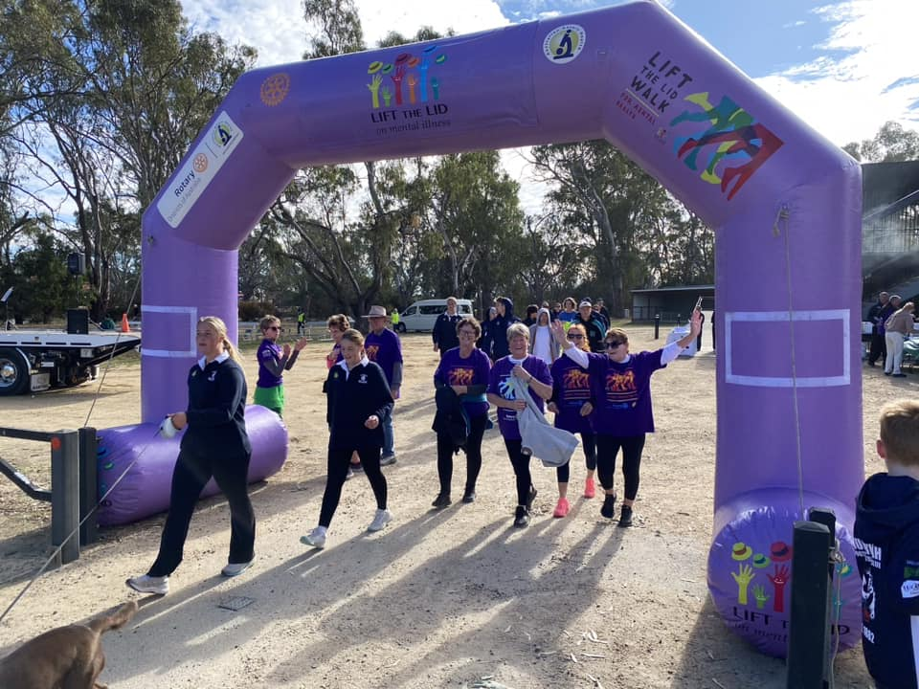Thanks to the generous sponsorship of NCN Health we were able to promote this worthy cause with a picturesque 5km walk in Numurkah with numerous NCN staff participating, plus Rotarians, members of the public & sporting clubs registering @ $30/head & proudly wearing the purple t-shirts. A highlight was the inspiring words provided by “The Unbreakable Farmer” Warren Davies who is one of Australia’s leading rural mental health speakers and advocates. His keynote topics centred on resilience; persistence; determination; leadership and wellbeing.

Particular thanks to President Julie, President Elect Linda, Secretary Chris, Sally, Kate, Lou, Geoff H, Jeff Buzza & Squish for being involved & particularly for finalising preparations for the event when I was unable to.

The inaugural event was deemed a success raising in excess of $4,500 & we hope to attract more participants & to raise more funds in future annual events.

A date will be nominated for 2025 in due course.

Jennifer Rodger

Foundation Chair

# YOUTH REPORT

The partnership between our Rotary Club and the Numurkah Primary School Breakfast Program has continued this year. The mutual benefits of healthy eating for learning, and relationships being built between Rotarians and school students throughout the community continue. Many thanks always go to our hard-working volunteers for supporting this program.

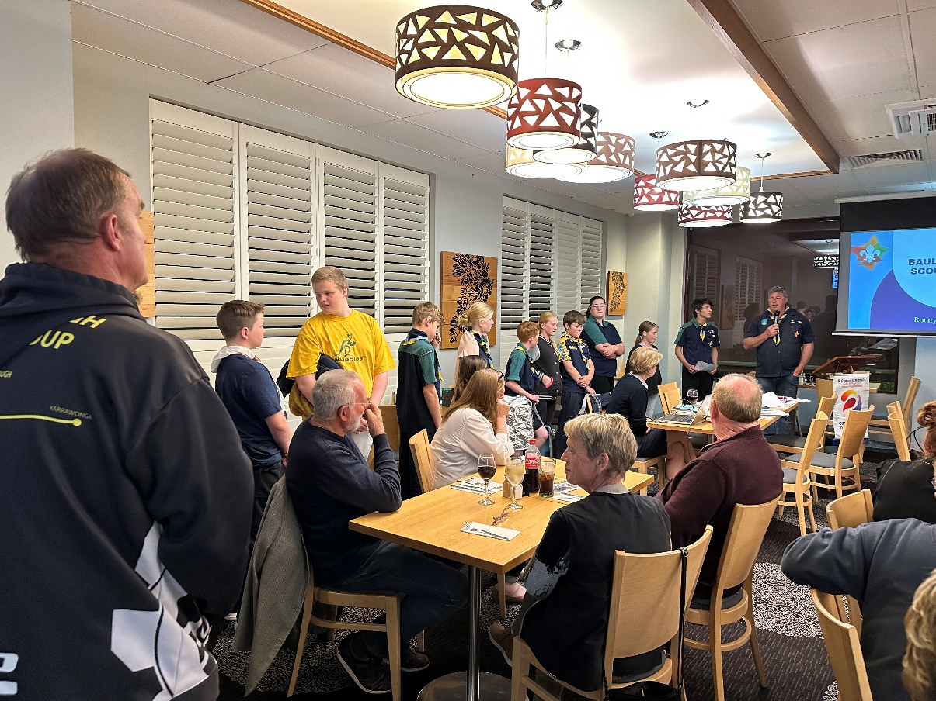

***Baulkamaugh Scouts***

# VOCATIONAL SERVICE REPORT

2023/24 enjoyed many activities in the club which strengthened our relationships with the business community and educated members in the vocational opportunities pursued in the district.

On site visits were held at the local farm providing produce for Gelato Messina, Buzza Furniture and The How Now Dairy company factory. Visits enable club members to experience the hands-on nature of local business and include a BBQ to enhance club fellowship.

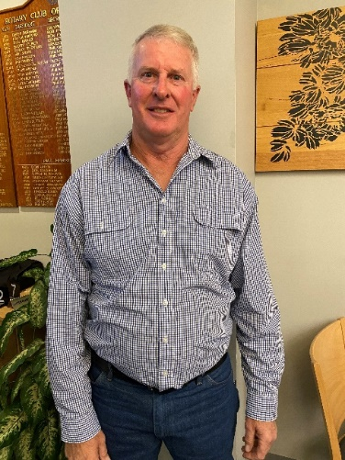At each weekly meeting the club enjoys a presentation by a community member which often is about their particular vocation. This year we have had the pleasure of hearing from a number of business people including Graeme Sutton from Sutton

***Graeme Sutton***

Transport, Nathan Shannon from J&M Shannon Pastoral, Mark Walpole recipient of the Dairy Farm of the year award, as well as Mick Hogan, Sarah Peters, Wendy Alford and Jacque Phillips. All these people demonstrated their passion and excellence in their profession.

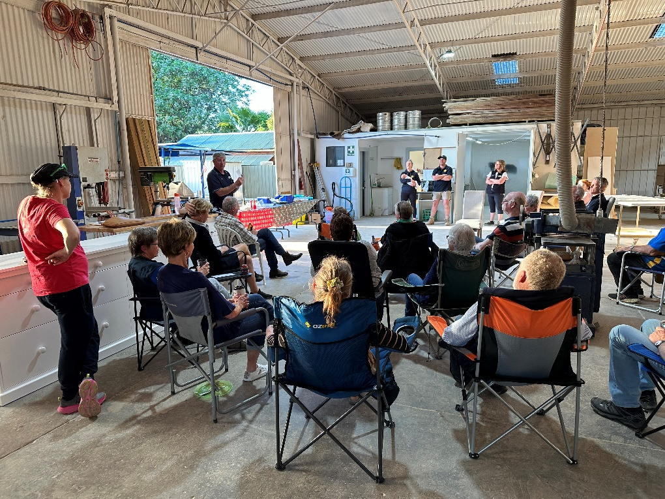Each week the Chairman for the meeting presents to the club a three-minute talk on their business and what may be happening in their particular vocation. This allows all members to gain an insight into what is happening in various vocations and industries.

***Vocational Visit to Buzz Furniture***

2024 will see the inaugural Ernest Jones pre-apprentice award to be given to the best and most committed student to their particular trade area. The award will be a monetary award to the value of $250 to enable the student to purchase tools, equipment or clothing to allow them to commence their apprenticeship.

In combination with Youth Service we have assisted in the organisation of a tractor restoration project at Numurkah Secondary College initiated by the Harry Ferguson Club. The project involves students working with appropriate Rotary and community members to enable the students to restore a Ferguson tractor as part of their education in the trade area.

This year’s Jack Duncan Memorial Vocational Service Award went to Ian Tilley for his work at the Numurkah Secondary College. Ian was selected for his excellent work in the trades area and his engagement of the students in trade and technical skills.

Jeff Buzza.

Vocational Services Director.

# RIDE TO CONFERENCE REPORT

The D9790 Ride to Conference Shepparton Ride was staged on April 17th to 19th leading up to this year’s Conference. We have continued with the short program and we thank the RC of Numurkah who continued to be the overarching sponsor club to for the Ride to Conference Event.

The format consisted of loop rides, from a home base of Big 4 Caravan Park Kialla. The first day consisted of Tatura loop where we were warmly welcome by DG Neta Kirby. Thursday the riders, did a Violet Town Loop, and even got to have a free hearing test during our lunch break. Friday the group rode what is known as the Scotty People’s Ride Loop. We were able to utilize some of the beautiful bike tracks in and around Shepparton on two of the days, making it very beautiful and safe getting in and out of town. Approximately 225 kms in total for the 3 days.

It was great to have a few more riders back this year, with a few riders just joining us for a day or two. There were 17 riders and 3 crew participating, representing 8 Clubs from D9790, Albury North, Bright, Deniliquin, Cobram, Eltham, Numurkah, Shepparton South and Seymour. We also had continued support from the RC Clubs of Corowa. It was wonderful to have David Freeman back with us this year and bring along new rider Chris Bence, both from the RC of Seymour.

Riders and crew commit to contributing sponsorship to participate in this ride, and as a team raised $8000 for Australian Rotary Health, supporting in particular our Indigenous Scholar, and the remaining funds to ARH Mental Health Programs. This bringing the total raise for the Ride to Conference since its inception some 16 years ago to over $216,000. Congratulations to all riders and crew.

Congratulations to crew member Heather Crosthwaite, Family of Cobram Rotary, who was awarded the Margaret and Brown RTC Trophy and keeping it in the family, rider Gifford Crosthwaite RC of Cobram for being awarded the Tony Thomas Captains Trophy.

Thank you to Clay Doyle & the RC of Shepparton South for your assistance in putting the ride together and also hosting the Team at your weekly meeting, which was a great night of fellowship and hearing a presentation by local riding legend Leigh Egan.

And a big thank you again to our riders and support crew. An amazing team.

See you all next year for DGE Stephen’s Conference in Albury. Albury North boys have got the ride sorted already!!

Chris Sutton

D9790 RTC Team

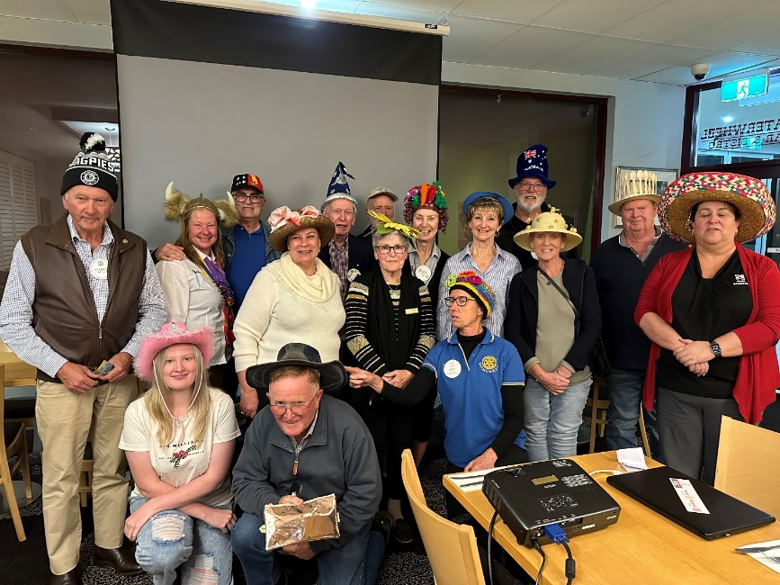

# FINANCIAL STATEMENTS

***Financial Statement to 12 June 2024***

Bank accounts 01/07/2023 12/06/2024 Movement

Admin a/c $11,029.42 $12,380.99 $1,351.57

Disbursement $16,706.59 $20,078.84 $3,372.25

Art Show a/c $1,804.64 $1,538.33 ($266.31)

Cash Float $200.00 $200.00 0.00

Term deposit $27,473.66 $28,297.87 824.21

Nett **$5,281.72**

***Receipts***

4WD W/E $4,120.00

Aust Day Breakfast - Donations Jar $81.10

- Moira Shire Council $2,000.00 $2,081.10

Bowel Cancer Kit sales $44.00

Bendigo Bank Grant for Numurkah Secondary College $2,500.00

Catering Income - Flavorite $1,900.00

* Sprunt Family $ Dairy Australia $250.00 $2,150.00

Clearing sales $1,162.00

Donations

* Bendigo Bank community bus Grant $10,000.00
* Anonymous $963.00
* Donations received for Community bus& $7,250.00
* Anonymous $3,200.00 $21,413.00

Fines $4,141.30

Garage Sale $1,721.50

Interest received $827.09

Katamatite Lions Club for manning Rodeo gates $880.00

Meeting Income $3,039.00

Membership subs $6,600.00

Misc Income $145.00

**Lift the Lid Walk\***

-Walk up registrations & merchandise sales $1,092.00

-Sponsorship $5,500.00 $6,592.00

- pre Registrations paid directly to ARH $2,730.00

Total Income for LTL Walk $9,322.00

Mooroopna car raffle ticket sales $1,100.00

Nathalia Rotary $1,000.00

Ritchies IGA Rewards program $573.98

Town BBQs $1,628.05

RSL Gunfire Breakfast, Donations Jar $415.00

Show us ya wheels BBQ $3,220.40

Spit Roast & Cup eve social $615.00

Transfer from Art Show a/c  *$15,000.00*

**Total $80,973.42**

***Payments***

4WD Weekend Costs $1,042.91

Aust day costs;

Catering $467.48

* Presentation frames & Australiana $230.95
* Peter Cox Electrical $250.00
* Numurkah Town Band $566.67
* Numurkah Ukulele Club $566.00 $2,081.10

Bank fees $365.47

BBQ Supplies $5,348.30

Cards & Flowers $170.07

Draw down of Art Show a/c $266.31

Disbursements 48,478.70

Membership costs;

* Club Runner $1,056.12
* Consumer Affairs Victoria $47.70
* District 9790, Assembly & PEDS $240.00
* PO Box $174.00
* Numurkah Leader club brochures $220.00
* Numurkah Leader engraving for handover dinner $35.00
* RDU Handover dinner costs $186.54
* RDU Magazine levy $663.00
* RDU Magazine levy 2nd six months of year $635.33
* RDU promotional banners $552.04
* Club dues to Rotary International $2,326.91
* Club dues to Rotary International 2nd half of year $1,879.93
* Rotary International Club Subscriptions $3,141.00
* Honour Board upgrade $385.00
* New Club PA System $2,095.50
* Rotary Foundation for PHF $1,034.00
* Rotary International $1,575.00
* **Total $16,247.07**

Guests Meals $473.20

Misc expenses $64.35

Moira Shire Council BBQ Licence $96.00

Mooroopna Rotary purchase of Raffle tickets $503.00

NG&BC Combined dinner with RC Nathalia $1,015.00

VicRoads, $129.88

**Total $75,691.70**

**Nett $5,281.72**

***Notes to accounts***

* The community Bus Project was launched under President Gary Phillips in February 2022 with a donation of $25,000.00 from Rotary, this was followed by another donation of $16,000.00, the proceeds of the 2022 Rotary Art Show. Fund raising was completed by president Rex Shields. With long delays from Toyota in being able to supply buses, President Julie Andrew was able to handover the two buses to NCN health on the 1st of June 2024. The total amount raised by the community to support Rotary with this project was $144,406.25.

** The early bird registrations of $2730.00 were paid directly to ARH.

***Disbursements***

1st Baulkamaugh Scouts $1,000.00

Australian Rotary Foundation $500.00

ARH; Ride to conference $1,000.00

ARH; Lift the Lid Walk $1.588.80

BBQ for bus handover $225.60

Catering for RSL Gunfire Breakfast $589.22

Defibrillator installation costs $131.04

KidzFix $250.00

Lift the Lid Walk Costs**;

* Paden Printers Lift the Lid Shirts $3,753.20
* Hire of Archway $500.00
* Guest Speaker $750,00
* Payment of surplus to ARH $1,588.80

Nathalia Pergola Painting $1,000.00

NCN Health Palliative Care equipment $7,695.40

NCN Health Community Bus, donation $17,250.00*

News Express awards vouchers for local Primary schools $550.00

Numurkah Laundrette Vouchers $300.00

Numurkah Historical Society Soldier Settlement Project $500.00

Numurkah Primary School Grip Leadership Program $487.00

Numurkah Secondary College Academic Awards $500.00

PALS Shop Trolley $795.00

Plan International, sponsor child. $612.00

RAWCS Project Lemur $1,000.00

RAWCS Project Benevolent 9 DG’s Project $1,000.00

Support for Umoja Orphanage;

* Sponsorship of Alare $1,200.00
* Funds for Julie and Charlotte to spend at Umoja $1,000.00
* Garage sale to support Umoja $1,721.05 $3,921.50

Southern Biological, Microscope for NSC $2,579.50

**Total $48,478.26**

