
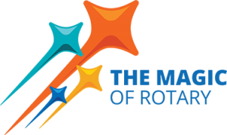
THE ROTARY CLUB OF NUMURKAH Inc.

ANNUAL REPORT

&
FINANCIAL STATEMENTS

20
24

-

2025

CONTENTS

2024 – 2025 BOARD MEMBERS…………………………………………………………3
2025 – 2026 Board Members…………………………………………………………….4
CHANGEOVER PROGRAM Monday 30.06.25 AT 6:30pm…………………….5
PRESIDENTS REPORT…………………………………………………………………………6
CLUB SERVICE REPORT………………………………………………………………………9
PUBLIC RELATIONS REPORT…………………………………………………………….10
MEMBERSHIP REPORT…………………………………………………………………….12
ART & CRAFT EXHIBITION REPORT…………………………………………………..13
COMMUNITY SERVICE REPORT………………………………………………………..15
INTERNATIONAL REPORT…………………………………………………………………18
FOUNDATION REPORT…………………………………………………………………….19
YOUTH REPORT……………………………………………………………………………….20
VOCATIONAL SERVICE REPORT………………………………………………………..21
RIDE TO CONFERENCE REPORT…………………………………………………………22
FINANCIAL STATEMENTS………………………………………………………………….24



2024 – 2025 Board Members
TITLE | NAME
President | Linda Boyd
President Elect | Chris Hardham
Past President | Julie Andrew
Secretary | Chris Sutton
Treasurer | Stephen Mills
Public Relations | Julie Andrew
Club Service Director | Mark McNamara
Community Service Director | Geoff Holmes
International Director /Foundation | Jennifer Rodger
Youth / New Generations Director | Michael Tymensen
Vocational Service Director | Jeff Buzza
Membership | Kate Hodge

2025 – 2026 Board Members
TITLE | NAME
President | Chris Hardham
President Elect | Geoff Stewart
Secretary | Sally Rose
Treasurer | Stephen Mills
Community Service | Megsy Steel
Vocational Services | Jeff Buzza
International Service | Geoff Stewart
Rotary foundation | Chris Sutton
Immediate Past President | Linda Boyd
Membership | Kate Hodge
Public Relations | Julie Andrew
Club Governance | Mark McNamara
New generations | Michael Tymensen
Youth Protection Officer | Sally Rose
Sergeant-at-Arms | Terry Brennan



CHANGEOVER PROGRAM

Monday 30th June at 6:30pm
Master of Ceremonies | John Watson AM
Acknowledgement of Country | Sally Rose (Jacquie Phillips to fill in if Sally’s granddaughter is born)
Toast to Rotary & Rotarian Partners  Rotary Grace | Mark McNamara
Rotary Grace | Terry Brennan
President’s Address  Annual Report 2024 -2025 | Linda Boyd
Community Service Award | Geoff Holmes, Director of Community Service
Vocational Service Award | Jeff Buzza  Vocational Service Director
Induction of 2025-26 President | Neta Kirby – Past DG
Incoming President’s Address | President – Chris Hardham
Introduction of 2025-26 Board | President – Chris Hardham
Close of Meeting - 4 Way Test | Chris Hardham

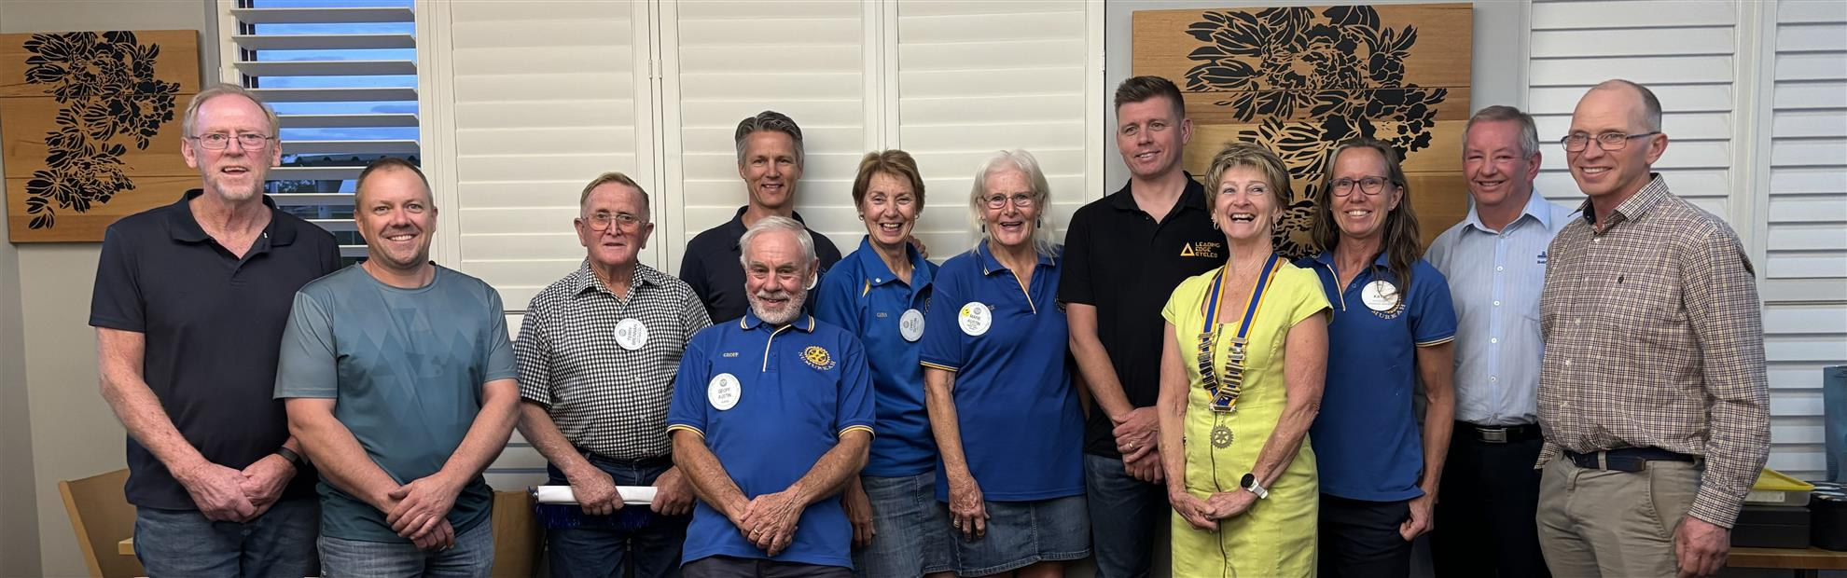

PRESIDENTS REPORT

As the Year of Magic draws to a close, I am reflecting on what was achieved throughout this year and asking myself, “Was this a successful year, were people enjoying themselves and have we made a difference within our club and the community?”

Personally, I would like to think that the answer was a resounding YES to those 3 questions.

Absolutely, an emphatic YES.

And was I able to achieve my primary goal, which I set myself 12 months ago?

My goal was to increase membership, whilst at the same time not lose any existing members. By having a dedicated Membership Director in Kate Hodge, we have had an astounding intake of 10 new members and retained all existing members.
And we also have another potential 3 members eagerly awaiting to join our club.
We must be doing something right!!

I am overwhelmingly proud of what our club does, who we are and how we represent ourselves in our community.

I believe that we have a great club made up of great members. We are all different and all working with one purpose, and that is, to do good in our community and around the world.

We are a club of Action and we are acknowledged as such by the township of Numurkah.

Our yearly Art and Craft Show; an event running 3.5 days, plus 3 days of setting up and the many hours of preparations beforehand requires all member’s input. It never ceases to amaze me how willingly everyone turns up, works together and gets the jobs done. Our members work tirelessly to give the community a professional Show and allow the exhibitors a forum to show their talent.

Our Open Gardens – what a success!
Again, a multi-day event, requiring Rotary members to man the gardener’s gates around the district and the gardeners to showcase their passion for creative gardening. We showcased more gardens this year over a greater area of our district starting from Numurkah out towards Strathmerton, Waiaa, and Naring.

And while praising gardens and gardeners a special mention must go to Sue Church and Meggsie Steel. Not only do they show off their garden to the public, but they have also hosted events for our club such as the Xmas celebrations and the Melbourne Cup. Thank you both for being so generous.

We were approached by the Numurkah Historical Society to assist with their adventurous plans for the 150 years celebrations. They required financial help and manpower – we could help with both. I feel immense pride in being able to give this assistance which culminated in a wonderful Numurkah event and is still on going.

Our Rotary Park! Who can drive past without admiration of the gleaming train and tractors. Mark McNamara championed this project to rejuvenate the park for the momentous year of celebration. Our club again was able to finance and work for the benefit of our community.

Our club continues to support our schools and our youth; they are our future. We deliver programs, financial support for awards and development and we continue to run the Breakfast program at the Numurkah Primary School. We are also developing a social link to the Umoja Orphanage in Kenya for the Primary School students.

The Umoja Orphanage has become an integral part of our overseas projects; many members have had the fortune of being able to visit and work at the orphanage.

The battery collection spearheaded by Geoff Holmes, another great project. For over 3 years Geoff has collected and stored vehicle batteries on his property, they are now cashed in, well done to all those who assisted.

Another Lift the Lid Walk was organised this year, to raise awareness of mental health issues within our society, consisting of a 5km walk for the community, and attended by guest speakers from Beyond Blue.

Ride to Conference was again supported by our club, with 6 members participating in bike riding around beautiful but challenging Albury countryside to raise money for Rotary Health.

The blue BBQ trailer was in action in Numurkah and district for several events throughout the year.

The 4 Wheel Drivers took to the High Country again, to enjoy another successful weekend, regardless of the rain, spirits could not be dampened.

Recently, I was extremely fortunate to honour one of our great Rotarians, Terry Brennan, for achieving 50 years of service to Rotary and his community. A plot was formulated, unbeknown to Terry, and to his great surprise the Combined Services Dinner became a huge celebration with his friends and family present. Terry was awarded a Paul Harris Sapphire pin by our DG Stephen O’Connell who also serenaded him on the saxophone. This celebration will definitely be the highlight of my year as President.

Through Rotary we are given the opportunity to help people, to create projects, develop friendships and to dream of a better future for all mankind.

Our club is in great health both financially and socially, we are seen in our District, as being a club to aspire to. I am proud of what we have achieved throughout this year, and I am proud to be a Rotarian.

To conclude; I have had a wonderful time being the President of our club, Chris Sutton our secretary, has been my support and mentor throughout the year and I truly thank her for her professional knowledge of Rotary and her ability to get things done.

My directors, to all of you – what a team!

A club needs strong, unified and nurturing leadership and you gave it with gusto, thank you all.

Finally, my club members; I have tested and teased you all with ridiculous games during our meetings and surprisingly you all participated regardless. I hope that you will forgive me, the pride and admiration which I feel for every one of you will be emblazoned in my heart. My only wish is that you have enjoyed the year 2024-25 and will join with me in being as supportive to Chris Hardham and her incoming team as you have been to me.

Thank you, Numurkah Rotary Club, for a wonderful year.
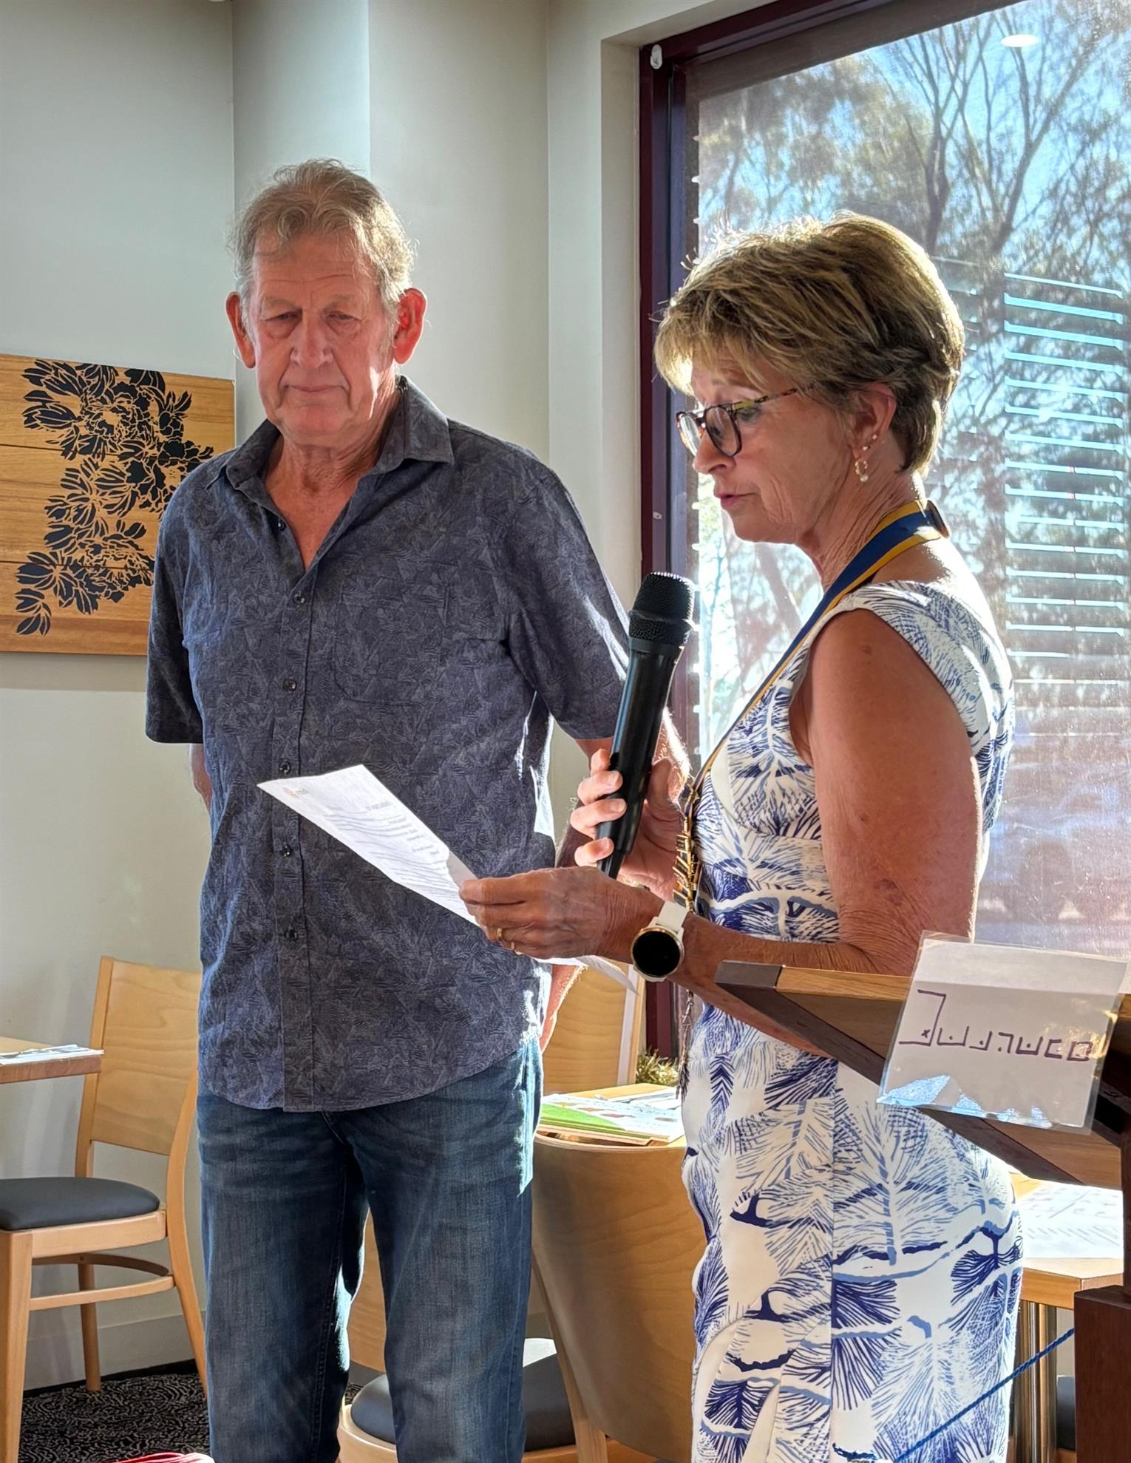
Retiring President 2024-2025
Linda Boyd

CLUB SERVICE REPORT

The success of our club has many parts to it, with our weekly dinner meeting at the Numurkah Golf Club being a key component. Each week a different Club Member has the opportunity to be the Chairman for the night and to invite a guest speaker along to tell their story to our club. Our members have excelled in the range of speakers who have accepted their invitation, as well as several club members who have told their story as well.

We have heard from the head CEO’s of Moira Shire, NCN Health and Go Farms, and have had elite Olympians, in Brett Lancaster and Jeremy Tyndall, reveal to us their personal insights of the highs and lows of their respective professional cycling and wheelchair basketball careers.

In recognition of our town’s 150th year we have heard about Glenice Holmes and Lou Hamon’s family story and Terry Brennan told us about the history of the Numurkah Rifle Club. A highlight was a social night at Rob and Narelle Graham’s restored shearing shed, where we heard about the Graham family, who were original selectors in the Wunghnu district.

Many other fantastic speakers have told us about their professional careers and life stories, however the one that touched us the most was brave young Nathalia mum and schoolteacher Katie Keys. Katie, who was fighting breast cancer with all her might when she spoke to us in February, has now thankfully been given the all clear to begin her long recovery.

Being a member of the Rotary Club of Numurkah will lift your spirit and touch your soul if you let it, while providing the opportunity to be able to give back to our wider community in the process.

Regards Mark McNamara
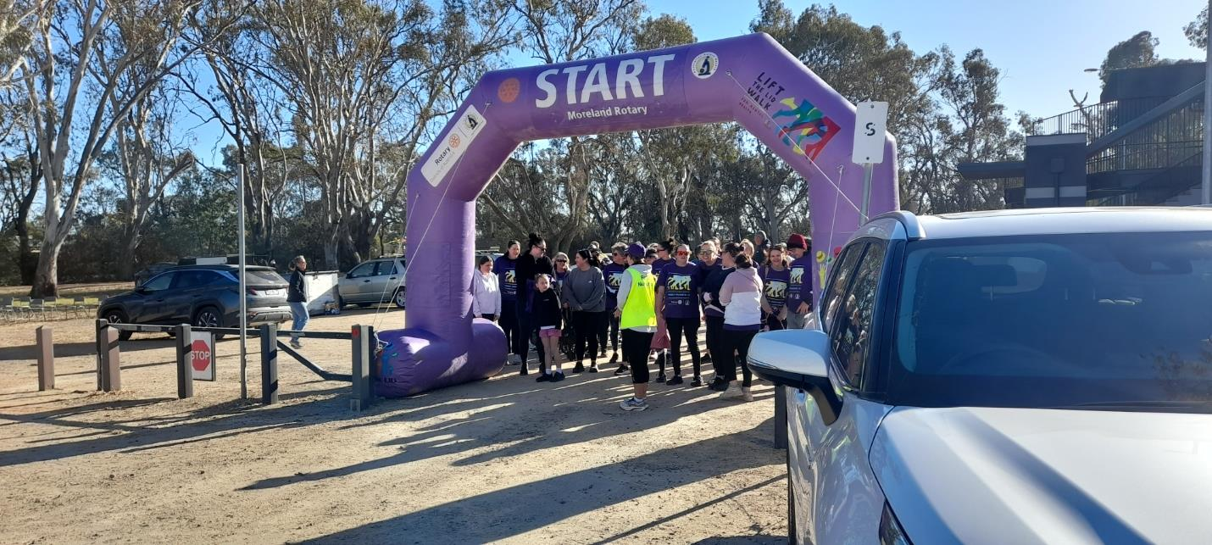
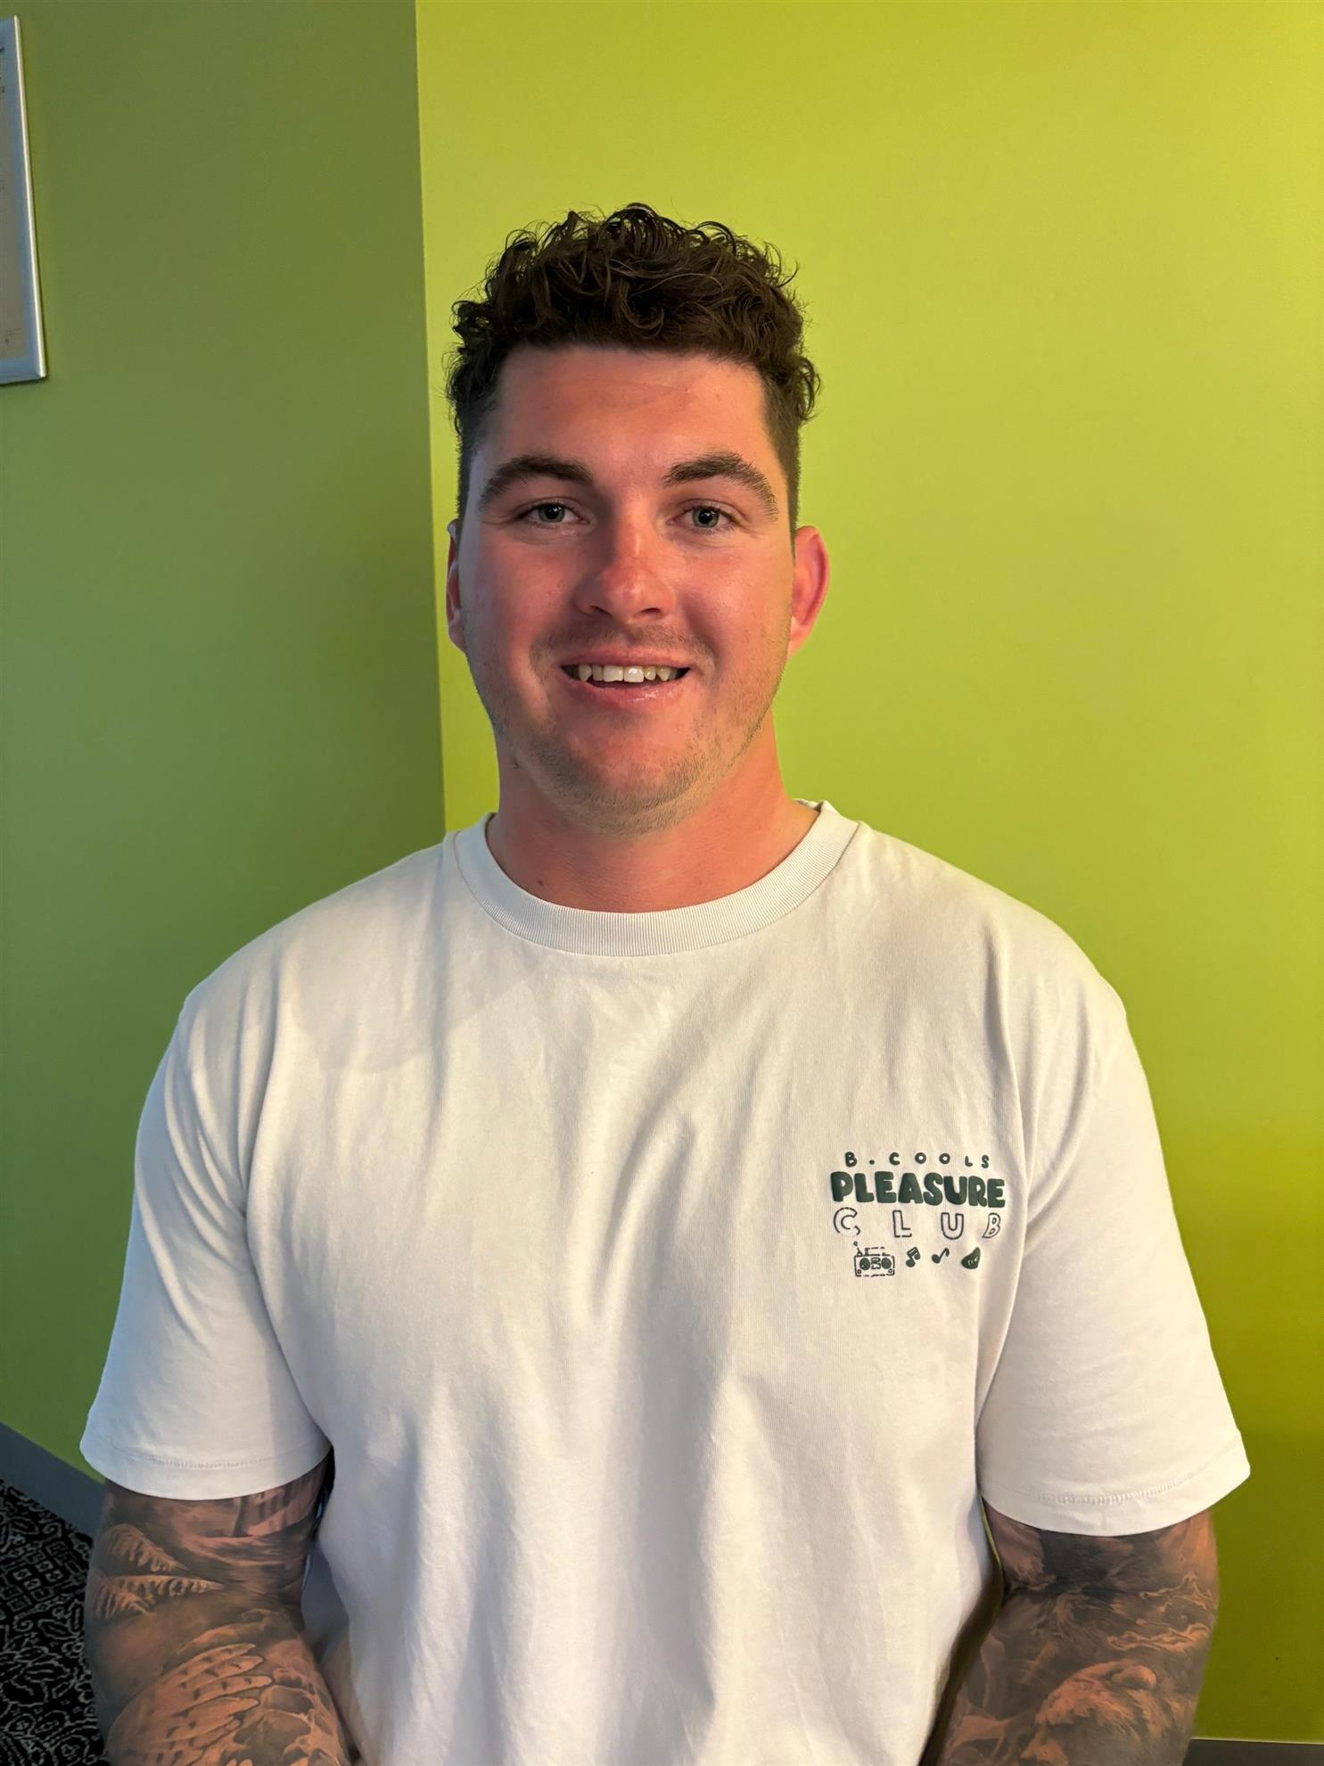

PUBLIC RELATIONS REPORT

The 2024–2025 Rotary year has been one of growth, connection, and renewed community engagement for the Numurkah Rotary Club. The Public Relations portfolio has played a vital role in supporting these efforts by ensuring that our club’s initiatives, events, and achievements were visible, timely, and positively represented across various media platforms.
Key Activities and Achievements
1. Media Engagement
Press releases and event coverage submitted to local outlets such as Numurkah Leader, Shepparton News, and community radio.
Achieved promotion of service projects and fundraising to new member inductions.
Coordinated media for major events such as the Art & Craft Exhibition and Annual Lift the Lid Walk.
2. Social Media and Online Presence
Regular updates were maintained on Facebook, increasing follower count by 25%.
Instagram engagement grew through curated posts and behind-the-scenes stories, especially around youth and international service events.
3. Branding and Visual Identity
All promotional materials adhered to Rotary International’s branding guidelines.
Created professional digital and print flyers, event banners, and signage for key events.
4. Event Promotion
Australia Day BBQ and Awards Ceremony
Used a combination of print media, posters, social media, and word-of-mouth to maximise attendance.
5. Community Engagement
Encouraged greater visibility through partnerships with local schools, sporting clubs, and other community groups.
6. Club Communications and Website
The club’s communication with its members continues through the weekly publication of the Members’ Bulletin. This bulletin includes summaries of recent meetings and other relevant club updates and announcements.
Our club website continues to serve as a vital interface between the club and the broader public. It provides comprehensive information including profiles of current office-bearers, details of upcoming events, weekly updates on club activities, and regularly updated photo albums capturing the club in action.
For members, the website is an essential resource. It offers access to a wide range of documentation and historical records, including Annual Reports, photo archives, club history, by-laws, Board Meeting minutes, and bulletins dating back to 2013. Additionally, a searchable membership directory with member profiles supports communication and networking among members.
The website also functions as an effective tool for volunteer coordination. Office-bearers can post calls for support for club activities and events, and members can easily indicate their willingness to participate.
Furthermore, the platform supports administrative functions by tracking member attendance and providing demographic insights into the club’s composition. Members’ birthdays and anniversaries are also highlighted to foster community engagement and recognition.
Challenges
Limited volunteer capacity for content creation and digital media management.
Some delays in receiving photos and event details for timely posting.
The need for a long-term strategy to transition to newer platforms like TikTok or YouTube Shorts to engage younger audiences.
Recommendations for 2025–2026
Establish a PR subcommittee to share workload and bring diverse creative input.
Develop a content calendar to plan and schedule key communication efforts in advance.
Provide training/workshops for members interested in contributing to PR tasks.
Expand multimedia content – including video clips, interviews, and event recaps.
Continue nurturing relationships with local media to ensure coverage consistency.
Conclusion
Recognition needs to also go to Past Public Relations Director PP Lou Hamon OAM for his continued support and dedication with the role.
The Public Relations efforts of the Numurkah Rotary Club during the 2024–2025 year have contributed to the visibility and positive perception of our club in the local community. By sharing our stories, celebrating our successes, and reinforcing the Rotary brand, we have strengthened our connection with both members and the public.
With sustained effort, innovation, and teamwork, PR will continue to play a crucial role in helping the Numurkah Rotary Club thrive in the years to come.

Julie Andrew
Public Relations Chair
Rotary Club of Numurkah 2025

MEMBERSHIP REPORT

Prepared by Kate Hodge

As Membership Director, I started the year off with a bang, being sponsored by our

Club and District to attend the “Fit For Purpose” workshop in Sydney.

It was a fabulous weekend shared with Club representatives from all over Zone 8.

Presenters were of high calibre, and I came away full of enthusiasm about the

changes ahead in Rotary Membership. At one point we were challenged to talk

about Rotary with a prospective member without mentioning meetings or BBQs!

I was impressed that Rotary International was prepared to listen to young voices,

current, prospective, and past members and make changes to keep Rotary alive.

Service Club memberships are reducing, but Rotary is prepared to shake the norm

and move with the times.

I am thrilled that we have 10 new members this year – all actively involved, enjoying

the friendships formed and spreading the good of Rotary.

I welcome Ashley, Nic, Nat, Cathy, Dean, Lesley, Grant, Pam, Russel and Pam to

our club and thank them for their willingness to join in and support the Club. Your

service, enthusiasm and friendship are much appreciated.

I also thank current Rotarians for encouraging friends to join. We have a healthy

Club of which we should all be proud.

The big change that has made it easier for new members to join is the lack of

pressure to attend 100% of meetings. Rotary is becoming service-centric rather than

meeting-centric. However, as we have seen, new members come as regularly as

they can as they enjoy service and the weekly meetings.

There have been multiple surgical procedures on our Rotarians this year, but they

still zoom in or turn up on walking sticks and frames- as they don’t want to miss out!

What a great sign.

Following the workshop in Sydney, I also was keen to set up a Satellite Club with

younger community members. A meeting was held in Waaia, and the new approach

to a Rotary Service club was detailed. We suggested that this Satellite Club would

be for 20 to 40-year-olds. They would commit to service projects of their choice,

gather at times that suit them, but be held under the banner of our Club until there

are 20+ members. The response has been slow, but I am keen to readdress this

initiative in September when a key driver returns from his holiday.

It has been important to spread the good of Rotary, encourage community minded

people to join but also ensure that current members are happy, actively involved and finding purpose in the magic of Rotary. Well done to all our members.

Welcome Nic, Lesley, Ash, Cathy, Grant, Pam Dean, Nat and Smithy.
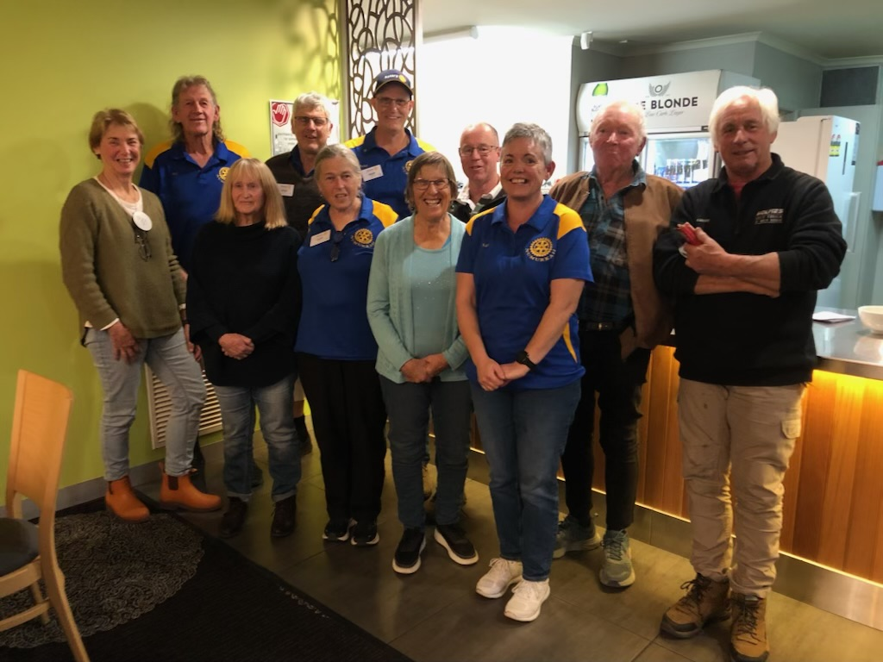

ART & CRAFT EXHIBITION REPORT

The 45th Annual Art & Craft Exhibition once again staged in the Numurkah Town Hall from Friday 7th March to Monday 10th March.
Opening night entertainment was provided by Penny and Randall Mathews: Penny played the harp and Randall accompanied with a variety of stringed instruments.
President Linda Boyd welcomed all those attending . Show was official opened by Jeff Blackley, Chair Numurkah 150th Anniversary Exhibition. Jeff linking art to history saying, “art is a window into the past”.

The Art Judge was Glenda Cornell and she announced the following winners:
- Best in Show “The Dressage Horse” by Glen Hoyle
- Runner Up, “Can You Drive a Manual Baarb”, by Geoff Lugg,
- Best Watercolour, “Avenel” by Ross Paterson,.
- Best Oil “Golden Lake” by Do Noble,
- Best Pastel “Its Dogs Life” by Jeanette Graham
- Best Acrylic “Dangerous Mail”. By Col Brown,
- Best Mixed Media “Here comes the rain again”. By Janet Grealy
- Can Hub Inc. Encouragement Award “You Are So Rude Doris”. By Geoff Lugg,
- Kevin Davis Regional Artist Encouragement Award ‘Three little Cacti”, by Janet Tett

The Photographic Judge was Doug Spowart , and he announced the winners:
- Photographic Award single frame photo, “Moralana Windmill “by Dennis Rickard
- Runner Up Photography Award, “Bendigo Reflections” by Bobby Murphy
- Digital Art Photographic Award, “Harley “by Dennis Rickard,
- Theme Photo “Heritage of Numurkah”, “Slaughter Yards” by Linda Schirmer

The Craft Judge was Fiona Carruthers and she announced the following winning entries:
- Best Craft Entry, Christmas Stockings by Anita Seiter.
- Other textiles, Red Silk Shawl by Shona Thomas.
- Woodwork, Metalwork and Pottery, Olive wood music box by Joseph Ganino,
- Quilt Award, Bargello Quilt by Anne Boase.

Special thanks to the Art & Craft Exhibition Committee who, once again as a team presented an excellent exhibition.
- Kate Hodge & Julie Andrew – Art section entries
- Sally Rose, Chris Hardham Craft entries
- Jennifer Rodger – Sponsorship
- Michael Tymensen – Treasurer
- Lorraine Greenwood – Raffle co-ordinator
- Sue Church – Catering
- Geoff Holmes/Terry Brennan/Ivan Routley Set up Coordinators
- Gary Phillips – Ground Support
- Special thanks Linda Watson for providing the floral displays
Thanks to all club member and partners for their full support. Fantastic seeing so many of our new members also getting involved in this project.

This year’s Art & Craft Exhibition has raised an amazing $15,000 for our clubs’ disbursements to community and international projects.

A wonderful addition to this year, as a result of the Numurkah 150th Celebration , was the Display staged in the Presidents Room by the Numurkah Historical Society .

The combination of the two exhibitions presented a weekend which was an outstanding success providing a window of opportunity to view art of the present and the past.

Chris Sutton
Art Show Committee Chair
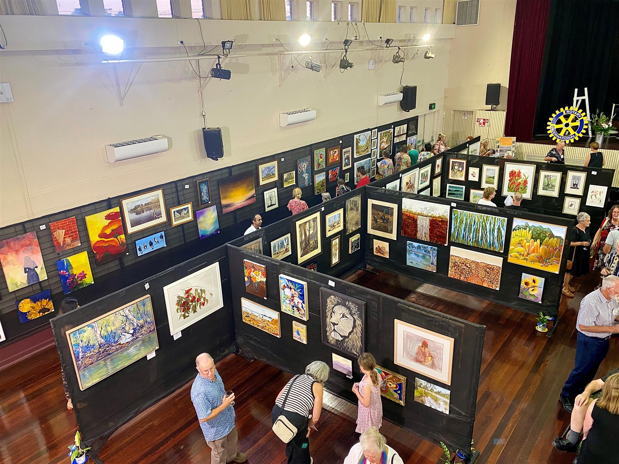
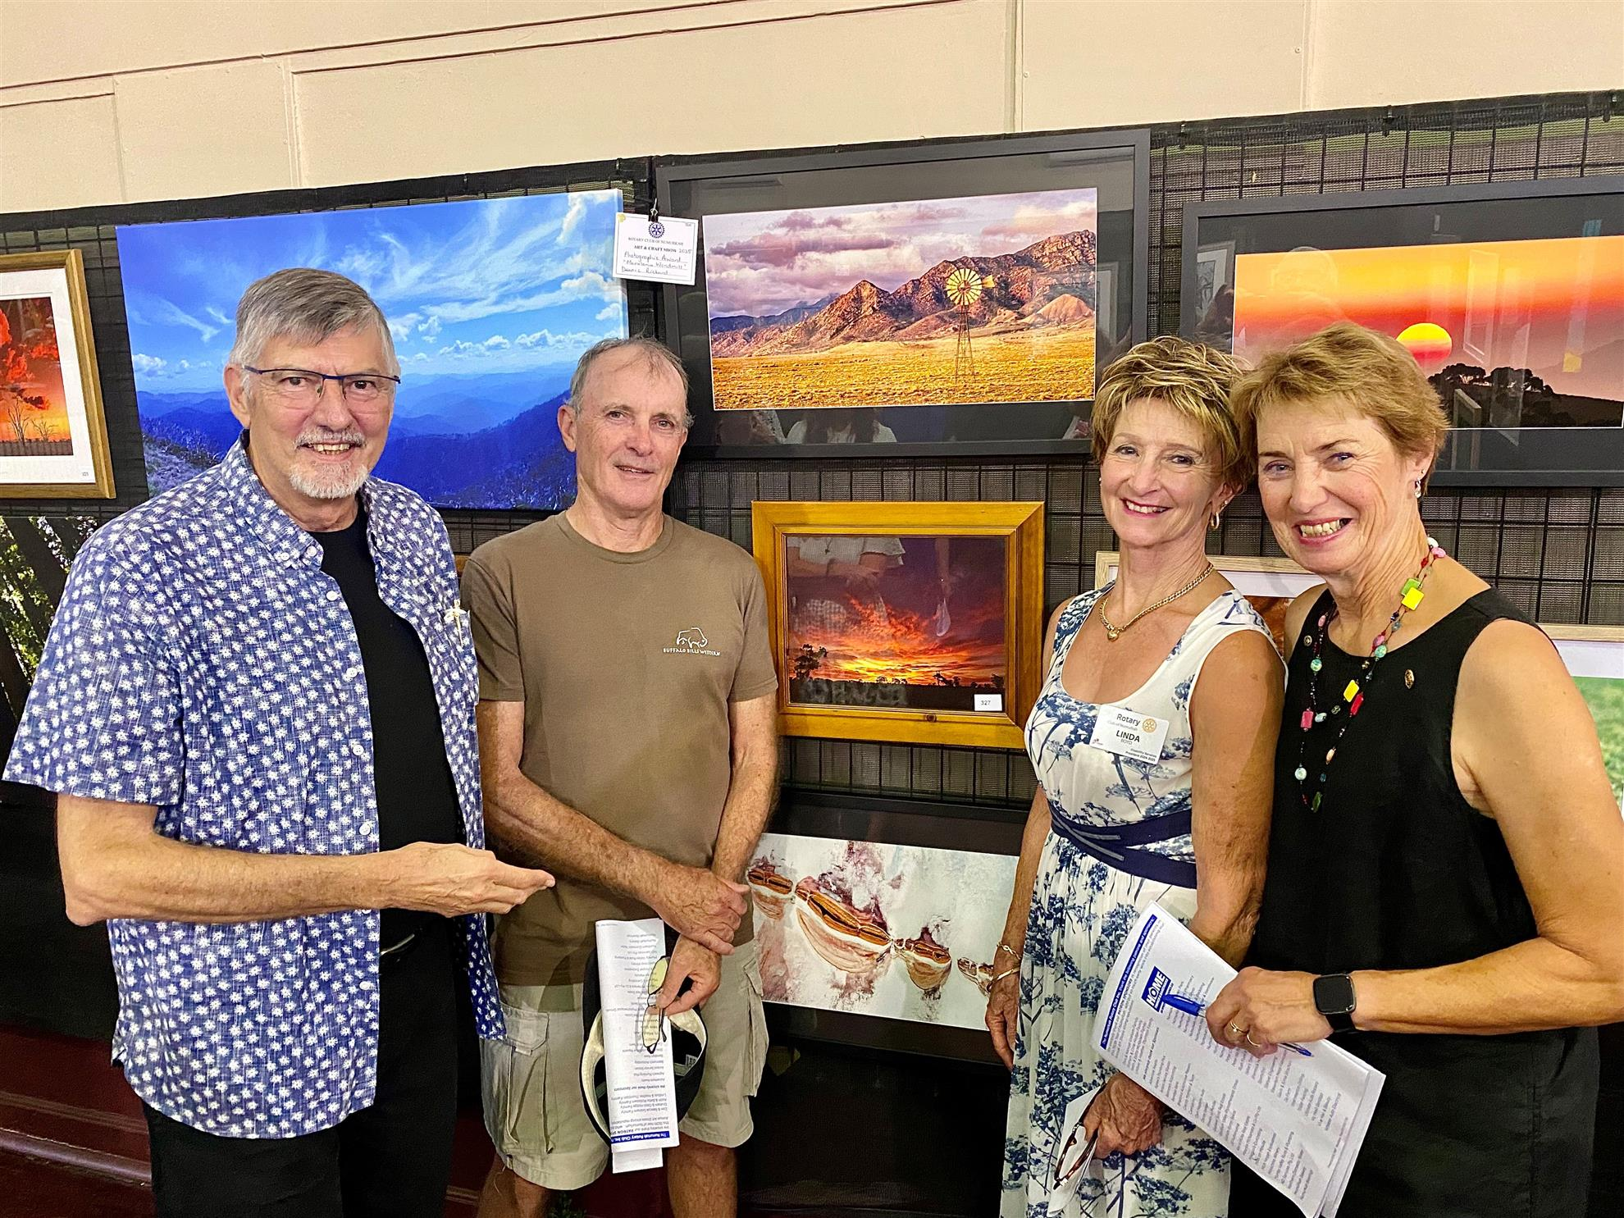

COMMUNITY SERVICE REPORT

Throughout the year the Rotary Club hosted numerous BBQs, and our little trailer got a lot more use. Note – the BBQ trailer is kept in tip top working order with TLC from Terry and Ivan. IGA Ritchies, Newman Square were regular venues for most of the year. The Club also catered for clearing sales as well.

All through the school year, the Numurkah Primary School “Breakfast Club” has been supported by our Rotary Club’s band of volunteers, 5 days a week. They provide a variety of healthy foods with toast and vegemite always the favourite. If a volunteer is unable to turn up, there is always someone to fill in. The program has increased in popularity with the students, providing them with a good start for the day for better learning. It has been noticed, by the teachers, that children are more settled and ready to learn. The appreciation and the good manners from the children, has given all the volunteers positive feedback.

Show Us Ya Wheels had a fantastic turn out for their weekend in the main street. The weather was again magnificent which brought masses of people from near and far. Again, our catering entourage had prime position at the Post Office site next to the stage truck. The amount of hardware driven into town was mind blowing, from the main street out to the showground and down to the hospital precinct. A great community project headed by Dean Graham.

We also catered for the staff on site at the Flavorite hothouses for their Christmas end of year function as we did last year. Over a hundred employees were fed and, maybe to their relief, there were no tomatoes in the salad.

During the year we had a small band of volunteers helping out with the St Joeys Fun Run braving the elements hot and cold. This event continues to be a great community get together.

March is always a busy month with our annual Art Show but to make it even more hectic our yearly 4WD trip was planned two weeks later. This year, number 19, we headed off towards Merrijig and ended up at Fry’s Hut campground with 38 attendees and, yes, more cooking. Friday night steak and Saturday night spit roasts. Normal breakfasts consist of porridge, toast, jam, tomato and of course the ever-popular eggs and bacon. On Friday night we had a bit of rain but that didn’t dampen our spirits because Saturday the sun shone, and the weather was quite warm all weekend. Around the fire on Saturday night, we had a “show and tell” of favourite camping gadgets. Thanks to the Seagers for their hacks, of which I can’t tell you about, due to modesty. Needless to say, you will have to ask Phil what his was (hint – something to do with bodily functions). The small folk and some brave adults did take a dip in the pristine water in the creek and for a small fee, other brave adult men included, got their fingernails painted. Due to the damp conditions only a few brave (or hardy) souls ventured up the 4wd tracks. But never fear with Nick Comma’s bravado he saved a damsel (and her male companions) from imminent demise by winching their mis adventurous vehicle back onto the trail. Thanks to all the Rotarians and partners (and all the others who attended) for helping out and making it another successful weekend.

As part of our community service, each year we volunteer to assist the CFA in collecting donations for the Good Friday Appeal.
Similarly, ANZAC day is an auspicious occasion for the Numurkah community and as usual the Rotary Club were up very early cooking at the RSL hall for the gunfire breakfast. A huge crowd attended the dawn service then descended on the egg and bacon sandwiches with tea and coffee (with additives!!). Having the Secondary College and Primary Schools involved with the morning service continues to reinvigorate the local reminiscence of the sacrifices made by service men and women during the various conflicts over the years.

The “battery project” came to fruition in April 2025 when we loaded all of the donated batteries onto a truck and trailers and took them down to Future Metals, who agreed to pay in excess of their list price. I’m not sure if they knew how many batteries we had (30 pallet loads), but the final sum came to $10,080.00. Thanks to Stephen Holmes for the use of one of his tilt trucks.

In this Rotary year a Paul Harris Award was made to Faye Holmes for her organisational prowess for the culinary delights on the 4WD weekend. This was our 19th year of which Faye had a helping hand in most of them.

At the end of our 2024/2025 year, we had our annual combined Numurkah Lions/Rotary/Combined Services dinner held at the Shamrock Hotel. Thanks go to Mark McNamara for bringing to Board the idea of a surprise celebration of Terry Brennan’ 50 years in Rotary. Terry knew something was afoot only when most of his immediate family turned up. Terry is a quiet achiever and has been, and still is, an extremely active member over the entire time. Not only in Rotary but a host of other organisations benefitted from Terry’s active involvement. To name a few – Numurkah Rifle Club, the Goulburn Valley Car Club, the Numurkah Town Bowls. He also runs/plans a motorcycle ride each month which gets together riders from a wider area to enjoy a pleasant Sunday. They usually end up with a meal somewhere and fellowship. Terry is an inspiration to us all and was presented with a Saphire Paul Harris medal by DG Stephen O’Connell who at the end of the night serenaded us with his rendition of Somewhere Over the Rainbow on saxophone. A great time was had catching up with friends of the combined services and their partners. President Linda closed the night and a comment was heard, “that one will be hard to beat”.

During most of the year Mark Mac has been busy getting in place proposals for the 150th celebrations. In consultation with the Historical Society, Mark has worked with their members to help organise successful event(s) for 2025. With Mark’s amazing organisational skills, he carolled us (headed by Terry and Ivan) and others into completing the refurbishment and painting of our town’s train K180 and the tractors in the Rotary Park. Now they look sensational every time we drive past. The culmination of which went off with a tremendous weekend on February 8 and 9 with events on Saturday at the showgrounds and then the raising of the time capsule on Sunday in the Rotary Park with many people in attendance. The time capsule was a Rotary project started in 1975 and again in 2000.

The Community Service Award this year was awarded to Jeff Blackley for his involvement in the Historical Society and especially in the organisation and ongoing 150th celebrations for Numurkah and Wunghnu. Much work has gone into this one event that started ages ago. Permits, grant applications and booking community groups just to mention a few. Jeff and the members of the Historical Society deserve more than a medal.

This year they also completed and attached the plaques for various historical buildings with descriptions and pictures of their former use. As per the 150th most of the work consists of permit applications, grants and ticking the right boxes, never an easy task! Jeff will be away on June 30th but he may be able to zoom in on the night.

Geoff Holmes
Community Services Director
2024/2025
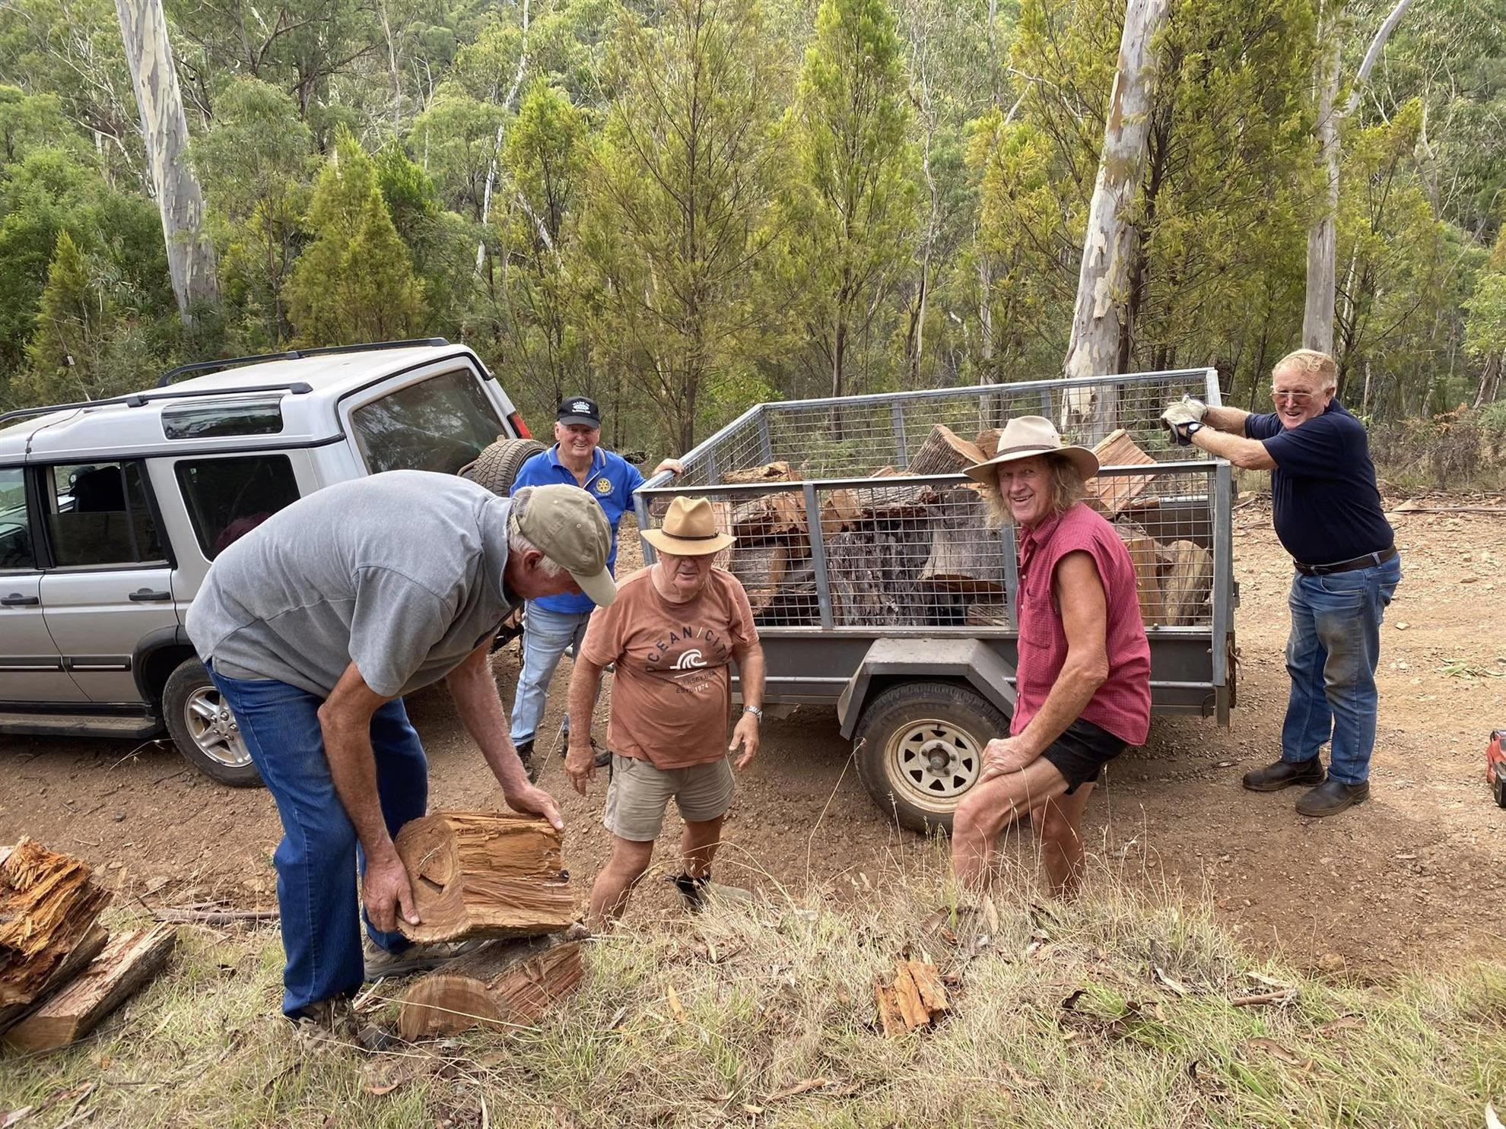
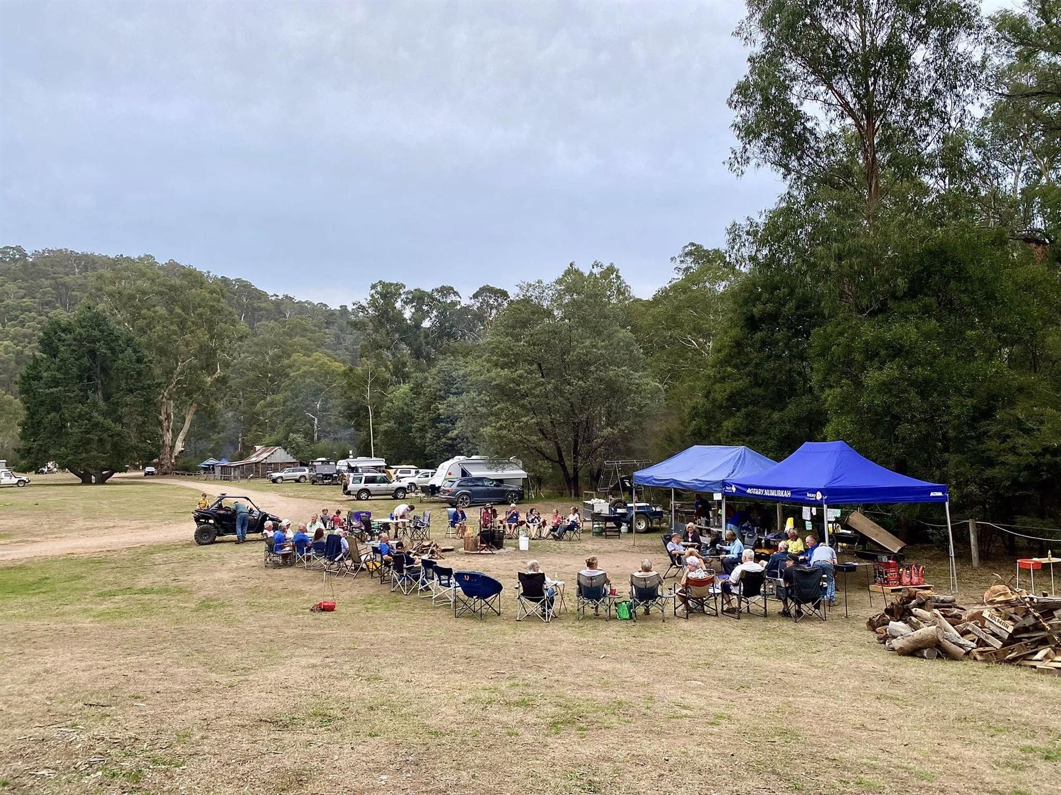

INTERNATIONAL REPORT

Our Club has continued their long-term support of the RAWCS project - Umoja Orphanage, near Mombassa, Kenya. The name Umoja means “the spirit of unity and togetherness” in Swahili.

Cathy Booth from the Rotary Club of Bundaberg Qld, founded the orphanage.

Cathy continues to gain sponsorship, to provide love, education and resources to children in dire need.

Jeff and Gayle Buzza volunteered last year and had an amazing experience at the Orphanage and the wildlife safari.

We continue our sponsorship of Alare, and we receive monthly updates of his progress. He is healthy, enjoys school, is a hard worker, he enjoys being on the farm with the animals, farm workers and planting crops. Our sponsorship of $100/month helps purchase food, clothing, schoolbooks, uniforms, medical assistance, medication and school fees.

Other club members sponsor children as well which is a significant monthly contribution from Numurkah to a worthwhile project.

Esther, our Plan International girl in Ghana, also receives our sponsorship and support. Our support helps ensure that her rights are respected and that she receives food, clean water, sanitary care, a safe and nurturing environment and most importantly, an education.
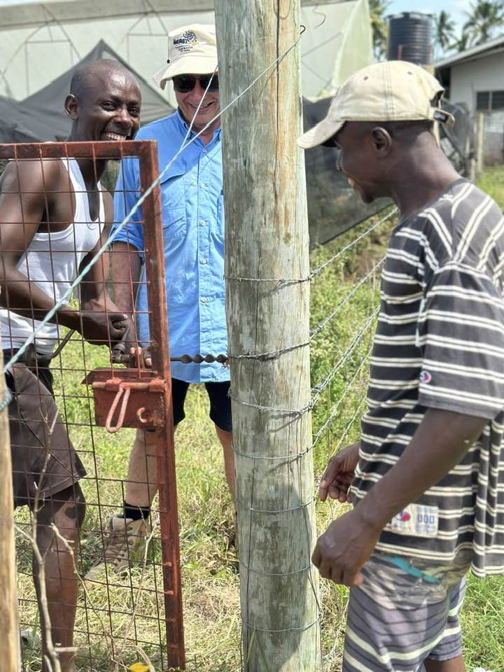
Jennifer Rodger
International Chair
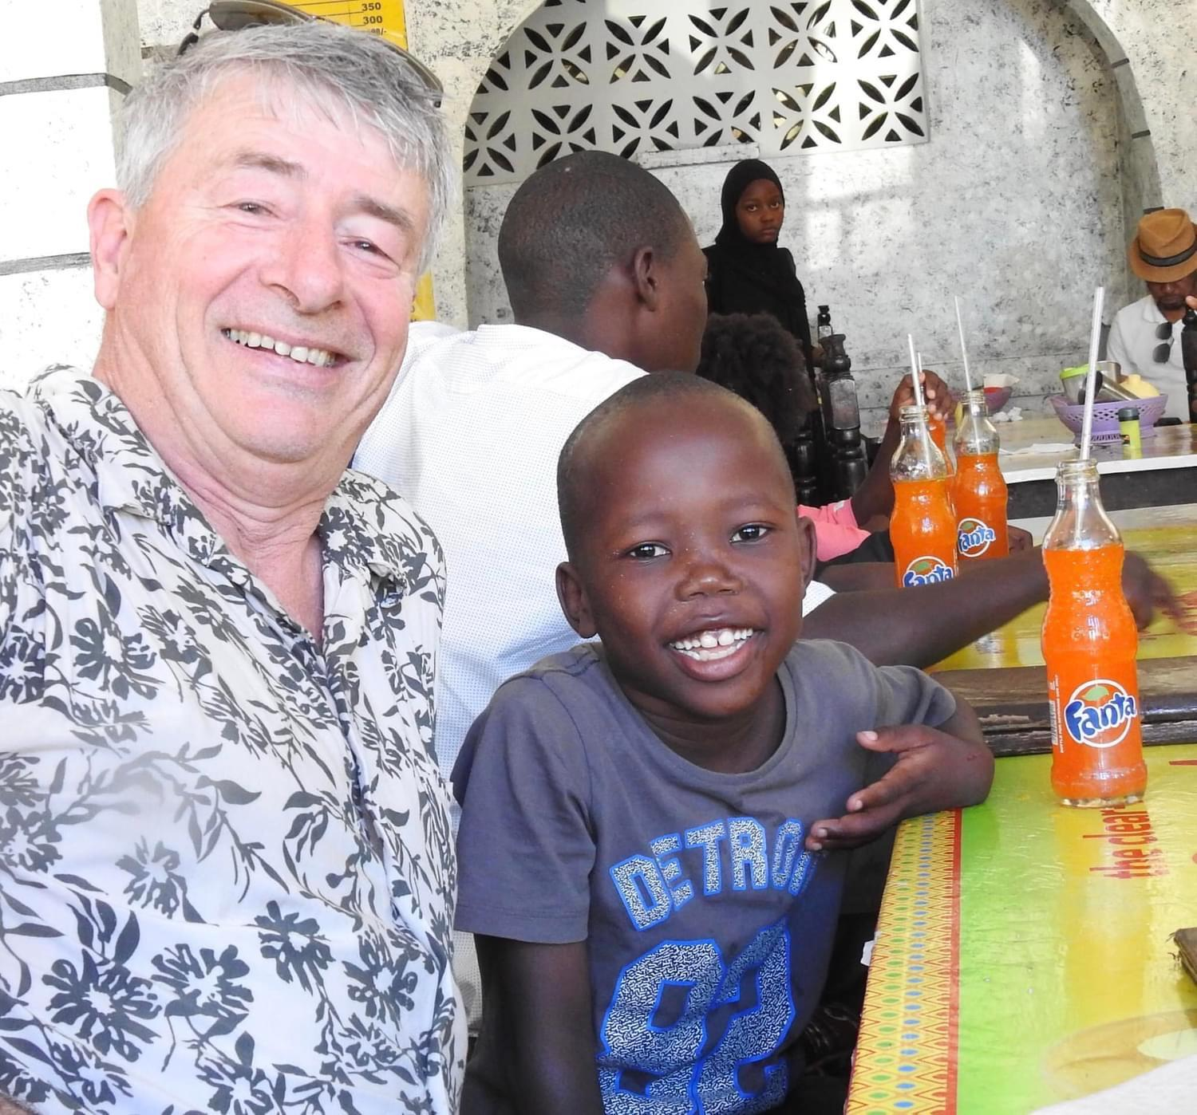

FOUNDATION REPORT

The Rotary Foundation is Rotary's own charitable fund and is operated exclusively for charitable and educational purposes throughout the world. The purpose of The Rotary Foundation can be found in its motto: "Doing good in the world."

Attached is a Fact Sheet taken from My Rotary which provides a summary on the global spending of Rotary on Foundation.

Through its seven areas of focus, The Rotary Foundation seeks to fulfill its mission by awarding grants to Clubs to implement projects at both a local and an international level, projects that improve the lives of children, providing access to health care, education, adequate food, shelter and clean water, ensure peace and care for the environment.

The Rotary Foundation is OUR Foundation, YOUR Foundation.
We conducted our second Lift the Lid Walk held on 18/05/2025 on a cold Sunday morning. Whilst numbers were lower than last year, and the route had to have last minute adjustments due to construction work from the Shire, it was a successful event and encouraged participants to discuss mental health issues.

Beyond Blue provided two guest speakers who spoke of their personal experience with mental health and provided information on local resources.

Jennifer Rodger
Foundation Chair
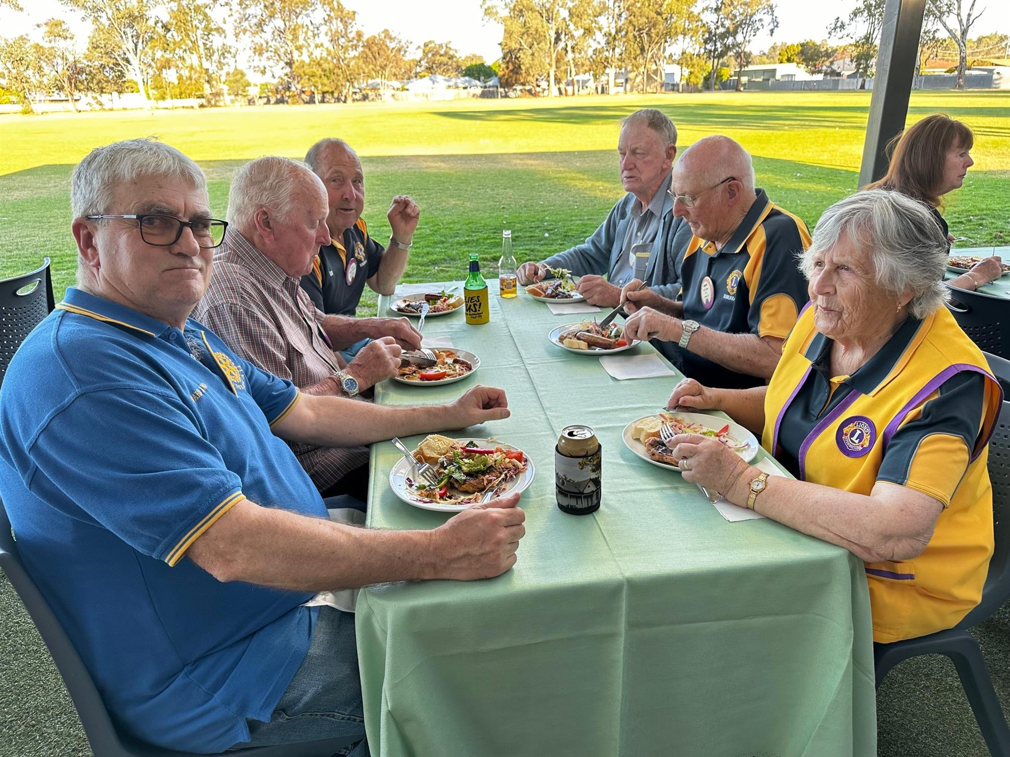
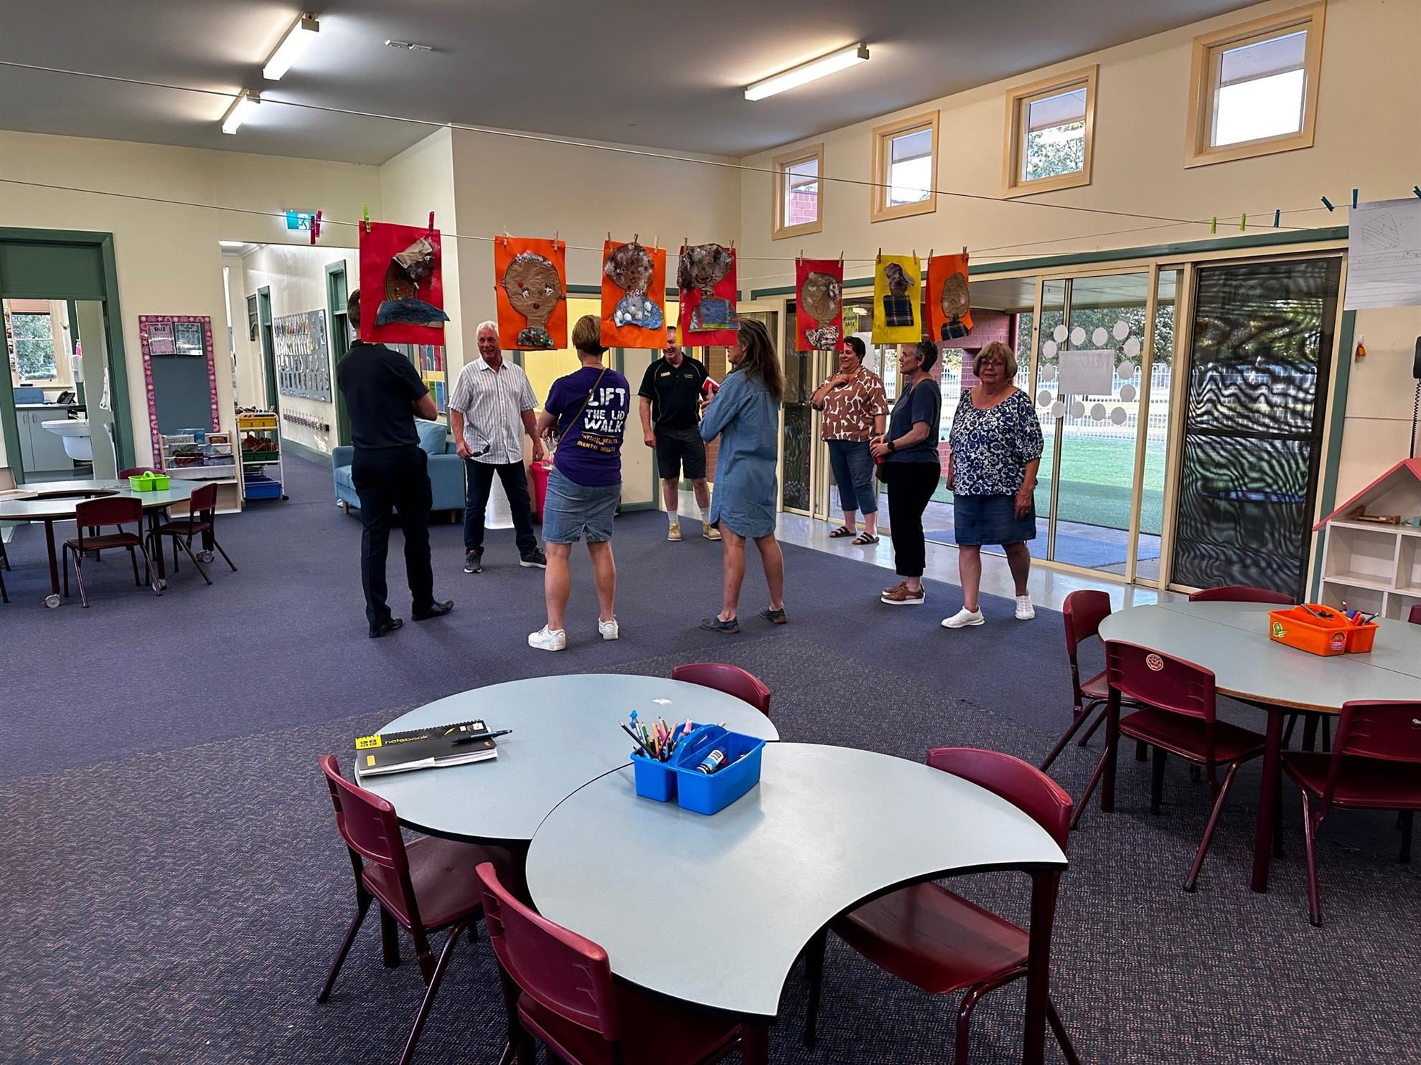

YOUTH REPORT

The Rotary Club is deeply committed to supporting and empowering the youth of our local community through a variety of impactful programs and initiatives.

By fostering leadership, education, and community engagement, the club plays an active role in helping young people reach their full potential.

Key youth-focused efforts include offering mentorship opportunities, such as the Tractor Project at the Numurkah Secondary College and organizing youth leadership development events such as Rotary Youth Leadership Awards (RYLA).

Additionally, the Rotary Club has continued to support the Numurkah Primary School Breakfast Program and has also partnered with the St Joseph’s Primary School to enhance the recycling of drink containers through the Victoria Container Deposit Scheme.

Through these efforts, the Rotary Club continues to inspire the next generation of leaders and community advocates.

Squish Davis
Youth Director

VOCATIONAL SERVICE REPORT

In accordance with Rotary’s idea of vocational service this year the club has continued on with activities that demonstrate and educate members in the concept of vocational service.

Each week where the Chairman for the meeting is still in employment, they present to the club a three-minute talk on their business and what may be happening in their particular vocation. This allows all members to gain an insight into what happens in particular vocations and industries.

At most meetings the club enjoys the presentation of a guest speaker. The speakers are drawn from a wide range including presentations on various professions in the area. This allows the club to discover what is involved in various fields of endeavour and also in some cases how their vocation may help with existing projects or encourage them to commence an appropriate project. This year we have enjoyed presentations from members of the military, the professions of optometry, teaching, health and local water services. Site visits to Graincorp, Stevenson Engineering and St Joseph’s Primary School.

This year’s Jack Duncan Memorial Vocational Service Award went to Trish Chmiel for her work in education at St. Josephs Primary School and now Cobram Anglican Grammar. Trish was selected for her dedication to her profession and the way she has extended that into her community work with the Numurkah District Soccer Club, the Park Run and her work with and encouragement of students and adults in the field of music.

This year saw the inaugural Ernest Jones Pre-Apprenticeship Award being given to the Numurkah Secondary School student who demonstrated the most commitment and ability in their chosen trade. The award was presented to Ryan Russo, the award carries with it a monetary prize of $250

Jeff Buzza
Vocational Services Director

RIDE TO CONFERENCE REPORT

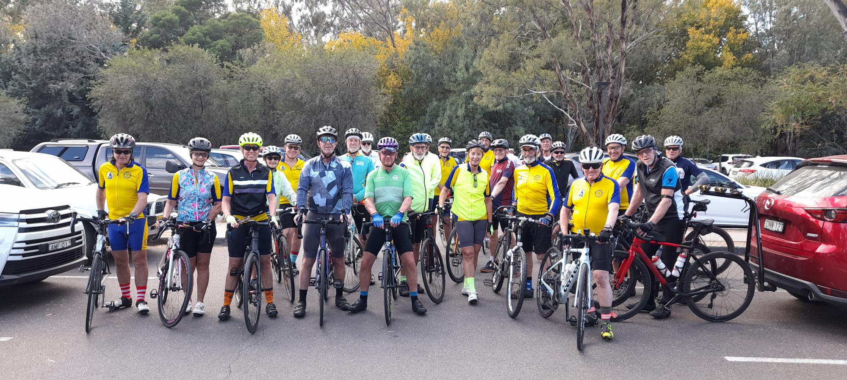

District 9790 Ride to Conference

The D 9790 Ride to Conference is a multi-Club project, which comes under the banner of the Rotary Club of Numurkah. The event took place Wednesday 9th of March through to Friday 11th of March prior to the D9790 Albury Conference.

The event presented some challenges for twenty cyclists participating, but it’s not a race, and much fellowship was enjoyed by the riders. The group was supported by a wonderful crew who kept the team safe on the route and made sure most of the time, that no one got lost. They also provided nourishing morning/afternoon teas and lunches along the way.

Albury North, Bright, Cobram, Eltham, the E Club, Numurkah, Seymour, Shepparton South and Moreland Rotary clubs were represented. The team was also supported financially by the RC of Corowa, who are the foundation Club for this event.

Our group stayed at the Lake Hume Tourist Park, which was our starting point for each day's ride.

Day 1 was a short 62 km ride alongside Lake Hume, cattle and sheep farming country and the rolling hills in and around the towns of Kiewa and Tangambalanga.

Day 2 began with the 42 km rail trail to Tallangata for morning tea. The hills then beckoned on the back roads to Bethanga and the final climb of the 88km day was up to the Kurrajong Gap Lookout - a steep climb indeed. We were rewarded with wonderful views at the top and a chance to catch our breath before the steep descent.

Day 3 was a more leisurely 56 km ride along a rail trail through a forest and a loop of the beautiful Albury Wetlands.

Congratulations go to Peter Dow RC of Albury winning the Margaret and Graham Brown Trophy for all the work he put into organizing the ride. Also, congratulations to Peter Drummond also RC of North Albury for winning the Tony Thomas “Spirit of the Ride " Trophy.

The Sports Woman of the Year Trophy also came back to the Ride to Conference Team this year which I was fortunate enough to be awarded.

The Ride to Conference is a fund raiser for Australian Rotary Health / mental health research and in particular supporting for our Indigenous Health Scholar Zarah Kelly-Carroll, who is studying medicine at the Flinders University. This years’ ride raised at a total of $12,837.85 A fantastic effort for a small team, and we sincerely thank all our supporting Clubs, participants and generous sponsors for their financial support

Chris Sutton
Ride to Conference Co Ordinator
D9790

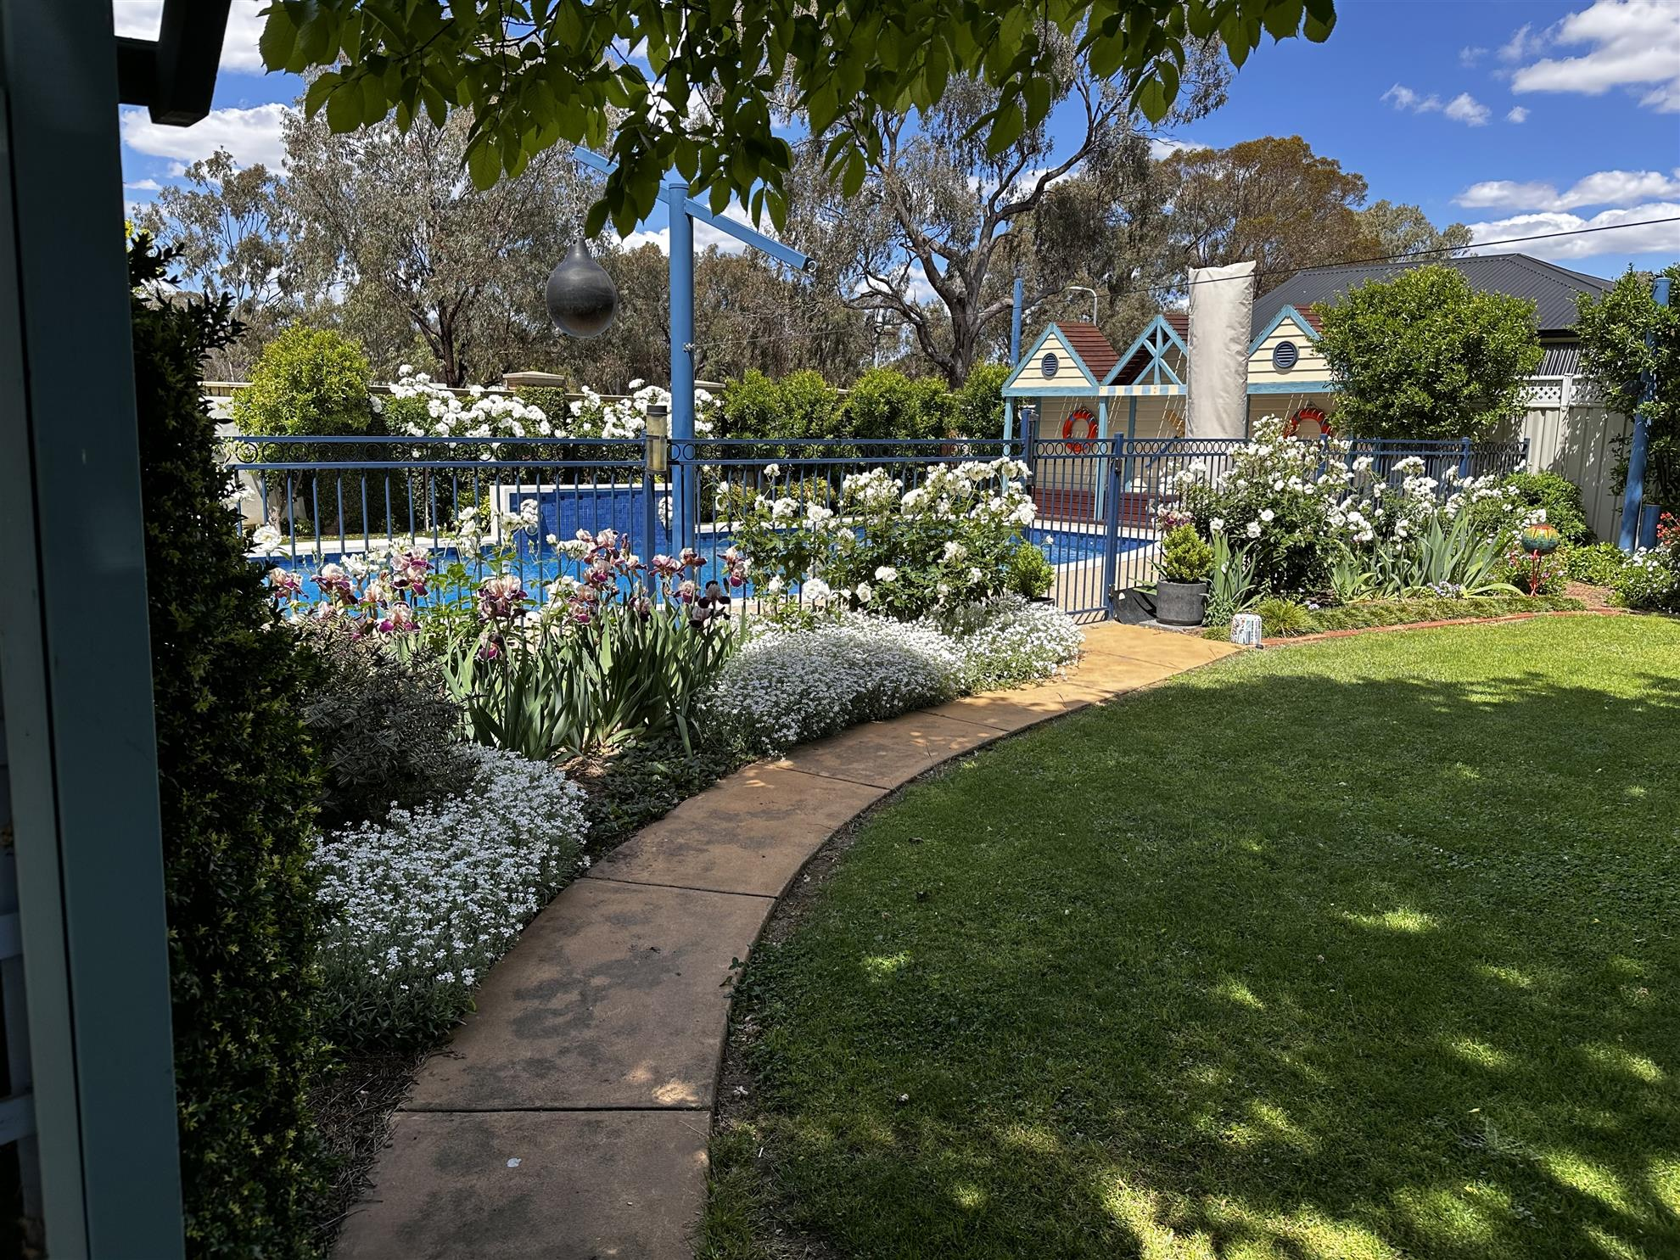
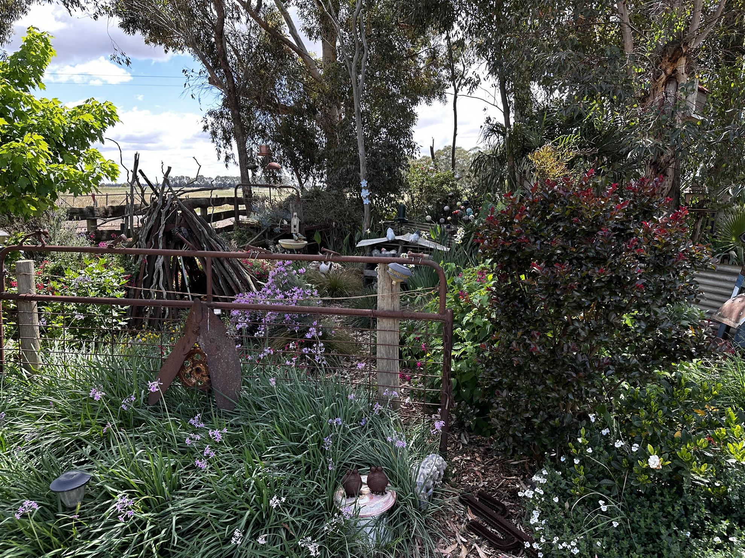

FINANCIAL STATEMENTS

Prepared by Stephen Mills, Treasurer of RC of Numurkah – 17th June 2025
Rotary Club of Numurkah, Financial Statements - 24/25
Income
Community BBQ’s
IGA Town BBQ's for NHS & Love Your Sister | 590.75
Show us Your Wheels & Election Day BBQ's | 3,867.95
CFA, RSL & Sidebottom BBQ's | 1,467.56
Vocational Service Meetings @ GrainCorp, SES & Graham's | 1,188.00
150th Anniversary Dinner | 6,480
Catering for Flavorite Christmas Function | 2,300.00
Donations from E. Adams, J Hewson & Art Show | 246.00
Donation from Mills Family for Tractor Painting | 500.00
Raffle Ticket Sales | 2,270.00
Moira Shire Council for Australia Day | 2,000.00
Open Gardens Weekend | 7,000.00
4WD Weekend | 5,940.00
Scrap Battery Sales | 10,080.00
Lift the Lid Walk for Mental Health | 1,330.00
Tee Shirt Sales & @ June Dinner Bookings | 820.00
Membership Subscriptions | 5,950.00
Fines | 3,694.50
Interest Received | 1,348.19
Can Sales from St Joseph's | 1,892.60
IGA Rewards Program Payments | 524.51
Shepparton School Sports Day BBQ | 1,009.60
Entry Fees | 3,090.00
Food & drink sales opening night | 487.95
Donations from Patron Families | 4,000.00
Commission on Sales | 4,401.05
Door Sales | 3,249.80
Raffle Ticket Sales | 4,407.50
Sponsorship | 13,955.00
Kitchen Sales | 1,284.10
Total Income | $95,375.06

Expenses | Column1
Altegra; New Gazebo | 1623
Shamrock Hotel | 6520
4WD Weekend costs | 2177.67
Bank fees | 327.2
BBQ Supplies | 3306.68
Disbursements (attached) | 28068.41
Guest's meals | 870.05
Flavorite Catering Costs | 759.77
Cards & Flowers | 185.95
Club Runner | 1076.83
Rotary District fees & Insurance Levy | 4147
Rotary International | 4127.23
RDU Magazine fees | 1253.17
RDU Membership Costys | 1439.91
Overheads & Miscellanoes | 788.05
Australia Day Costs | 2000
Open Garden Project Costs | 1176.64
CLUB Cup eve & Christmas Socials | 381.75
Repairs & Maintenance to Rotary Shed | 543.85
Show us Your Wheels costs | 1052.57
Training for Directors | 670.68
Purchase of Tee Shirts | 569.75
Advertising | 2,242.40
Clean-up Costs | 348.99
Food & drink for the opening | 540.6
Hall Hire | 500
Judging | 700
Kitchen Expenses | 298.5
Music | 400
Postage | 152.02
Priting | 1507
Prizes | 4850
Rotary Acquisition for 2026 Raffle | 450
Sponsorship, art Purchases | 8,330.00
Total Expenses | 83,385.67

Disbursements
Cobram & District Quilters |  | 500.00
ARH; Crazy Hats fines session |  | 250.00
ARH; Ride to Conference sponsorship |  | 2,000.00
Donation to Numurkah CFA |  | 452.00
Interplast Australia; DG's Partner Project |  | 1,000.00
KidzFix |  | 500.00
Local Primary School Award Vouchers |  | 625.00
Love Your Sister |  | 282.50
Numurkah Bowling Club |  | 100.00
Numurkah Community Learning Centre senior’s lunch |  | 88.42
Numurkah Historical Society support for 150th Anniversary |  | 5,221.75
Numurkah Laundrette for Vouchers |  | 200.00
Numurkah Primary School for leadership program support |  | 573.95
Numurkah RSL support for Gunfire Breakfast |  | 487.05
Numurkah Secondary College; Ernest Jones & Academic Awards |  | 878.55
Numurkah SES for a mule carrier one wheel specialist stretcher |  | 3,525.30
Numurkah Show us your wheels community BBQ |  | 190.81
Plan International; sponsorship of Esther in Southern Ghana |  | 612.00
RC of Mooroopna |  | 920.00
Rotary District 9590, western Qld Flood Appeal |  | 2,000.00
Rotary Foundation through PHF |  | 1,590.00
Rotary Park Restoration Project |  | 2,665.08
Umoja Orphanage Kenya |  | 2,200.00
YMCA Family pool passes |  | 1,206.00
Total Disbursements |  | $28,068.41
Bank Reconciliation
Opening Balance Closing Balance | Opening Balance $62,605.33
Admin A/C $12,480.69 $ 6,551.99 | Plus Income $95,375.06
Disbursement A/C $20,088.44 $11,879.95 | Sub Total $157,980.39
Art Show A/C $1,538.33 $1,120.05 | Less Expenses $83,385.67
Term Deposit No 1 $28,297.87 $29,642.73 | Closing Balance $74,594.72
Term Deposit No 2 0.00 $25,000.00
Float $200.00 $400.00
$62,605.33 $74,594.72
Details of Term Deposits
No1. $29,642.73 invested until 22/10/2025 @4.6% at Bendigo Bank
No2. $25,000 invested until 15/09/25 @ 3.4% at Bendigo Bank

